Manual for Hepatitis C Elimination System

Table of Content
Short description of the Elim C System and its functionality 4
SSA – Reception Role 5
Demographic Data 6
Registration 6
New Patient’s Page 9
Patient’s History 12
Page of patients waiting list for committee decision 13
Page of Problematic Patients 14
SSA – Regional Reception Role 14
Demographic Data 15
Registration 16
Page of New Patient 19
NCDC - Reception Role 21
Demographic Data 22
Registration of Screening Results 23
Committee Member Role 23
Committee Process 24
Drug Registrar Role 26
Drug Registration 26
Balance Sheet 29
Warehouse Balance 30
Drug Deduction 31
Role of Drug Distributor 32
Supplies in Clinics 32
Drugs in Clinics 33
Sending the drug 34
Invoice 36
Sending the drug from one clinic to another 37
Deduction 38
Drug Logistic Manager Role 39
Balance Sheet 39
Committee 41
Detailed Turnover 42
Balance sheet by clinics 42
System Administrator 44
Creation of system user 44
Patient’s Additional Information 45
Access to monitoring 48
Technical Issues 50
Applied Infrastructure 50
Short description of program code 50

Short description of the Elim C System and its functionality

Elim C is located on www.elimination.moh.gov.ge and recommended “Browser” is “Google Chrome”.
Every system user has their own User and Password. Entering User and Password on the main page is necessary for authorization (Picture 1.1)
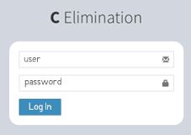
(Picture 1.1 Log in Page)
There are different types of roles with different functions in the system:
- SSA – Reception Role
- SSA – Regional Reception Role
- NCDC - Reception Role
- Committee Member Role
- Drug Registrar Role
- Drug Distributor Role
- Drug Logistic Manager Role
- System Administrator Role
Access to specific information for every user is predefined according to their role.

SSA – Reception Role

User with SSA Reception role identifies patient in the system with ID document or passport (Picture 2.1)
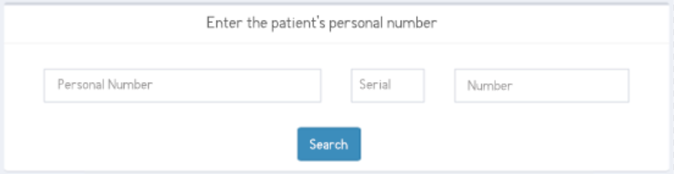
(Picture 2.1 Patient’s identification with ID document)
If patient has new ID document, user fills only Personal Number and Number of ID Document (Picture 2.2)
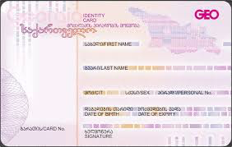
(Picture 2.2 Patient’s identification with a new ID document)
If patient has old ID Document, user fills Personal Number, Serial number and Number of ID Document (Picture 2.3)
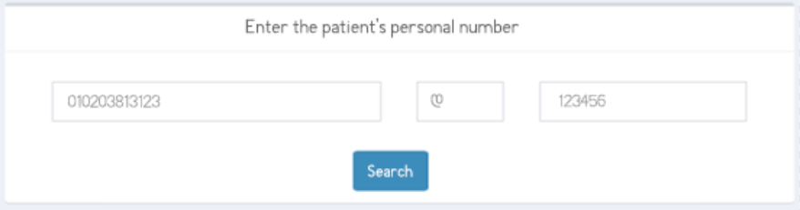
(Picture 2.3 Patient’s identification with an old ID document)

Demographic Data
After searching the information, there is demographic data section, where some information is already filled from Ministry of Justice. All empty fields should be filled accordingly (Picture 2.4)
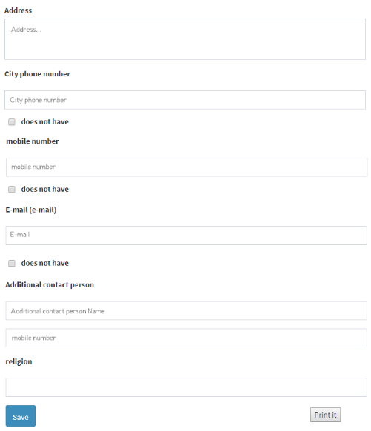
(Picture 2.4 Demographic Data Section)

Registration
Within the Elim C program, Patient can be registered into the program several times. So called “Patient’s Case” is opened on the first conformation test and can be closed for different reasons, such as: cure, death, lost from monitoring and etc.. It is visible to see how many times was patient involved in treatment process. If only start date is mentioned and there is not any end date, it means that patient has just started some activity in the system, which is not finished yet, so the Patient’s Case” is active. Active case can be chosen to register it for diagnostic tests or drug issue waiting lists (Picture 2.5).


(Picture 2.5 Choosing the Patient’s Active Case for some activity)

After choosing the Patient’s Case”, there is Demographic Data section, where some information is already filled from Ministry of Justice. All empty fields should be filled (Picture 2.6).
(Picture 2.6 Demographic Data Section)
After filling the all demographic data, result of first confirmation test should be entered. If the result is already entered into the system, it means that laboratory user filled it and can’t be changed. Moving to the next section is only allowed if following notification will appear after saving the data “Test result is already entered” (Picture 2.7)
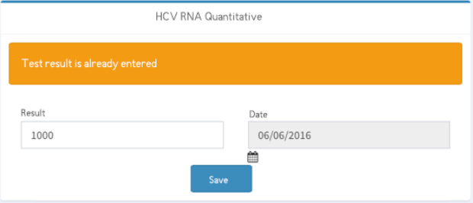
(Picture 2.7 Notification “Test result is already entered”)
After the filling first confirmation test result (HCV RNA Quantitative in this case), next section is “Registration Page”, where patient choses desirable region and provider clinic to get treatment (Picture 2.8)
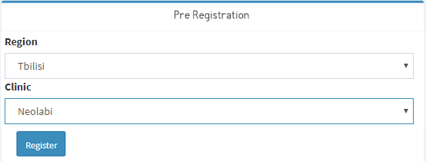
(Picture 2.8 Choosing desirable region and clinic)
If patient wants to get treatment in different provider clinic (not the same clinic, where he had his confirmation tests done), redirection is possible to another provider clinic according to patient’s will. If patient does not express any interest to change the clinic, he should be registered at the same clinic. Once registration is done, two copies of registration paper should be printed. One signed registration papers should be given to patient and another copy should be saved with other mandatory documents.

New Patient’s Page

Link of “New Patient” is visible for SSA Reception role (Picture 2.9)
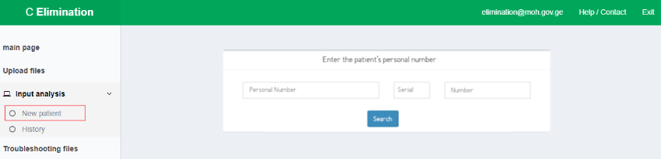
(Picture 2.9 New Patient)
After following the link, some information, such as: patient’s history, diagnostic tests results, defined regimen and uploaded documents will be loaded (Picture 2.10)

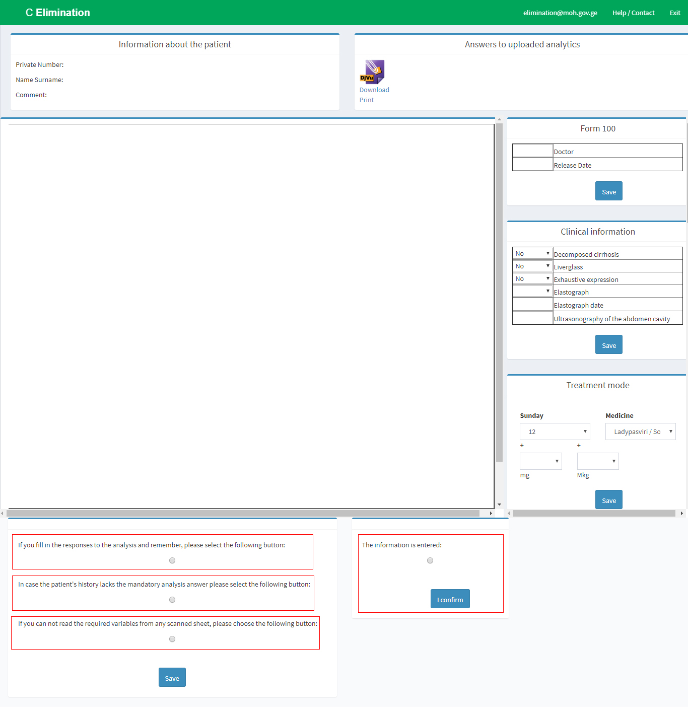
(Picture 2.10 Information regarding the patient)
Following page consists of information about patient, also download of uploaded tests result are available from the same page. After matching the uploaded and entered information, SSA Reception user should check following information:
- Following button should be checked if all test results are entered into the system and saved – If represented tests results and information in the system matches, following button should be checked and finally confirmed.
- Following button should be checked if some mandatory test result is missing from patient’s history – If mandatory test result is missing following button should be checked. After checking the button, comment field will appear, where some additional information should be entered.
- Following button should be checked if information is not visible on a scanned document due to bad quality scanner - If any of scanned document is not readable, following button should be checked. After checking the button, comment field will appear, where some additional information should be entered.
- Information is entered correctly - Mandatory button to be checked for final confirmation.

Patient’s History
SSA Reception user has access to Patient’s history page, where patient’s search is possible via Personal Identification Number, also with name and surname.
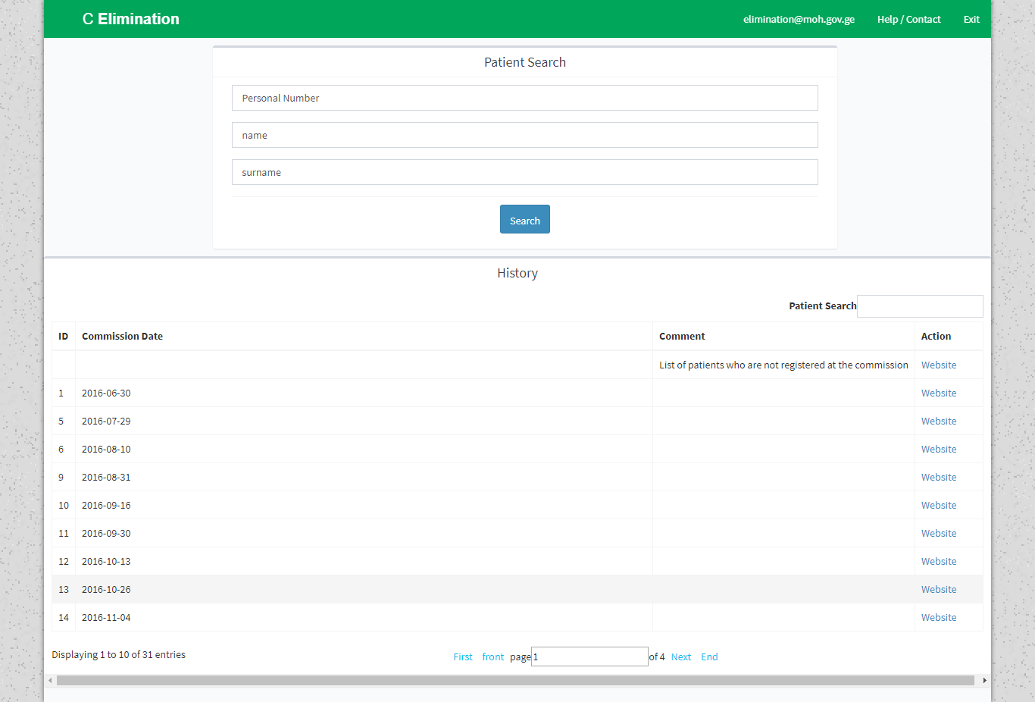
(Picture 2.11 Patient’s search via PID, Name, Surname)
On the same page, there are available committee lists and link of patients, waiting for committee. Committees are sorted according to date.

Page of patients waiting list for committee decision
Following information should be filtered and searched after moving to patients waiting list for committee decisions:
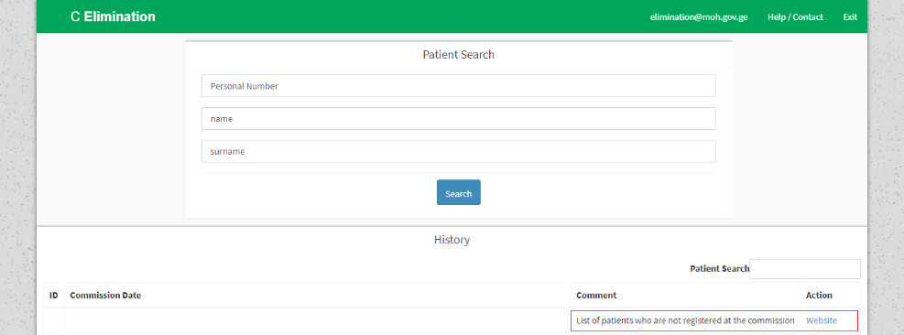
(Picture 2.12 Filtering and search of patients, waiting for committee decision)
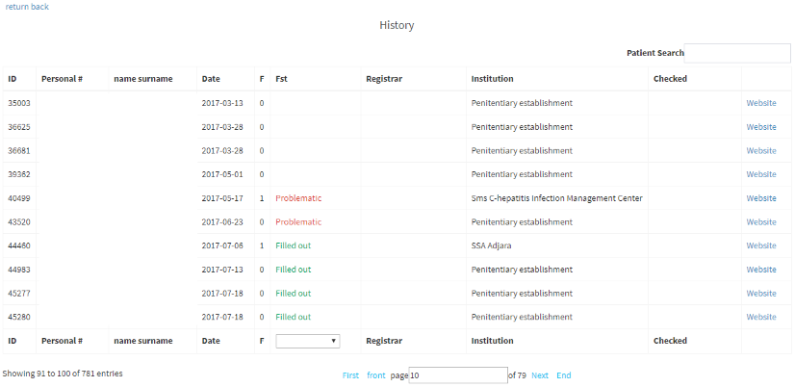
(Picture 2.13 of patients, waiting for committee decision)
- Name, Surname - Patient’s Name, Surname
- Personal Number – Patient’s Personal Number
- Date – Registration Date
- Status - Status of patient’s case. Filled and Confirmed or problematic
- Registrar - Name and surname of the person, who registered the specific patient in to the system.
- Provider Clinic – Clinic, where the patient was registered
- Confirmation - Name and surname of user, who confirmed patient’s documentation.

Page of Problematic Patients
If patients test results and uploaded documents do not match each other, patient gets at the page of “Problematic patients” (Picture 2.14)

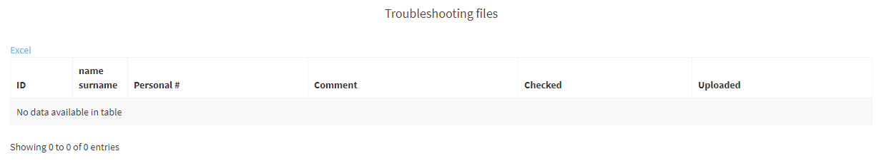 (Picture 2.14 Page of “Problematic patients”)
- Name, Surname - Patient’s Name, Surname
- Personal Number – Patient’s Personal Number
- Comment - Comment regarding unreadable information
- Confirmation - Name and surname of user, who confirmed patient’s documentation.
- Upload - Name and surname of user who uploaded document
Following page enables controlling files of problematic patients and ensures adequate reaction on them.

SSA – Regional Reception Role
SSA – Regional reception user after authorization into the system, identifies patient with ID document or passport (Picture 3.1)
(Picture 3.1 SSA – Regional Reception user identifies patient)
If patient has new ID document, user fills only Personal Number and Number of ID Document
(Picture 3.2)
(Picture 3.2 Patient’s Identification with new ID document)
If patient has old ID Document, user fills Personal Number, Serial number and Number of ID Document (Picture 3.3)
(Picture 3.3 Patient’s Identification with old ID document)

Demographic Data
After searching the information, there is Demographic Data section, where some information is already filled from Ministry of Justice. All empty fields should be filled. (Picture 3.4)
(Picture 3.4 Demographic Data Section)

Registration
Within the Elim C program, Patient can be registered into the program several times. So called “Patient’s Case” is opened on the first conformation test and can be closed for different reasons, such as: cure, death, lost from monitoring and etc.. It is visible to see how many times was patient involved in treatment process. If only start date is mentioned and there is not any end date, it means that patient has just started some activity in the system, which is not finished yet, so the Patient’s Case” is active. Active case can be chosen to register it for diagnostic tests or drug issue waiting lists (Picture 3.5).

(Picture 3.5 Choosing the Patient’s Active Case for some activity)
After choosing the “Patient’s Case” there is Demographic Data section, where some information is already filled from Ministry of Justice. All empty fields should be filled. (Picture 3.6).
(Picture 3.6 Demographic Data Section)
After filling the all demographic data, result of first confirmation test should be filled. If the result is already entered into the system, it means that laboratory user filled it and can’t be changed. Moving to the next section is only allowed if following notification will appear after saving the data “Test result is already entered” (Picture 3.7)
(Picture 3.7 Notification “Test result is already entered”)
After the filling first confirmation test result (HCV RNA Quantitative in this case), next section is “Registration Page”, where patient choses desirable region and provider clinic to get treatment (Picture 3.8)
(Picture 3.8 Choosing desirable region and clinic)
If patient wants to get treatment in different provider clinic (not the same clinic, where he had his confirmation tests done), redirection is possible to another provider clinic according to patient’s will. If patient does not express any interest to change the clinic, he should be registered at the same clinic. Once registration is done, two copies of registration paper should be printed. One signed registration papers should be given to patient and another copy should be saved with other mandatory documents.

Page of New Patient
Link of “New Patient” is visible for SSA Reception role (Picture 3.9)
(Picture 3.9 New Patient)
After following the link, some information, such as: patient’s history, diagnostic tests results, defined regimen and uploaded documents will be loaded (Picture 3.10)

(Picture 3.10 Information regarding the patient)
Following page consists of information about patient, also download of uploaded tests result are available from the same page. After matching the uploaded and entered information, SSA Reception user should check following information:
- Following button should be checked if all test results are entered into the system and saved – If represented tests results and information in the system matches, following button should be checked and finally confirmed.
- Following button should be checked if some mandatory test result is missing from patient’s history – If mandatory test result is missing following button should be checked. After checking the button, comment field will appear, where some additional information should be entered.
- Following button should be checked if information is not visible on a scanned document due to bad quality scanner - If any of scanned document is not readable, following button should be checked. After checking the button, comment field will appear, where some additional information should be entered.
- Information is entered correctly - Mandatory button to be checked for final confirmation.

NCDC - Reception Role
NCDC Reception user is identifying patient in the system with ID document or passport (Picture 4.1)
(Picture 4.1 Patient’s identification with ID document)
If patient has new ID document, user fills only Personal Number and Number of ID Document (Picture 4.2)
(Picture 4.2 Patient’s identification with a new ID document)
If patient has old ID Document, user fills Personal Number, Serial number and Number of ID Document (Picture 4.3)
(Picture 4.3 Patient’s identification with an old ID document)

Demographic Data
After searching the information, there is demographic data section, where some information is already filled from Ministry of Justice. All empty fields should be filled accordingly (Picture 4.4)
(Picture 4.4 Demographic Data Section)

Registration of Screening Results

Screening process is administed in separate Stop C Screening system, which is allocated at http://stop-c.moh.gov.ge and manual for admins and users to work with the screening system is provided in separate files.

Committee Member Role
After authorization of committee member user into the system, short notification is displayed on a screen, where committee process is described.
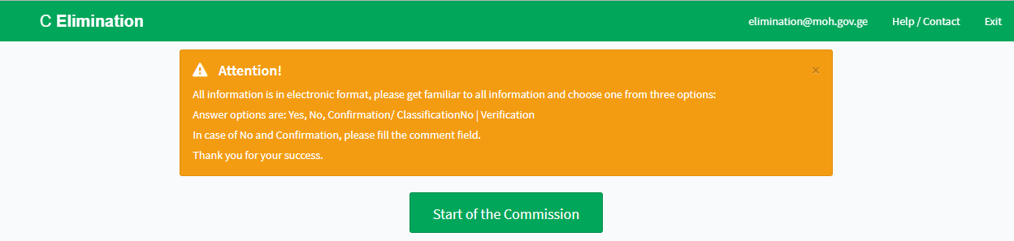
(Picture 5.1)
All information is in electronic format, please get familiar to all information and choose one from three options:
Answer options are: Yes, No, Confirmation/ Classification
In case of No and Confirmation, please fill the comment field.
Committee Process
After pressing the button “Start the committee process”, patients cases are loaded in random way. All information about patients in committee waiting list and already checked cases are displayed on the same page.
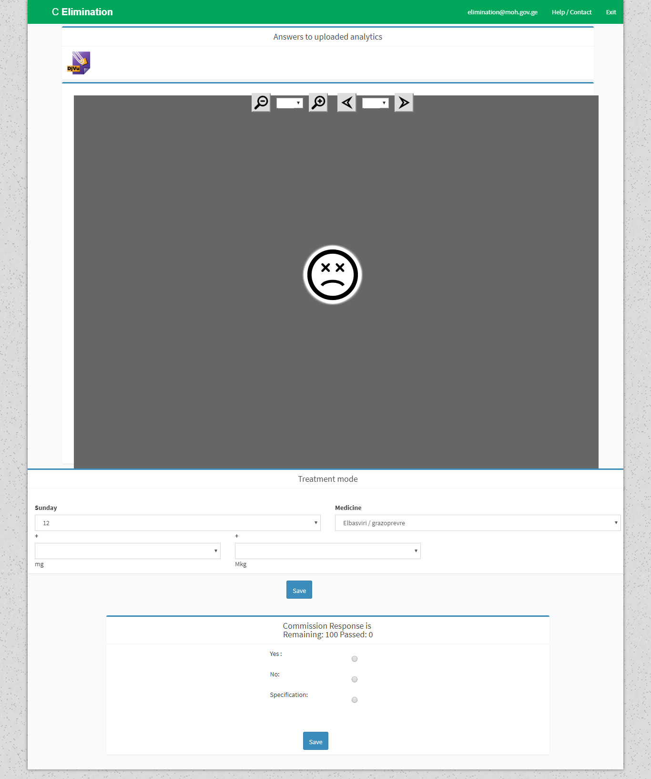
(Picture 5.2 Committee Page)
Committee member studies all uploaded documents, patient’s history and treatment regimen. Committee member can chose one answer from 3 options:
- Yes
- No – Reason field is mandatory to be filled in case of choosing an answer No
- Classify - Reason field is mandatory to be filled in case of choosing an answer Classify/Confirm

Drug Registrar Role

Drug registrar user registers medicines in stock, manages stock, deducts drugs from stock and controls information visibility regarding stock control. Following information is visible for Drug registrar user:
- Drug Registration
- Balance sheet
- Stock
- Deduction

Drug Registration

Drug registration form should be filled on Drug Registration page, where following information is noted:
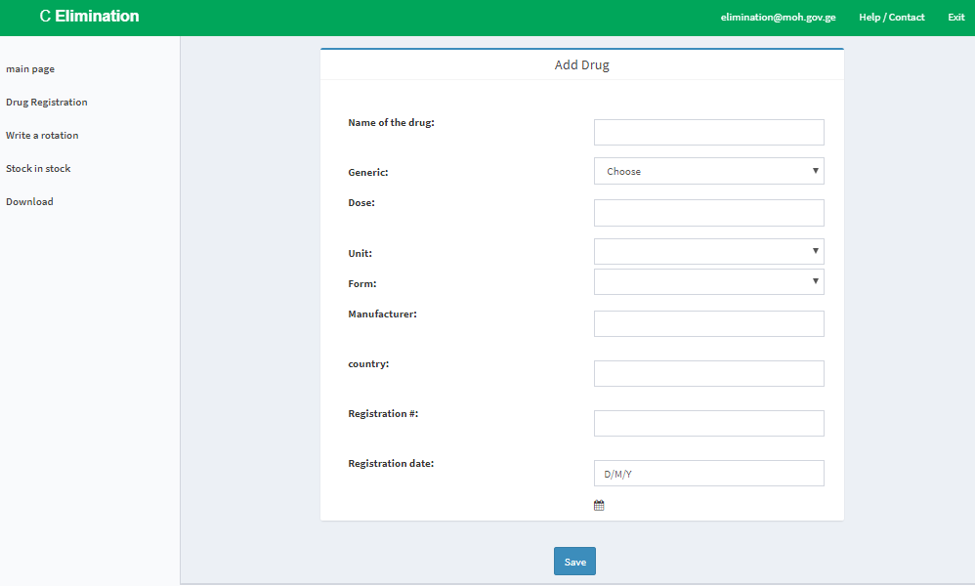
(Picture 6.1)
- Drug Name – Drug Name
- Generic - International name of medicine
- Dose – Dosage of medicine
- Unit - Drug unit Mg/Mkg
- Form – Drug form
- Syringes
- Ampules
- Tablets
- Capsules
- Drug manufacturer - Name of drug manufacturer company
- Country - Name of drug manufacturer country
- Registration Number - Registration Number in Georgia
- Registration Date - Registration Date in Georgia
After filling the main features of the medicine, Drug Invoice should be added (Picture 6.2)

(Picture 6.2 Adding drug Invoice)
Pressing the button “Add Invoice” redirects to a page of adding a specific drug invoice (Picture 6.3)
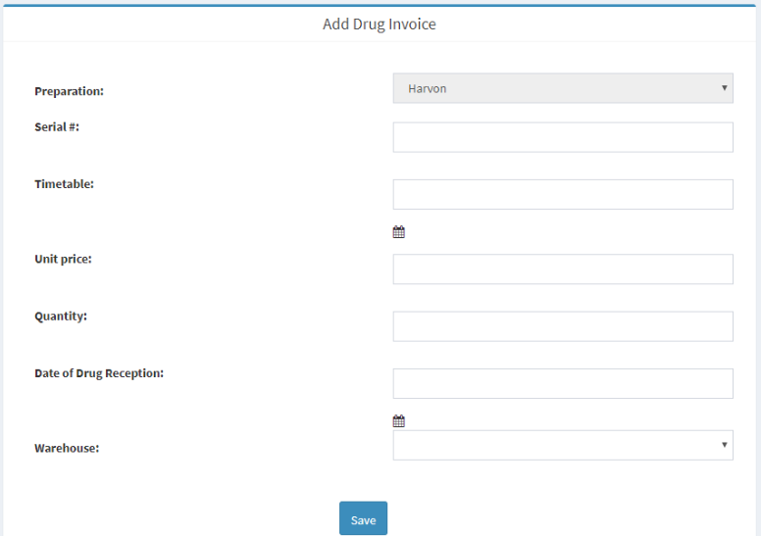 (Picture 6.3 Adding specific drug invoice)

Following information should be entered on that page:
- Medicine - Following field is always filled according to which drug invoice is added
- Serial number – Serial number of medicine
- Expiration Date
- Unit Price – Unit price in Gel
- Quantity - Quantity of drug, registered into the stock (with the same serial number)
- Receiving Date - Date of drug received in stock
- Warehouse –Place, where following drug and serial number should be registered (Mental Health and Drug Prevention Center/Medpharma+)
After pressing the “Save” button, following medicine is registered in the stock. Edit or delete actions are available for the registered case (Picture 6.4)

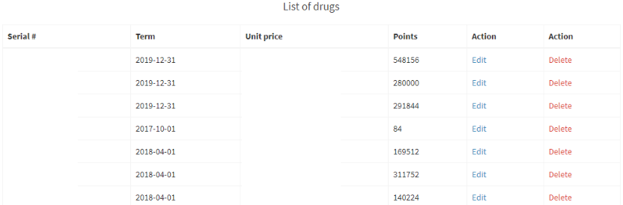
(Picture 6.4 Registered drug in the warehouse )

Balance Sheet
Balance Sheet page displays cumulative information of received drug in warehouse and drug issued to clinics, also quantity and prices of deducted and destroyed drugs for specific period of time (Picture 6.5)
This type of list can be downloaded from that page in Excel format.
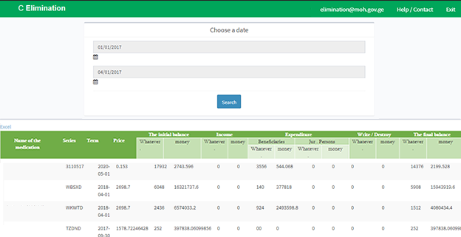
(Picture 6.5 Balance sheet)
After selecting the desirable period, with search button, information of drug turnover is loaded.
- Drug Name – International name of the drug
- Expiration Date - Expiration Date of the medicine
- Serial number - Serial number of the medicine
- Price – Price of pill
- Starting Balance
  - Quantity - Starting drug balance (quantity of pills) for specific period
  - Money – Starting amount of money for medicine for specific period
- Income
  - Quantity - Quantity of received medicine (pills) for specific period
  - Money - Amount of Money received for medicine for specific period.
- Expenses
  - To Beneficiary
  - Quantity - Quantity of medicine (pills) issued to beneficiary for specific period
    - Money - Amount of money, price of issued medicine to beneficiary for specific period
  - To legal entity
  - Quantity - Quantity of medicine (pills) issued to legal entity for specific period
    - Money - Amount of money, price of issued medicine to legal entity for specific period
- Deduction
  - Quantity - Quantity of Deducted medicine (pills) for specific period
    - Money - Amount of money, price of Deducted medicine for specific period
- Final Balance
  - Quantity - Final drug balance (quantity of pills) for specific period
Money – Final amount of money for medicine for specific period

Warehouse Balance
User should choose a specific warehouse at Stock page, which balance sheet should be displayed. After searching the data, information about drugs in desirable stock will be loaded.
This type of list can be downloaded from that page in Excel format.
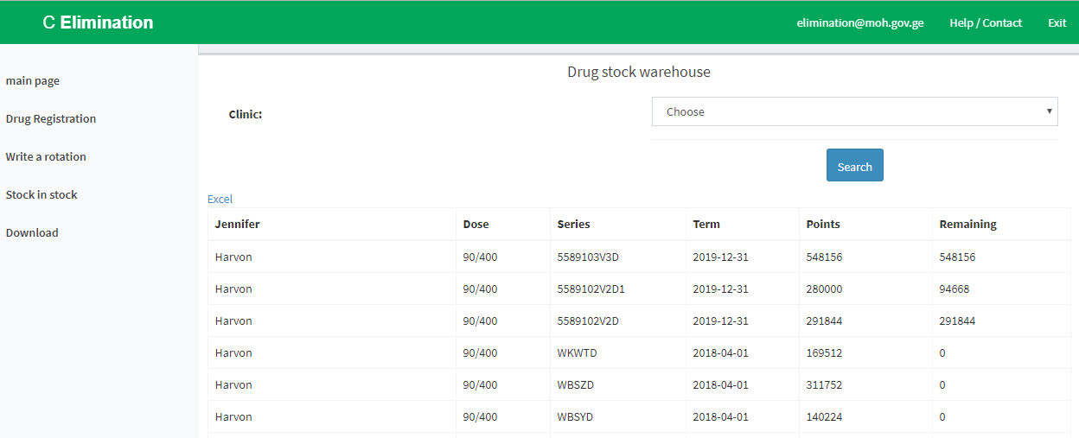
(Picture 6.6Balance sheet in warehouses)
- Generic – International name of medicine
- Dose – Dosage of medicine
- Serial number – Drug serial number
- Expiration Date - Expiration Date of the medicine
- Quantity - Quantity of drug registered in the warehouse with specific serial number
- Leftover - Quantity of drug left in the warehouse with specific serial number

Drug Deduction
Drug Deduction form is available on “Drug deduction” page, where medicine should be chosen and information should be saved
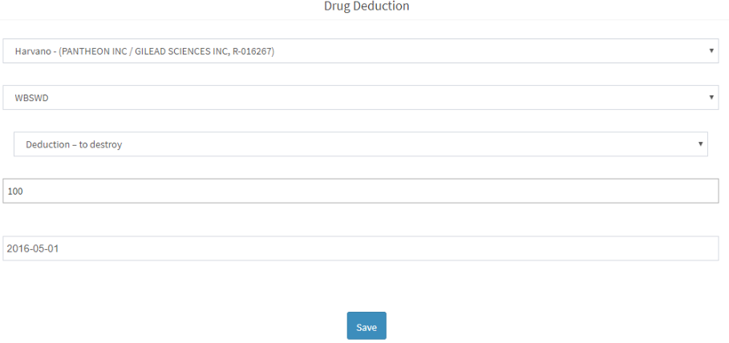
(Picture 6.7 Drug Deduction)
- Choose medicine
- Choose serial number (where all information is visible regarding the existing medicines in warehouse and in which warehouse is chosen drug)
- Reason for Deduction
  - Deduction – to destroy
  - Deduction – to donate
  - Deduction – to send back
  - Deduction – to distribute
- Quantity of deductible drugs
- Deduction Date
After pressing the “Save” button, following medicine is deducted from the warehouse in specific date. All deducted drugs are shown in the “Deducted drugs” list, where all information about drug name, serial number, quantity and deduction date is noted.

Role of Drug Distributor
In Elim C system, drug distributor ensures sending the drug from the warehouse to the clinic, also moving the drug from one clinic to another, and deduction of drugs from the clinic. Following pages are visible for drug distributor user:
- Supplies in clinics
- Drug in clinics
- Sending the drug
- Sent drugs
- Invoice
- Sending the drug from one clinic to another
- Deduction from the clinic

Supplies in Clinics
On a page of drug supplies in a clinic, information should be filtered according to relevant period, specific provider clinic or all clinics and searched information will be loaded after pressing the “Search” button.
Download of mentioned list in Excel format is also available from that page.

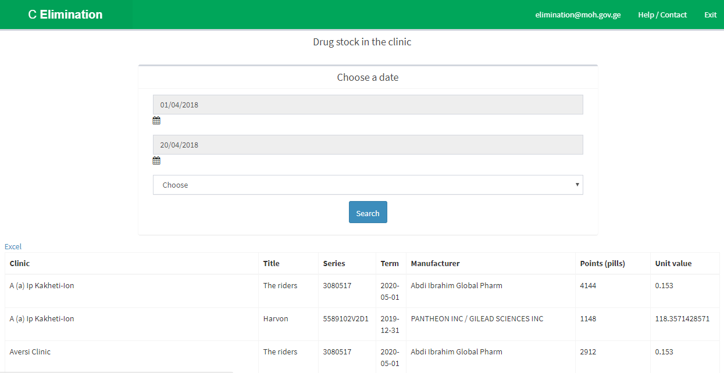
(Picture 7.1 Supplies in Clinics)
Following information about sent medicines to the clinic for the specific period of time is displayed on that page:
- Clinic - Clinic, where the medicine was sent to
- Name – Drug name
- Serial number – Drug serial number
- Expiration Date - Expiration Date of the medicine
- Manufacturer – Manufacturer of the medicine
- Quantity – Drug Quantity (pills)
- Unit Price – Price of unit

Drugs in Clinics
Filtering the information according to committee date is available on that page. Information will be loaded after selecting and searching desirable committee.
Download of mentioned list in Excel format is also available from that page.
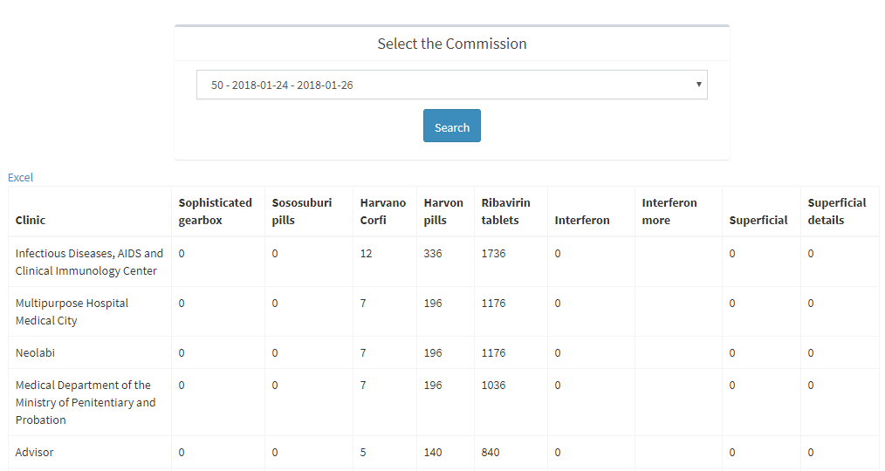
(Picture 7.2 Drugs in Clinics according to Committee date)
Information on medicine name, quantity, necessary for the specific clinic is displayed on that page and sorted by committee date (information only for specific committee aspects). Information consists of data about clinic name, and all used drugs involved in treatment process. Drugs quantity is shown in pills and in boxes.

Sending the drug
Drug sender user within the ElimC program ensures sending the drug from drug warehouse to clinics. Drug Sending Form should be filled, and following information should be noted:

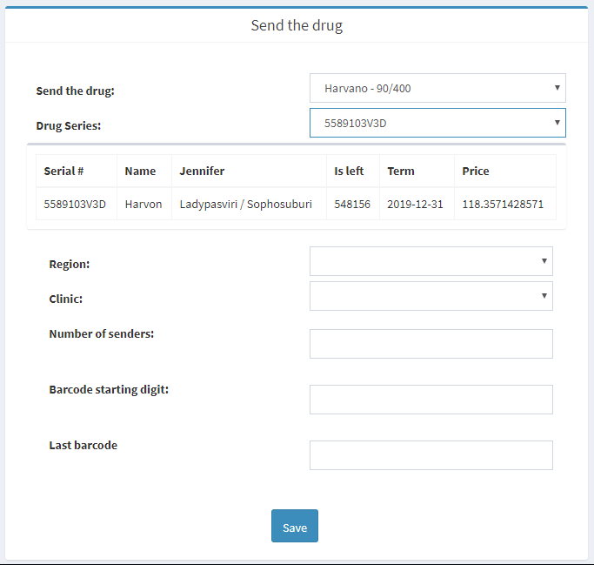
(Picture 7.3 Drug Sending From)
- Sending the drug - Select the drug
- Serial Number - Serial Number of the medicine which should be sent
Following information appears automatic after selected the serial number:
  - Serial number – issued drug’s serial number
  - Name – Name of the Medicine
  - Generic – International name of the drug
  - Leftover – Quantity of left drugs (pills)
  - Expiration Date - Expiration Date of the medicine
  - Price – Price of the selected drug
- Region – Selected region where the drug should be sent
- Clinic - Selected Clinic where the drug should be sent
- Quantity - Quantity of drugs to be sent (pills)
- First number of Barcode - if the drug has barcode, first number of the barcode should be entered
- Last number of Barcode - if the drug has barcode, last number of the barcode should be entered
After filling the following information, transfer is ready to be sent .

Invoice
From the invoice page, transfer details should be checked finally and sent.
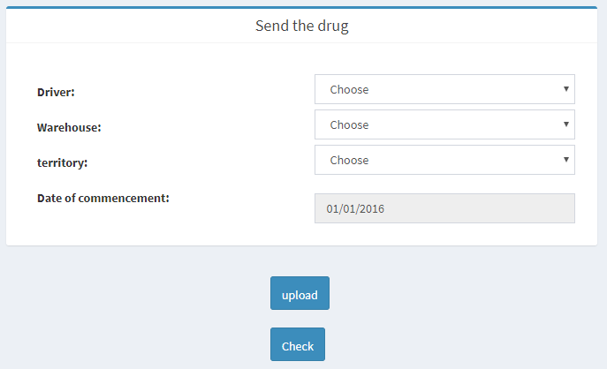
(Picture 7.4 Sending the Drug - Invoice)
Relevant information should be entered on that page:
- Driver - Driver should be chosen for transfer (it is important, that Personal identification number and car numbers to be filled correctly, as the information is automatically uploaded on rs.ge
- Warehouse – Warehouse, which sends drug to the clinic
- Territory - Tbilisi Or regions
- Date of distribution start - Distribution date can be only one day after the current date
After filling the following information, user should check all the entered information and press the button “Check”. Transfer information will be loaded.
Once drug distributor ensures transfer validity, he can click button “ Upload” and the following information will be uploaded on rs.ge

Sending the drug from one clinic to another
If the clinic has some is unused drug supplies, Drug sender user can send the drug from that clinic to another.
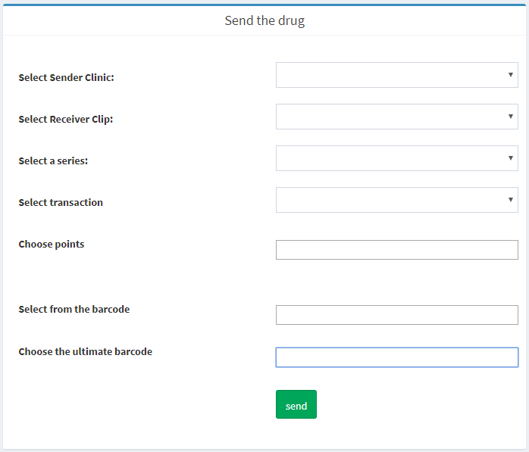
(Picture 7.5 Sending the drug from one clinic to another)
- Choose the sender clinic - Clinic should be chosen which sends the drug
- Chose the receiver clinic - Clinic should be chosen which receives the drug
- Serial Number - Serial Number of the medicine
- Chose the transaction - transaction number of the medicine which should be sent (quantity of the selected drug in the clinic is visible)
- Choose the quantity – Quantity (pills) should be mentioned
- First number of Barcode - if the drug has barcode, first number of the barcode should be entered
- Last number of Barcode - if the drug has barcode, last number of the barcode should be entered
After filling the following information, transfer is ready to be sent.

Deduction
From the “Deduction page” is available to deduct the drug from specific clinic.
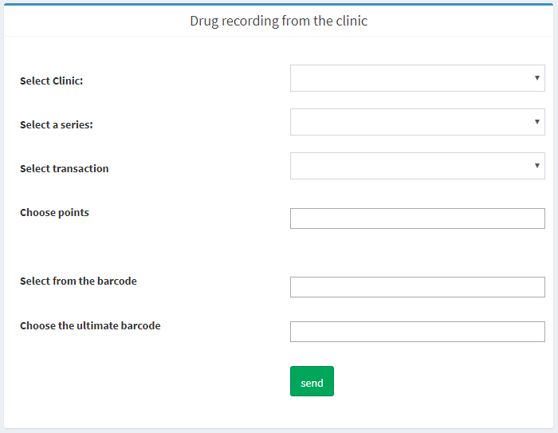
(Picture 7.6 Drug deduction from the clinic)
- Choose the clinic - Clinic should be chosen where from the drug will be deducted
- Serial Number - Serial Number of the medicine
- Chose the transaction - transaction number of the medicine which should be deducted (quantity of the selected drug in the clinic is visible)
- Choose the quantity – Quantity (pills) should be mentioned
- First number of Barcode - if the drug has barcode, first number of the barcode should be entered
- Last number of Barcode - if the drug has barcode, last number of the barcode should be entered
After pressing the “Save” button, relevant drug quantity will be deducted from the clinic in specific date. All deducted drugs are shown in the “List of deducted drugs”, where all information regarding the drug name, serial number, deducted quantity and deployment date is noted.

Drug Logistic Manager Role
Following pages are visible for the drug logistic manager user:
- Balance Sheet
- Committee
- Detailed turnover
- Balance sheet by clinics

Balance Sheet

Balance Sheet page displays cumulative information of received drugs in warehouse and drugs issued to clinics, also quantity and price of deducted and destroyed drugs for specific period of time (Picture 8.1)
This type of list can be downloaded from that page in Excel format.
(Picture 8.1Balance Sheet)
After selecting the desirable period and searching the data, information of drug turnover will be loaded.
- Drug Name – International name of the drug
- Expiration Date - Expiration Date of the medicine
- Serial number - Serial number
- Price – Price of one pill
- Starting Balance
  - Quantity - Starting drug balance (quantity of pills) for specific period
  - Money – Starting amount of money for medicine for specific period
- Income
  - Quantity - Quantity of received medicine (pills) for specific period
  - Money - Amount of Money received for medicine for specific period.
- Expenses
  - To Beneficiary
  - Quantity - Quantity of medicine (pills) issued to beneficiary for specific period
    - Money - Amount of money, price of issued medicine to beneficiary for specific period
  - To legal entity
  - Quantity - Quantity of medicine (pills) issued to legal entity for specific period
    - Money - Amount of money, price of issued medicine to legal entity for specific period
- Deduction
  - Quantity - Quantity of Deducted medicine (pills) for specific period
    - Money - Amount of money, price of Deducted medicine for specific period
- Final Balance
  - Quantity - Final drug balance (quantity of pills) for specific period
Money – Final amount of money for medicine for specific period

Committee
List of performed Committees are available on Committee page, creating the new committee is also available from the same page.
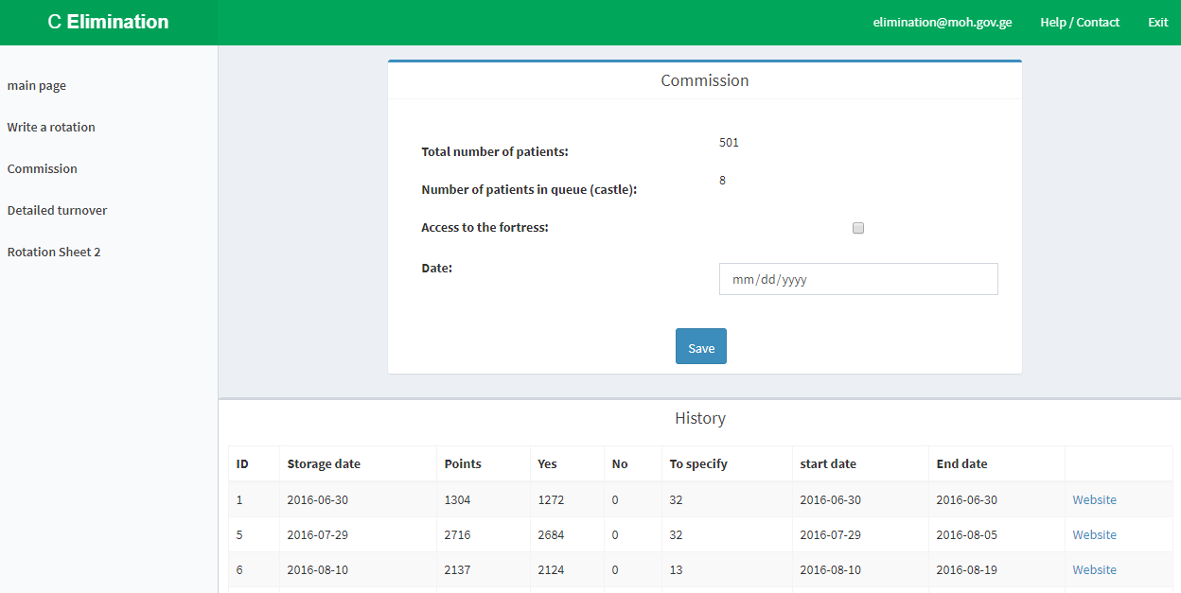
(Picture 8.2)
- Quantity of patients in the list - Quantity of patients waiting for the committee results
- Quantity of imprisoner patients in the list - Quantity of patients from prisons, waiting for the committee results
- Permission from the prison - if the prisoner is permitted to be in waiting list, this button should be checked
- Date - Date should be chosen, till what date registered patients should be included in the committee lists.
“Save” button creates the committee.

Detailed Turnover
Information should be filtered on the clinic stock page by specific period, specific clinic or for all clinics. After pressing the search button, relevant information will be loaded.
This type of list can be downloaded from that page in Excel format.
(Picture 8.3 Detailed Turnover)
Following information regarding the sent drug is shown on the page in specific period of time:
- Clinic - Clinic where the drug was sent
- Drug Name –Name of the drug
- Serial number - Serial number of the medicine
- Expiration Date - Expiration Date of the medicine
- Manufacturer - Manufacturer of the drug
- Quantity – Quantity of the drug (pills)
- Unit Price - Unit Price of the drug

Balance sheet by clinics
Balance Sheet page displays cumulative information of drug received in clinic stock and drug issued to patients, also quantity and price of deducted and destroyed drugs for specific period of time (Picture 8.4)
This type of list can be downloaded from that page in Excel format.
(Picture 8.4 Balance sheet for specific clinic)
After selecting the desirable period and searching the data, information of drug turnover will be loaded.
- Drug Name – International name of the drug
- Expiration Date - Expiration Date of the medicine
- Serial number - Serial number of the medicine
- Price – Price of one pill
- Starting Balance
  - Quantity - Starting drug balance (quantity of pills) for specific period
  - Money – Starting amount of money for medicine for specific period
- Income
  - Quantity - Quantity of received medicine (pills) for specific period
  - Money - Amount of Money received for medicine for specific period.
- Expenses
  - To Beneficiary
  - Quantity - Quantity of medicine (pills) issued to beneficiary for specific period
    - Money - Amount of money, price of issued medicine to beneficiary for specific period
  - To legal entity
  - Quantity - Quantity of medicine (pills) issued to legal entity for specific period
    - Money - Amount of money, price of issued medicine to legal entity for specific period
- Deduction
  - Quantity - Quantity of Deducted medicine (pills) for specific period
    - Money - Amount of money, price of Deducted medicine for specific period
- Final Balance
  - Quantity - Final drug balance (quantity of pills) for specific period
Money – Final amount of money for medicine for specific period

System Administrator

Following pages are visible for ElimC system admins:
- Add User
- Patient’s Information
- Access to Monitoring
- List of dead people
- Cancel the transfer process

Creation of system user
For creating the system user, admin should move to the page “ Add user” and fill the following form:
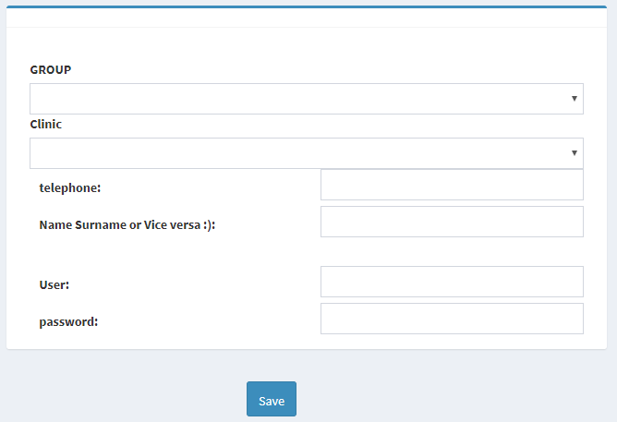
(Picture 9.1 Adding new user)
- Group - Group should be selected
- Facility – Provider clinic or SSA service center should be chosen
- Telephone – User’s telephone number
- Name and surname - User’s Name and surname
- User - User name to log in to the system
- Password - to log in to the system
After saving the information, following user is allowed to log into the system and have an access to predefined information in Elim C system.

Patient’s Additional Information
System admin is able to see some additional information regarding the specific patient. Admin identifies the patients with ID document or passport (Picture 9.2)
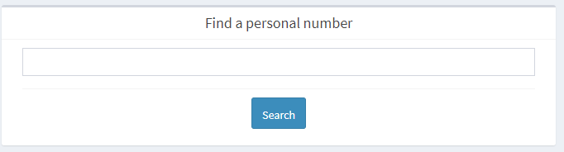
(Picture 9.2 Patient’s identification in the system)
Next page is “Patient’s case”, where all Patient’s history with its open and close dates are recorded. To see the case of specific patients, the button “View” should be applied (Picture 9.3)
(Picture 9.3 View the Specific Case)
Following information is displayed on the page of “Patient’s Additional Information”:
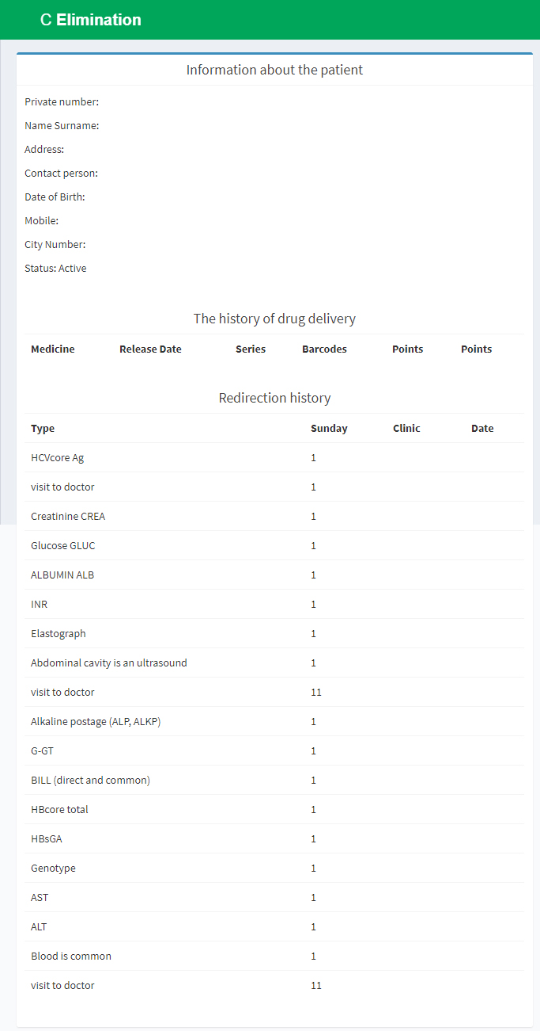
(Picture 9.4 Patient’s Additional Information)
- Patient’s Demographic Data
  - Personal Number – Patient’s Personal Number
  - Name, surname - Patient’s Name, surname
  - Address - Patient’s Address
  - Contact Person - Additional contact person. Information is filled with patient’s demographic data
  - Mobile numer of contact person - Information is filled with patient’s demographic data
  - Date of birth - Patient’s Date of birth
  - Mobile - Patient’s Mobile number
  - Home telephone number - Patient’s telephone number
  - Status - Active/Closed
- History of drug issue to the patient
  - Drug Name –Name of the drug, issued to patient
  - Date of issue - Date of drug issue to patient
  - Serial number – issued drug serial number
  - Barcode - Barcode of issued medicine
  - Quantity – Quantity of issued drugs (pills)
- Redirection history
  - Type - Test type, patient was redirected to
  - Week - week when redirection to diagnostics has happened
  - Clinic - Clinic where patient had tests
  - Date – Date of redirection
Information can be edited and saved from the following page.

Access to monitoring
System admin has a permission to Access to Monitoring Page. Only in some exceptional cases, patient gets permission to SVR tests.

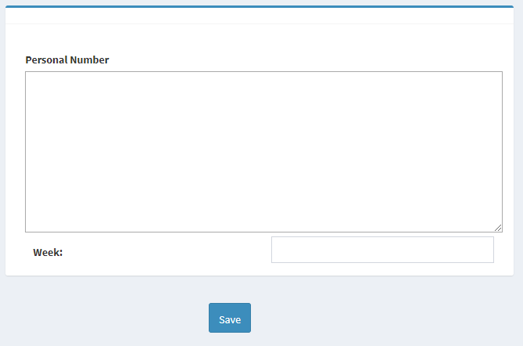
(Picture 9.5 Monitoring Page)
- Personal Number – Patient’s Personal Number
- Week - 1212 / 2424 – depends on patient’s treatment regimen 12/24. If the regimen if for 12 weeks, 1212 should be noted, otherwise - 2424.
After saving the data, patient gets permission for SVR tests and reception user of provider clinic can redirect the patient to the relevant tests.

Technical Issues

Applied Infrastructure
System is allocated on a server of Ministry of labour, Health and Social Affairs VMWare. Operational system is CentOS .
Database and application is allocated on different servers:
Application Server IP - 172.17.216.11; Director: /usr/share/nginx/html
Database server: IP - 172.17.7.120; Database Name: stopcv2
Link: http://elimination.moh.gov.ge/

Short description of program code
The system is created using PHP technologies and MySQL Database. Not even one template or framework is used in the system. Business logic is described in separate files, which is located in “Include” folder and Visualization templates in themes/2015 folder. Each group (Admin, Provider clinic, Committee) has their own folder and roles inside (Doc, Laboratory, Manager and etc.)

Some external services are applied in the system:
- Service with Ministry of Justice – Used for checking the personal Identification number
- SMS Service - For sending the committee results to the patients
- Service with RS.ge - For uploading drug transportation invoice
- Screening Service- Used for different provider clinics to use first time confirmation tests results

