https://en.wikipedia.org/wiki/Healthcare_in_Georgia_(country)
In 2013, the enactment of a universal health care program triggered universal coverage of government-sponsored medical care of the population and improving access to health care services. Responsibility for purchasing publicly financed health services lies with the Social Service Agency (SSA) .

Contents
[hide]
- 1Historical Introduction
- 2Current healthcare system
- 3Statistical Overview of Health Status
- 3.1Life Expectancy
- 3.2Fertility and Mortality Rates
- 3.3Disease and Leading Causes of Death
- 4Organization
- 4.1Regulation
- 4.2Financing
- 5Criticisms
- 5.1Accessibility
- 5.2Quality
- 5.3Efficiency
- 6Principal Healthcare Reforms
- 7See also
- 8References
- 9External links

Historical Introduction[edit]
From 1921 to 1991, the Georgian health system was part of the Soviet system. Till 1995 health care system in Georgia was based on Soviet Semashko model. The first dramatic change was implemented in 1995, when the budget transfers were complemented with additional sources of the financing: the mandatory health insurance contributions (employer and the employee mandatory contribution - 3% and 1% respectively), funds allocated for Healthcare from the territorial budgets, official co-payment for medical services, which could not be financed by the state programs (1).
Mandatory social health insurance was abolished after the 2003-2004 Rose Revolution. (2) In 2003, the social insurance tax was replaced by social tax, which was accumulated in the state budget and from 2007 the GoG decided to delegate management of state allocations for health insurance for targeted groups of population (the poor, teachers, law enforcement officers and military personnel (or about 40% of the population), to the private insurance companies, which have become the health service purchaser for the mentioned population groups. This meant that a portion of the population could not access health insurance. The state retained control over a few medical facilities dealing with mental illness and infectious diseases, while all other hospitals and clinics were privatized. (2)
Implementation of universal healthcare was a key priority of the Georgian Dream party, which came to power in the 2012 election. It established the current Georgian healthcare system from 2013 (4).

Current healthcare system[edit]
Since 2013, there has been a radical change of direction in health financing policy as a new government embraced the move towards universal health coverage rather than targeted benefits (4).

Statistical Overview of Health Status[edit]

Life Expectancy[edit]
In 2016 average life expectancy for Georgians is 72.7, which lies just below the European average of about 78 years (2014). The life expectancy in Georgia is 68.2 for males, and 77.1 for females. ⁽⁵⁾
Fertility and Mortality Rates[edit]
In 2016 the total fertility rate is 2.24 children per woman. Live birth rate is 15.2 per 1000, and mortality rate is 13.7 per 1000.(^{3]} In 2016 infant mortality rate was 9.0 per 1000 live births, and the under-5 mortality rate was 10.7. By 2030, the Maternal mortality rate is expected to drop to 12, and the under-5 mortality rate is expected to drop to 6.0. Maternal mortality is 23.0 per 100,000 live births in 2016.^{[7]} While still high in international comparison, maternal and infant mortality rates have been steadily decreasing.

Disease and Leading Causes of Death[edit]
In Georgia, as in the most countries, mortality burden is mostly due to non-communicable diseases. The major causes of death are diseases of the circulatory system, neoplasms, diseases of respiratory system and accidents and injuries.^{[7]} . The leading position in the structure of morbidity is associated with Diseases of the respiratory organs, digestive system and circulation system. Infectious diseases are still the source of significant health problems, especially MDR tuberculosis.

Regulation[edit]

Organizational Structure of Healthcare

The key actors in Georgian Health Care System are presented in the fig. described below.

Figure: Organizational Struqture of Health care System

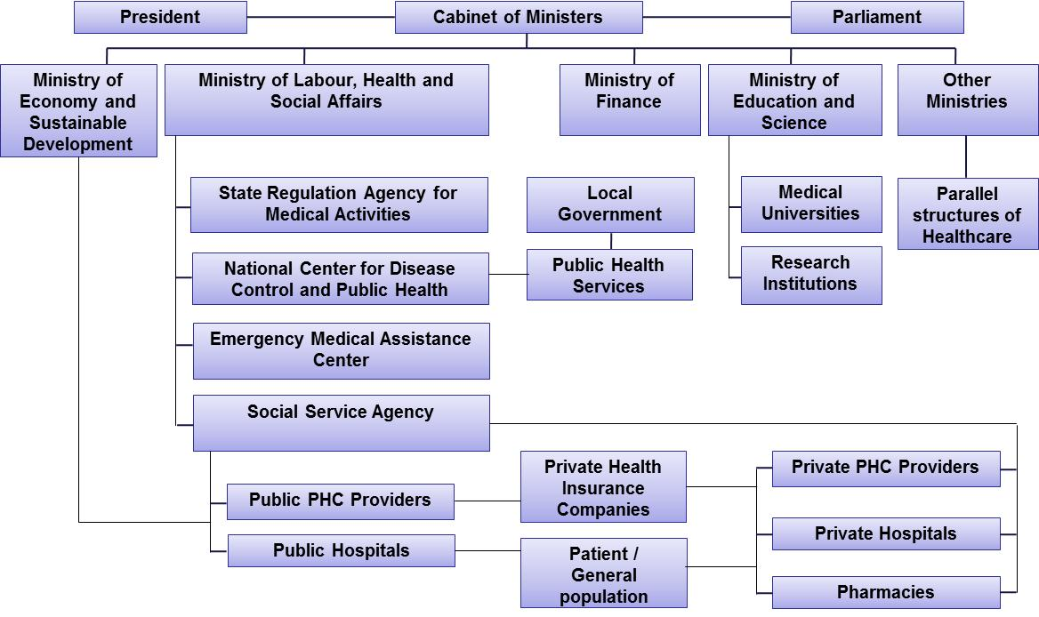

The health care system in Georgia is highly decentralized and was extensively privatized from 2007 to 2012. Regulations are also very liberal and MoLHSA is now working to ensure the quality of care provided is adequate (2).
In 2013, the enactment of a universal health care program triggered universal coverage of government-sponsored medical care of the population and improving access to health care services (4).
In the end of 2014 By Government of Georgia was approved Georgian Healthcare System State Concept 2014-2020 “Universal Healthcare and Quality Management for Protection of Patient Rights”, which is a vision of healthcare system development that comprises basics of the sector development in relation to principles and values recognized at international and national levels (8).
Ministry of Labour, Health and Social Affais (MoLHSA) is formally accountable for the health of the population, oversight of the health system, the quality of health services and equity in relation to access to health care throughout the country. There are Legal entity under state control of the Ministry: LEPL “Social Service Agency” (SSA), LEPL “National Centre for Disease Control and Public Health” (NCDC), LEPL “State Regulation Agency for Medical Activities (SRAMA) and LEPL Emergency Situations Coordination and Urgent Assistance Center (ESC&UAC).
Administration and management of the Health and Social care State Programs including UHC is providing by SSA, which is subordinated institution under the MoLHSA. SSA's territorial offices are located at 68 municipalities and more than 2000 are employed in them.
The NCDC is a legal entity of Public Law accountable to the MoLHSA with a dedicated line in the State budget. The NCDC provides national leadership in preventing and controlling communicable and non-communicable diseases through developing national standards and guidelines, health promotion, disease surveillance, immunization, laboratory work, research, providing expert advice, and responding to public health emergencies.
SRAMA formally responsible for issuing and control the licenses and permits for health care facilities, regulating medical professionals and pharmaceuticals.
ESC&UAC Ensures/coordinates quality emergency medical and referral assistance for improving the state of health of the population during the disaster and martial law situation. ESC&UAC is functioning in all municipalities of the country except in the capital city. By this time 85 medical branches are included.
Following extensive privatization and decentralization, most providers in primary and secondary level are private for-profit entities in terms of ownership, governance and management. Many of them are vertically integrated with private health insurance providers and pharmaceutical companies.
The development of professional medical associations in Georgia is still at an early stage although there are many of them in existence. Since 2005, the major activity of professional associations has been supporting the MoLHSA in its endeavor to elaborate national clinical practice guidelines and protocols.

Numerous international partners such as WHO, UNICEF, UNFPA, World Bank, USAID, EU, Global Fund and etc. strongly support the health sector in Georgia.

Financing[edit]
Georgia entered the 1990s with a wholly tax-funded healthcare system, but reforms in 1995 replaced this system with a social insurance model run through the State Medical Insurance Company.^{[1]} Under the social insurance model, basic healthcare was paid for by the state insurance company, with additional funds coming from Municipal Health Funds and preventative activities provided by the Ministry of Labor, Health, and Social Affairs.^{[1]} In 2003, after the "Rose Revolution" the social insurance tax was replaced by social tax, which was accumulated in the state budget (social tax has been abolished since 2008). Since 2005, state health programs are financed under the budget assignations only.
2007 can be considered as the new phase of the Reform, as the government of Georgia decided to delegate management of state allocations for health insurance for targeted groups of population (the poor, teachers, law enforcement officers and military personnel), to the private insurance companies, which have become the health service purchaser for the mentioned population groups. Therefore, if till 2007 administration of personal health service purchases was carried out by the single payer state agency, from 2007 health care services are partially purchased by private insurance companies, which provided administration of more than half of state resources allocated for state health care programs by 2012 (2).
In February 2013, the Government of Georgia launched the UHC Program, which marked a significant shift in how health care is financed and health services are purchased in Georgia, as well as the culmination of nearly two decades of health system reforms in Georgia. The UHC Program extended publicly financed entitlement to health care coverage to the entire population. The nature of the program is noncontributory, in the sense that Georgians do not have to contribute for enrollment. Enrollment involves registering with the primary care provider of choice. The benefits package covers a range of primary and secondary care services and limited essential drugs. Administratively, the reform transferred responsibility for purchasing health care services from private insurance companies to the SSA under MoLHSA, thus putting in place a platform to shift from passive to active purchasing (4).
The health financing reforms introduced since 2013, and backed up by significant increases in public health spending, have moved Georgia closer to European norms. These include: (i) near universal population entitlement to publicly financed health care; (ii) free visits to family doctors; (iii) referral and prescribing systems; (iv) a single purchasing agency; and (v) higher public spending on health (WHO 2016). Sustaining the coverage achieved to date and deepening coverage through better financial protection against OOP costs are the policy priorities for the Government of Georgia.
Total health spending in Georgia–at 8.5 percent of GDP in 2015 is much higher than the average for upper-middle-income countries (7.0 percent) and approaching the EU average (10 percent) (World Bank 2016). From 2012 to 2015, the health budget more than doubled, increasing from 5.3 percent to 8.6 percent of total government spending, and as a percentage of GDP from 1.7 percent to 2.9 percent. In this respect, Georgia is experiencing a steep increase in its health sector spending, which is consistent with other middle-income countries’ experience at the time of UHC introduction. Public spending on health in Georgia is mainly drawn from general tax revenues and allocated to the UHC Program and vertical programs, all of which are administered by the SSA (9).
Despite rising public spending on health, OOP remains the dominant source of financing for health in Georgia, filling the void of health spending that is not covered through public sources. OOP spending in Georgia is decreased and estimated to be 57 percent of all health spending (73% in 2012) (9).

Accessibility[edit]
There is an extremely high number of doctors per capita in Georgia compared with other European countries, and it had 573.3 physicians per every 100,000 people in 2015.^{[7]} Number of nurses per 100000 population since 1998 is going down and is much less, than in countries mentioned above (419 per 100000 population). A ratio of the number of nurses to the number of physicians was equal 0.7 in 2015 (3)

In 2015, there were 12830 hospital beds (2014 - 11675) in the country. The number of beds per 100,000 population was 345.1 (2014 - 313.3), occupancy rate - 193.1 (2014 - 188.3), ALOS - 5.3 (2014 - 5.2), turnover rate - 36.4 (2014 - 36.3). Following the introduction of the universal health care program, the rapid growth of the admissions was observed in both outpatient and inpatient institutions. Compared to 2012, the hospital service provision for 100,000 population increased by 50%. In 2015 the numbers of encounters of the population with outpatient facilities grows to 4.0 per 1 person (2.1 in 2012) (3).

Principal Healthcare Reforms [edit]
Major health care reforms and policy measures till 2013 see in the box.

Major health care reforms and policy measures
Before 1995 | Semashko model, completely state-funded services
1995-2003 | Introduction of social health insurance, mandatory payroll taxes for health and creation of the state health fund (SHF)
1999 | National Health Policy developed
1999 | MoH and Ministry of Social Affairs merged into MoLHSA
2007 | State Hospital Development Master Plan, envisioning a complete change of course in hospital sector based on privatization approved by the Government; Almost of hospitals sold to the private sector
2007-2014 | Public Funds given to private insurance companies for the administration of the state health insurance program for the target population (people under poverty line, teachers act.)
2009-2010 | Introduction of state voluntary health insurance coverage program
2012-2014 | Establishment of state health insurance program for pensioners, children under 5, Students, disability persons
2013 | Introduction of Universal health Care program (Phase I-II)
2014 | Introduction of prescription system
2015 | Introduction of Hepatitis C elimination program
2015-2017 | Establishment of perinatal services regionalization
2017 | Introduction of State drug program for chronic diseases
2017 | Starting of Phase III of Universal health Care program - Service stratification according to revenue groups

Since 2013, the Universal health Care program has been launched, which was commencement of universal access to medical services funded by state for all citizens of Georgia. The Universal health Care program covers the planned outpatient, urgent outpatient-in-patient and planned surgical services, as well as the treatment of oncological diseases and delivery (4).

The research carried out by the World Bank, the World Health Organization and the US Agency for International Development revealed the main achievements of the Universal health Care Program: increased access to medical services, increased use of medical services, and reduction of financial barriers and expansion of coverage. In the publication of European Health Report 2015 of World Health Organization's European Bureau, Universal Health Care Program in Georgia has been recognized as the successful project.
From May 2017 to further reform of the program, it was expedient to elaborate new criteria for differentiation of beneficiaries. The basic object of reform is to provide services more oriented on need and to develop the approach -"social equity". The services package is connected to the income of the population.

From July 1, 2017 for people with chronic illnesses who are registered in the unified database of "socially unprotected families" and their rating score is not exceeding 100 000, have been enacted state program for providing medicines for chronic diseases. The program envisages providing patients with number of medicines for cardiovascular chronic illnesses, lung chronic diseases, diabetes (type 2) and thyroid gland diseases.

On April 21, 2015 Memorandum of Understanding was signed between the company "Gilead" and the Government of Georgia, which laid foundation for the elimination of hepatitis C in Georgia. The services are provided for persons with hepatitis C certifying citizenship of Georgia and persons with neutral travel documents, as well as for accused/convicts placed in penitentiary establishments.

Increased government funding for maternal and child health and ease of access to the high quality health care services played an important role in the reduction of the number of deaths of mothers and children. Georgia has been able to reach the Millennium Development Goal №4, since in 2015 the mortality rate of children under five was 10.2 per 1000 live birth.

The initiative of starting the perinatal care regionalization process from May 2015 is a significant step forward in strengthening the maternal and newborn health care system, which considers defining the levels of perinatal service providers and their role and responsibilities in order to provide the correct timing of the correct patient to a correct medical institution and, if necessary, effective referral.

References[edit]
  - Gamkrelidze et al. 2002. "Health Care Systems in Transition: Georgia." European Observatory on Health Care Systems. Vol. 4, No. 2.
  - Chanturidze, et al. 2009. “Georgia: Health system review.” Health Systems in Transition.
  - L. Sakvarelidze National Center for Disease Control and Public Health. 2015. “Health Care Statistical Yearbook 2015” (http://ncdc.ge/AttachedFiles/yearbook%202016_53210b52-12da-4279-9f27-f7a361c84c96.pdf)
  - World Bank Group. 2017. Georgia Public Expenditure Review. (http://documents.worldbank.org/curated/en/630321497350151165/pdf/114062-PER-P156724-PUBLIC-PERFINAL.pdf)
  - National Statistics Office of Georgia - GeoStat. http://geostat.ge/index.php?action=page&p_id=164&lang=eng (Retrieved October 23, 2017)
  - . L. Sakvarelidze National Center for Disease Control and Public Health. 2015. “Health Care Statistical Yearbook 2015” (http://ncdc.ge/AttachedFiles/yearbook%202016_53210b52-12da-4279-9f27-f7a361c84c96.pdf)
  - L. Sakvarelidze National Center for Disease Control and Public Health. 2017. “Health Care Statistical Yearbook 2016” http://ncdc.ge/ka-GE/DiseaseStatistics/StatisticalYearbook
  - Government of Georgia. Decree N724, 26.12.2014. On Approval of Georgian Healthcare System State Concept 2014-2020 “Universal Healthcare and Quality Management for Protection of Patient Rights”
  - Ministry of Labour, Health and Social Affairs of Georgia. National Health Accounts 2001-2015. http://moh.gov.ge/en/566/National-Health-Account

