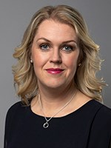 CV Lena Hallengren Minister for Health and Social Affairs
Ministry of Health and Social Affairs
Party Swedish Social Democratic Par
Areas of responsibility
• Disabilities
• Gambling policy
• Health care
• Public health and sport
• Social services including care for older people
Personal
Born 1973. Lives in Kalmar. Married and two children.
Educational background BA in Education,
Kalmar University 1993–1996
Positions and assignments
Minister for for Health and Social Affairs 2019–
Minister for Children, the Elderly and Gender Equality 2018–2019
Member of the Riksdag; Chair, Committee on Education 2014–2018
Member of the War Delegation 2010–2018
Member of the Riksdag; Deputy
Chair, Committee on Health and Welfare 2010–2014
Member of the Riksdag;
Chair, Committee on Transport and Communications 2009–2010
Member of the Riksdag; Member of the
Committee on Environment and Agriculture 2006–2009
Minister for Preschool Education,
Youth Affairs and Adult Learning 2002–2006
Secretary of the Swedish Social Democratic Youth League 1999–2002
Local politician in Kalmar 1997–1999

