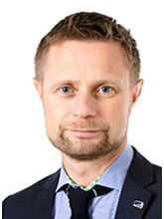 H.E. Mr Bent Høie Minister of Health and Care Services, Norway
Mr Høie was appointed Minister of Health and Care Services in October 2013. He was elected Member of Parliament in 2000. He has held a range of political appointments since 1990, including municipal government. He was Chair of the Standing Committee on Health and Care Services from 2009–2013, and has served on other Parliamentary Committees on local government and public administration, health and social affairs, energy and the environment. He studied hotel administration at the Norwegian School of Hotel Management.

