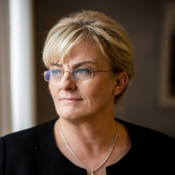

Her Excellency Ms. Pirkko Mattila
Minister of Social Affairs and Health
Republic of Finland

