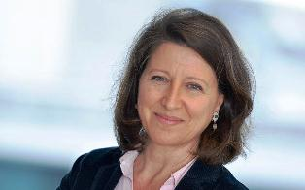
Former intern of Paris Hospitals, Agnès Buzyn has spent most of her career as a hematologist clinician and academic at Paris V-Hôpital Necker University where she was responsible for the intensive care unit for adult hematology and of bone marrow transplant from 1992 to 2011.
Her research career led her to lead an Inserm team working on tumor immunology at the Institut Cochin-Paris V (2002-2006). His extensive work in the areas of bone marrow transplantation, acute lymphoblastic leukemia (ALL) and chronic myeloid leukemia (CML) has resulted in more than 150 original publications in scientific journals in the English language.
Agnès Buzyn has taught hematology and immunology of tumors and transplantation in several university modules and is currently Professor of Hematology at Pierre & Marie Curie University - Paris VI.
She keeps a hematology consultation activity at the Saint-Antoine Hospital, in clinical hematology.
She has held numerous positions within scientific societies and boards of directors: member of the medical and scientific council of the Biomedicine Agency (ABM), member of the Scientific Council of the French Blood Establishment (EFS), President of the Scientific Council of the French Society of Marrow Transplantation and Cellular Therapy (SFGM-TC).
She has also been a member of the College of Qualified Persons of the Higher Council of Programs, advisory body of the Ministry of National Education, from 2013 to January 2016.
In terms of responsibilities within state agencies, she served as Chair of the Board of Directors of the Institute for Radiation Protection and Nuclear Safety (IRSN) from 2008 to 2013, while being a member of the Atomic Energy, from 2009 to 2015.
She was appointed a member of the Board of Directors of the National Cancer Institute (INCa) in 2009, as a qualified personality, became Vice President in October 2010, before being appointed President by Presidential Decree. of the Republic on May 27, 2011. She held this position until February 2016.
In March 2016, she was appointed President of the College of HAS (High Authority for Health).

