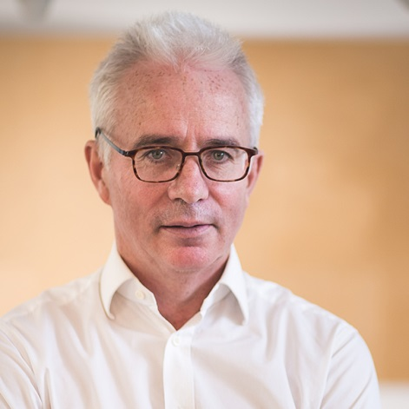 Executive Director of Global Fund

Mr. Peter Sands

His engagement with global health issues includes:
- Chairing the US National Academy of Medicine’s Commission on a Global Health Risk Framework for the Future, which in January 2016 produced a highly influential report, “The Neglected Dimension of Global Security: A Framework to Counter Infectious Disease Threats”.
- Chairing the World Bank’s International Working Group on financing preparedness, which in May 2017 published “From Panic and Neglect to Investing in Health Security: Financing Preparedness at a National Level”.
- Authoring several papers on infectious disease crises in the New England Journal of Medicine, The Lancet and British Medical Journal.
- Between 2011-2017, being the Lead Non-Executive Director on the Board of the UK’s Department of Health, providing policy direction to the UK’s National Health Service.
- Being an active member on both the US National Academy of Science’s Committee on Ensuring Access to Affordable Drugs and the Forum on Microbial Threats.
Sands has served on various boards and commissions, including as Lead Non-Executive Director of the Department of Health in the United Kingdom, a Director of the World Economic Forum and Co-Chairman of Davos, Governor of the United Kingdom’s National Institute for Economic and Social Research, Member of the International Advisory Board of the Monetary Authority of Singapore, Member of the Browne Commission on Higher Education Funding in the United Kingdom, Member of the China People’s Association for Friendship with Foreign People’s Global CEO Council, Co-Chair of the UK-India CEO Forum, Board Director of the Institute of International Finance, Chairman of the International Monetary Conference, Member of the International Advisory Board of Lingnan University, China, Trustee of the Camden Roundhouse, London.

