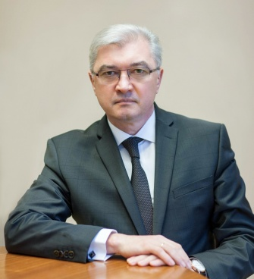 Ministry of Health of the Republic of Belarus

Mr. Valery Malashko
Leads the Ministry of Health of the Republic of Belarus since January 27, 2017.
The Minister of Health delivers the public policy and regulates the health sector. Their duties include:
• enforcing the constitutional provisions, upholding the rights and interests of individuals and legal entities and supporting state-to-state cooperation on health issues;
• managing cooperation with the National Assembly, the Presidential Administration and the Council of Ministers of the Republic of Belarus, the State Control Committee, as well as law enforcement agencies and other republican bodies of state administration;
• supervising the central bodies of the Ministry of Health, subordinate public bodies and other organizations that entered contracts with the Ministry;
• enforcing the health law and conducting general oversight of subordinate bodies, their establishment and dissolution;
• exercising control over:
- Legal Department,
- Board on Human Resources Policy and Educational Institutions,
- Board on Accounting Methodology and Reporting,
- Control and Auditing Department,
- Department of Foreign Affairs,
- Press Secretary,
- Assistant.

