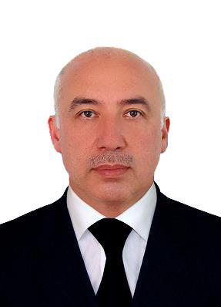

Alisher Shadmanov Kayumovich - Minister of Public Health of Uzbekistan
Alisher Shadmanov has been appointed as a Health Minister of Uzbekistan on 21st of February, 2017.
Alisher Shadmanov (born in 1962), Doctor of Medical Sciences, Professor, graduated from Andijan Medical Institute in 1985.
Prior to this appointment, he had served as the chairman of the Committee on Science, Education, Culture and Sport of the Legislative Chamber (member of Adolat party).
Supervises:

- Control inspection
- Main Department of economics and financing
- Department of work with personnel
- Department on licensing and quality control of the health services, being provided by non-governmental institutions
- Foreign economic activities and relation with international organizations
- Special Department
- Territorial Health Care Management Authorities
- Republican Specialized Scientific and Practical medical centers
- Republican Specialized Medical Centers
- Work with other ministries, institutions and organizations
- "Medical Journal of Uzbekistan"

