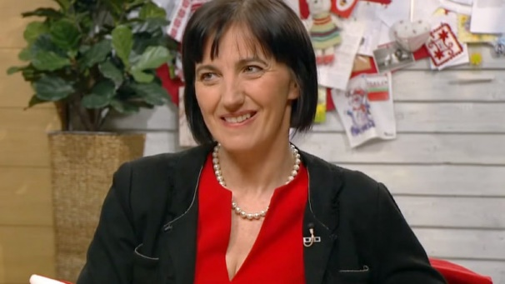
Ildikó Horváth, State Secretary for Health at the Ministru of Human Capacities of Hungary
ldiko Horvath, MD, DMSc is a professor at the Department of Pulmonology of the Semmelweis University in Budapest, Hungary. She was trained as a human physiologist and then as a specialist in pulmonology and worked in the NIH, Bethesda, US and also at the Imperial College, London, UK. She has different teaching duties at the University. She is heading the research programme on Chronic Inflammatory Airway Diseases. This includes biomarker discovery studies for disease diagnosis and monitoring and also translational research in asthma and COPD pathomechanism in collaboration with other national and international centres. Her major focus is exhaled biomarkers including exhaled nitric oxide, exhaled breath condensate and electronic smellprints. Under her supervision 10 PhD degree were obtained and two of her fellows working on it now.
Dr Horvath serves as a reviewer on many international scientific journals including the American Journal of Respiratory and Critical care Medicine, European Respiratory Journal, Chest, Thorax, Journal of Applied Physiology and others. She is a board member of the Journal of Breath Research.
She has participated in the European Respiratory Society (ERS) leadership from 2000 acting as the Director of External Courses in the ERS School followed by being a secretary and later the chair of Scientific Group 5.2 (Monitoring airway diseases). Between 2010 and 2011 she was the secretary of Assembly on Airway diseases and now she serves the Assembly as its Head. She is also member of the HERMES Examination Committee and one of the organiser of the popular ERS School Course on Monitoring airway diseases. At national level she served for 8 years in the Executive Committee of the Hungarian Respiratory Society.
She received national and international awards for her scientific achievements including the UNESCO-Loreal Hungary Scientific Award in 2006.
Dr Horvath has published 109 papers and 12 book chapters and was a guest editor of the ERS Monograph on Exhaled biomarkers together with J de Jongste. Her citation index is 2514 and has a Hirsch-index of 24

