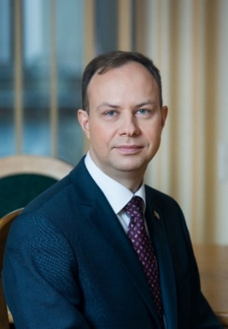
Mr. Aurelijus Veryga - Minister of Health of Lithuania
Date of Birth: 1976
Education
2004 Completed residency and gained the qualification of psychiatrist. Gained a PhD in Biomedical Sciences the same year.
2000 Together with colleagues initiated and founded the Kaunas Youth Narcological Aid Centre
2000 Gained the profession of medical doctor
1994 Joined Kaunas Medical Academy (today – Lithuanian University of Health Sciences)
Work Experience
Since 14th of December, 2016 Minister of Health of the Republic of Lithuania
Since 2015-Professor in the Department of Health Psychology of the Lithuanian University of Health Sciences
2009 Associate professor in the Department of Preventive Medicine (later – Department of Health Psychology) of Kaunas Medical Academy, Lithuanian University of Health Sciences
2004 Began the practice of psychiatrist
2004 Together with colleagues founded the National Tobacco Control Coalition, became its president
2004 Member of the Advisory Committee of ENYPAT (European Network on Young People and Tobacco)
2004 Lithuanian expert in the preparation of ASPECT Consortium document for the European Commission on control of tobacco in the enlarged European Union
2005 Member of the National Health Council
Since 2008 Board member of ENSP (European Network for Smoking Prevention)
2008 Freelance expert of the Committee on Health Affairs of the LR Parliament
Since 2009 Board member of NORDAN (The Nordic Alcohol and Drug Policy Network)
2009–2012 Public adviser for the Prime Minister on the prevention of tobacco, alcohol and drugs
2011 Head of the Health Research Institute (WHO cooperation centre) under the Faculty of Public Health of the Lithuanian University of Health Sciences
Additional Information
Family Wife Rasa, son Tadas (born in 2001) and daughters Ieva (born in 2005), Vaiva (born in 2008)

