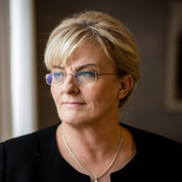

Ms. Pirkko Mattila - Minister of Social Affairs and Health Republic of Finland

Political career and Personal details
Minister of Social Affairs and Health since 25 August 2016 to present
Member of Parliament, 2011 to present
Master of Arts, Registered Nurse, Qualified Teacher, Member of Parliament
Blue Reform
Date and place of birth: 2 April 1964 Yli-Ii
Place of residence: Muhos

Other work experience and societal responsibilities
Oulu Adult Education Centre, Trainer, 2007-2011
Northern Ostrobothnia Hospital District, Nurse, 1988-2007
Muhos Local Council, 2005 to present
Muhos School and Early Childhood Education Committee, 2012 to present
Muhos Technical Committee, 2005–2008
Board of the Regional Council of North Ostobothnia, 2013 to present
Assembly of the Regional Council of North Ostrobothnia, 2009-2012
Muhos delegate for the Rokua Foundation 2005–2010
Oulu Region Joint Authority for Education, Council member, 2005–2008

Publications
Yli-Iin Leuvanjoen kylä maankäyttölain mukaisena asutusalueena (Village of Leuvanjoki in Yli-Ii as a populated area defined in the Land Use and Building Act), University of Oulu, Department of Geography 2005

Other information
Spouse: Juha Mattila
three children
Interests: hiking, orienteering, genealogical research
Language skills: English, Swedish, German, sign language

