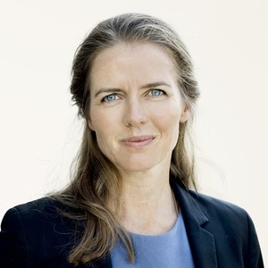
Ellen Trane Nørby - Minister for Health of the Kingdom of Denmark
(The Liberal Party)

Ellen Trane Nørby was appointed Minister for Children, Education and Gender Equality on 28 June 2015.
Ellen Trane Nørby, born February 1st 1980 in Herning, grew up in Nørre Nissum. Daughter of biologist and Mayor of Lemvig Jørgen Andreas Nørby and architect Merete Nørby MAA.
Member period
Member of Parliament for the Liberal Party in South Jutland greater constituency from November 13th 2007.
Member of Parliament for the Liberal Party in South Jutland County constituency from February 8th 2005 to November 13th 2007. Candidate for the Liberal Party in Sønderborg nomination district from 2004.
Parliamentary career
Minister for Health from November 28th 2016.
Minister for Children, Education and Gender Equality from June 28th 2015 – November 28th 2016. November 2016.
Political spokeswoman 2011-2014, spokeswoman on media 2006-2015, spokeswoman on social affairs and gender equality 2007-2011, and cultural policy spokeswoman 2005-2007.
Education and jobs
Minor subject, social studies, University of Copenhagen, from 1999 to 2001.
MA (history of art), University of Copenhagen, from 1998 to 2005.
Upper secondary school, Lemvig, from 1995 to 1998.
Primary school, Nørre Nissum, from 1985 to 1995.
Political employee, Christiansborg, from 1999 to 2004.
Various student and temporary jobs.
Affiliations
President of LYMEC, European Liberal Youth 2002-2004, vice-president 1999-2002.
Candidate for the Liberal Party in Copenhagen County for the European Parliament election 2004.
Chairwoman for the Liberal Party's European Affairs Committee 2004-2009.
Vice-chairwoman of the Danish European Movement 2007-2013, acting chairwoman 2012–2013.
Publications
Co-author of the book »Smag på Europa – med honning og chili« (Taste Europe – with Honey and Chilli), Saxo, 2004.
Initiative-taker for and editor of the book »Flere med - nye regler« (Several with - new Rules), Forlagskompagniet, 2004.
Previously columnist in the Danish Trades Union Congress' (LO) weekly newsletter 'Ugebrevet A4', the political magazine 'RÆSON' (REASON) and various other magazines and periodicals.

