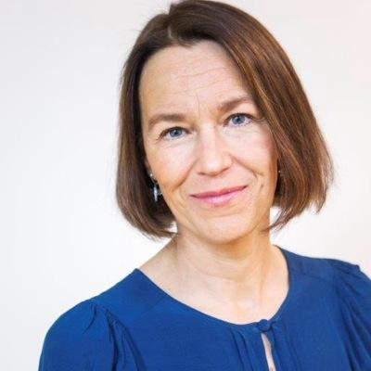

Ms. Olivia Wigzell - Director-general of the Swedish National Board of Health and Welfare
Olivia Wigzell is Director-General at the National Board of Health and Welfare. Former DG of SBU- the Swedish Council on Health Technology Assessment. Between 2008 and 2014 she was Director at the Ministry of Health and Social Affaires and head of the Division for Public Health and Healthcare. Previously she was Director at the National Board of Health and Welfare. She has been an investigator for the Government which resulted in reports on equal care and on stewardship, governance and divsion of responsabilities in the Swedish Healthcare sector. Wigzell has also been working at the Ministry of Foreign Affairs as well as in the Foundation of Alva and Gunnar Myrdal. Wigzell holds a degree in communication and political science. Wigzell has been chairing (2011-2016) an EU-expert committee on the topic of Health System Performance Assessment. She has been on the board of European Observatory on health systems and policies and in the board of Gothia Fortbildning AB. 2016-2018 an Executive Board-member for WHO. Chair of the Health Committee in OECD and Chair of the Board for Örebro University.

