National Technical Focal Points for Communications (NTFPCs)
WebEx meeting

Link to the WebEx meeting: https://who-euro.webex.com/who-euro/j.php?MTID=mb422ecc1590567594c29c152ebaee43a
Date: Friday, February 02, 2018
Starting time: 11:00 am (CET) - (please note: we will open the virtual meeting from 10:30)
Meeting number: 843 020 770
Meeting password: WtXSjM4C

HOW TO CONNECT(step-by-step)
-----------------------------------------
1. Connect a headset (with microphone and speakers) to your computer and ensure it is switched on and functioning.
2. If you have the possibility, also connect a webcam to your computer and ensure it is switched on and functioning.
3. Open your invitation message, and then click the link Join WebEx meeting to join the meeting. The Meeting Information page appears.

4. If you don’t have Cisco WebEx software, you can install it following option 1 and 2 that will appear on your screen. In case if you don’t want to install it, click on “Run a temporary application” below the two installation options:
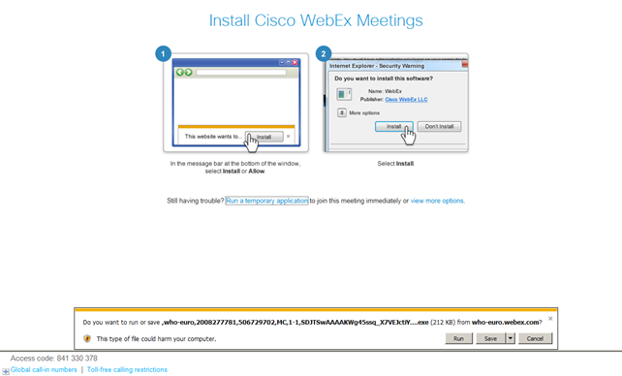

5. Under Join Meeting Now, type your name as you like to display in the meeting and your e-mail address.
6. If requested, enter the meeting password – see on top of page 1.

7. Click “Join Now”.
You are connected to the meeting.

8. After you join a meeting, YOU HAVE TO SELECT THE AUDIO OPTION Call Using Computer.

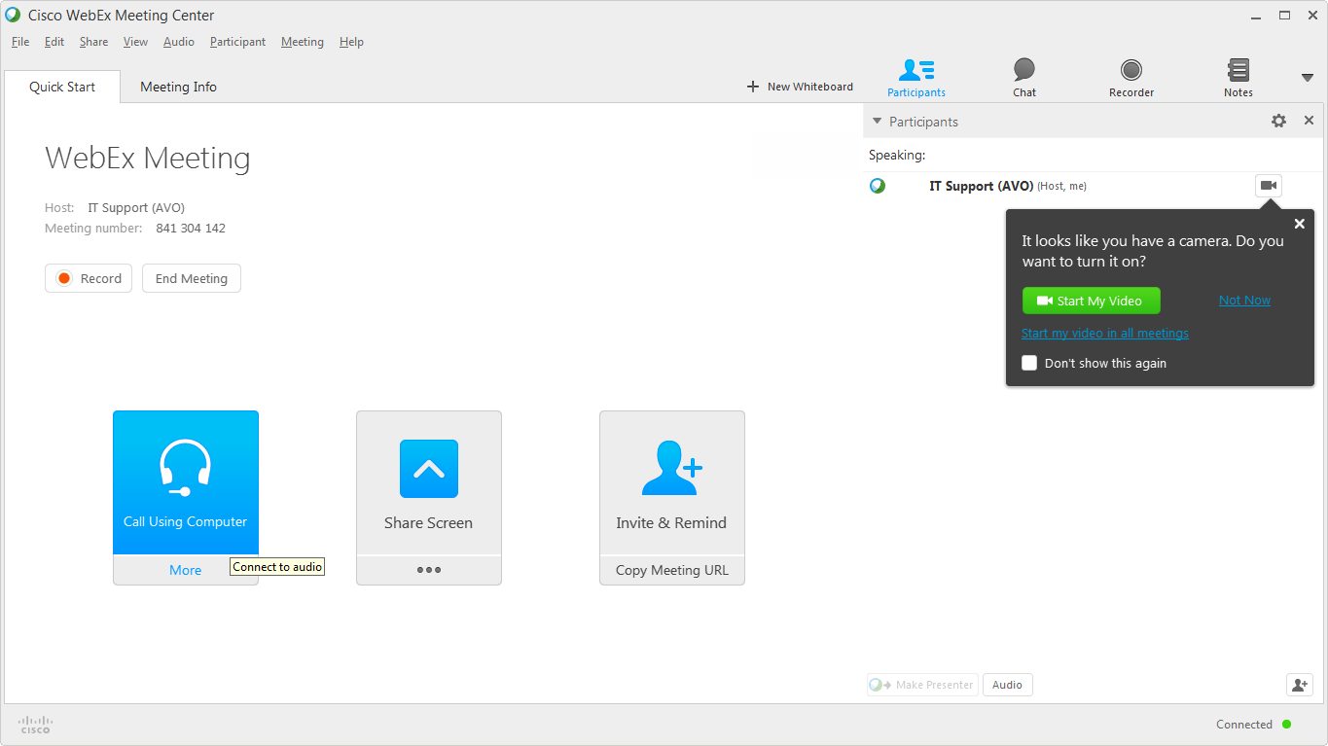

After you clicked on Call Using Computer, a window pops up for testing your audio.
Make sure you can hear the test sound and that the microphone indicator is reacting!!!
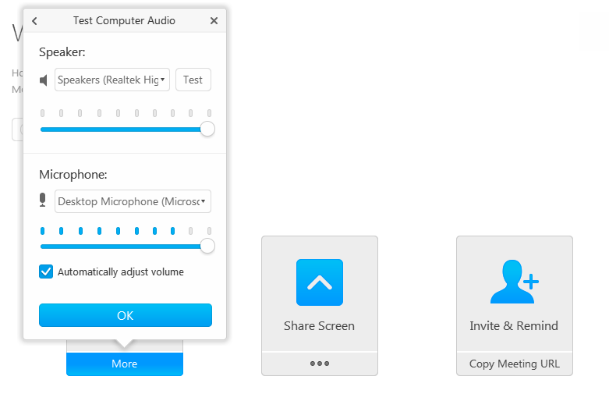

After you are successfully Connected to Audio and you are getting the Headset icon in front of your name:

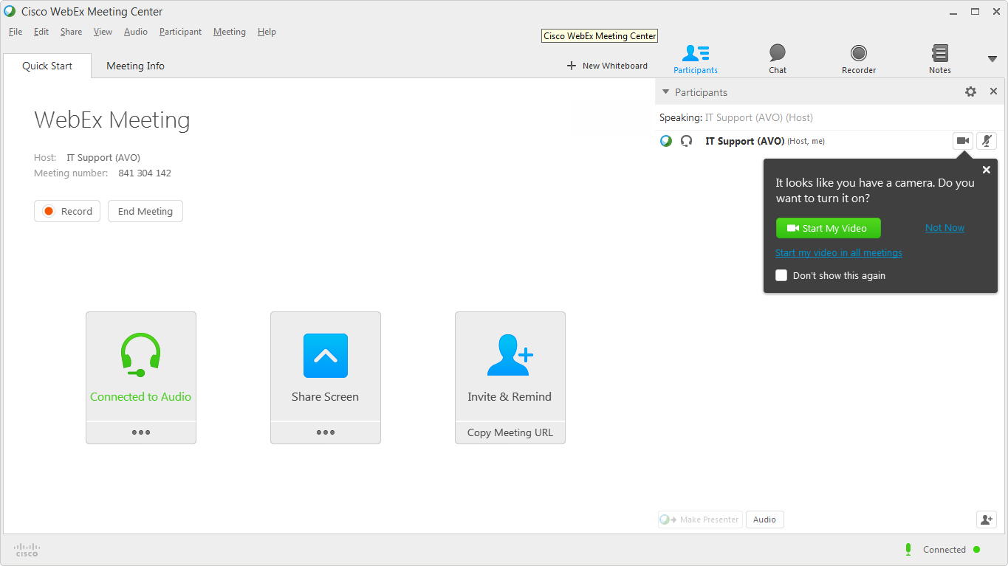

You can connect to the audio conference with a telephone, or with a computer through VoIP (Voice over Internet Protocol).
After you join a meeting, click the dots ( ) to display more choices.
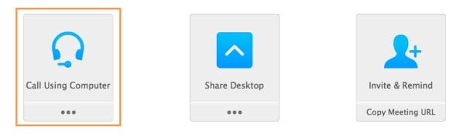

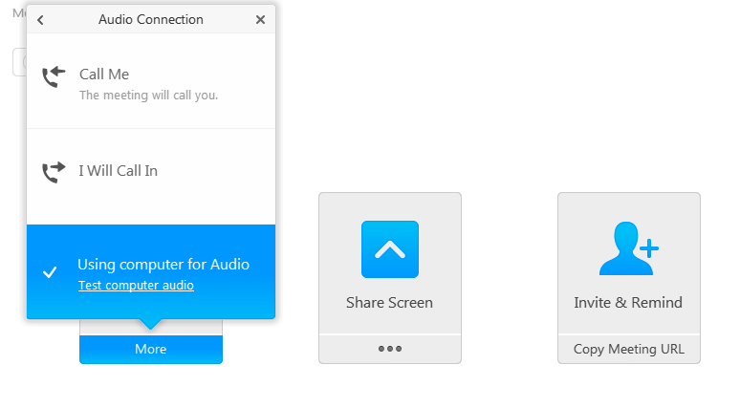

9. Activate your webcam in the WebEx software and use the chat function as required.

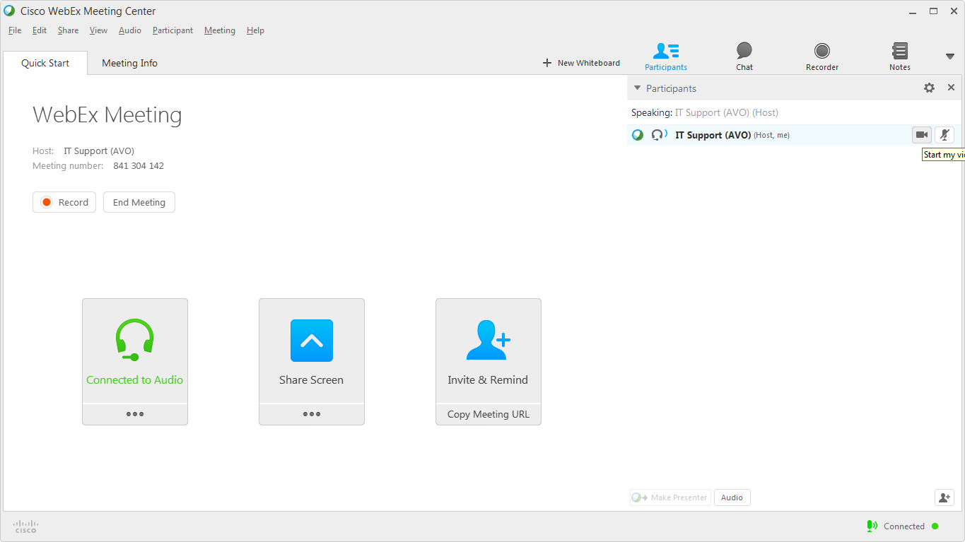

Note that you should MUTE YOUR MICROPHONE and be aware the meeting host may do this on your behalf so as not to disturb other participants. Therefore, if you wish to speak or make a comment at any time, *** Please indicate that you wish to speak through the CHAT FACILITY in the Webex software ***
We will then unmute your microphone and the local audience will be able to hear (and see) you.
----end----

