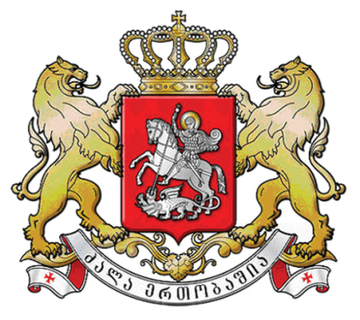
HIGH LEVEL INTERACTIVE DEBATE on
International Conference on Population and Development Beyond 2014
3 APRIL 2014, NEW YORK
How has condition of women changed in Georgia in the last 20 years given that the country was in transition?

Dr. Mariam Jashi
Deputy Minister of Labour, Health and Social Affairs of Georgia

Your Excellency President Tong, Executive Director, Distinguished Guests,

ICPD agenda indeed came at a critical transition time, when Georgia as a newly independent country aspiring to democratic values positioned human rights and gender equality agenda high on its political agenda.

Over the last 20 years, the country demonstrated consistent political commitment towards protection and promotion of women’s rights that has brought substantial progress:

  - Gender-equality provisions are secured throughout the national laws and policies and the country has ratified relevant international human rights instruments, including the Convention on Elimination of all forms of Discrimination Against Women (CEDAW).

  - Women and men have equal access to basic social services, including education, universal health care entitlements and social allowance systems operating in the country.

  - Georgia adopted national Laws on Gender Equality, Anti-trafficking, Anti Domestic Violence. National policy has been led by Human Rights and Gender Equality Advisor of the Prime Minister. Gender Equality Council of Parliament has been established that has led two cycles of National Action Plans formulation.

  - 2012 General elections resulted in 11% representation of women MPs (17/150 MPs), thereby surpassing for the first time the 10% threshold, as during the last 2 decades proportion of women MPs varied from 5 to 9%.

  - Today women hold four key Ministerial portfolios in Justice, Education and Science, Foreign Affairs and Environmental Protection. Women also lead the National Security Council and the Central Election Committee of the country.

  - Economic empowerment of women has been also visible since 1994 with 30% of women being primary breadwinners and 20% heading business enterprises. Furthermore 60 percent of the public thinks that women must engage more actively in economic activities.

  - Maternity leave policy has been improved, both in terms of remuneration (from GEL 600 to 1000) and the lengths (from 4 to 6 months).

However despite the visible progress, Georgia is still in the process of advancing gender equality agenda:

    - Women are still under-represented at decision-making levels - 11% representation in Parliament and self-governance and 20% in the executive branch of the government.

    - Labour force participation for women remains lower (55.8% vs. 74.2%) and in the last 13 years (1999-2012) the average monthly salary of women is 54% of that of employed men.

    - Vertical and horizontal gender segregation in the labour market is obvious from the high concentration of women in lower-paid positions in the less profitable sectors of the economy – education, agriculture and healthcare.

    - Despite greater economic independence of women, traditional views on gender roles and gender division of labour remain strong. Women’s main function is considered to raise children and take care of the household, while men shall support the family financially.

    - Almost everyone agrees with the notion that an employer must give maternity leave to a woman, while only 40 percent think the same about men, and

    - And still selective abortion is considered to be an issue with gender ratio at birth equaling to 1.09 and the Government has already started a comprehensive analysis and programming in close partnership with UNFPA.

The findings of the ICPD global review as well as the country-level research reinforce the key message: progress is evident, however fulfilling of women empowerment commitments need further investments.

The progress made over the last 2 years provides extraordinary opportunities and a platform for action that Georgia in line with the international community shall continue to build on.

