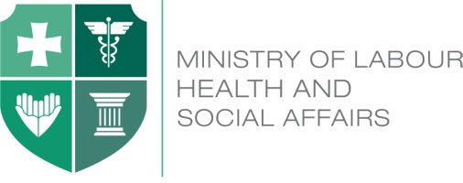

Georgia Health Utilization and Expenditure Survey

June 24, 2015
Expo-Georgia (Hall 3)

Agenda

10:30 – 11:00 Registration

11:00 – 11:30 Introduction
Speakers: Irakli Gharibashvili, Prime Minister of Georgia
David Sergeenko, Minister of Labour, Health and
Social Affairs of Georgia
Henry Kerali, Regional Director, S. Caucasus, the World Bank (TBC)
Hans Kluge, Head of WHO Regional Office for Europe, video address
Jean Malkin, video address

11:30 – 12:00 Georgia Health Utilization and Expenditure Survey 2014

- Key Results of the Survey
Speaker: Aparnaa Somanathan, Senior Economist, the
World Bank

- Implications for the policy
Speaker: Sarah Thomson, Senior Health Financing Specialist,
WHO Regional Office for Europe

12:00 – 12:45 Coffee Break/ Press Conference

12:45 – 13:30 Q&A session

13:30 - 13:45 Closing remarks

