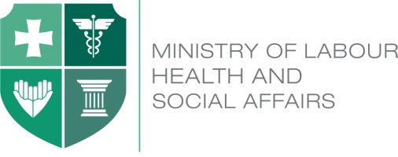
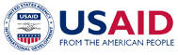

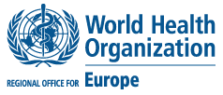

Georgia Health Utilization and Expenditure Survey

June 24, 2015
Expo-Georgia (Hall 3)
Agenda

10:30 – 11:00 Registration

11:00 – 11:30 Introduction
Speakers: David Sergeenko, Minister of Labour, Health and
Social Affairs of Georgia
Irakli Garibashvili, Prime Minister of Georgia
Henry Kerali, Regional Director, S. Caucasus, the World Bank (TBC)
Stephen Haykin, Mission Director, USAID Caucasus Georgia
Hans Kluge, Director of the Division of Health Systems and Public Health, WHO Regional Office for Europe, video address
Jean Elie Malkin, President of consulting company „Global alliance for Health and Social Compact“, video address
11:30 – 12:00 Georgia Health Utilization and Expenditure Survey 2014
- Key Results of the Survey
Speaker: Aparnaa Somanathan, Senior Economist, the
World Bank
- Implications for the policy
Speaker: Sarah Thomson, Senior Health Financing Specialist,
WHO Regional Office for Europe
12:00 – 12:45 Coffee Break/ Press Conference
12:45 – 13:30 Q&A session
13:30 - 13:45 Closing remarks

