Global Response to Tuberculosis Epidemic

High global burden of disease and death
- TB is one of the top 10 causes of death and top infectious killer worldwide. It is also the main cause of deaths related to antimicrobial resistance and the leading killer of people with HIV, in 2016, 40% of HIV deaths were due to TB.
- In 2016, 10.4 million people fell ill with TB, and 1.7 million died from the disease (including 0.4 million among people with HIV). Over 95% of TB deaths occur in low- and middle-income countries.
- In 2016, an estimated 1 million children became ill with TB and 250 000 children died of TB (including children with HIV associated TB).
- During the period 2007–2016, the WHO European Region faced an unprecedented increase in HIV prevalence in incident TB cases from 3% to 12%. This is higher than both the global average and the dynamic, which declined from 13% in 2007 to 10% in 2016.
Estimated Tuberculosis Cases per 100,000 population 2016
- Multidrug-resistant TB (MDR-TB) remains a public health crisis and a health security threat. WHO estimates that there were 600 000 new cases with resistance to rifampicin – the most effective first-line drug, of which 490 000 had MDR-TB. About 6.2% of MDR-TB cases had XDR-TB in 2016.
- Nine out of 30 countries with the highest multidrug-resistant (MDR) TB burden in the world are in the WHO European Region. The proportion of RR/MDR-TB among new and previously treated TB cases in the Region is also significantly above the global average, with 19% in new and 55% in previously treated cases compared to 4.1% and 19% respectively.
- About one-quarter of the world's population has latent TB, which means people have been infected by TB bacteria but are not (yet) ill with the disease and cannot transmit the disease.
- Tuberculosis affects populations inequitably, contributes to the cycle of ill-health and poverty, that malnutrition and inadequate living conditions all contribute to the spread of tuberculosis and its impact upon the community, and that tuberculosis is fundamentally linked to a majority of the leading development challenges addressed by the 2030 Agenda for Sustainable Development
Impact of global response
- An estimated 53 million lives were saved through TB diagnosis and treatment between 2000 and 2016.
- Globally, TB mortality rate fell by 37% between 2000 and 2016. Regionally, the fastest declines in the TB mortality rate are in the WHO European Region and the WHO Western Pacific Region (6.0% and 4.6% per year, respectively, since 2010).
- The pipelines for new diagnostics, drugs, treatment regimens and vaccines are progressing, but slowly. Rapid molecular diagnostic test for detection of TB and rifampicin resistance was developed. New TB drugs with novel mechanism of action were approved for first time in 40 years and as part of efforts to improve outcomes for MDR/XDR-TB, 89 countries and territories had started using new drug bedaquiline and 54 had used - delamanid by June 2017.
- Stop TB Partnership/Global Drug Facility has, since its creation in 2001, increased access to high quality and affordable TB treatment and diagnostics to populations in need.
- The number of people falling ill with TB each year is declining, but too slowly. Regionally, the fastest decline in TB incidence is in the WHO European Region (4.6% from 2015 to 2016). Globally, TB incidence is falling at about 2% per year. This needs to accelerate to a 4–5% annual decline to reach the 2020 milestones of the End TB Strategy.
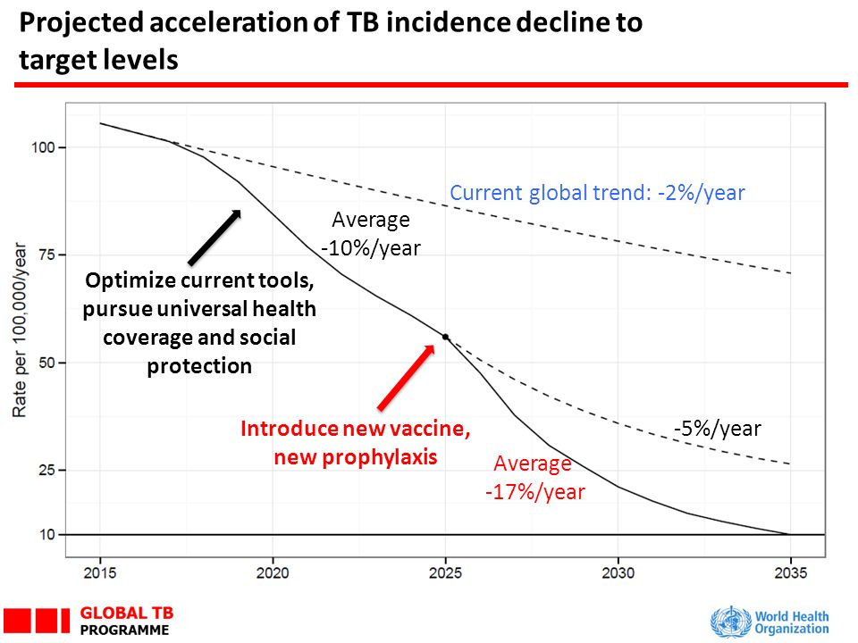
Persistent gaps in care and financing

- Underreporting and underdiagnosis of TB cases continues to be a challenge, especially in countries with large unregulated private sectors and weak health systems. Of the estimated 10.4 million new cases, only 6.3 million were detected and officially notified in 2016, leaving a gap of 4.1 million.
- Only one in five MDR-TB cases were started on treatment. India and China accounted for 39% of the global gap. Treatment success remains low, at 54% globally.
- In 2016 less than half of the estimated cases of tuberculosis in people living with HIV and AIDS were found and notified, and less than 60 per cent of known tuberculosis patients were tested for HIV, precluding treatment and resulting in preventable deaths;
- Most people eligible for TB preventive treatment are not accessing it.
- For TB care and prevention, investments in low- and middle-income countries fall almost US$ 2.3 billion short of the US$ 9.2 billion needed in 2017. In addition, at least an extra US$ 1.2 billion per year is required to accelerate the development of new vaccines, diagnostics, and medicines.

End TB Strategy
The WHO End TB Strategy, adopted by the World Health Assembly in May 2014, is a blueprint for countries to end the TB epidemic by driving down TB deaths, incidence and eliminating catastrophic costs. It outlines global impact targets to reduce TB deaths by 90%, to cut new cases by 80% between 2015 and 2030, and to ensure that no family is burdened with catastrophic costs due to TB.
Vision | A WORLD FREE OF TB  -Zero deaths, disease and suffering due to TB
Goal | END THE GLOBAL TB EPIDEMIC

Ending the TB epidemic by 2030 is among the health targets of the newly adopted Sustainable Development Goals. WHO has gone one step further and set a 2035 target of 95% reduction in deaths and a 90% decline in TB incidence – similar to current levels in low TB incidence countries today.
Indicators | MILESTONES |  | TARGETS
Indicators | 2020 | 2025 | SDG 2030 | END TB 2025
Percentage reduction in the absolute number of TB deaths (compared with 2015) | 35% | 75% | 90% | 95%
Percentage reduction in the TB incidence rate (compared with 2015) | 20% | 50% | 80% | 90%
Percentage of TB affected households experiencing catastrophic costs due to TB | 0% | 0% | 0% | 0%
Achievement of the above targets from 2018 to 2022 will require:
- Successful treatment of 40 million people with tuberculosis, including 3.5 million children, and 1.5 million people with drug-resistant tuberculosis including 115,000 children with drug-resistant tuberculosis, with special focus on reaching those who are vulnerable and marginalized populations and communities included among the 4 million each year who have been most likely to miss out on quality care.
- Provide 30 million people with preventive treatment.
- Integrated response to address TB/HIV, NCDs, UHC, health systems.
- Research and innovation.
- Mobilize financing: $13 billion annually by 2022 for implementation; $2 billion annually for research.
- Accountability mechanisms at country level.
Ending the TB epidemic requires action beyond the health sector to address the risk factors and determinants of the disease. It requires a comprehensive response, including towards achieving Universal Health Coverage, and one that addresses the social and economic determinants of the epidemic and that protects and fulfils the human rights and dignity of all people.
The WHO Global Ministerial Conference on ending TB and the UNGA high-level meeting on TB provide a historic opportunity to galvanize the political commitment needed to step up the battle against TB and put the world on the path to ending the TB epidemic.
The first WHO Global Ministerial Conference on Ending TB in the SDG Era: A Multisectoral Response, held in Moscow in 2017 calls for urgent action regarding notably: advancing the response to tuberculosis within the SDG Agenda; ensuring sufficient and sustainable financing; pursuing science, research and innovation; and developing a multisectoral accountability framework. The Conference resulted in high-level commitments from Ministers and other leaders from 120 countries to accelerate progress to end TB. Heads of State will gather in New York at the United Nations General Assembly first-ever high-level meeting on tuberculosis (TB) to accelerate efforts in ending TB and reach all affected people with prevention and care. The theme of the meeting is “United to end tuberculosis: an urgent global response to a global epidemic”. The high-level meeting should result in an ambitious Political Declaration on TB endorsed by Heads of State that will strengthen action and investments for the end TB response, saving millions of lives.

