Non-communicable diseases in Georgia

Non-communicable diseases make the greatest proportion of the total burden of disease and injuries in Georgia affecting the most productive years of life. According to WHO 2014 Health Report, non-communicable diseases account for nearly 94% of all deaths, among them 69% due to CVDs, 14% - cancer, 1% - diabetes, 4% - chronic respiratory diseases; they make influence not only on health but also on sustainable development of the country.
For the effective prevention and control and for the effective NCD surveillance Georgia implemented The WHO STEPwise approach; 2 rounds of STEPS surveys have been conducted in 2010 and 2016 with technical and financial assistance of the WHO-Euro and WHO-HQ and giving the unique possibility to compare the data not only with other countries but to monitor and evaluate patterns and trends of NCDs and risk-factors in Georgia.

These are the first steps to contribute to building sustainable surveillance systems, which improved national capacity and provided the better health information and thus better opportunities necessary for effective NCD prevention and control to improve the health of our citizens.
Based on the information provided by the STEPS surveys the multisectoral state council on NCDs prevention and control is established; National Strategy of NCDs Prevention and Control and 4-year AP are endorsed; Essential drugs for major NCDs for Georgia – IHD and stroke, asthma and COPD, Diabetes type 2 and thyroid gland dysfunction are arranged into the Universal Healthcare Program.
With the assistance of the WHO-Euro and other international organizations Georgia uses all possibilities to obtain the information on NCDs and their risk-factors through the surveys such as Global Tobacco use Survey (GYTS), Reproductive Health Surveys (RHS), Migrant Health Survey, HCV survey, Health Behavior School Survey (HBSC), Childhood Obesity Surveillance Initiative (COSI), National Iodine Survey, etc. and through the registries such as cancer registry, birth registry, and etc.
The micronutrients deficiency surveillance system has been established under the CDC/USA and NCDC/Georgia Collaborative Project using the sentinel surveillance approach to study existing situation on micronutrient deficiency. Data on micronutrient status indicators (Hemoglobin and serum ferritin in 12-23 month children and 1st trimester pregnant women; serum folate and urinary iodine in 1st trimester pregnant women; urinary iodine in 12 year old school children; cases of the neural tube defects, spina bifida and anencephaly) were/are being collected across four sentinel regions in Georgia. The surveillance system showed that 34% of children 12 – 23 months old are anemic; more than 50% of 1st trimester pregnant women were found to be iron deficient (based on serum ferritin <15 µg /dL) and 20% folate deficient (based on serum folate concentration <3 ng/mL); their median serum folate (7.5 ng/mL) is quite low, and increases the risk of fetuses developing neural tube defects.

There is Iron and folic acid supplementation program for reproductive age women at preconception and during pregnancy. The issue of mandatory fortification of wheat flour that is an effective, simple, and inexpensive strategy for supplying folic acid, iron, and other vitamins and minerals to large segments of the country population is under discussion.

Iodine deficiency disorders are endemic in Georgia; they are caused by low iodine levels in water and soil and, therefore, in locally produced food products. To determine status of iodine nutrition of the population in Georgia the national survey has been conducted by the NCDC in collaboration with the UNICEF-Georgia. The results of the survey confirmed that Georgia has a sustained, effective USI program with more than 90% coverage of the population with quality iodized salt. Optimal iodine nutrition status has been achieved and sustained for the general population (based on assessments of SAC) and PW, but further monitoring of iodized salt use and iodine nutrition is recommended to assure permanent IDD elimination and optimal iodine nutrition in Georgia.
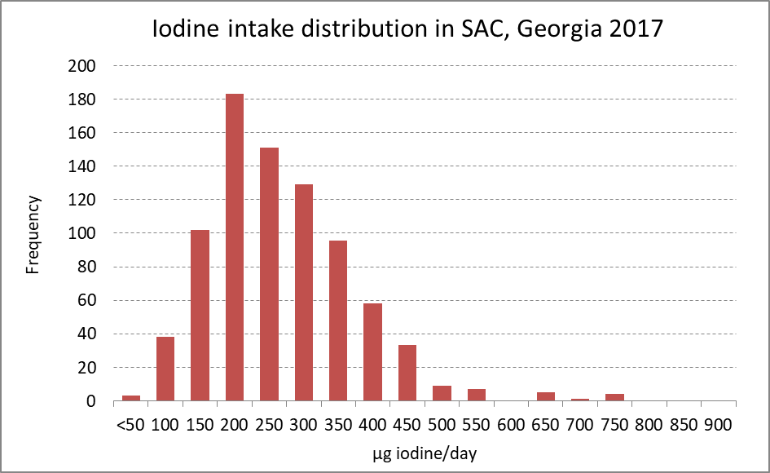
Tobacco control is an important aspect for Georgia’s EU integration process. One of the obligations under the EU Association Agreement signed in 2014, is effective implementation of the international agreements in the field of health, that are recognized by the parties, namely, the International Health Regulations and the WHO FCTC.
Georgia has one of the highest smoking prevalence among the countries of World Health Organization European Region. According to the STEPS 2010 and 2016 results smoking prevalence has increasing trend; 33% of Georgian adult population are current smokers of whom about 40% want to stop. According to the Global Youth Tobacco Surveys (GYTS 2014-2017) smoking prevalence is also increasing among 13-15 year olds. European School Survey Project on Alcohol and Other Drugs (ESPAD) survey conducted in 16 years old adolescents showed higher figures of current smoking (26% in boys, 9% in girls, 18% overall.)

Georgia has been selected as a FCTC2030 project Partner Party among other 14 countries, the only country from the European region. This project is a new initiative of the WHO FCTC Secretariat to directly help countries to scale up tobacco control measures.
Within the frames of the project „FCTC 2030 Georgia“, UNDP, WHO, Ministry of Health, Labour and Social Affairs of Georgia and other governmental entities collaborated to evaluate “Investment Case”, that evaluated economic loss associated with tobacco and savings which would be generated if the country fully implements FCTC responsibilities.
According to the investment case evaluation 11,400 Georgian citizens die annually because of tobacco-related diseases, out of which 9,300 annual deaths due to smoking and 2,100 annual deaths due to second hand smoke exposure. Tobacco is responsible for 13% of Georgia’s GEL 2.5 billion total healthcare expenditure. Total annual direct and indirect costs associated with tobacco-use is GEL 824.9 million that is equivalent to an annual loss of 2.43% of GDP. Without implementing four priority FCTC interventions/measures, over 15-year period 171,300 Georgian citizens will die prematurely from tobacco-attributable diseases, tobacco-attributable healthcare costs will reach a cumulative GEL 4.9 billion and total economic costs from tobacco will reach GEL 12.4 billion. Investments in four FCTC measures/interventions will save 53,100 lives and have positive impact for future well-being of Georgian citizens and will result in GEL 3.6 billion total economic gains over 15 years. For every GEL 1 invested in key FCTC interventions now Georgia receives total economic gain of GEL 161 over the first 5 years and GEL 357 after 15 years. Full implementation of the new tobacco control legislative package will promote equity; strengthen economic growth and reduce healthcare costs.
In 2013 in order to address the devastating health and economic burden of the growing tobacco epidemic in the country, the Government of Georgia created the State Tobacco Control Committee. The Committee is chaired by the Prime Minister of Georgia. The goal of the Committee was to develop and advocate new tobacco control policies, which is in line with the World Health Organization (WHO) Framework Convention on Tobacco Control (FCTC) and with the standards of the European Union. As a result of the work of the Committee National Tobacco Control National Strategy Committee (Government Decree #196, 2013), a 5 year Action Plan (Government Decree #304, 2013) and amendments to 5 related laws in March 2013 were prepared and approved by the Government of Georgia.
From May 2018 the amendments to the Tobacco Control bills - On Tobacco Control", "On Advertising", "On Organizing Lotteries, Games of Chance and Other Prize Games", "On Broadcasting" and in the Administrative Offenses Code of Georgia - have entered into force.
Important issues of new Georgian tobacco control regulations are: Ban of smoking (including e-cigarettes and hookah) in all public transport and buildings, except of private homes, prisons, casinos and taxis; ban of all forms of advertisement, sponsorship and promotion of tobacco, its accessories and devices for its use, including ban of display at points of sales and restriction of demonstration of smoking in movies and massive performances; Increasing size of health warnings to 65% and obligatory pictorial warnings on front side of the packages of smoking tobacco; ban of direct or indirect participation of industry in decision making on health issues; ban of "drive tobacco"; updated model of administration of the law; Introducing plain packaging from January 2022. Monitoring results indicate that population of Georgia is consciously aware of the processes and the violations are minimal.

Challenges
- A lack of adequate commitment and policy expertise to integrate measures to address NCDs into national SDGs responses
- Unmet demands for technical assistance to be provided through bilateral and multilateral channels to strengthen national capacity
- Slow progress in engaging the whole-of-government and key sectors beyond health, which is a prerequisite in developing national multisectoral NCD responses, including the implementation of the “best buys” for NCDs
- Lack of action to allocate funding to implement NCD control priorities, by domestic mobilization of resources or external aid
- Still weaknesses of health system development and inadequate capacity in public health
- Insufficient analytical, legal and tax administrative capacity to reduce risk factors and support the implementation of the best buys
- Actions of opposing forces, including industry interference that blocks the implementation of certain key measures.
- Limited progress in engaging non-health sectors

Future Steps

- Set national NCD targets for 2025 or 2030 and monitor results
- Implement national multisectoral action plan - regularly assess population needs, support use and analysis of existing data
- Implement the "best buy" interventions to reduce NCD risk factors and to strengthen health systems to address NCDs
- Analyse the case for change and refine plans for addressing NCDs.
- Responding to NCDs is not simply a matter of changing individual behaviours in isolation; broader changes in social, economic, environmental and cultural contexts are also needed.
- Leadership and action from the health sector is the anchor for NCD responses; but actions from other sectors and stakeholders is crucial, especially to address social determinants; whole-of-government and whole-of-society responses
- To address limited frameworks and limited consensus on best practices, lack of data, and lack of appropriate methods, it is important to develop innovations in methods to evaluate and monitor comprehensive interventions.
- Various forms and types of training should be available at local and national levels; to meet the needs may require examining virtual and digital approaches, social media
- Network of partnerships at all levels among health system policy makers and other stakeholders to improve health outcomes through context specific research evidence; expanding networks create new opportunities for synergies and collaborative learning from existing experiences and best practices to advance the fields of primary and public health
- Introduction of a PHC-centred health care system
- Strengthen coordination and governance - policy specifically addressing NCDs, clear targets for NCDs, planning and accountability in inter-sectoral action, continuity of care and coordination of action between the health and social sectors, focus on equity in planning and activities, evidence-based services and analysis of the quality of care, outcomes and cost–effectiveness
- Introduce NCDs management systems based on public and primary health care - patient at the centre of care, increase the coordinating role of PHC, outcome measurement at all levels of care, linking outcome measurement with accountability mechanisms and incentive systems, review the roles of physicians and nurses in primary and specialist care, specialists for prevention, patient education and other activities, patient pathways and standardized discharge management, disease management guidelines, increase the availability of disease prevention and health promotion programmes integrated at public and primary healthcare, strengthen the capacity of human resources for prevention activities, screening targeting certain age and risk groups
- Develop the e-health system from a document-based approach to standardized information, enforce data collection
- Empower patients - start health literacy programmes from preschool age, support patient organizations and other civil society organizations both financially and with capacity-building, increase the volume of social marketing campaigns and other communication initiatives to empower patients and inform them of their rights.
- To elaborate Information, Education and Communication (IEC) materials to ensure accessibility and explicitness of health-related information intended for diverse population groups as well as general population.

