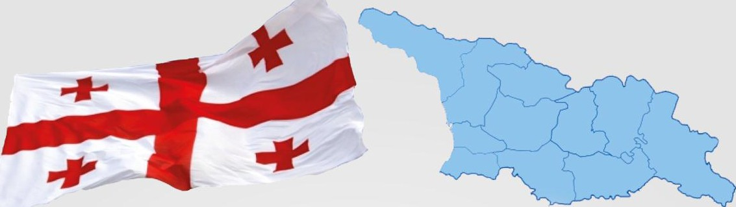

GEORGIA
Hepatitis C Profile



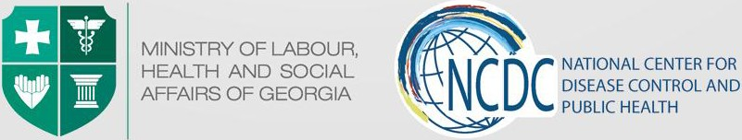

2

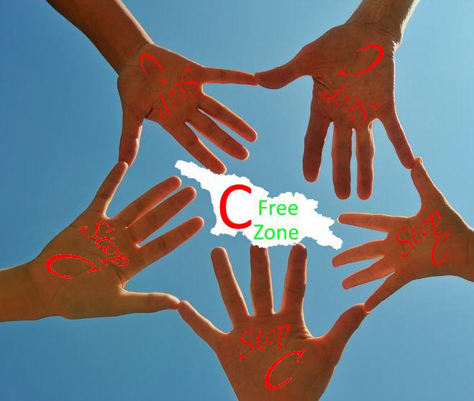

Country Background
Georgia is located at the crossroads of Western Asia and Eastern Europe; bounded to the west by the Black Sea, to the north by Russia, to the south by Turkey and Armenia, and to the southeast by Azerbaijan. The capital city is Tbilisi. Georgia covers a territory of 69,700 square kilometers (26,911 sq. mi). Population – 3,729,500.

 | 2011-2012 | 2013 | 2014
GDP per capita (USD) | 3231-3523 | 3,600 | 3,681
Government expenditure on health as % of GDP | 1.7% | 2.1% | 2.7%
Health expenditure:  Public funding Private funding International Aid | 18.3% - 21.4%  78.8% - 75.8%  2.8% - 2.8% | 28.9%  68%  3.1% | 30%  67%  3%
 | 18.3% - 21.4%  78.8% - 75.8%  2.8% - 2.8% | Launch of Universal Health | 30%  67%  3%
 | 18.3% - 21.4%  78.8% - 75.8%  2.8% - 2.8% | Care Program, targeting 2.4 | 30%  67%  3%
 | 18.3% - 21.4%  78.8% - 75.8%  2.8% - 2.8% | million uninsured | 30%  67%  3%
 | 18.3% - 21.4%  78.8% - 75.8%  2.8% - 2.8% | populations. | 30%  67%  3%
 | 18.3% - 21.4%  78.8% - 75.8%  2.8% - 2.8% | 100% of Georgian | 30%  67%  3%
 | 18.3% - 21.4%  78.8% - 75.8%  2.8% - 2.8% | population is covered with | 30%  67%  3%
 | 18.3% - 21.4%  78.8% - 75.8%  2.8% - 2.8% | basic benefit package | 30%  67%  3%
Key Statistics | 2012 | 2013 | 2014
Birth Rate | 12.7 per 1000 | 12.9 per 1000 | 16.3 per 1000
Mortality Rate | 11.0 per 1000 | 10.8 per 1000 | 13.2 per 1000
Life Expectancy at Birth | 74.7 years | 75.2 years | 72.9 years
Maternal Mortality Rate per 100,000 live births | 22.8 | 27.7 | 31.3
Infant Mortality Rate per 1000 live births | 14.6 | 11.1 | 9.5
Under 5 Mortality Rate | 14.4 | 13.0 | 10.9

HCV Epidemiology
Based on available data, Georgia is among the countries with high hepatitis C (HCV) Prevalence, however, the reasons of the high burden of the disease has not been studied sufficiently. Collapse of the health care system in 1990s, sub-optimal quality standards of health services had negative influence on safe injection practices, infection control and blood safety in health care settings over the years. All these conditions along with the widespread practice of needle sharing among people who inject drugs (PWID) contributed to the spread of HCV in the general population.

General population | Prevalence | Source
Surveys among blood donors | 1) 7.3% | 1) Tbilisi blood donors 1998
Surveys among blood donors | 2) 7.8% | 2) Tbilisi, Batumi, Poti blood
Surveys among blood donors | 3) 2% overall | donors 1997-1999
Surveys among blood donors | 3) 2% overall | 3) “Safe Blood” Georgia State
Surveys among blood donors | 3) 2% overall | Program, 2012
Population-based surveys | 6.7% | Tbilisi population-based survey  2000-2002
Population-based surveys | 7.7% Anti-HCV+  5.4% HCV RNA+ | National Population survey,  2015
High risk populations
PWID | 1) 70% | 1) ever-IVDU 2002 (Tbilisi)
PWID | 2) 50% | 2) PWID 2006-2012 (Georgian
PWID | 3) 66.2% | Harm Reduction Network)
PWID | 3) 66.2% | 3) PWID (BSS, Curatio
PWID | 3) 66.2% | International Foundation)
HIV infected PWID | 73.4% | Chkhartishvili N et al. 2014
Other
STI patients | 11.3% | Tsertsvadze, 2008
TB patients | 21% | Lomtadze et al. 2013
Men who have sex with men (MSM) - Tbilisi | 7.1% | BSS among men who have sex with men in two cities of Georgia, 2015
MSM - batumi | 18.9%
Health care workers | 5% | Butsashvili M et al. 2012

There are no precise data available on HCV prevalence in Georgian prisons as no sero-prevalence study has been conducted. Data collected during the free HCV screening offered to prisoners as part of the prison-based HCV treatment program demonstrated a prevalence of ~48%. In the mortality structure among prison population deaths associated with HIV/AIDS and viral hepatitis are the third highest with 17.53% (including liver cirrhosis and cancer), only after cardiovascular and respiratory disease mortality rates. The HCV prevalence among HIV infected people is reported as 48,6% and as 73,4% among HIV infected PWID.

According to the Latest population-based survey, conducted by the National Center for Disease Control and Public Health (NCDC) and US Centers for Disease Control and Prevention (CDC) estimated national seroprevalence of hepatitis C is 7.7% and the prevalence of active disease is 5.4%.

HCV Genotypes in Georgia

Genotype | General pop  (2002)* | General pop  (2003-2013)** | General pop  (2015) *** | IDU (2012)† | HIV Co-infected¶
HCV GT 1 | 62% | 43% | 39.5% | 22% | 42%
HCV GT 2 | 11% | 24% | 24.5% | 20% | 18%
HCV GT 3 | 27% | 33% | 34.3% | 66% | 35%
*Source: Stvilia, et al: J Urban Health; 83(2):2006:289-298; ** Georgian Infectious Diseases, AIDS and Clinical Immunology Research Center
data for 2003-2013; *** 2015 seroprevalence survey. in appx. 2% GT is indeterminate; †Bouscaillou, J., et al. (2014). : Int J Drug Policy;
¶Karchava, et al: Georgia Medical News: 2009 Dec; (177): 51-55

There is a significant difference between the results of these investigations in general population, especially in case of genotypes 1 and 2. Distribution of HCV genotypes by years has changed substantially in Georgia: According to the data of the population-based HCV seroprevalence survey, which was conducted in collaboration with CDC between May-August, 2015, proportion of genotype 1 is 39.5%, much less compared to the proportion in 2002 that was estimated at 62%, While proportion of genotype 2 has increased. The genotype 3 is the most widespread after genotype 1 followed by genotype 2.

HCV Care and Treatment
- Until 2014 diagnostics and treatment of Hepatitis C were neither financed by the state nor private insurance schemes, treatment was fully dependent on patient’s ability to pay out of pocket.
- The Global Fund HIV Program has been covering HCV treatment for HIV/HCV co-infected patients – 150
per year since 2011.
- Starting from 2014 Government of Georgia covers treatment of HCV infected patients with Pegylated Interferon + Ribavirin (Peg/Riba) regimen at the penitentiary system.
- In 2014, Ministry of Labour, Health and Social Affairs (MoLHSA) negotiated preferential pricing of Peg/Riba for the general population. The new price for standard dual therapy has been established at a price of 92.88 USD per vial of Peg/Riba. This has dramatically lowered a price for HCV standard treatment regimens to 1115 and 2230 USD for Genotypes 2, 3 and Genotype 1 respectively.
- Prior to initiation of the above programs, approximately 150 -200 patients received the HCV treatment in the private sector per year.
- Specialists experienced in the HCV treatment and monitoring are mainly consolidated in Tbilisi. The
expertise in this area outside Tbilisi is limited, but they have experience of managing infectious diseases and in 2015 they received basic training on HCV care and management using new Directly Acting Antiviral drugs (DAAs).

Major HCV related diagnostic methods implemented in Georgia

Method | Year of implementation
ELISA | 1984
Western Blot | 1985
Qualitative PCR | 1995
Quantitative PCR | 1996
HCV Genotyping | 2003
HCV RNA quantitative tests using real-time PCR | 2006
Transient liver elastography and other noninvasive markers | 2007
IL28B Genotyping | 2010
NS5B and 5’UTR/Core region sequencing | 2010

Timing of implementation of HCV antiviral treatment approaches in Georgia

Treatment approach | Year of implementation
Interferon alpha monotherapy | 1996
Interferon alpha + ribavirin | 1998
Pegilated interferon alpha | 2001
Pegilated interferon alpha + ribavirin | 2002
Pegilated interferon alpha + ribavirin + telaprevir or Boceprevir | 2011
Sofosbuvir + pegilatedinterferon alpha + ribavirin | 2014
Sofosbuvir + ribavirin | 2014
Sofosbuvir + ledipasvir | 2015
Sofosbuvir + daclatasvir | 2015
Ombitasvir + paritaprevir + ritonavir + dasabuvir | 2015

Prevention and harm reduction
- Harm reduction programs introduced with the support of the Global fund in 2005, currently are co-funded by the government and cover outreach, needle and syringe program, and opioid substitution therapy for IDUs;
- Blood and blood products screening program is in place since 1997.

Progress towards elimination
The Government of Georgia declared intention to eliminate hepatitis C in Georgia and this initiative already received strong international support. The national Hepatitis C elimination program became operational in 2015.

2011-2012 | 2013 | 2014 | 2015 | 2016
The Global Fund Project “Improving management of HIV/HCV Co-  infection in Georgia” - Free of Charge Hepatitis C treatment for HIV/HCV co- infected patients with Peg/Riba | State Program “Hepatitis C Treatment in the Prison Population” - Free of Charge Hepatitis C treatment for prisoners;  Government negotiates for Peg/Riba treatment course price reduction to $4,500;  MoLHSA negotiated for additional 10,000 treatments for civil population with price reduction of 60% | Prisoner HCV Treatment Program;  MoLHSA 10,000 civilians treatment program;  1st National workshop on Hepatitis C was conducted, feasibility of elimination was discussed.  National commission on Hepatitis C was established  The Georgian Government announces Hepatitis C as a high governmental priority  Protocol for population- based HCV seroprevalence survey was developed by the CDC  Dr. David Sergeenko, the Minister of Labour,  Health & Social Affairs of Georgia discussed and started negotiations regarding possibilities of HCV response strengthening and elimination with US partners and Gilead  HCV elimination perspectives in Georgia were discussed during the annual meeting of the EASL in London | National Program for Short-term/urgent Measures (1st phase) of Hepatitis C Elimination Action Plan for 2015 is developed and approved by the Georgian Government in April  Long-term elimination strategy for 2016-2020 is developed  2nd National workshop on Hepatitis C was conducted  Memorandum of Understanding between Georgian government and US pharmaceutical company Gilead is prepared and officially signed on April 21, 2015  Progress towards elimination of HCV in Georgia is discussed during the annual meeting of EASL in Vienna, World Hepatitis Summit in Glasgow, as well as WHO Euro regional committee in Vilnius and high-level ministerial meeting in Minsk  HCV seroprevalence survey is conducted during May-August, 2015  Technical Advisory Group meeting is held in Tbilisi, November 3-4 | Harvoni is introduced in the elimination program  3rd National HCV Elimination Workshop is held in Tbilisi  Long-term elimination strategy for 2016-2020 is approved by the government  Inclusion criteria are removed – all HCV- positive patients get treatment  2nd Technical Advisory Group (TAG) meeting is held in Tbilisi, October 24-25

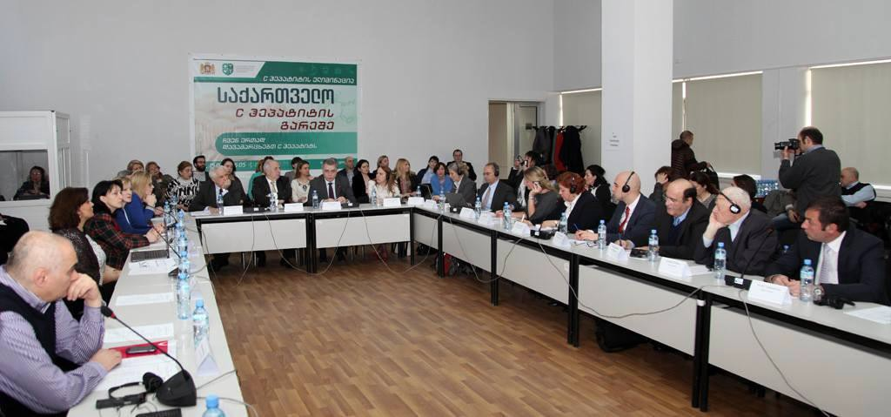
Georgian 2nd National Workshop on Hepatitis C, March 26, 2015

- Over the past several years the Government of Georgia substantially stepped up its efforts against hepatitis C by implementing national programs such as free of charge hepatitis C treatment for HIV/HCV co- infection patients (funded under the Global Fund HIV Program since 2011); Free of charge hepatitis C treatment at the penitentiary system and 60% price reduction on combination of pegilated interferon and ribavirin for the general population.
- In February 2014 MoLHSA (Minister Dr. David Sergeenko) initiated discussion regarding strengthening Hepatitis C response in the country with US partners.
- In March 2014 the 1st National Workshop on Hepatitis C, organized by CDC, MoLHSA, NCDC, Georgian
Infectious Diseases, AIDS and Clinical Immunology Research Center (IDACIRC), Bristol University, and Emory University, developed the first concept of hepatitis C elimination in Georgia. The concept was endorsed by the Government of Georgia and declared intention of eliminating HCV infection in the country. In April 2014 the concept was discussed at the WHO supported hepatitis summit in Geneva and later CDC helped to organize dedicated satellite meeting on hepatitis C elimination in Georgia during the 49th annual meeting of the European Association for the Study of the Liver (EASL) in London.
- In 2014 the Georgian Government started negotiation with pharmaceutical company Gilead which is one of the global leaders in manufacturing potent DAAs, including Sofosbuvir and fixed-dose combination of Ledipasvir/Sofosbuvir regarding possible elimination of HCV in Georgia.
- Under the MoLHSA, a special commission on HCV was established that is in charge of overall coordination of national HCV elimination movement. In addition, a working group of experts was created to elaborate national strategy and action plan for HCV elimination. National Program for Short-term/urgent Measures of Hepatitis C Elimination Action Plan for Georgia has been developed.
- Georgian delegation with the support of the US CDC and Open Society Foundation Georgia visited Egypt in February 2015 to get familiar with the ongoing Sofosbuvir treatment program and use experience of Egypt in planning elimination strategy for Georgia.
- In March 2015 2nd National HCV Workshop was organized by MoLHSA, NCDC and IDACIRC with the
support of the US CDC and participants from governmental and non-governmental stakeholders, local experts and international experts from CDC, WHO and Emory University. Short term/urgent measures of Hepatitis C elimination Action Plan for 2015 was discussed and finalized during the workshop and later in April was approved by the Georgian Government.
- Memorandum of Understanding between the Government of Georgia and US pharmaceutical company Gilead was prepared and officially signed on April 21, 2015

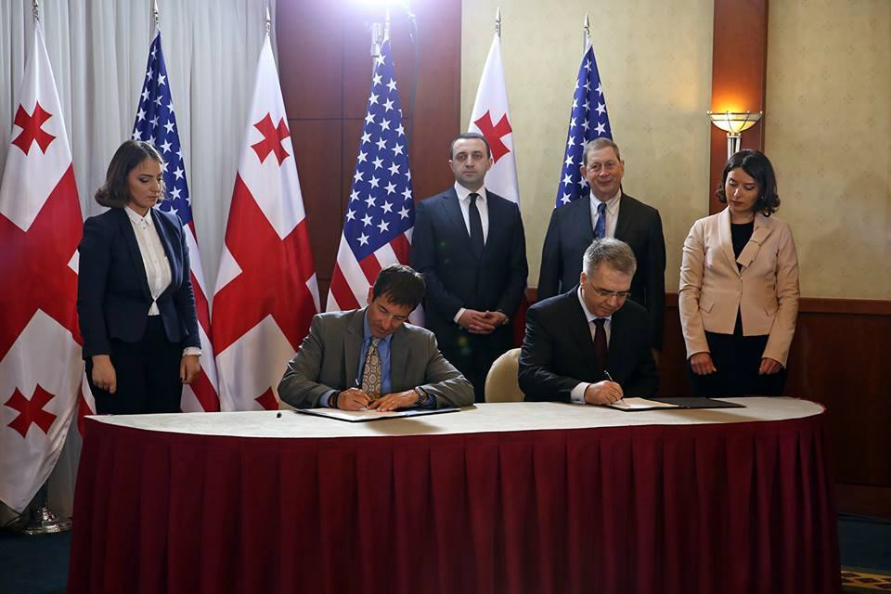

Official signing of Memorandum of Understanding, April 21, 2015

- Population-based HCV seroprevalence survey was conducted in May-August, 2015. It aimed to estimate the prevalence of HCV infection in the general population by age groups, regions, and urban/rural residence, as well as to assess risk factors for HCV infection in Georgia, to describe HCV circulating genotypes and identify knowledge and perceptions towards hepatitis and its prevention and treatment. The survey estimated that 7.7% population is anti-HCV positive and 5.4% are HCV RNA positive.
- Long-term elimination strategy for 2016-2020 is developed. To facilitate the process of elaboration, several workshops and a meetings were organized with support of CDC and WHO. The Technical Advisory Group (TAG) composed of 12 international experts was established with support of the CDC and the first meeting was held in Tbilisi on November 3-4. After the meeting, TAG provided a set of recommendations on long-term elimination strategy.
- With Support of CDC, WHO and Eurasian Harm Reduction Network, MoLHSA and NCDC conducted 3rd
National HCV Elimination workshop on April 6-8, 2016 in Tbilisi. National and international experts discussed results of national serosurvey, 1st phase of elimination program and Elimination Strategy for 2016-2020.
- Georgian government scaled up screening activities. Since January, 2015, more than 220,000 people have been screened for HCV through several funded programs. Diagnostic yield (positive HCV cases found) within ongoing screening programs varies from 0.4% among pregnant women to 46% among PWIDs.
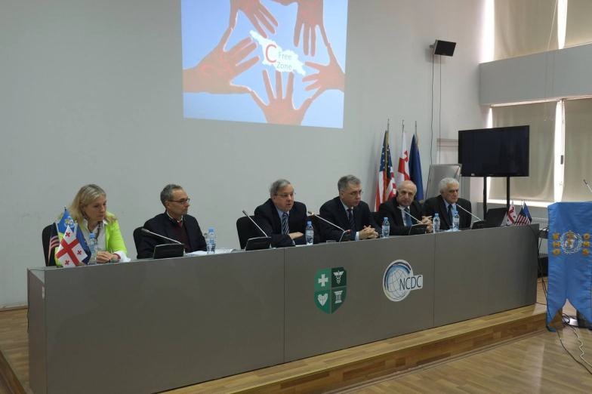
Georgian 3rd National Workshop on Hepatitis C, April 6-8, 2016
- 2nd Technical Advisory group (TAG) meeting was held in Tbilisi on October 24-25, 2016. Recent progress towards elimination, monitoring and evaluation indicators and priorities for 2017 were discussed.

8

Preliminary results of 2015 National Program on Hepatitis C (1st Phase of elimination program)

Implementation of elimination program started in April 2015 and currently 24 service centers in different cities, and 1 center in penitentiary system, are providing diagnostic and treatment services to program beneficiaries. By the end of September, 2016, 36 457 beneficiaries presented with positive anti-HCV test, 21 275 patients were authorized by the state committee to start treatment with different regimens based on Sofosbuvir and Harvoni, and 9688 already completed the treatment.

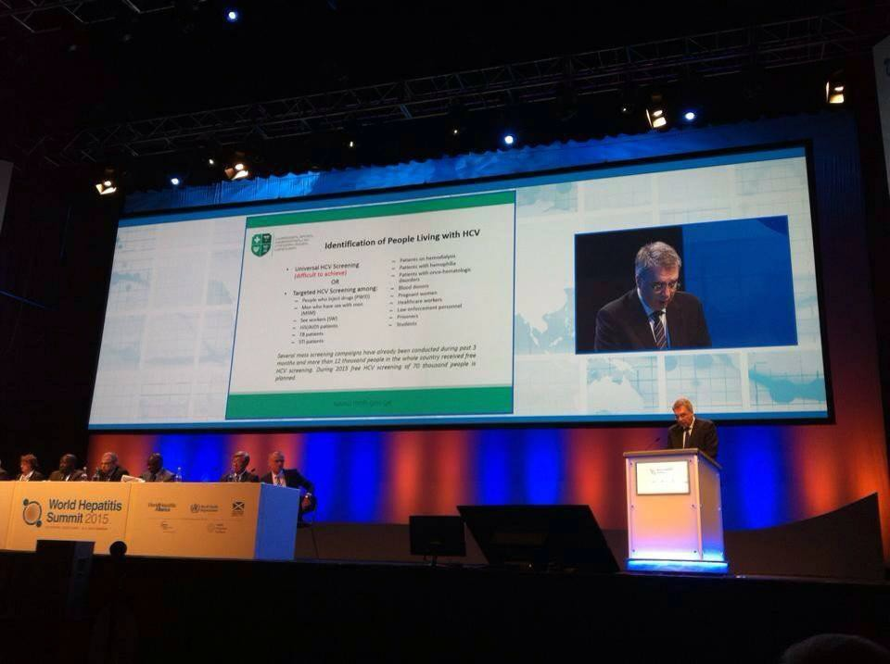
Georgian Minister of Health, Labour and Social Affairs Davit Sergeenko at World Hepatitis Summit, 2-4 September, 2015

Why is Elimination of Hepatitis C in Georgia Feasible and Achievable?
- High prevalence of HCV infection in general population;
- Small size of the country (69,700 km2) with population of 3.7 million people;
- Strong Governmental commitment towards elimination of HCV;
- Availability of all modern HCV diagnostic and treatment methods;
- Strong human resource capacity in the field of viral hepatitis, and particularly in hepatitis C;
- Adherence to principles of evidence-based medicine for hepatitis C as evidenced by the availability of national guidelines for many years;
- Existence of effective systems for implementing large-scale national and international health programs, including through multi-sectoral approach;
- Availability of logistic and control mechanisms within existing national HIV/AIDS, Tuberculosis and hepatitis C treatment programs that effectively prevent leakage of medicines to local and/or neighboring markets;
- Best practice experience in the field of HIV/AIDS that can be replicated for hepatitis C programs. Namely,
achievement of universal access to antiretroviral therapy that remains unique in the Eastern European region for more than a decade.

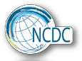

National Center for Disease Control and Public Health

9 M. Asatiani street Tbilisi 0177 Georgia Phone: (+995 32)
231 17 54

E-mail: ncdc@ncdc.ge

www.ncdc.ge Facebook: www.facebook.com/ncdcgeorgia



12

