Maternal and child health and sexual and reproductive right
- Introduction
At the International Conference on Population and Development in 1994, diverse views on human rights, population, sexual and reproductive health, gender equality and sustainable development merged into a remarkable global consensus that placed individual dignity and human rights, including the right to plan one’s family, at the very heart of development.
On the Base on ICPD principles, Maternal and child health sexual and reproductive right is one of the priority health system of Georgia. Georgia has achieved remarkable progress in reducing under–five and neonatal mortality rates to 10.2 and 6.1 per 1000 live births respectively by 2015 thus accomplishing the Millennium Development Goal #4 (MDG) set at the 2000 Millennium Summit: Reduce by two-thirds, between 1990 and 2015, the under-five mortality rate.
Country have very ambitious goals under SDG3: By 2030, reduce the maternal mortality ratio of Georgia to at least 12 per 100,000 live birth and end preventable deaths of new-borns and children under 5 years of age, aiming to reduce neonatal mortality to at least 3 per 1,000 live births and under-5 mortality to at least 6 per 1,000 live births.
- Methodology and process for the review
In preparation of report were involved all stakeholder: Ministry of Labour, Health and Sosical Affairs, National Center for Diseases Control and Public Health, GeoStat, UNFPA, NGOs. Data was collected from all available sources.
- Summary of progress
  - Key achievement
Georgia was one of the Country in the world, has achieved remarkable progress in reducing under–five and neonatal mortality rates to 10.2 and 6.1 per 1000 live births respectively by 2015 thus accomplishing the Millennium Development Goal #4 (MDG) set at the 2000 Millennium Summit: Reduce by two-thirds, between 1990 and 2015, the under-five mortality rate. Last years, the share of deliveries in health institutions, reached the maximum value (99.9%) and stayed unchanged.
All of this has contributed to a number of reforms implemented in the country. In 2013 has introduced Universal Health Care in Georgia aimed to improve the general population’s access to healthcare. For better monitoring of maternal and child mortality cases emergency notification system has been started in February 1, 2013. In 2016, MoLHSA in alliance with NCDC launched the nationwide electronic registry “Mother’s and neonate’s health surveillance system”, so called “Georgian Birth Registry” (GBR). National MNH Strategy 2017-2030 with related short-term Action Plan (2017-2019) is developed and approved by the government in 2017.
  - Analysis of progress and Means of implementation
In the transition period from the MDG framework to Sustainable Development Goals (SDG), a complex assessment of maternal mortality is necessary to identify successful areas and address existing problems.
Maternal and child Health is one of the priorities for Georgian Health Care System. Since 2013, a number of reforms have been undertaken in the prevention of MCH preventable deaths. For better monitoring of maternal and child mortality cases emergency notification system has been started in February 1, 2013, which ensures urgent provision of information on maternal mortality, 0-5 year’s child mortality and stillbirth cases. Each medical organization is obliged to notify MoLHSA by phone call within an hour in case of maternal or 0-5 child mortality and stillbirths and in the next 24 hours confirm the call by the written notification.
The initiative of starting the perinatal care regionalization process from May 2015 is a significant step forward in strengthening the maternal and new-born health care system, which considers defining the levels of perinatal service providers and their role and responsibilities in order to provide the correct timing of the correct patient to a correct medical institution and, if necessary, effective referral. Regionalization was be completed in 2017. 105 facilities assessed, 82 facilities have designated level of care. All 82 facilities strengthened their capacity for infrastructure/equipment and competencies of service providers according to the level requirements.
In 2016, MoLHSA in alliance with NCDC launched the nationwide electronic registry “Mother’s and neonate’s health surveillance system”, so called “Georgian Birth Registry” (GBR). The system tracks information on all cases of pregnancy, delivery, postpartum, neonatal care and abortion.
National MNH Strategy 2017-2030 with related short-term Action Plan (2017-2019) is developed and approved by the government with the aim to provide long-term guidance and coherent plan of action for the improvement of maternal and new born health in Georgia.
The principle of protecting the universal rights of Georgian population has been achieved in healthcare sector from 2013s the whole population of Georgia is insured for basic medical service under state Universal Health Care program. Children under 0-5 and 5-18 are covered planned ambulatory care, emergency out-patient and in patient services, elective surgery, Chemo-hormone- and radiotherapy, delivery and C-section.
In order to decrease number of mortality of mothers and children, also number of perinatal death from iron deficiency anemia, and number of early delivery and inborn anomalies, from June 2014 all pregnant population is provided with folic acid up to 13th week of pregnancy and in case of iron deficiency anemia – with, iron deficiency anemia medication from 26th week of pregnancy. From 2018 under Maternal and child heath state program Government covers 8 antenatal visits by WHO new guidelines.
Maternal and child health state program includes:
- Antennal screening for HIV / AIDS, H & C and hepatitis and syphilis
- Screening for genetic pathologies
- Prevention of hepatitis B, HIV / AIDS and syphilis in pregnant women and transmission of hepatitis to mother from mother
- New-born and child screening on hypothyroidism, phenylketonuria, hyperphenylalaninemia and mucosididase
- Screening for newborn hearing screening
In March, 2017 MoLHSA initiated a selective contracting of facilities providing perinatal care services. Social Service Agency contracts only facilities which demonstrate required compliance with pre-defined quality criteria. Currently 30 facilities, providing perinatal care services from three largest cities of Georgia (Tbilisi, Kutaisi and Batumi) are involved in selective contracting process. The existed contract includes 10 quality indicators, covering the critical issues related to obstetric and neonatal care in Georgia.
The routine clinical audit of cases of stillbirth and maternal and neonatal mortality has been introduced by the MoLSHA in 2017 with aim to advance practice of obstetrics and neonatal care and improve the quality of services through detailed clinical analysis of selected mortality cases. The comprehensive audit process allows identification of root causes of gaps and deficiencies in existing practices and in the health system and planning the corrective policy and practice measures at the local and national level.
Results of the reforms
From 2015 maternal mortality ratio were significantly reduced and in 2016 reached 23.0 per 100,000 new-borns. The structure of the maternal mortality is as follows: 22% (3 cases) were caused by intrapartum and postpartum haemorrhage, 22% - (3 cases) by sepsis, 7% (1 case) – by ectopic pregnancy, 7% (1 case) – amniotic fluid embolism. Among 4 cases of indirect deaths 1 was caused by tuberculosis, 1 – by hepatitis A, 1 – meningitis, and 1 – by arteriovenous malformation
Maternal mortality ratio per 100000 live births, Georgia (SDG 3.1.1)
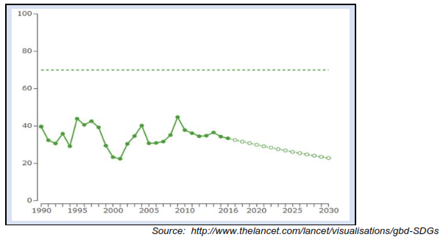
Last years, the share of deliveries in health institutions, reached the maximum value and stayed unchanged.

Rate of childbirth in health centers, assisted by qualified medical personnel (%), Georgia (SDG 3.1.2)
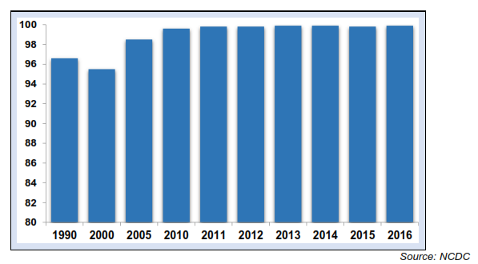

In Georgia, in 2016, a share of neonatal death in under-5 mortality was 58.9%. According all sources, such as official statistics, international experts estimates (the UN Inter-agency Group for Child Mortality Estimation - IGME), and large-scale studies (Georgian Reproductive Health Survey GERHS), Global Burden of Disease Study – GBD, Georgia, has reached the Millennium Development Goal in reducing the under-five mortality rate. It is important that GBD’s and IGME-'s assessments for the global and regional levels almost matched, the matching level - 98%.

Under-5 mortality rate per 1000 live births, Georgia (SDG 3.2.1)
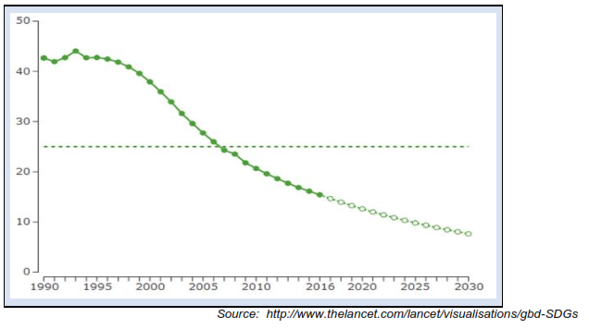
Introducing Universal Health Care in Georgia in February 2013 aimed at improving the general population’s access to healthcare, has benefited more Georgians, particularly those relatively less well-off, from gaining access to health services when ill and being less prone to impoverishment or catastrophic out-of-pocket spending on healthcare. This was achieved through a strong political commitment and process to create an equitable health financing system.
In 2013, after implementation of the UHC program, service coverage has increased significantly and rapidly from 29.5% of the population in 2010, to about 40% by the end of 2012 and up to 99.9% by 2014.
UHC program has significantly reduced the out-of-pocket payments and improved financial protection of the population. Out-of-pocket spending declined from73% in 2012 to 57% in 2016.
OOP as Share of Total Health Expenditure (SDG3.8.2)

NHA data

All vaccinations included into the National vaccination calendar are free of charge for the population. To guarantee high quality and safe immunization, for immunization of the population State purchases vaccines, which are prequalified by the World Health Organization. In 2016, compared to 2015, in the frame of the State immunization program, the vaccination coverage rates for most antigens is higher, although, coverage rates for all vaccines have not yet reached 95%
Share of children (%) aged under-2, vaccinated against measles (SDG 3.b.1)

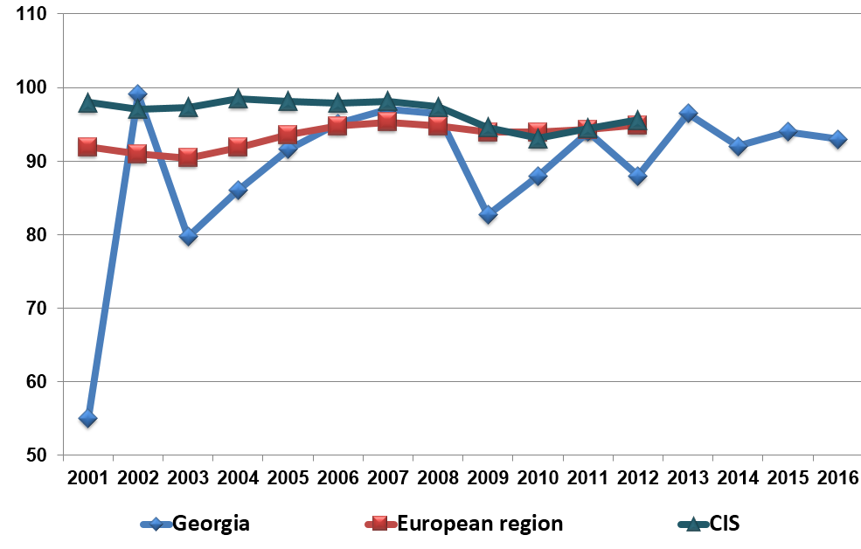

Georgia is considered as a country with low prevalence of HIV/AIDS. However, in recent years incidence of HIV/AIDS is characterized by the growing trend. In 2016, in Georgia, 719 new cases of HIV were registered (incidence per 100000 population – 19.3).
With respect to the first “90” target from the UN three 90s targets (90-90-90) – timely diagnosis of people living with HIV is problematically low in the country. Accordingly, 37.4% of the new HIV cases are diagnosed at the AIDS stage.
HIV incidence per 100000 population, Georgia (SDG 3.3.1)
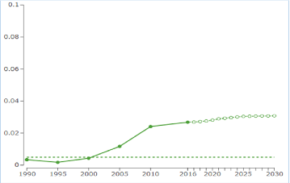
Source: http://www.thelancet.com/lancet/visualisations/gbd-SDGs
(SDG 3.7.1) New data for use of contraceptive and family planning will be available after Melty indicator Cluster Survey (MICS) in 2019. Although overall contraceptive use increased since 1999 from 41% to 54% in 2010, Georgia still has almost the lowest level of use of the countries in Eastern Europe. Use of traditional methods (rhythm and withdrawal) remained almost unchanged in Georgia, with still about one third of all users applying those unreliable methods, or 18.5% of all married couples. This is high in comparison to the European average (13.9%), and particularly in comparison to Western Europe (3.2%). Of all married women in Georgia in 2010 only 35% used a modern FP method, mostly being condoms or an IUD. Use of oral contraception (4%) was still remarkably low compared to Europe as a whole (21.4%).
In 2010, according to RHS 2010, 12.3% of all married couples did not use any FP method, although they were at risk of unwanted pregnancy. In addition to this, 18.2% of married women at risk used an unreliable method. Together, this represents an unmet need for modern contraception of 30.5%, which is very high for European standards. Unmet need is particularly high in rural areas, where it can reach 40%.
In 2016, according to the National Statistics Office of Georgia, birth rate in women aged under-20 reduced and reached 43.6
Adolescent pregnancy rate (rate per 1000 women aged 15-19) (SDG3.7.2)
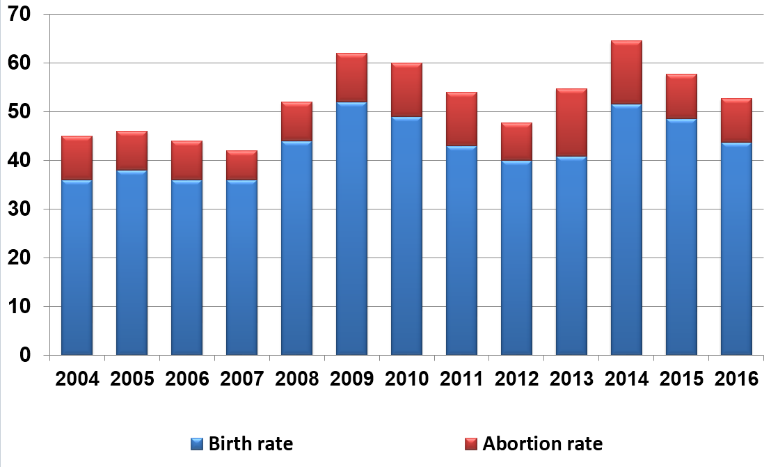

Adolescent pregnancy rate (SDG3.7.2)
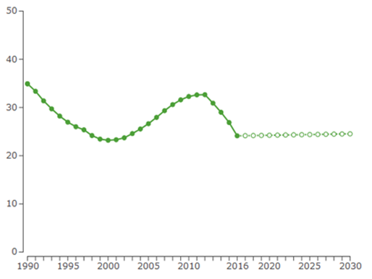
Source: http://www.thelancet.com/lancet/visualisations/gbd-SDGs
(SDG 5.6.1) New data for use of contraceptive and family planning will be available after Melty indicator Cluster Survey (MICS) in 2019. Gender equality for women and girls is an essential prerequisite for making informed choices about their health and to seek and receive services they want and need. The process of making informed family planning choices begins long before people visit a provider, and many people make informed choices without face-to- face communication with a provider. When clients do seek services, however, there is substantial evidence on what clients and providers can do together to ensure that family planning decisions are based on the principle of informed choice.
Trends in Type of Counseling Received Among Women Aged 15-44 Who Had Used a Modern Method Within the Last 5 Years; 1999, 2005 and 2010

GERHS-2010

- Conclusion
For achieving SGD and ICPD priorities, it is important to implement of National MNH Strategy 2017-2030 actions which aims to provide long-term guidance and coherent plan of action for the improvement of maternal and new born health and reproductive right in Georgia

8.8.1: Frequency rates of fatal and non-fatal occupational injuries, by sex and migrant status
- Introduction
In order for the country to reach the goal 8.8. “Protect labour rights and promote safe and secure working environments for all workers, including migrant workers, in particular women migrants, and those in precarious employment” (indicator 8.8.1: Frequency rates of fatal and non-fatal occupational injuries, by sex and migrant status) Georgia has undergone deep changes in its labour institutions and practices in managing human resources. It is only with the arrival of a new Government late 2012 that Georgian authorities started to take the necessary steps to amend the labour legislation in compliance with International Labour Standards (ILS). The amendments to the Labour Code address previous shortcomings related to workers’ rights and guarantees, such as the freedom of association, anti-union discrimination, collective agreements and bargaining, decent working conditions, child labour, overtime work, dismissal procedures, and mediation mechanisms
- Methodology and process for the review’
Since social partnership has been established and Tripartite Social Partnership Commission is in place, social partners together with the state institutions are actively involved in all above mentioned processes.
- Summary of progress

  - Key achievement
In 2015, the Labour Conditions Inspection Department was established in the Ministry of Labour, Health and Social Affairs. The department oversees the safety of labour conditions and compliance with labour laws. “State Programme for Inspecting Labour Conditions” is being implemented by the Government of Georgia through approving the programs annually. Resolution of Government of Georgia “On Approval of Rule of State Supervision/Labour Inspection of Prevention of and Responding on Forced Labour and Labour Exploitation” was elaborated and approved in March 2016.
Georgia also has passed legislation to provide some Occupational Safety and Health (OSH) protections, in Georgia’s most hazardous industries as part of a pilot project through September 1, 2019, together with amendments to the Law on Entrepreneurial Activity that will authorize unannounced inspections by labour officials acting within the scope of their mandate and has committed to take additional legislative and regulatory steps to give full effect to the eventual OSH protections.

  - Analysis of progress and Means of implementation
Since the day of establishment of the Labour Conditions Inspection Department this is from 2016 when the Department started investigating accidents and accordingly, recording fatal and non-fatal occupational injuries. Though the statistics are not gender or migrant status aggregated.
As statistics from Labour Conditions Inspection Department show there were 8 fatal and 0 non-fatal occupational injuries in 2016, 20 fatal and 14 non-fatal occupational injuries in 2017, and 15 fatal and 17 non-fatal occupational injuries in 2018 (as for June).

- Conclusion
The Government of Georgia, in particular, Ministry of Labour, Health and Social Affairs of Georgia is working on improvement of collecting and recording gender and migrant status segregated data by the Labour Conditions Inspection Department.
Overall, Georgia is committed to ensuring the integrity, utility, and efficiency of its inspection regime, taking steps to achieve Sustainable Development Goals and continues to explore best practices toward this end with the ILO and partner countries.

One of the most important priorities of the Government of Georgia is to improve social – economic conditions of citizens. The Governmental policy is directed to create a social protection system oriented to reduce social risks caused by poverty and ageing and will support disabled and vulnerable groups to integrate in society.
To achieve these goals many effective measures have been implemented in the country:
- Amount of state pension/social package increased several times and state pension and social package for severe disabled persons and disabled children consists 180 Gel.
-From September 2016, those residents of mountainous regions, that are entitled to receive state pension/social package, receive in addition 20% of the state pension/social package.
-“Demographic situation promotion program” was approved by the resolution of the Government of Georgia №262 on March 31, 2014. The aim of the program is to improve the demographic situation in Georgia, especially in the rural areas, through financial incentives of birth rate. In the frames of the same program, according to the Georgian law on “Development of Mountainous Regions”, children born after January 1, 2016 also gained the right to receive the monetary social assistance, whose one of the parents has permanent resident status of living in mountainous region.
- Targeted social assistance is a special cash assistance programme aimed at reducing poverty level of the most vulnerable households in the country. The programme is based on the assessment of households using special methodology that uses Proxy Means Testing formula and assesses households with “wellbeing score”.
Since 2015 with the support of World Bank and UNICEF revised methodology of assessment for socially vulnerable families and assistance scheme was introduced.
Assistance is provided based to the gradation system- families, having lower scores receive more financial support. The new methodology better reveals the needs of the children and families with children.
Implemented measures are directly connected to the fulfillment of obligations taken under nationalized sustainable development goals.
Namely: for first goal (End poverty in all its forms everywhere) Adjusted Indicator of Georgia - Target 2030: - 1.1.1. Proportion of population living below the international poverty line: < 1 %
According to the World Bank data for 2016 this indicator in 2015 was -4%, in 2016 was 4.2%. (1.9$ (2011 PPP)
1.3.1: At least 35% of the population in need is covered by major social protection systems, by sex, distinguishing children, older persons, persons with disabilities, and the poor and the vulnerable
As of January 2018, population in need are covered with targeted social assistance program, by age and sex groups: 8,2 % (except of pensioners and receivers of social package), children: 36,5%, women: 54,3%. Social package: 4,5 %, where 20.3% are children, 37,4 % women, pensions 19.7% -women 71%.
Georgia continues to make important steps and implements comprehensive measures in different directions, including social protection sphere, in order to achieve sustainable development goals through the effective reforms.

World Contraceptive use 2011. UN Department of Economic and Social Affairs; Population Division. (Wallchart).
https://data.worldbank.org/indicator/SI.POV.DDAY?end=2016&locations=1W-GE&name_desc=true&start=1981&view=chart

