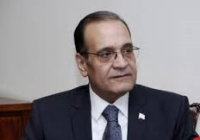 | H. E. Mr. Tareq Ebrahim Mohamed Maaty  Ambassador Extraordinary and Plenipotentiary of the Arab Republic of Egypt to Georgia  (with residence in Yerevan)
Term in Office | 10.12.2015
Visits to Georgia | Amb. Maaty visited Georgia in December 2015 and in 2016 (May and August).
Date of Birth | 14.08.1958
Education | - Bachelor in Economics and Political Sciences Cairo University, 1980;  - Diploma in Economics, International Institute for Islamic banks and Economy, Cyprus 1983;
Foreign Languages | French, English
Curriculum Vitae | Previous post: Deputy Assistant of Foreign Minister for Immigration, Refugees and combating trafficking in human beings, MFA of Egypt;  Previous Missions: Khartoum, Caracas, Bucharest, Abidjan;

Note: Married with children.

