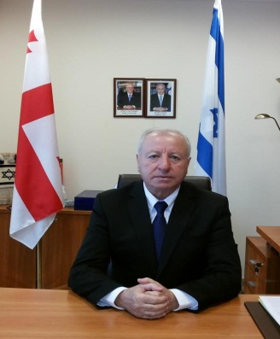
Shabtai Tsur - Ambassador of Israel to Georgia

Born in Vani, Georgia on 15.02. 1951

- ​Education:
- 1972 - First degree in economics from the University of Saint Petersburg;
- 1985 - Diploma in banking;
- 1996 - First degree in Management from the branch of TVU university (England).
- Courses:
- 1979 - Investment at bank in the frame of the local authority;
- 2000 - Course in executive management course;
- 1996 - courses of the Local authority and the Jewish Agency.
- Languages:
- Fluent in Hebrew, Russian and Georgian;
- Good knowledge of German and English.
- Employment:
- 1973–1989: Senior employee of Bank Leumi
- 1985–1989 Member of Ashkelon municipality;
- 1989 – 1991 Deputy Mayor of Ashkelon;
- 1991–2003 First Deputy Mayor of Ashkelon;
- 2003 Mayor of Ashkelon;
- 1990–2004 Chairman of board of directors of Halperin Home for Elferly.
- 1995 – 2004 Chairman of the National and International Federation of immigrants from Georgia to Israel;
- 1996 – 1998 Adviser of the Prime Minister of Israel regarding Georgia and Caucasus;
- 1998 – 2004 Honorary Consul of Georgia in Israel;
- 2002 – 2013 Chairman of the World Congress of Jews from Georgia;
- 2002 Member of the Board of Directors of Bezek Company;
- 2003 Chairman of the Municipal Environmental Association, Ashkelon and its surroundings;
- 2005–2008 Ambassador of Israel to Georgia;
- 2011 – 2013 Chairman of Ashkelon's port company;
- 2011 – 2016 Chairman of Ashkelon's Educational Institutions;
- 2012 – 2016 Vice Mayor of Ashkelon;
- 2013 –2016 Chairman of the Finance Committee and in charge of industry, commerce and international relations of Ashkelon's Municipality;
- July, 2016 Ambassador of Israel to Georgia.

