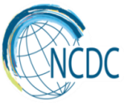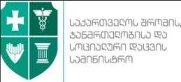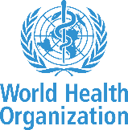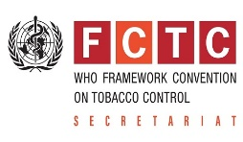

„Get free from tobacco smoke“
Launching of communication campaign
28 February 2018, 14.00
8 Rustaveli ave, Tbilisi, Block B, Shota Rustaveli Hall

Time | Agenda | Speaker
14.00-14.15 | Welcome, State tobacco control policy of Georgia and Communication campaign to implement the law | Akaki Zoidze – Chairman of the Committee of Healthcare and Social Issues
14.15-14.25 | FCTC Implementation in Georgia – Achievements and Challenges | Vera Luiza da Costa e Silva - Head of the Convention Secretariat WHO FCTC
14.25-14.35 | State policy on protection from tobacco smoke – priority of healthcare sector | David Sergeenko – Minister of Labour, Health and Social Affairs
14.35-14.45 | Ongoing Reforms and preparation for implementation of state policy on protection from tobacco smoke | Deputy Minister - tbd, MIA
14.45-15.00 | Switching on Timer | Akaki Zoidze, Vera da Costa, David Sergeenko, Deputy Minister of MIA
15.00-15.20 | Reception, Interview with Media

