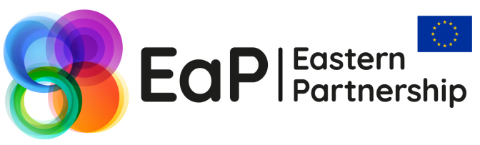
Workshop on
Functional and Institutional Analysis of Public Institutions, Organisational Structure
20 April 2018
Tbilisi, Georgia

- Background

The overall goal of the functional/institutional analysis of the government institutions within the civil service reform in Georgia is to achieve effective governance through establishment of unified and coherent standards for public administration. Over the last years Georgia started to gradually reform its civil service. In the long run, the civil service reform implies further development of the legal and institutional environment for formation of a stable, well-organized and transparent civil service system.
The progress on overall institutional set-up and civil service reform was achieved through the promotion of the Civil Service Reform Concept approved by the Government Decree no 627/Nov 19 2014 and the Law on Civil Service adopted on 27 October 2015. According to the new regulations, the central and local government agencies and legal entities of public law (LEPLs) have been obliged to provide functional analysis of their institutions.
In order to achieve effective governance through establishment of unified and coherent standards for public administration the Civil Service Bureau (CSB) has launched the functional analysis of central government institutions in 2015. To this end, methodology for internal use during planning of functional analysis has been developed; the CSB task force conducted interviews with representatives of the ministries (19 Ministries, 85 interviews), consolidated and analyzed collected data. In addition, the “Guiding Principles and Methodology for Organizational Set-up of the Public Institutions” were adopted by the ordinance of the Head of CSB, on April 25, 2017 and published/distributed. The functional analysis of the ministries was assessed against a set of these principles. First phase of analyses covered the study of the structure of public agency, as well as optimal number of structural units and human resources, for purpose of elaboration of standards for better management of the organization. The questionnaire was distributed for filling to each ministry. The questionnaire included the issues such as priorities and objectives of the organization, achievement, structure and number of employees, as well as functions – duties and subordination level of each structural unit.
As a result of processing information received from the ministries, general gaps in structure and organizational set up were identified and was planned the second phase of institutional analyses– vertical analyses, which means distribution of the functions for implementation of priority and strategic objectives on the level of structural units, in accordance with the mission – goals of the agency.
On December, 2017 the Final Report on Institutional Review of Central Governmental Institutions (line ministries) was elaborated and on December 29, 2017 was published on webpage of CSB. The report consists of description of methodological approach and overview of the progress; key findings and recommendation and possible overlaps and duplications detected as a result of structural analyses, as well as the gaps against each principle identified as a result of vertical analyses of the ministries are reviewed.
At the same time, the process of functional analysis for local self-governmental institutions was launched in 2017. During 2018 it is planned to finalize the process and propose recommendations and guiding principles for organizational set-up of Local Self-Governmental Institutions. Furthermore, during the 2018, CSB is tasked to conduct the functional analysis of the Independent and Ministerial Agencies of Georgia.
For the purpose of sharing Georgian and international experience a workshop on “Functional and Institutional Analysis of Public Institutions, Organizational Structure” is organized in accordance with the Eastern Partnership 2018 Work Programme for the Panel on Governance and Public Administration Reform under the Platform Strengthening Institutions and Good Governance.

- Venue & Timing

The workshop will be held on 20th April 2018, in Tbilisi, Georgia. The event will take place at the Holiday Inn hotel – 1, 26 May Square 0171 Tbilisi, Georgia. The event will start at 10:00 am on 20th of April and last until 17:00 pm. A registration desk will be open at the venue, from 09:30 am, on the date of the event.

- Key Objectives

The forthcoming workshop is targeted at exploring the means and mechanisms of functional and institutional analysis of public institutions and providing a platform to share experiences and solutions in Eastern Partnership (EaP) as well as the EU countries and through benchmarking discussions amongst the stakeholders involved.

- Target Audience

The workshop will bring together about 50 delegates. The event aims to host delegates from EaP and the EU countries represented by public institutions as well as international and local experts and civil society organizations.

- Workshop Approach

The event will be organized in the format of presentations, discussions, conducive to mutual experience sharing, networking and partnership. Interactive format of the event will provide a platform to address the most critical element of the topic, compare national and regional experiences and discuss solutions to address common challenges. The working language of the event will be English, Russian and Georgian, and interpretation will be provided respectively.

