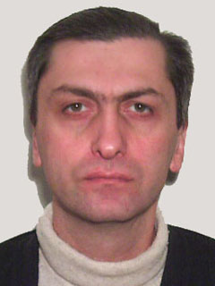Koberidze Merabi

Tbilisi
Micheladze st. 11-26
Phone: 2522605, 595267637
E-Mail: merab.koberidze@hotmail.com

OBJECTIVE
Delphi, C# and SQL Programmer, Programmer/Analyst, and Software Developer.
MS SQL Server administrator.

EDUCATION
Georgian Technical University
Engineer-Designer-Technologist of Radio Equipment, 1992

WORK EXPERIENCE
2007-present
“Bank Constanta”
Senior Programmer
Database Development, Maintenance and Administration/Analysis (MS SQL Server)
Developing and Maintaining Client's Applications (Visual C#, Sencha)
2004-2007
“Aversi-Pharma” Co. Ltd.
Data Base Programmer
Database Development, Maintenance and Administration/Analysis (MS SQL Server)
Developing and Maintaining Client's Applications (Delphi, Visual C#)
1999-2003
Ltd "Mtawminda-7", Supermarket "Zemeli"
Computer Operator
Writing Applications for Accounting and Logistics Management
Administration and Technical Support of Network
Maintaining and Administrating the Database
Programming (when needed)
2003
Café "Nica"
Computer Operator
Writing Applications for Accounting and Logistics Management
Administration and Technical Support of Network
Maintaining and Administrating the Database
Programming (when needed)
2002-2003
Ltd "Infopark"
Programmer/Analyst
Automation of Organization's Business Process
Database Development, Maintenance and Administration/Analysis (Oracle, DB2)
Developing and Maintaining Client's Applications (Delphi)
1998-2002
Private Orders
Programmer/Analyst
1998
Ltd "Stimuleiting"
Engineer designer/Programmer
Automation of Workflow
Automation of Warehouse's Business Process and Commodity Circulation, (Delphi, InterBase, Paradox)
1993-1998
Railway Department of Georgia, SC-5
Radio engineer
Ensuring Work and maintenance of Radio Communications System

TECHNICAL SKILLS
Operating Systems: Microsoft Windows 95/NT4/98/ME/2000/XP/2003/2008
Languages: Delphi, C#, Sencha, Transact SQL, PL SQL
Databases: DB2, MS SQL Server, Oracle, Interbase, Dbase, Paradox
Report Systems: Quick report, Rave report, MS SQL Server 2005 Report Server, Cristal Report
OTHER SKILLS
Fluent in Russian
Technical English

