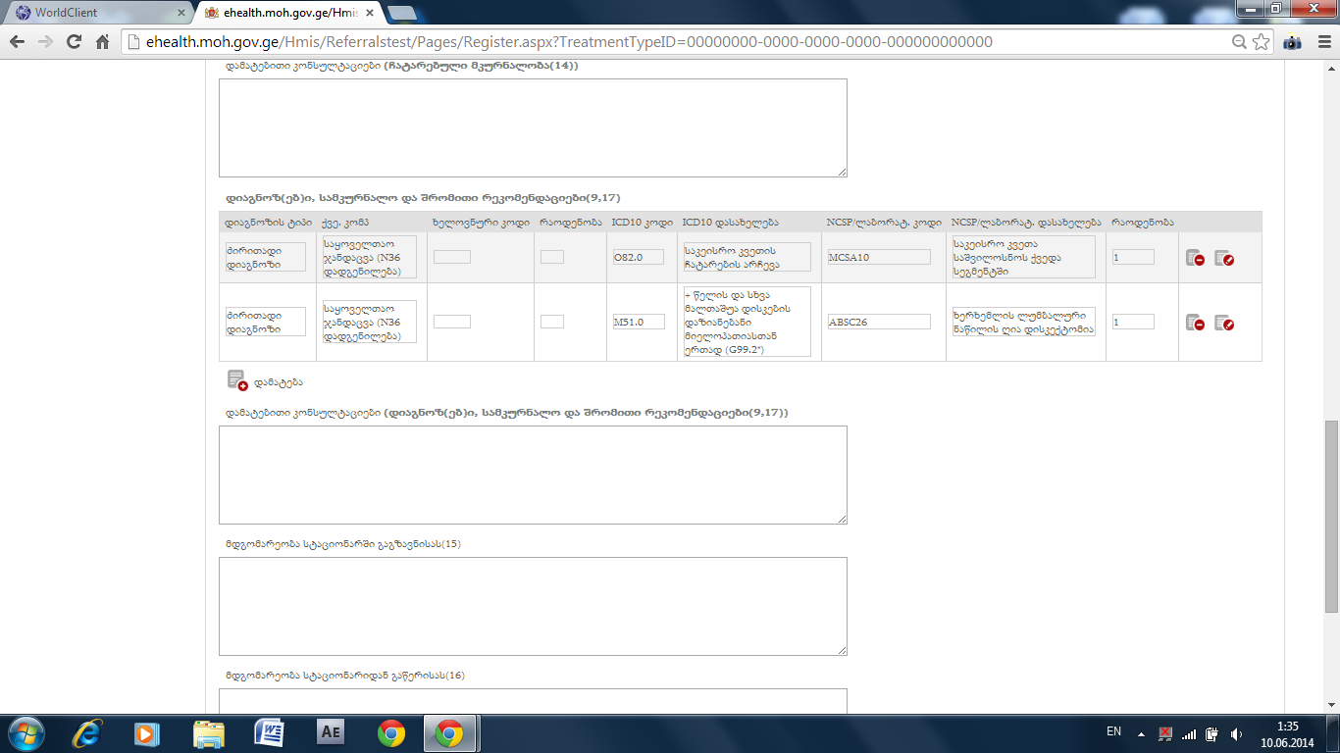

Ori dziritadi diagnozi ar unda sheidzlebodes, erti unda ikos dziritadi da tanmxlebis da gartulebis damateba sheuzgudavad.

Redaqtirebis dros forma 100-s gverdze rac vimushave cvlilebebis shenaxvamde, shenaxvis shemdeg dzveli versiebi datova kalkulaciis gverdze, miuxedavad imisa, rom mimartvidan ar gamovsulvar, unda rchebodes mxolod bolo daseivebuli versia

Uarkopaze errors agdebs
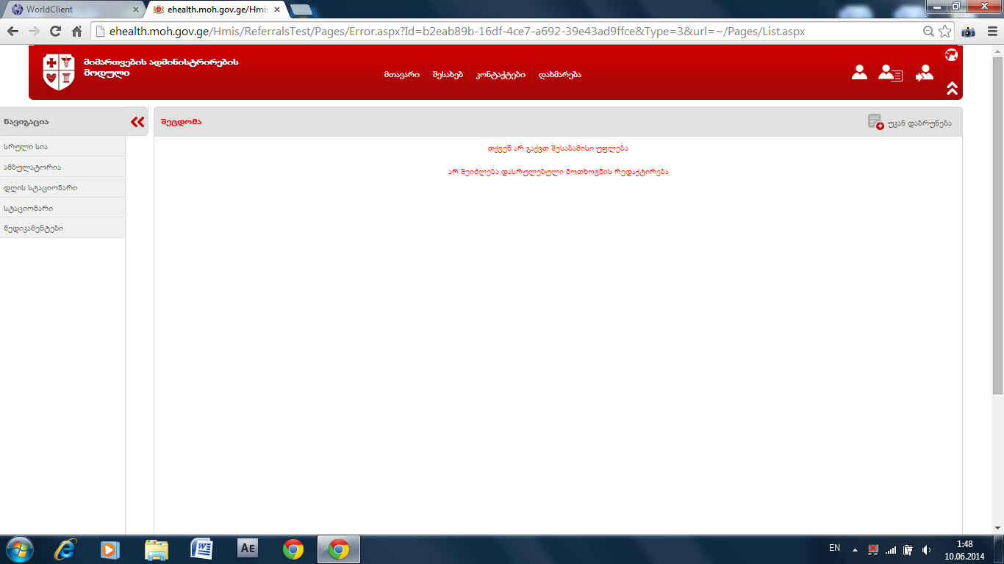

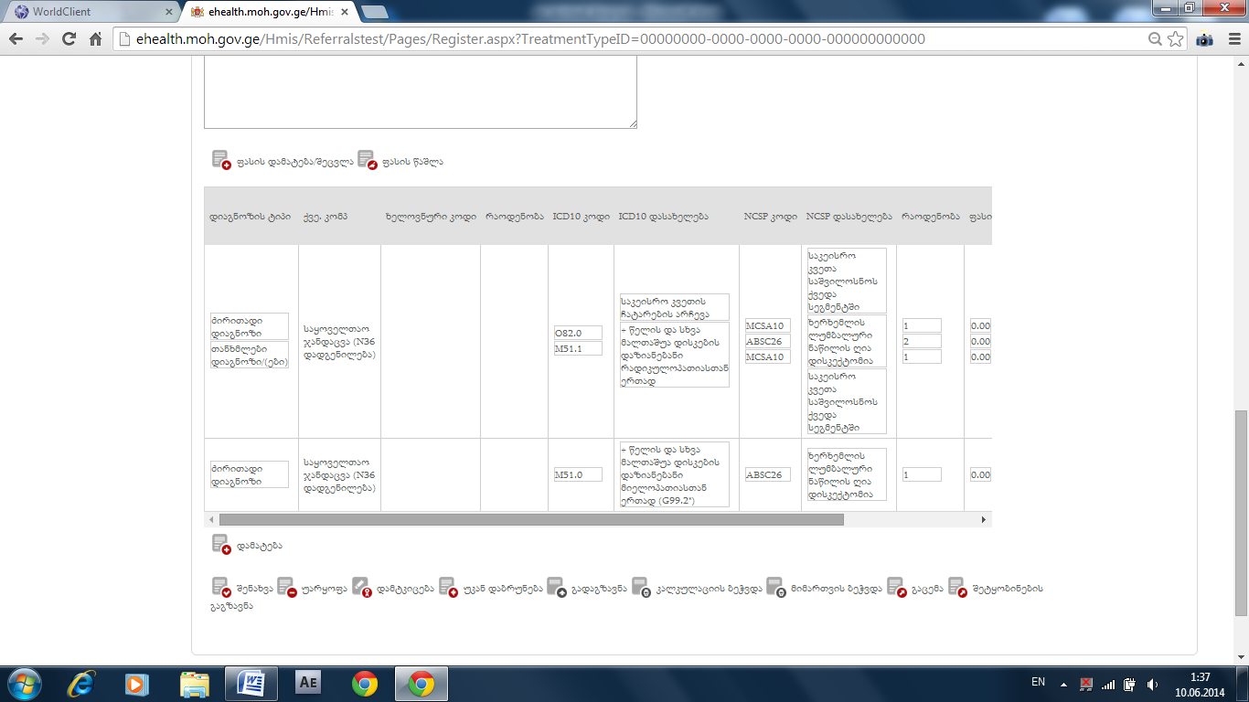

Erti cavshale da monishvnis miuxedavad imis gascvriv rac iko kvela cashala, datova mxolod calke damatebuli
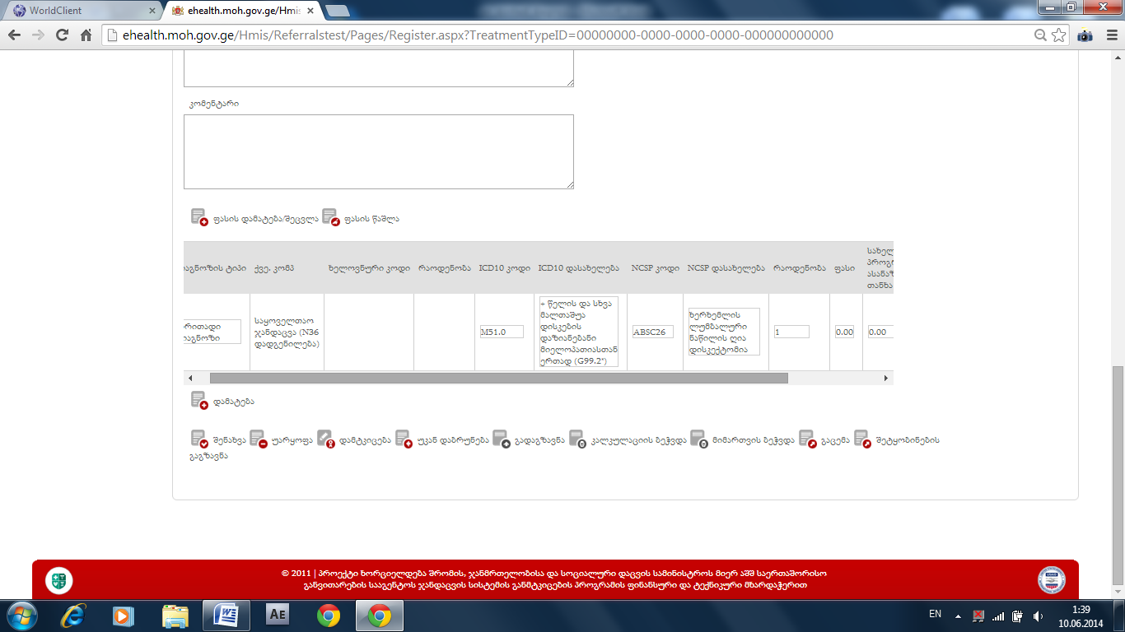

Kvelapris ertad daseiveba sheidzlebodes kalkulaciis gverdze, exla micers errors
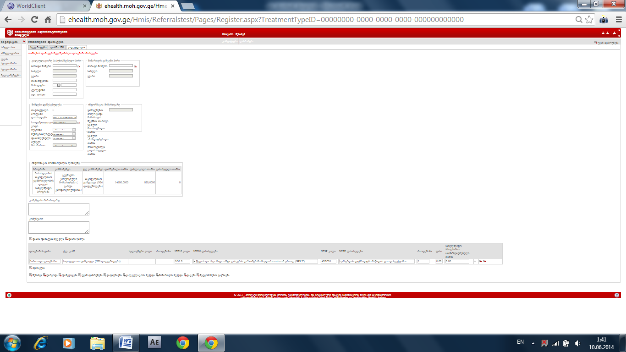

Diagnozs da charevavas ver vaseiveb pasuxismgebeli piris mititebis gareshe
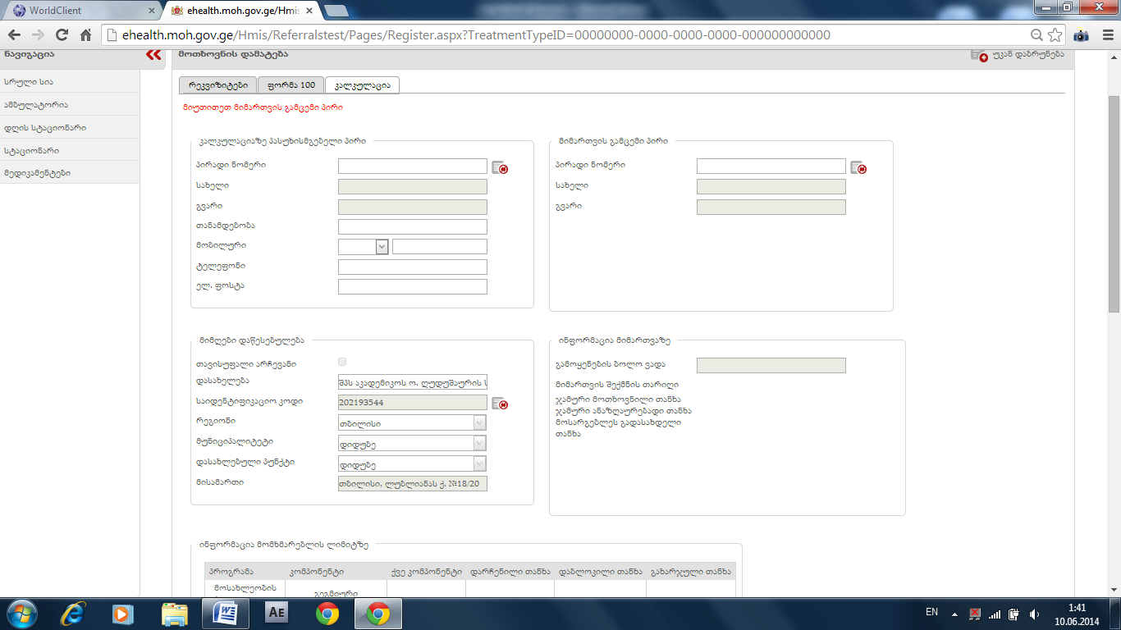

Fasis mititeba rom mindoda, ucbad isev cashlili diagnozebi da kodebi gamoxta:

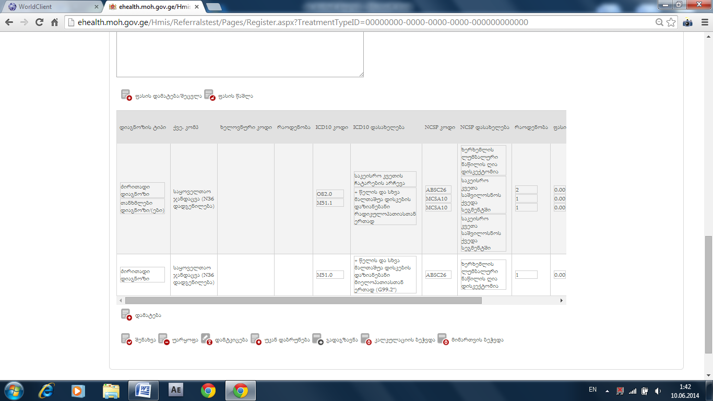

Sabechd versiashi diagnozebiani da kodebiani velebi saertod agar gadmodis?

Tumca dauarebis shemdeg srul reestrshi uarkopit pasuxs achvenebs
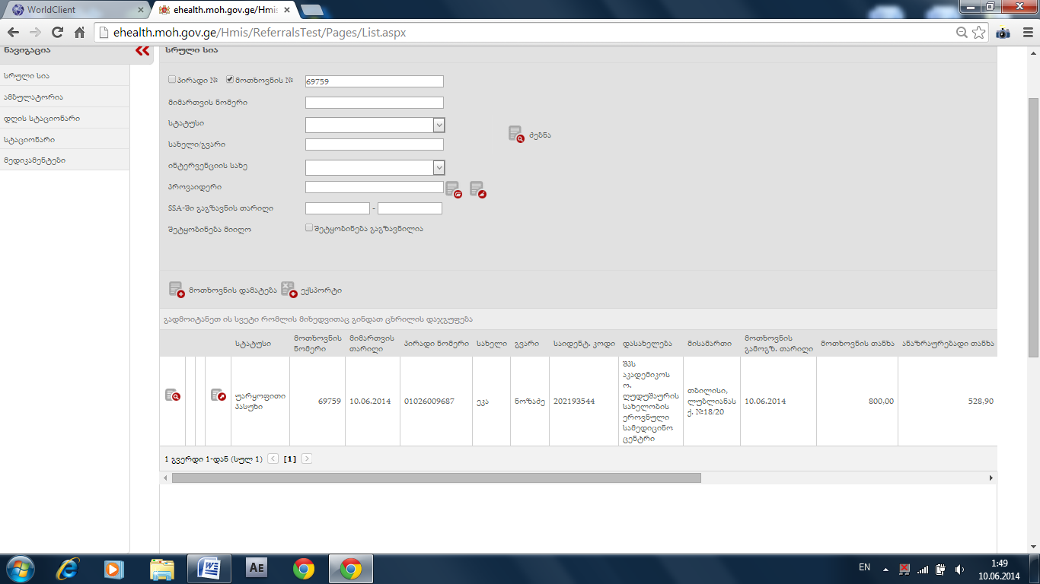

Uarkopiti statusiani ar agadgina, magram erorsac ar cers.

Uarkopit statusians agar aqvs gaukmebis gilaki.
Gacemul statusian ar maukmebinebs, qvekomponentis sia carieliao:
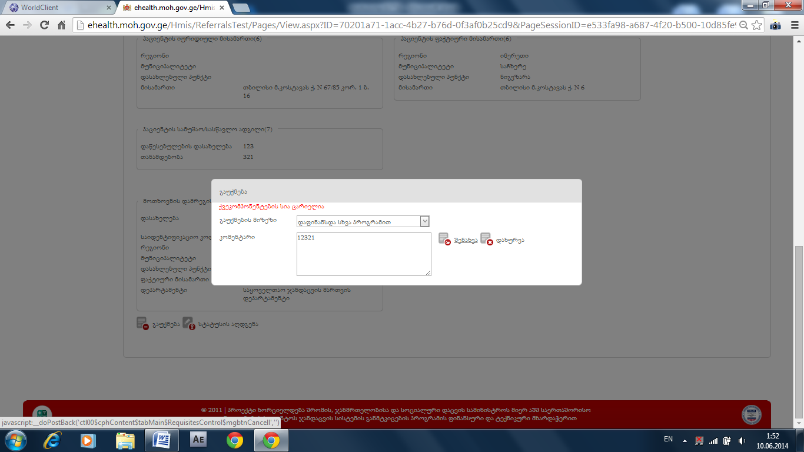
Vegarc statusi agvudgine, isev igives cers:
