Out-patient Software Module

Project | USAID Health System Strengthening Project
Version | 1.1
Date | September 9 2011

Contents
Introduction 2
Terms 3
Business Process 4
Current Situation 5
Program Objective 6
Components 7
Providers 8
Provider’s Contract 14
Concluding Contracts with Providers 14
Suspension/Termination of Provider’s Contract 18
Provider’s Contract Renewal 18
Beneficiaries 19
Beneficiary’s Contract 23
Concluding Contracts with Beneficiaries 23
Termination of Beneficiary’s Contract 23
Notifications 24
Finances 24
Data Import 24

Introduction____________________________________
The Government of Georgia finances certain medical services to improve health and social well-being of the Georgian population. There are different state-funded programs, among them an out-patient program discussed herein.
The Government covers certain out-patient services for the Georgian population under the state-funded out-patient program. There exist some limitations regarding the place services are provided, the individual’s age, type of service, etc.
This module aims at facilitating out-patient program administration process for the Social Service Agency (SSA) under the MoLHSA to ensure timely and purposeful management of state funds.

Terms_____________________________________________
- Out-patient facility- healthcare facility
- Beneficiary – citizen of Georgia who receives state-funded medical care
- Provider – healthcare facility
- State healthcare program – different state-funded programs beneficiaries to which are citizens of Georgia (in some cases individuals who do not have citizenship).
- Financing source – the organization that administers differend fundings.

Business Process________________________________
Individuals should visit an out-patient facility and register by signing a contract in order to receive out-patient care. Pursuant to the terms and conditions of the contract certain services provided in a specific out-patient facility shall be funded by the Government. This is a fixed-term contract and depends on the beneficiary’s age and health status. Individuals should register only in the out-patient facilities that are located in the municipalities where they actually live in order to receive state-funded care. Moreover, the out-patient facility must be involved in the state-funded program. In case actual address is changed individuals may change their out-patient facilities but they must annul their registration (terminate their contracts with the previous out-patient facilities). There are two options – the individual can either go directly to the out-patient facility and request for annulling registration or go to the SSA and request for annulling registration in the out-patient facility. Only after that he/she can register in another out-patient facility. Additional condition is that registration becomes valid only on the first day of the current month. It means that the Government finances out-patient services under the state program from the first day of the following month.
A contract shall be concluded between the MoLHSA and the out-patient facility in order to receive state funds for out-patient services. The contract envisages financing period, a list of reimbursable services and the amount of payment that may differ according to service type and territorial units.

Current Situation_______________________________
Today this process is reflected in MS Access files. Each out-patient facility has its own version of this file that may be updated by the MoLHSA. Periodically these files are collected by the MoLHSA and data are aggregated. Amounts payable to out-patient facilities are calculated based on the aggregated data.
It takes time to collect these files from the regions. Data aggregation is also a long routine when various mistakes may be made. While registering beneficiaries the issue of duplication cannot be controlled that may happen in one out-patient facility as well as between different out-patient facilities.
The above-mentioned has negative impact on accuracy of the amount payable to the amount-patient facilities and timely wire transfer.

Program Objective______________________________
The objective of the out-patient software module is to regulate beneficiary registration process, make clearer and more accurate movement of data under the state-funded out-patient program, eradicate financial inaccuracies and save time.

Components____________________________________

Due to the fact that the process of invovement of healthcare facilities into different state-funded programs is similar, a common software module should be created to register all state-funded healthcare programs, all healthcare facilities (providers) and the issue of conclusion of contracts.

State-funded programs will be registered through so called components. The components will group and show state-funded programs and their components according to hierarchy.
The name of the state program will be indicated at the first level of hierarchy, its components – at the second level and subcomponents – at the last level.
If a cofounder also finances the state-funded program, the program and its sub-hierarchy will be registered several times in the system for all funding sources.
Mandatory criteria for beneficiaries shall be determined under the subcomponent i.e. at the top of hierarchy. If the criteria are met the beneficiary will be covered under the state-funded program. E.g.:
- Age groups – age range
- Territorial units – regions and municipalities the population of which are covered
- Etc.

Providers______________________________________
The process of involvement of providers (healthcare facilities) into state programs is two staged. The provider must be registered in the system at the first stage and a contract must be signed with a funding source at the second stage.
In future the module can be used for administration purpose if the provider may have signed several contracts regarding payment for a specific nosology with different funding sources under one state program.
In case of the out-patient program the SSA is a funding source.
The provider is presented with a two-level hierarchy in the system. An organization (maybe a provider) is presented as a legal entity at the first level that shows its legal characteristics and information on the representative of the provider. Branches of the provider with their actual addresses are presented at the second level. Various state-funded medical and non-medical services are rendered in these branches. The two-level hierarchy is required due to technical reasons related to indicating payment that differ according to territorial units in the contract concerning involvement of the provider into the state-funded program and accurate payment . The contract concluded with Adit, a legal entity with different branches, can be set as an example. The number of such examples may be increased from September.
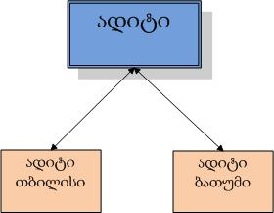
Provides must not be deleted in a provider list in accordance with the consensus reached at the meetings. Involvement of a healthcare facility in the state-funded program will be regulated under the contract.
The fields below must be filled out in case of registration of a provider.
Characteristics of the provider, a legal entity:

Group | Field | Note
Provider | Tax Code
Provider | Georgian Name
Provider | Latin Name
Provider | Legal Form | Individual entrepreneur, Ltd. or JSC
Provider | Office Telephone
Provider | E-mail | Official e-mail of the provider
Provider | E-Health Email | E-mail given by the MoLHSA to the provider to send information to the latter.
Address of Provider | Region
Address of Provider | Municipality
Address of Provider | Settlement | Name of selected municipality and a list of villages covered by the municipality
Address of Provider | Address
Bank details of Provider | Bank Code | International bank code where the provider has opened a bank account
Bank details of Provider | Name of Recipient | Name of recipient from provider’s side
Bank details of Provider | Settlement Account | The provider’s bank account number
Representative | Position | Position of the provider’s representative
Representative | Personal Number
Representative | First Name
Representative | Second Name
Representative | Mobile
Representative | E-mail | Office e-mail of the representative

Legal address of the provider is indicated under Address of Provider. Bank details are required to transfer money to the bank account of the provider. Representative of the provider is a legal representative of the provider with whom issues related to the provider will be negotiated.
Characteristics of the branch of provider:
Group | Field | Note
 | Name | Branch name
Actual Address | Region
Actual Address | Municipality
Actual Address | Settlement
Actual Address | Address
 | Service Sector | General type of service or a list of specific services, if necessary.

All fields concerning the provider and its branches must be filled out except Latin names.
Please, find below a registration form and a form for adding a branch of the provider.
While registering the provider a personal number of the representative will be checked in the Civil Registry and his/her first name and second name will be automatically displayed. More than one provider cannot be registered with one tax code under one subcomponent.

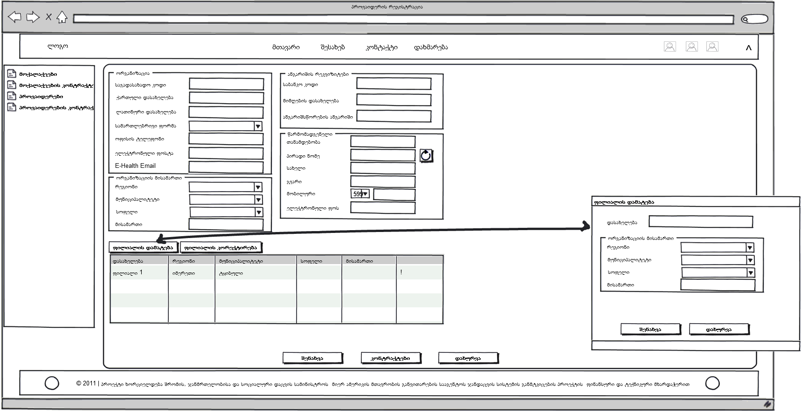
Figure 1. Registration of Providers
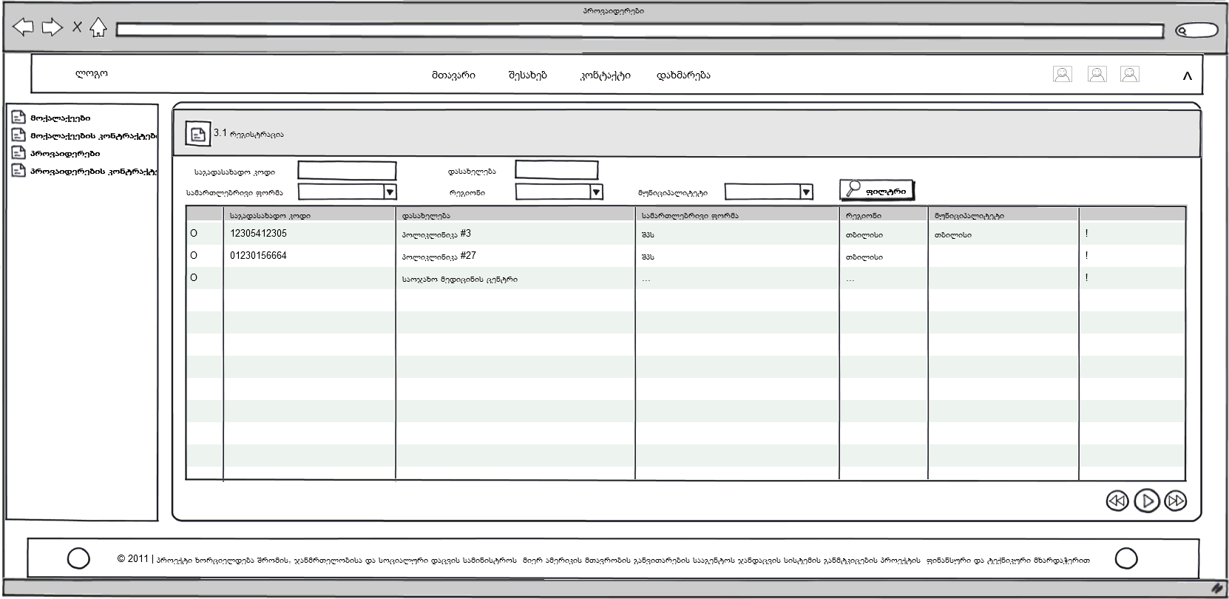
Figure 2. List of Providers

Provider’s Contract_______________________________________________________
A contract must be signed after registration of the provider in the system in order to involve in the state-funded program. The contract is concluded between funding source and the provider.

Concluding Contracts with Providers
The following information must be indicated to register the provider’s contract:
Group | Field | Note
 | Contract # | Automatically generated. The format is the following:  - Tax Code  - Year- last two numbers  - Component code – 2 symbols  - Number of contracts under a specific component during the current year – 2 symbols
 | Provider
 | Subcomponent | Determines the state-funded program under which a contract is concluded with the provider.
 | Contract Year | Year during which a contract is effective. Automatically generated. E.g. “2009“ or “2010-2011“
 | Budget Year | Under budget of which year the state program is funded./is covered
 | Tender Number
 | Start Date
 | End Date
 | Date of Signature
Representative of Provider | Position | Position of the representative of provider
Representative of Provider | Personal #
Representative of Provider | First Name
Representative of Provider | Second Name
Representative of the Ministry | Position | Position of the representative of the MoLHSA
Representative of the Ministry | Personal #
Representative of the Ministry | First Name
Representative of the Ministry | Second Name
 | Branch of Provider | The branch that is a party to the contract
 | Activity Area of Branch | The territorial unit covered by the branch. One branch may cover different areas. In this case different amounts of funding will be allocated.

Please, find a provider’s contract registration form in the annex to provider’s contract registration.
The contract should allow linking only effective subcomponents or the ones of current or next years. Moreover, under one subcomponent 2 contracts must not be signed with one provider effective periods of which overlap each other. It means that the provider must have only one effective contract in a specific time unit.
The effective period of contract must not exceed the effective period of component.
Representatives of the provider and the MoLHSA are the signers to the contract. The information on the representative of provider will be automatically displayed (the data were entered while registering the provider) though it can be entered manually as another person may represent the provider in accordance with notarized warranty.
The contract may be effective, suspended, terminated or expired. When the status is changed the reason for change must be indicated. While registering a contract it will be automatically activated and after the expiration date it will be automatically completed (the status – completed- will be assigned).

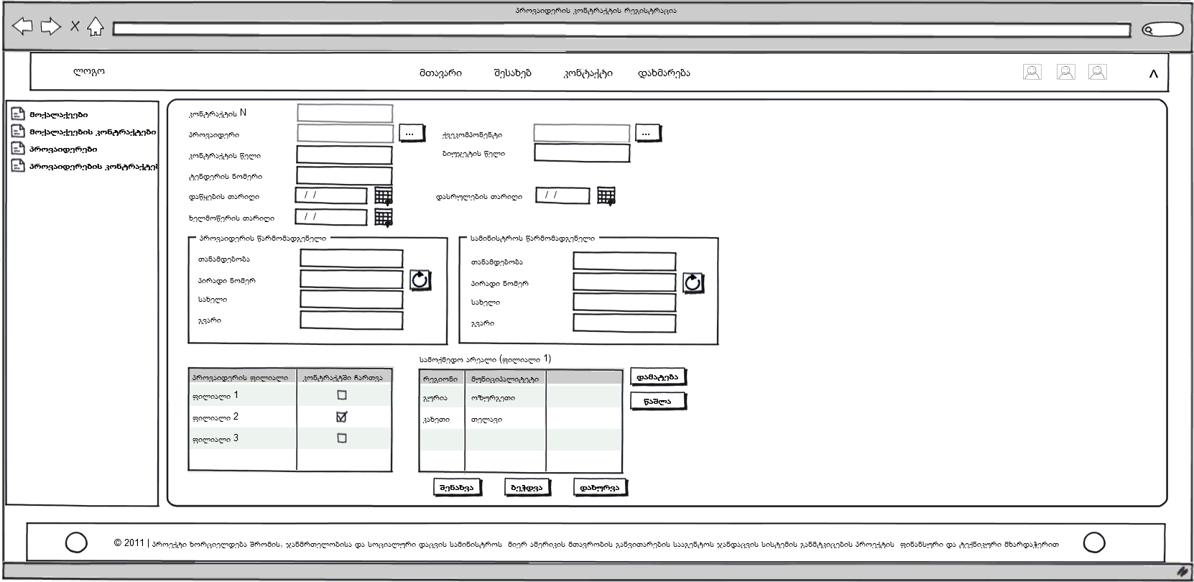
Figure 3. Registration of Provider’s Contract
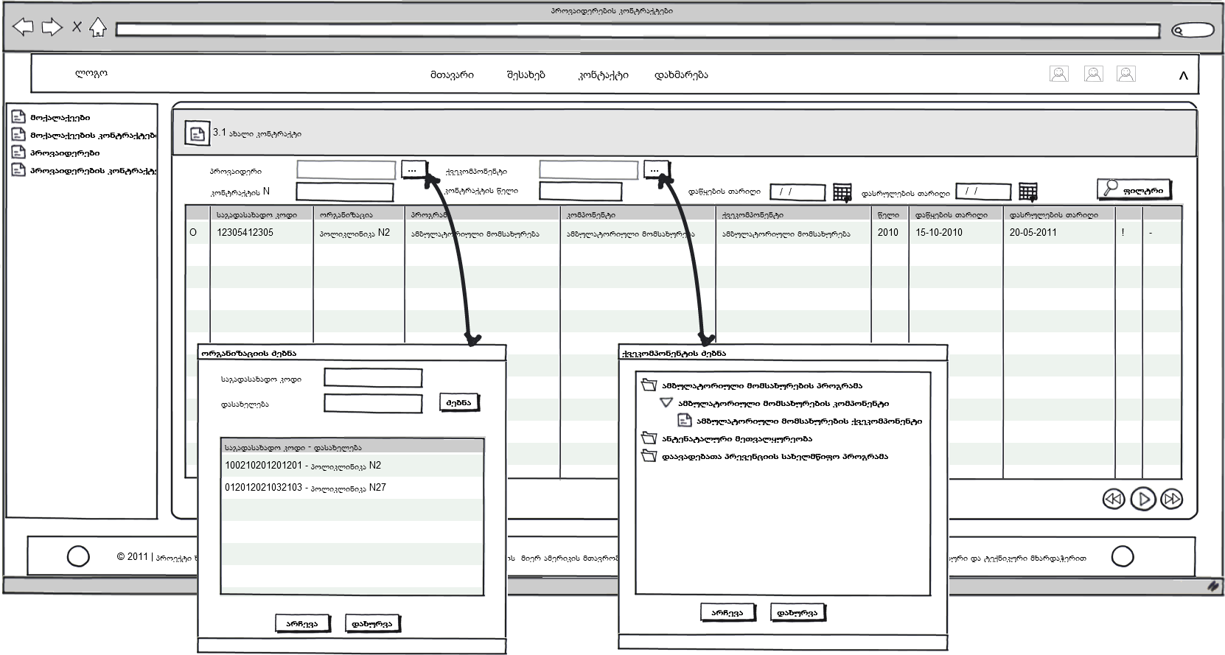
Figure 4. Provider’s Contract

Suspension/Termination of Provider’s Contract
The contract may be suspended or terminated. It may be suspended for a specific period or without time-limit. Termination means expiration/complete of the contract on a specific date that must proceed/ win uswrebs the expiration date (the system will control it).

Provider’s Contract Renewal
The provider’s contract may be renewed through a transitional contract. It is required by ending the state-funded program that will be continued but formal issues are not yet solved. In order to avoid charging services by the providers a transitional contract is signed. Starting date of the transitional contract must proceed the expiration date of the previous contract. Main contract can be renewed this way several times. Main and transitional contract must be related to each other (it needs to be specified).

Beneficiaries____________________________________
Individuals must register with providers in order to receive state-funded medical care. The beneficiary has a limited choice of providers only according to his/her residence. He/she may register only with the out-patient facility located in the municipality of/related to his/her actual address.
Necessary fields for registration of beneficiaries:

Group |  | Field | Note
Beneficiary |  | Personal # | It is mandatory if the individual is 6 or above.
Beneficiary |  | Birth Certificate # | It is mandatory if the individual has no personal #.
Beneficiary |  | First Name
Beneficiary |  | Second Name
Beneficiary |  | Gender
Beneficiary |  | Date of Birth
Beneficiary |  | Mobile
Beneficiary |  | Telephone
Beneficiary |  | E-mail
Beneficiary |  | Subcomponent | Determines the state-funded program under which an individual is registered with a provider.
Beneficiary |  | Branch of the provider | Beneficiary will receive covered services only in a relevant branch of provider.
Beneficiary |  | Insurance status | The individual is insured or not (“insured” or “without insurance)
Beneficiary |  | Age group | It determines the age of individuals who are eligible for the state-funded program. Different amounts of payment are set according to age group. The age group is a characteristic of the subcomponent and is determined according to the component during registration.
Beneficiary |  | Patients with diabetes
Beneficiary |  | Incurable
Beneficiary |  | Address of registration
Beneficiary | Actual Address | Region
Beneficiary | Actual Address | Municipality
Beneficiary | Actual Address | Settlement
Beneficiary | Actual Address | Address
Mother |  | Personal #
Mother |  | First Name
Mother |  | Second Name
Mother |  | Insurance status | The individual is insured or not (“insured” or “without insurance)
Mother |  | Single Mother | Marking this field means that she is a single mother.
Father |  | Personal #
Father |  | First Name
Father |  | Second Name
Father |  | Insurance status | The individual is insured or not (“insured” or “without insurance)
Guardian/carer |  | Personal #
Guardian/carer |  | First Name
Guardian/carer |  | Second Name
Guardian/caring organization |  | Personal #
Guardian/caring organization |  | First Name
Guardian/caring organization |  | Second Name

Personal number is a unique characteristic of the beneficiary. If he/she has no personal number, birth certificate number, the first 4 symbols of second name and year of birth are used as characteristic of the individual. By using the unique characteristic it may be determined whether the individual is registered with the provider or not.
If the beneficiary under age 18, parent(s), guardian or caring organization must be registered as he/she is not eligible to sign the contract. If mother is single there is no need to register information on father/father’s data.
It must be possible to see the following information/data relating to the insured:
- Insurance company
- Type of insurance
- Expiration Date of a policy
The following fields must be filled out when a beneficiary is added:
- Personal # or Birth Certificate #
- First Name
- Second Name
- Gender
- Date of Birth
- Insurance Status
- Age Group
- Actual Address
- Parent/Guardian if the beneficiary is under age 18 (personal number, first name, second name)
Registration validation:
- If the beneficiary is 6 or above his/her personal number must be indicated
- If the beneficiary is registered with another provider it must be impossible to register him/her
- If the beneficiary is under age 18 the parent’s (parents’) or the guardian’s personal number and full name must be indicated (as the beneficiary is not eligible to sign the contract)
- If the beneficiary or at least one of his/her parents is insured it must be impossible to register him/her
  - The beneficiary must not live in a rural area (according to actual address)
  - If the beneficiary’s actual address and one of the activity areas (region, municipality and Settlement) of out-patient facility (branch) envisaged under contracts on/regarding the component do not coincide, he must not be registered.
The following must not be changed while correcting the beneficiary:
  - The fields received from the Civil Registry and information on insurance.
By selecting a municipality the Settlement must show the name of municipality and a list of villages covered by the municipality. If similar meanings are selected under municipality and Settlement, it means that a city was marked otherwise – a village.

Please, see below an illustration for registration of beneficiaries.

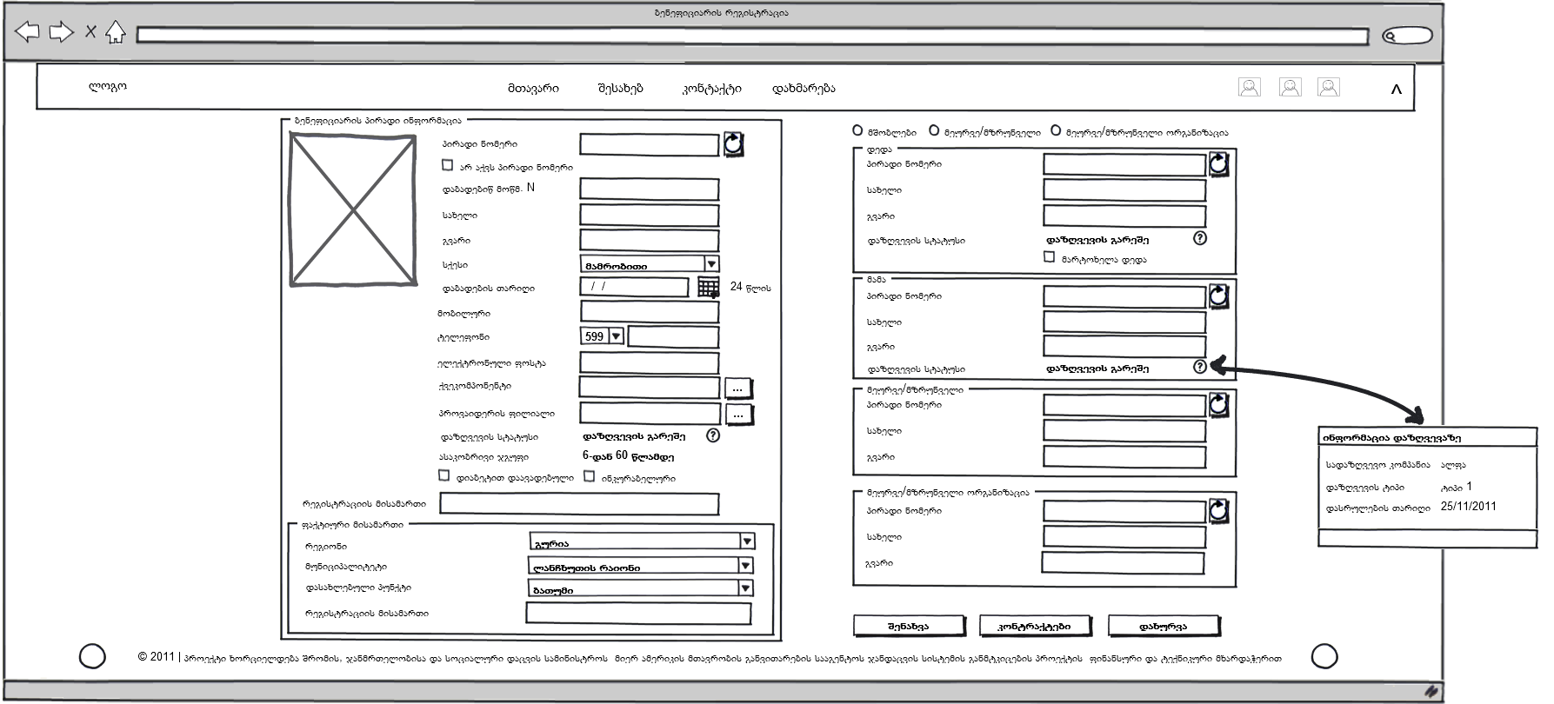
Figure 5. Registration of Beneficiaries

Beneficiary’s Contract___________________________________________________
The beneficiary’s contract must be stored in the database.
Contracts must be concluded between the beneficiary and the provider according to age groups. When the beneficiary moves to another age group his/her insurance package will automatically be annulled by the system and coverage will be stopped until signing a new contract. Notification of annulling will be sent to the provider.
- Statuses of the beneficiary’s contract:
  - Active
  - Suspended - for a specific period. It is suspended and activated automatically only by the system
  - Terminated - if it does not meet the following parameters:
    - Age
    - Death
    - Has no diabetes
    - Is not incurable
    - Changed address
    - Personal request
    - Other - note

Concluding Contracts with Beneficiaries

Termination of Beneficiary’s Contract

Notifications___________________________________

Finances_______________________________________

Data Import____________________________________

