User requirements analysis

Policlinic structure
The wHospital FM allows to define resources for each Operational Unit (OU).
Patient’s appointment can be scheduled for each resource.
A list of medical procedures (CPT) can be linked to each resource.
A resource can be for example a room where different doctor can visit patient or a personal agenda where a doctor can organize his own visit.
An operational unit defined the boundaries of sharing policies:
- All user linked to an operational unit can access to patient’s data inserted into that operational unit
- You need to get the sharing consent for accessing the patient’s data that has not been inserted into that operational unit
- A family doctor association (link of a patient to a family doctor) is provided only at an operational unit level.
During the project requirement analysis, it was decided to configure a single operational unit for each family doctor. All family doctor staff users (nurses and young doctor) have to be linked to the “family doctor operational unit”.
Several agenda can be configured for the family doctor operational unit:
- Agenda of chef doctor
- Agenda of a nurse
- Agenda of an another doctor
An user can be linked to one or more operational unit, so for example a nurse can work with two different family doctor. Anyway the resource (ex the nurse agenda or a visit room) is linked to a single operational unit.
This decision of having a single operational unit for each family doctor staff implies several advantages:
- Privacy of patients and doctor is guarantee (I cannot see the agenda of my colleagues)
- The patient and family doctor link management is clear and well defined. A family doctor has an unlimited access to patient’s data (data inserted to other hospitals, doctors….)
- The application developed for managing the family doctor and patient link has been made with this assumption (one operational unit – one family doctor staff)
Setting a system where there is a single operational unit for each family doctor staff has some minor side effects:
- An user that work for different family doctor staff will have different agenda, one for each family doctor operational unit
- It is not possible to set up the system where a resource is a physical object (a room or an equipment) shared between different operational unit (family doctor)
- A family doctor that visits a patient of a different colleague has to get the sharing consent to access to patient’s data
- A coordinator that manage overall Policlinic scheduling has to change operational unit for browsing between family doctor agendas
The analysis of the scheduling process for a policlinic is essential to define the right structure to be implemented.
The following information has to be collected:
- Family doctors list
Name | Surname | ID number | Email | Contact infos
Lorenzo
Gia
Sasha

- User list: other clinicians, nurses, super user that work in the policlinic.
Name | Surname | Role | ID number | Email | Family doctor OUs
Nurse 1 |  | Nurse |  |  | Lorenzo; Gia
Nurse 2 |  | Nurse |  |  | Gia
Nurse 3 |  |  |  |  | Lorenzo
Assistant |  | Assistant |  |  | Lorenzo; Gia; Sasha

- Resources list: for each family doctor staff a list of the resource to be implemented
Family doctor UO | Name of resource | User to be linked | Procedures
Lorenzo | Lorenzo personal agenda | Lorenzo | List of procedures A
Lorenzo | Nursing room | Nurse 1; Nurse 2 | List of procedures B
Gia | Gia personal agenda | Gia | List of procedures A

If a particular resource is shared between different family doctor (a room with a medical device like ECG, or EEG) than It will be possible to set up a single operational unit for that resource. All the information that will be collected in that operational unit will be available to the family doctor operational unit. This is provided by the patient-family doctor link that gives unlimited access to patient’s data.
The suggested method for collecting required information are:
- Getting the physical structure of the building
- Investigating on the scheduling process, a single point of contact for each doctor or a waiting room without any scheduling
- Collect the list of medical procedures linked to the resources (room, doctor, roles)
- Get the user list and roles
- Understand the right for each role to insert/plan/re- schedule/execute a visit
- Fill the excel for the fast system setup
After collecting all the above listed configurations the following front end functionalities will be settable
Manage different roles
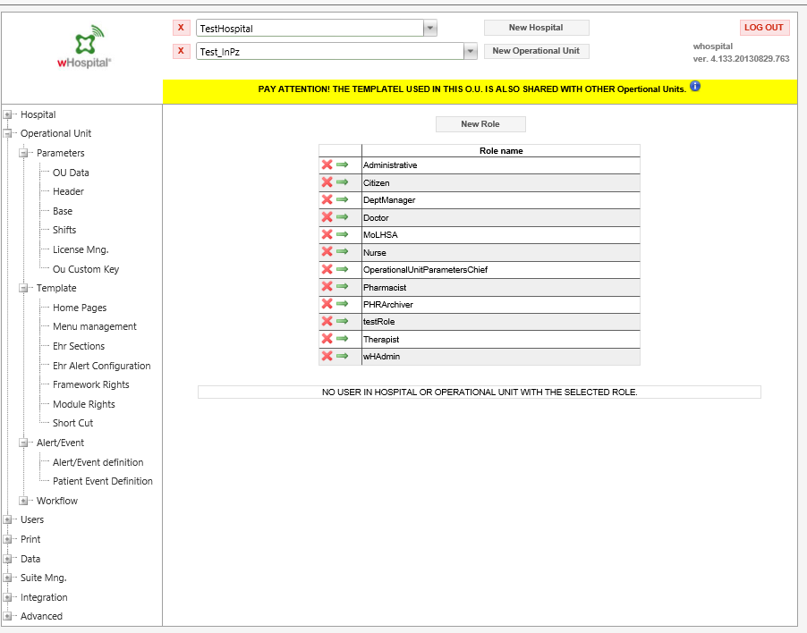

List of different resources
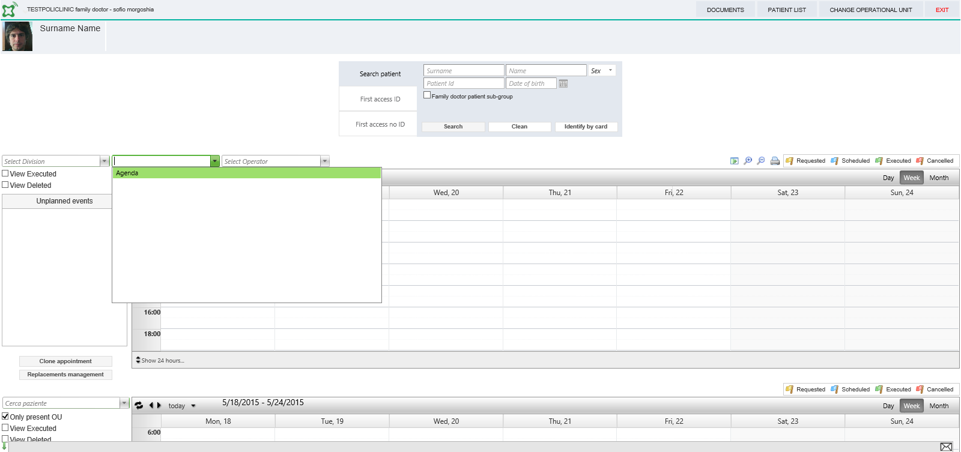

List of user linked to a resource
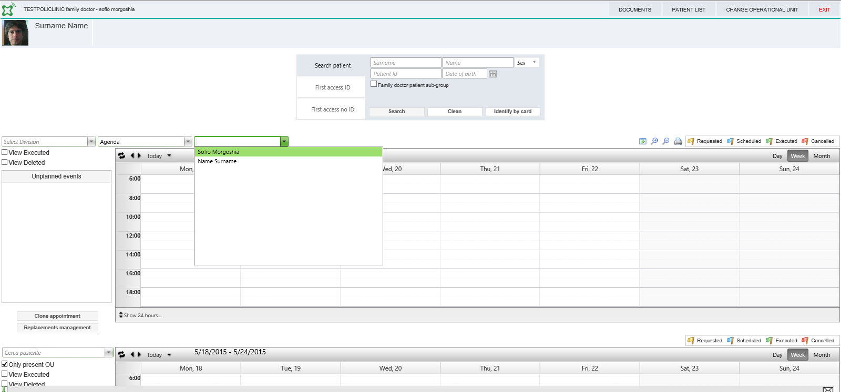

Procedure for a specific resources
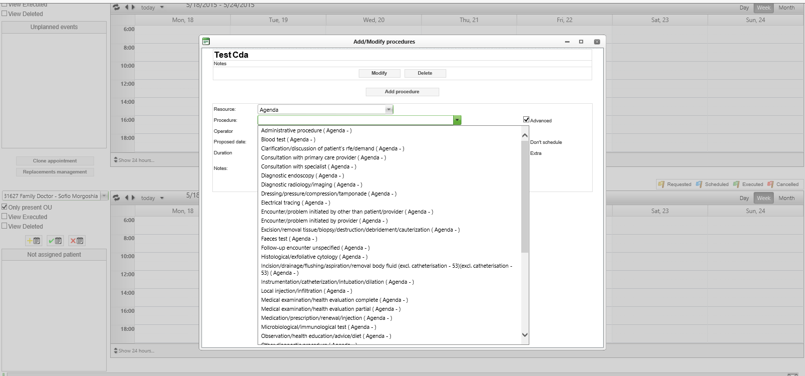

wHospital FM operational unit setup page
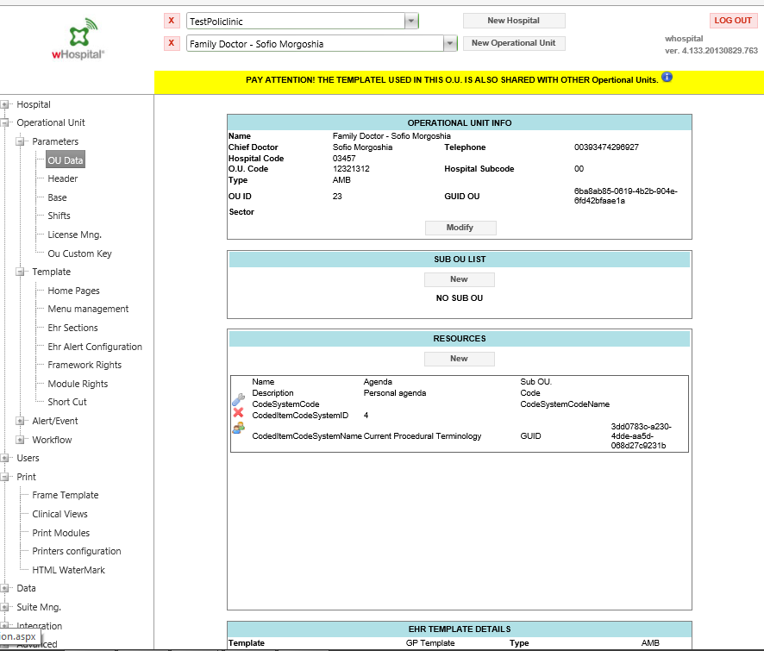

wHospital FM scheduler rights management

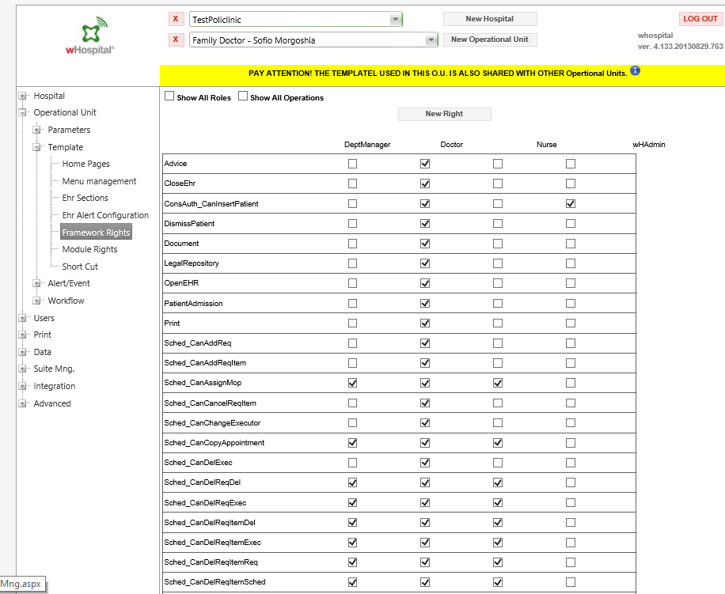

wHospital FM rights for scheduling

Sched_CanAddReq
Sched_CanAddReqItem
Sched_CanAssignMop
Sched_CanCancelReqItem
Sched_CanChangeExecutor
Sched_CanCopyAppointment
Sched_CanDelExec
Sched_CanDelReqDel
Sched_CanDelReqExec
Sched_CanDelReqItemDel
Sched_CanDelReqItemExec
Sched_CanDelReqItemReq
Sched_CanDelReqItemSched
Sched_CanDelReqReq
Sched_CanDelReqSched
Sched_CanExecOrEditReq
Sched_CanExtraExecution
Sched_CanModifyReq
Sched_CanModifyReqItem
Sched_CanModOnlyDateTime
Sched_CanSchedule
Sched_CanSubstituteMop
Sched_ChangeMopSelector
Sched_PatientOpenEditUserSched
Sched_SearchAllPatient

Electronic medical record template
The specific Georgia Central EMR platform license allows a single EMR template for all the family doctor’s operational unit.
Anyway any roles and specific rights role for any modules (cForm or cApp) can be configured.
The template configured during the project is based in an essential configuration:
- Patient’s summary: all the CCD section that can be automatically filled when document is uploaded to the platform
- Visit: a structured generic visit module
- Laboratory: a viewer and two module for inserting single test or complete routing exam
- Clinical view: a time line viewer of patient’s document, a form that collect data from patient’s summary for administrative purpose (form 100), a patient’s summary document that collect all patient essential information
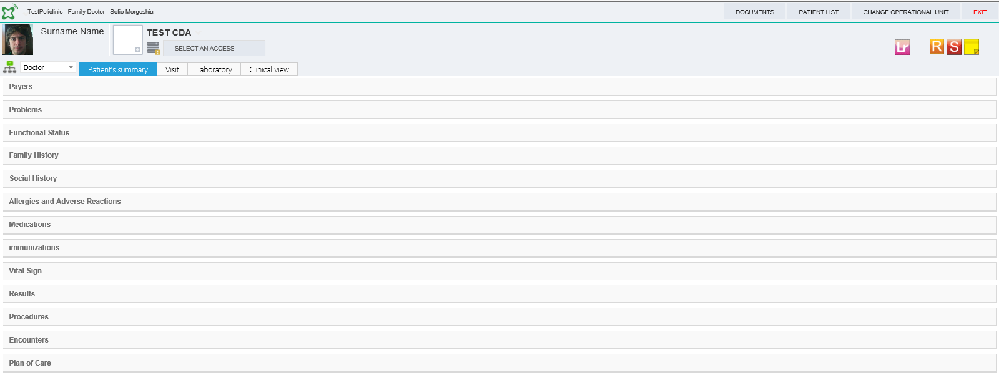

Other sections and modules can be added to EMR template.
Each module can produce a printable document with header and footer defined for each operational unit.
A complex set of modules can be setup, also having a single EMR template for each family doctor operational units.
For example can be set up a section where all different instrumental examination form can be linked. Each cForm can be configured to be accessible to a different role (EEG technicians, ECG technicians ….).
The suggested method to user requirement analysis for setting an EMR template for a generic family doctor operational unit is:
- Define a single family doctor visit structure that should include some clinical statements that can add item to patient’s summary (using dtlink to child control for field of visit cForm is possible to link patient’s summary sections element to the visit)
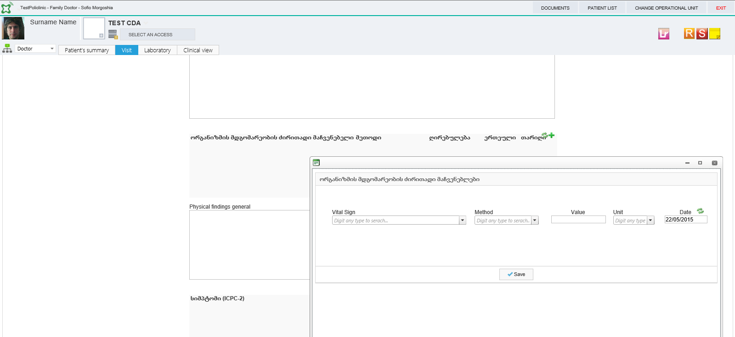

- Define a set of additional form for different roles (nurse, phycologist, laboratory tech, ECG tech…..)
- Define the access policies for different module (ex nurse cannot view patient’s visit)
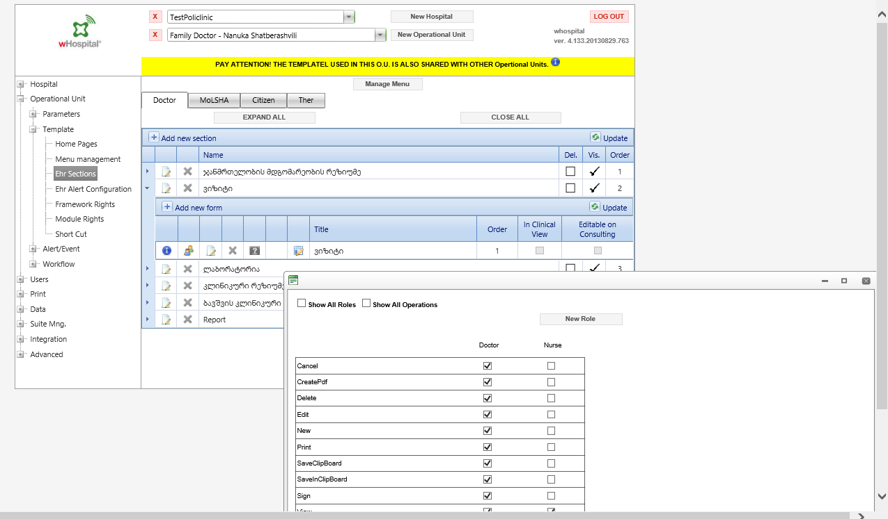

Additional information can be collected for a specific policlinic or operational unit:
- Specific template for printable document (header and footer for a document with information of specific health care provider)
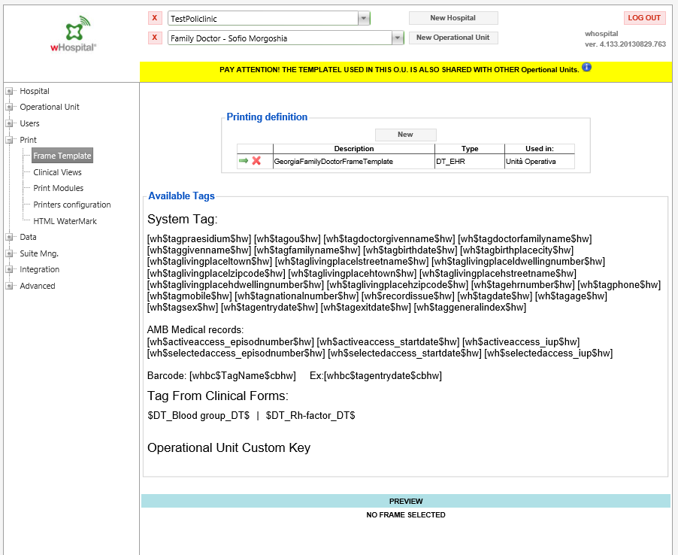
- Menu definition: it is possible to link different cApp
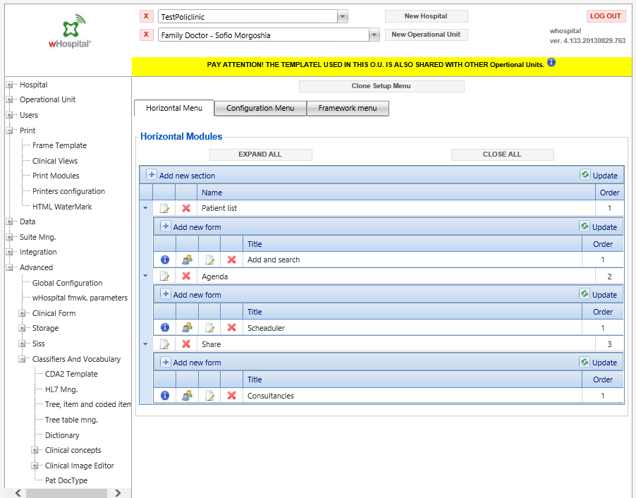

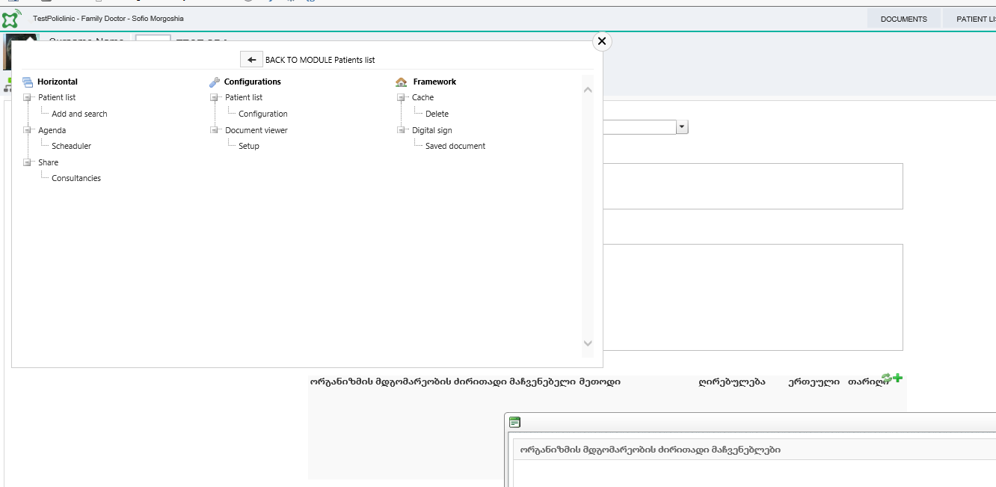

Pre configured patient’s list
A tool for fast uploading patients to a family doctor operational unit is mounted in the MoLSHA operational unit.
A simple excel files with the national ID number of patient can be requested to the policlinic in order to prefill a list.
A patient can be linked to only one family doctor.

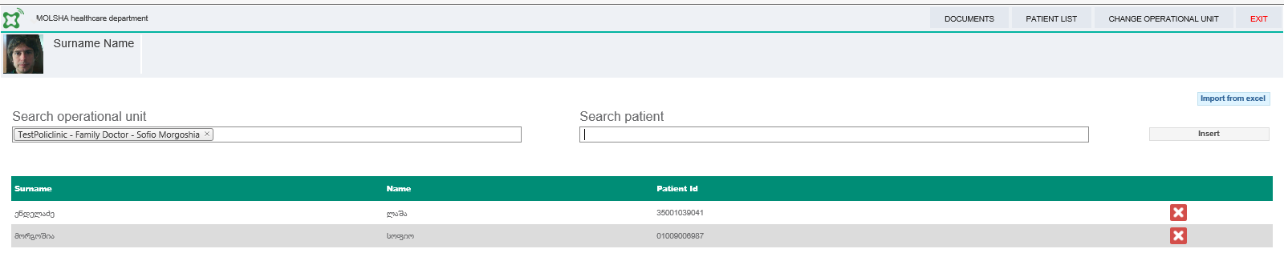

Consultancies cAPP
The management of a consult note request and its execution is implemented by a cAPP available on installed framework.
It can be used for a specific policlinic.
The consultancies working list is based on the resources definition. It possible to request a consultancies inside an Hospital (or a Policlinic) between different operational units.
A system framework key allows to extend the consultancies request to all the hospital (it is possible to request a consultancy for a operational unit of a different hospital).
The consultancy request insert an unplanned appointment for a generic resource of an operational unit, it is also possible to insert a request for a specific user.
A consultancy cAPP suite is composed by two modules:
- A module that can be attached to the EMR template: to request and view the consultancies for a specific patient
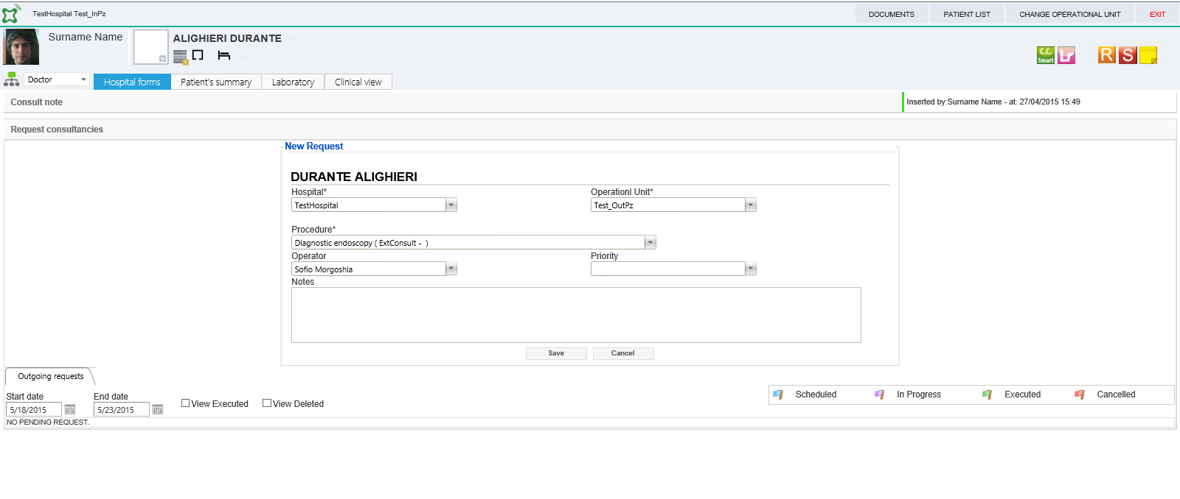
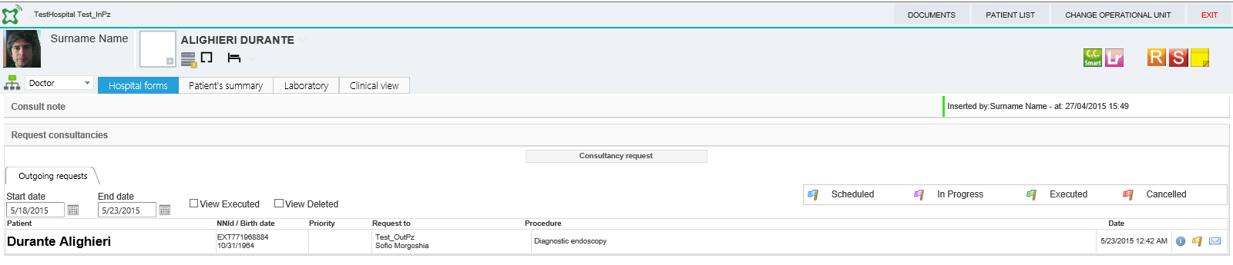

- A module that can be attached to the operational unit: to manage all requests and related executions for an operational unit
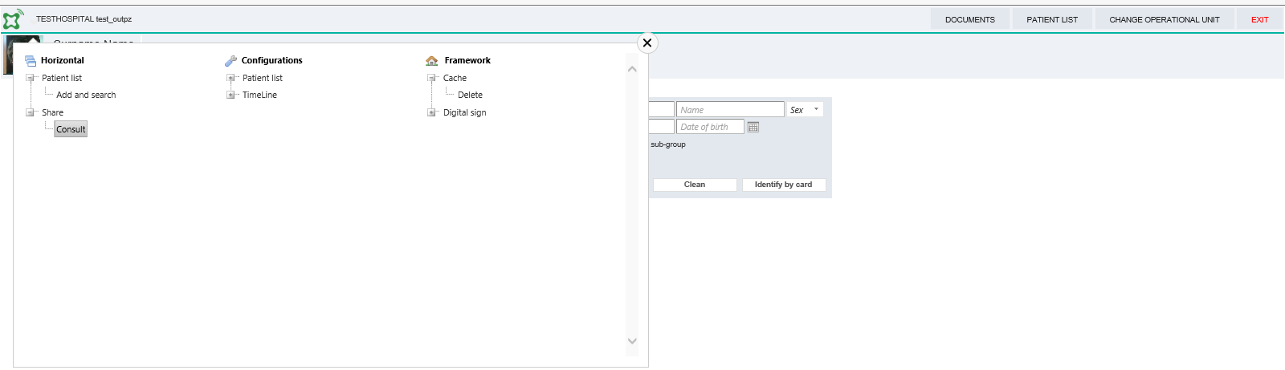
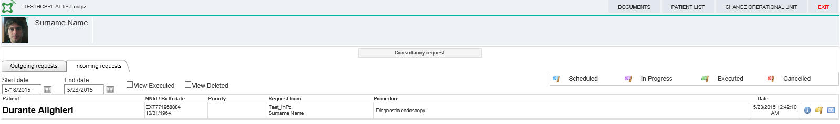
A full list of rights for different action can be configured for a specific operational unit.
The same right used for scheduling appointment in an agenda (previously cited) can be used.
For example, a nurse can plan a consultancy but not execute it.
The user requirement analysis should assess in the following items, considering the specific installation where a single EMR template can be implemented for family doctor operational unit:
- A specific role is able to request consultancy: setup the cAPP rights for the consultancy request module (view) that is linked to the EMR template
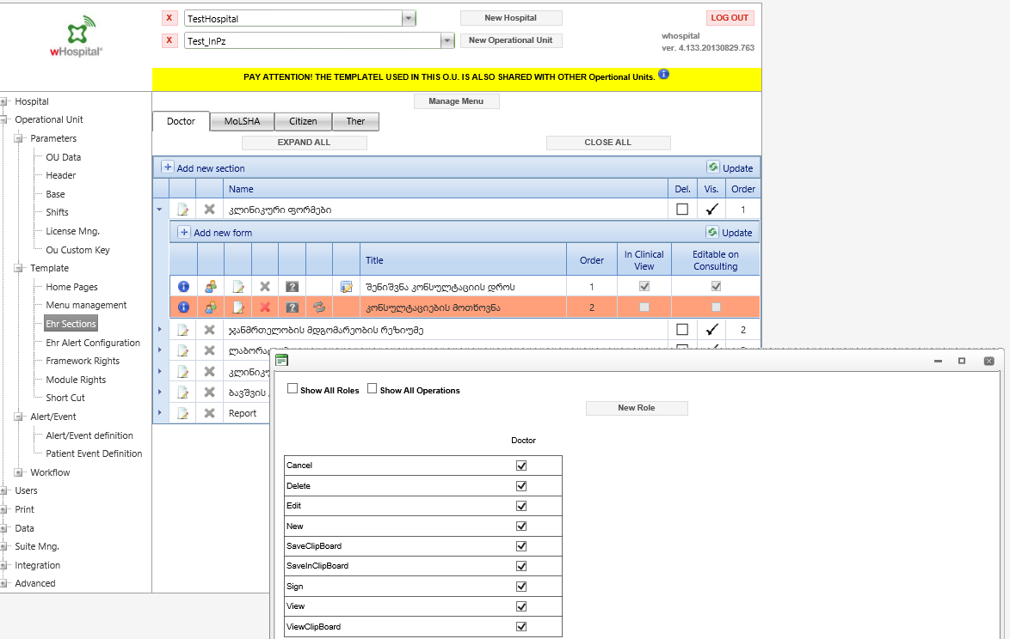
- A specific role is able to plan/ cancel / execute a incoming request: setup the framework rights

