Signed by  ______________________  «___»_________2015 г. | Signed by  ______________________  «___»_________2015 г.

Functional Specification
Collaborative Health Environment of Georgia
EMR 2.1

Part 1 (1 from 3)
EHR and HSSP Integration (Case Management)

56 Pages

Reconciliation sheet

Supplier
Position | Name | Signature | Date

Customer
Position | Name | Signature | Date

Content
Tables 5
Pictures 6
History of changes 7
Glossary 8
1. Overview 9
1.1. Purpose of the document 9
1.2. Main goals and Objectives 9
1.2.1. Project Goals and Objectives 9
1.2.2. Common requirements to the CHE architecture 10
1.2.3. Goals and objectives of EHR-HSSP integration ( Part 1) 11
1.2.4. Common scheme of Case registration process 12
1.3. Current infrastructure description 13
1.3.1. Current infrastructure deficiencies description 13
1.3.2. Current CHE architecture 14
1.3.3. Interaction between clinics and HMIS 15
2. Common requirements to integration 16
2.1. Integration types description 16
2.2. Common requirement to data flows between EHR и HSSP 17
2.3. Integration stages description 18
2.3.1. Stage 1: Case Management (integration type 1) 18
2.3.2. Stage 2: Clinical information exchange (integration types 2, 3 и 4) 18
2.4. Case registration schemes 19
2.4.1. Scheme «as is» 19
2.4.2. The main disadvantages of the current scheme 20
2.4.3. Scheme «to be» 21
2.4.4. Common requirement to new scheme of case registration implementation 22
2.4.5. Directories synchronization and validation of case data 22
2.4.6. Scheme of distribution of various types cases on HSSP modules 22
3. Requirements to data composition and structure 24
3.1. Typical case structure and composition 24
3.2. Case financial information 25
4. Requirements to core business processes 26
4.1. Summary table of the processes 26
4.2. Urgent-cases registration processes 27
4.2.1. Registration process of urgent-case by Class A clinic 27
4.2.2. Registration process of urgent-case by Class B clinic 30
4.2.3. Urgent-case process registration from external HIS 33
4.3. Planned-cases registration processes 36
4.3.1. Registration process of planned-case by Class A clinic 36
4.3.2. Registration process of planned-case by Class B clinic 39
4.3.3. Registration process of planned-case from external HIS 42
4.4. Beneficiary visit registration process 44
4.4.1. Registration process of beneficiary visit by Class A clinic 44
4.4.2. Registration process of beneficiary visit by Class B clinic 47
4.4.3. Registration process of beneficiary visit from external HIS 49
4.5. Information access processes 52
5. Functional requirements 53
5.1. EHR basic functions requirements 53
5.1.1. General information 53
5.1.2. User functions requirements 53
5.1.3. Automated services requirements 54
5.2. HSSP basic functions requirements 54
5.2.1. General information 54
5.2.2. User functions requirements 54
5.2.3. Automated services requirements 55
6. Other requirements 56
6.1. User interfaces requirements 56
6.2. Logging requirements 56

Tables
Table 1. Glossary 8
Table 2. Integration types of HSSP modules 16
Table 3. Typical case structure 24
Table 4. Summary table of cases by type and information source 26
Table 5. Common requirements to registration process of the urgent-case by Class A clinic 27
Table 6. Common requirements to registration process of the urgent-case by Class B clinic 30
Table 7. Common requirements to urgent-case registration process from external HIS 33
Table 8. Common requirements to planned-case registration process by Class A clinic 36
Table 9. Common requirements to registration process of planned-case by Class B clinic 39
Table 10. Common requirements to registration process of planned-case from external HIS 42
Table 11. Common requirements to registration process of beneficiary visit by Class A clinic 44
Table 12. Common requirements to registration process of beneficiary visit by Class B clinic 47
Table 13. Common requirements to registration process of beneficiary visit from external HIS 49

Pictures
Picture 1. Goal CHE scheme 10
Picture 2. EHR filling with clinical information 12
Picture 3. Current CHE scheme 14
Picture 4. Обобщенная схема потоков данных между EHR и HSSP 17
Picture 5. Current scheme of case registration 19
Picture 6. Demanded scheme of case registration 21
Picture 7. Iinformation source about cases in HSSP 23
Picture 8. Typical case structure 25
Picture 9. Registration of urgent-case by Class A clinic 27
Picture 10. Scheme of the process UrgentCR_A with registration via EHR Doctor Portal 28
Picture 11. Scheme of the process UrgentCR_A with registration via EHR Mobile Service 28
Picture 12. Urgent-case registration by Class B clinic 30
Picture 13. UrgentCR_B process scheme with information displaying via EHR Doctor Portal 31
Picture 14. UrgentCR_B process scheme with information displaying via EHR Doctor Portal 31
Picture 15. Urgent-case registration from external HIS 33
Picture 16. UrgentCR_HIS process scheme 34
Picture 17. Planned-case registration by Class А clinic 36
Picture 18. PlannedCR_A process scheme 37
Picture 19. Planned-case registration by Class B clinic 39
Picture 20. PlannedCR_B process scheme with displaying data in EHR Doctor Portal 40
Picture 21. PlannedCR_B process scheme with displaying data in EHR Mobile Service 40
Picture 22. Registration of planned-case from external HIS 42
Picture 23. PlannedCR_HIS process scheme 43
Picture 24. Registration of beneficiary visit by Class A clinic 44
Picture 25. BenVisitR_A process scheme with entering information via EHR Doctor Portal 45
Picture 26. BenVisitR_A process scheme with entering information via EHR Mobile Service 45
Picture 27. Registration of beneficiary visit by Class B clinic 47
Picture 28. BenVisitR_B Process scheme 48
Picture 29. Registration of beneficiary visit from external HIS 49
Picture 30. BenVisitR_HIS process scheme with entering information via external HIS 50
Picture 31. Access process scheme to case information 52

History of changes
Version | Date | Author | Comments
1.0 | 22.06.2015 |  | Version 1.0
2.0 | 24.06.2015 | Alexander Lahtin | Version 2.0

Glossary
Table 1. Glossary
CHE | Collaborative Health care Environment
EMR/EHR | Electronic Medical Records/ Electronic Health Records
HIS | Health Information System
HMIS | Health Management Information System
HSSP | Health System Strengthening Project
MoLHSA | Ministry of Labor, Health and Social Affairs of Georgia
Mobile Service | Mobile Service is service which is included into Mobile Platform and provides the access to Clinical information in EHR
Customer | Ministry of Labor, Health and Social Affairs of Georgia
Case | The fact of medical service provision to the patient ( in the context of this document)
Clinical Information | Medical information about the patients to be stored in EHR

Overview

Purpose of the document
This document contains the description of functional requirements to EHR-HSSP integration (Part 1). Within this Integration it is demanded to automate the management of cases (facts of medical services provisions to the patients).
The main requirements to the functionality of EHR-HSSP Integration (Part 1) are presented in the next sections:
Section 1.2.3 contains the description of the goals and objectives of integration
Section 1.2.4 presents general scheme of case information flow within Collaborative Healthcare Environment.
Section 2 contains the whole description of Integration requirements
Section 3 contains requirements to data structure
Section 4 contains the description of business process registration cases
Section 5 contains user functions requirements and automated functions
  - Main goals and Objectives
    - Project Goals and Objectives
Project main goals:
- Improving the efficiency of information management
elimination of data and data entry duplication
improving the quality of stored information through the use of common standards and classifiers
optimization of data streams
Reporting Information
- Implementation of quick access to the required information (medical, financial, etc.) in the required format for all users of a collaborative information environment

To achieve these goals the following main objectives need to be addressed:
- Development the common HMIS software architecture including existing and planned modules.
- Development of proposals for a partial restructuring of existing processes and data flows within HMIS based on the analysis of functional modules and the details of modules interaction.
- Integration between HSSP and EHR modules and partial adjustment of processes and HMIS subsystems functionality
- HMIS technical architecture clarification
- Technical requirements towards Healthcare Environment data Providers and Consumers development.

    - Common requirements to the CHE architecture
Picture 1 Generalized CHE target scheme, which must be implemented within the current phase of the project
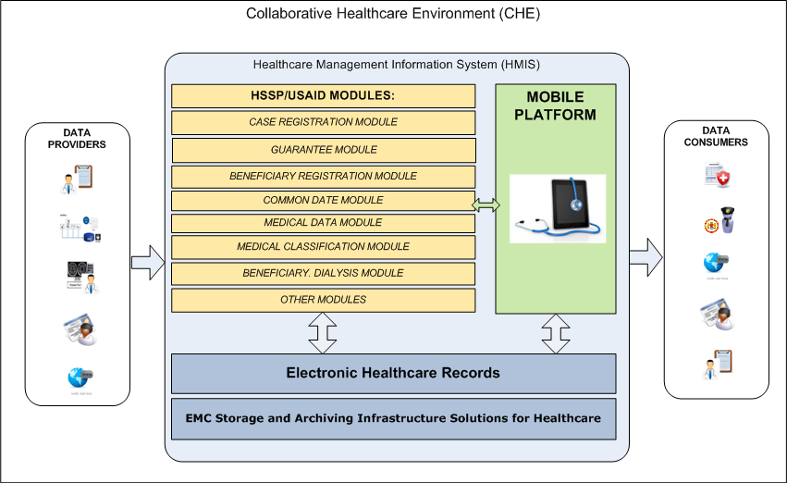
Picture 1. Goal CHE scheme

Goals and objectives of EHR-HSSP integration ( Part 1)
Main goals of Part 1:
Improving the efficiency of information management case (the facts of medical services to patients) by eliminating data storage and data entry duplication.
Allowing hospitals / doctors to carry out all the necessary inputs for the case through EHR interface (with following automatic data replication into HSSP / HSSP).
Speeding up the process of filling EHR database with health information by replicating information about cases registered via HSSP / HSSP interface.
To achieve these goals the following main objectives need to be addressed:
Expanding EHR functionality to allow input of additional information (financial and so on.) about cases.
Implementation of data replication services between EHR and HSSP / HSSP for synchronization of information about cases (thus from HSSP / HSSP into EHR the maximum amount of clinical information should be passed, and from the EHR into HSSP / HSSP minimum set of data should be passed which is necessary and sufficient to account the cases in respective HSSP / HSSP modules)
Picture 2 in Section 1.2.4 contains the common scheme of EHR database filling of the facts of medical services provision.
There are three main sources of information for filling EHR:
HSSP modules
Hospitals / doctor working directly with EHR
External HIS clinics connected to EHR

Common scheme of Case registration process
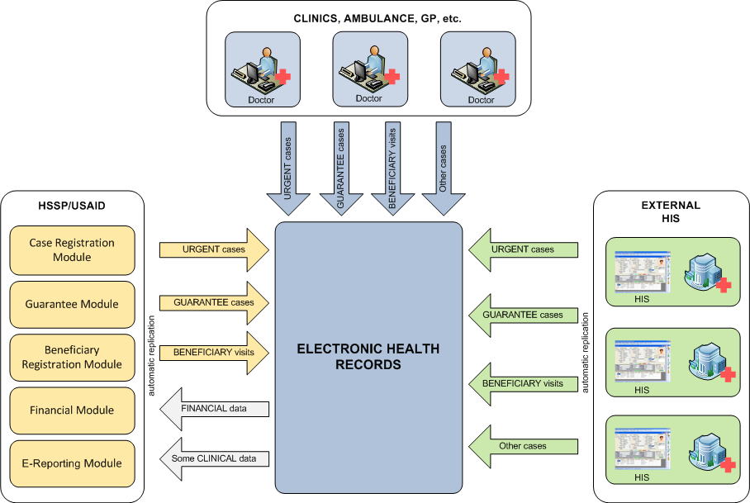
Picture 2. EHR filling with clinical information

  - Current infrastructure description
Currently MoLHSA operates Health Management Information System (HMIS), which includes a wide range of information modules that perform the registration and processing of information in the field of public health in Georgia. HMIS enables information exchange between key players in the health care system of Georgia, such as the Ministry of Health, Labor and Social Affairs of Georgia, hospitals, insurance and pharmaceutical companies, as well as Georgia citizens. The bulk of the existing software modules was implemented in the framework of HSSP Health System Strengthening Project and has more than 20 modules.
In addition to the modules within the HMIS a single register of health records (EHR) was implemented which is integrated with HIS. Along with EHR the WEB-portals, allowing access to information for doctors, Ministry employees and the citizens of Georgia were implemented.
Due to various circumstances, development of modules HMIS carried out in the absence of a unified architecture that would define the basic components of the System, the order of their interaction, data flows, strategy of the major subsystems development, and each module in particular, the procedure for the exchange of information with external stakeholders (suppliers and consumers of health information ).

Current infrastructure deficiencies description
The lack of a unified architecture and fragmentation of HMIS subsystems has led to the following consequences:
Clinical information contained in HSSP / HSSP modules is not transmitted to EHR. As a result, EHR database filling does not happen fast enough.
When clinics enter the information into EHR, it is not made available from the HSSP / HSSP. As a result, clinics have to enter data twice: at first clinical information into EHR, and then financial and the part of clinical information into HSSP / HSSP.
This in turn leads to an increase in overhead and duplication of data errors, as well as an inefficient use of information processing and analysis.
Picture 3 Section 1.3.2 contains the common scheme of current CHE.

Current CHE architecture

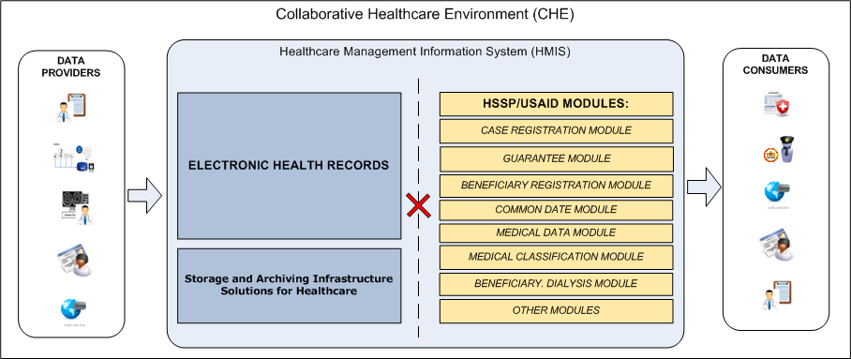
Picture 3. Current CHE scheme

Interaction between clinics and HMIS
All clinics interacting with HMIS, should be divided into two classes:
Clinics - Class A
Clinics have the possibility to work with EHR, they address directly to respective interfaces (Doctor Portal and so on.) They are the main information providers for EHR. The order of interaction these clinics with HSSP modules should be adjusted (see details in Section 1.3.3.1).
Clinics - Class B
Clinics, do not have the technical ability to work with EHR, they continue to work with HSSP modules without changes (see Section 1.3.3.2).

Clinics Class A
Currently urgent-case managing is carried out by the Case Registration Module. For Class A clinics the opportunity to work with urgent-case via EHR interface should be implemented. EHR interface should provide the ability to enter the whole necessary case information, including clinical and financial (with the subsequent transferring of the necessary information to the appropriate HSSP modules in automatic mode). The work of the employees of these clinics with other HSSP modules should be unchanged (through HSSP interfaces).

Clinics Class B
Class B clinics should be able to continue to work with HSSP modules. AT the same time the clinical information from separate modules should automatically be transferred into EHR. Some modules should be capable to receive the auxiliary information from EHR to improve the efficiency of experts work with the modules.

Common requirements to integration

Integration types description
EHR and HSSP functional modules Integration is one of the highest priorities in the context of building a collaborative health environment (CHE). Each HSSP module implements a specific functionality and operates an array of specific information. EHR-HSSP integration should be implemented taking into account the specifics of each particular module.
Table. 2 defines integration types and a list of modules for each type.
Table 2. Integration types of HSSP modules
Type | Description | Modules
1 | Intelligent Integration (case management).  Class A clinics which are working directly with EHR, should provide the way to interact with HSSP / HSSP modules via Doctor Portal. | Case Registration Module
1 |  | Guarantee Module
1 |  | e-Reporting Module
1 |  | Healthcare Programs Financing Module
2 | Transfer the data into EHR.  These modules contain information that needs to be accumulated in EHR. It is necessary to implement the ability to transfer data from HSSP / HSSP and receive in EHR. | Dialysis Program
2 |  | Beneficiary Registration Module - Psychiatry Program
2 |  | Beneficiary Registration Module – Diabetes
2 |  | Beneficiary Registration Module - AIDS
2 |  | Immunization Management Module
2 |  | Tuberculosis Electronic Module
3 | Modules are used in EHR as directories.  These HSSP / HSSP modules contain supporting information that can be used for displaying in EHR user interfaces. | Medical Data Module
3 |  | Common Data Module
3 |  | Medical Classifications Module
3 |  | Pharmaceutical Products Module
3 |  | Pharmaceutical Module
3 |  | Providers Directory
4 | Do not participate in integration.  These modules are not changed in functionality as well as data flows (incoming and outgoing) | Stock Management Module
4 |  | Dashboard
4 |  | Information Portal
4 |  | E-reporting Module For Insurance Companies
4 |  | User Management Module
4 |  | Vital Registration Module
4 |  | Mediation Module
4 |  | ePrescription Module
4 |  | Medical Staff Certification/Accreditation Module
4 |  | Healthcare Facilities Licensing/Permitting Module

Common requirement to data flows between EHR и HSSP
Picture 4 illustrates the requirements to the main data flows between EHR HSSP modules
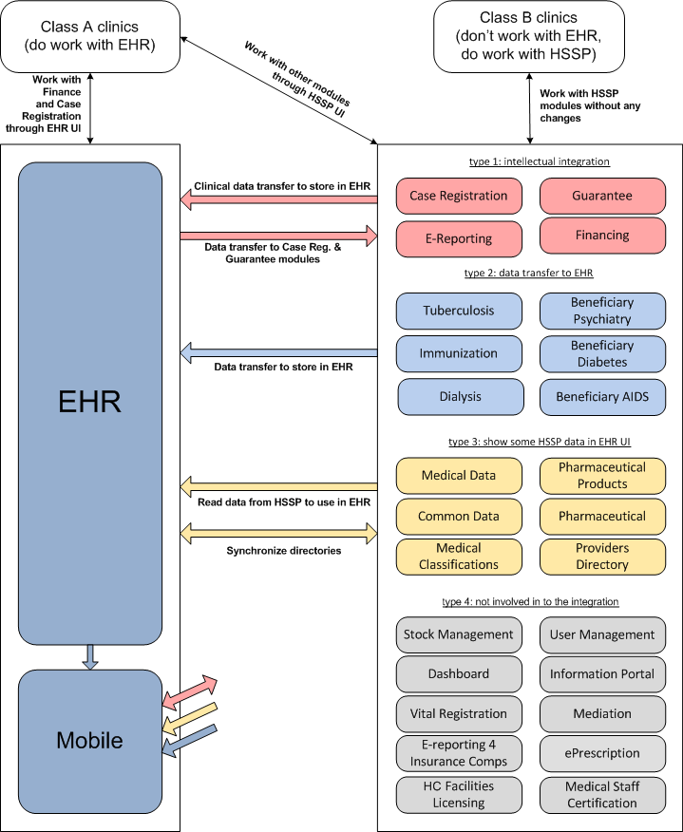
Picture 4. Обобщенная схема потоков данных между EHR и HSSP

Integration stages description
EHR and HSSP / HSSP integration work are carried out within the framework of the current project should be divided into two stages:
Stage 1: Case Management (integration type 1)
Current document contains the description of functional requirements to Stage 1 of EHR-HSSP Integration.
Stage 2: Clinical information exchange (integration types 2, 3 and 4)
The description of functional requirements to Stage 2 of EHR-HSSP Integration is presented in separate document «Functional specification . MoLHSA. Part 2».

Stage 1: Case Management (integration type 1)
During the Stage 1 the integration of type 1 (see sections 2.1 и 1.1) should be implemented. Registration process for the next types of cases should be automated:
Urgent-cases (integration with modules HSSP Case Registration Module и Financing Module)
Planned-cases (integration with modules HSSP Guarantee Module, Case Registration Module и Financing Module)
Cases for providing services to beneficiaries (integration with module HSSP E-Reporting Module for National Center for Disease Control and Public Health)
The requirements for the automation of the relevant business processes are presented in section 4. The functional and other requirements are presented in sections 5 и 6
The functionality of user interface and logic of business processes can be adjusted at the stage of design and development as agreed.

Stage 2: Clinical information exchange (integration types 2, 3 и 4)
On the stage 2 it is necessary to implement the integration with other HSSP / HSSP modules, containing the data for transferring to EHR, and vice versa, which require the access to the information containing in EHR to improve working efficiency.
Functional requirements for the 2 stage of integration are out of scope of this document.

Case registration schemes

Scheme «as is»
Picture 5 presents the current scheme of case registration
Picture 5. Current scheme of case registration

Comments to the scheme:
The facts of medical service provisions (cases) are registered by the clinicians on paper.
Then these cases are handled by clinics personnel. Information about them is entered (typically once a day) into the module HSSP / HSSP Case Registration Module.
Routine medical services, which require funding from MoLHSA have prior approval through the module HSSP / HSSP Guarantee Module. This module creates a request for funding, based on Form 100 which is pre-filled by clinic personnel. After receiving approval for the provision of services from MoLHSA the patient can contact the clinic to get approved services. These cases in the future are registered by clinic staff with indicating of reference to the approved guarantee provided by MoLHSA.
Once a month, appropriate reports on the services provided by the clinic are created. MoLHSA provides funding of medical institutions based on these reports.
In addition to the registration Planned / Urgent cases in Georgia the cases of patient visits to the clinic (Beneficiary Visits)are also registered. The process is similar to the scheme shown in Picture 5 except that the registration of the case takes place in the outpatient unit of the module HSSP e-Reporting HSSP / HSSP e-Reporting and it is not used directly as a basis for financing (funding clinics provides based on the data on the number associated with this clinic beneficiaries).

The main disadvantages of the current scheme
When registering in HSSP / HSSP system only those cases that should be involved in e-Reporting module for public funding are transferred into the module Case Registration Module.
All other cases of medical care are taken into account in e-Reporting for NCDC modules in HCCP for getting general statistics
These modules contain not the whole clinical information but only that part which is necessary to obtain financing (financial unit codes of diagnoses / procedures; number of issued state guarantees, etc.). As a result, the actual clinical picture of the patient remains in the hospital (on paper or in a local HIS).

Scheme «to be»
Picture 6 presents the goal case registration scheme which assuming HSSP and EHR integration (wHospital):
Picture 6. Demanded scheme of case registration
Comments to scheme:
In EHR the functionality allowing to register the fact of medical services directly by clinicians at the moment of these services provision is implemented.
The access to EHR by the doctors via Doctor / Hospital Portal web interface will allow (just at the moment with the patient) to obtain information about any cases.
Mobile service Implementation, which allows to enter information about the case, will connect the doctors who visit patients at home to the System as well as mobile users (ambulance workers, etc.)
The implementation of the interface to synchronize cases between EHR and HSSP / HSSP modules will enable smooth and painless transition to a new system of registration of cases, and saving the ability to work with cases for Class B clinics.

Common requirement to new scheme of case registration implementation
- EHR should provide the possibility to register the next case types:
- Planned-cases: the provision of services based on guarantees issued by the state, and scheduled services paid from other sources (private insurance companies, payment directly to the patient ...).
- Urgent-cases: any cases of unscheduled medical services.
- Beneficiary visits: cases of patient visits to the clinic in the community.
- Case registration in EHR should be possible using manual information entry on the web form, and by using an electronic communication via WEB-services. This will allow to integrate existing clinic HIS with EHR, as well as to implement mobile services of case registration by the doctors who visit the patients at home.
- Case Information registered in EHR should fully reflect the clinical picture of the patient’s condition. The volume of information which is transmitted into HSSP / HSSP should be necessary and sufficient for the normal functioning of the modules.
- Existing HSSP / HSSP modules containing clinical information should automatically transmit the information about registered cases into EHR.
- All urgent / planned cases, as well as beneficiary visits registered in EHR, should automatically be replicated into HSSP / HSSP modules system for further processing by public employees.

Directories synchronization and validation of case data
To provide the exchange of cases containing the information about the clinic (ProviderId) and the doctor (DoctorId) corresponding directories should be synchronized. For example if the case is replicated from EHR into HSSP the value “ProviderId” should be known for USIAD financial module for billing with a reference to a particular clinic. During reverse replication EHR system should also bind the case to the corresponding objects in its database related to the relevant clinic and doctor.
The procedure and method for synchronizing data about clinics and doctors should be defined at the design stage. It is admitted a one-time relevant data download by using text (XML, or XLS) files filled with information from HSSP database. When getting the case each system involved in the exchange of information should validate data for compliance with directory values (clinics, doctors, basic classifications - ICD10, NCSP, etc.). In case of unsuccessful validation the receiving system should return an error message that contains a brief description of reasons of case refusal.
Further synchronization of directories should be carried out manually. Automatic synchronization and validation of information of clinics and doctors is possible only if appropriate national level directories exist (similar to the CRA).
Detailed description of case validation in both systems should be performed at the design stage

Scheme of distribution of various types cases on HSSP modules
Picture 7 presents a schematic representation of information sources about different types cases in HSSP / USIAD. The module e-Reporting for NCDC also includes all cases registered in the module Case Registration. In addition, e-Reporting module contains data module Tuberculosis Electronic, Dialysis Program module and Capitation module. It is necessary to take into account when defining the data to be replicated in EHR from HSSP.

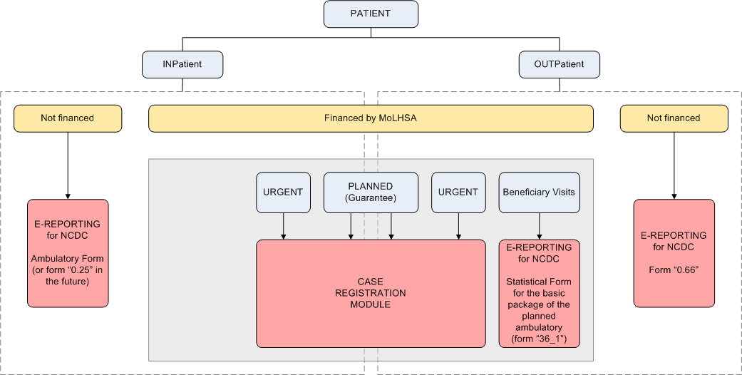
Picture 7. Iinformation source about cases in HSSP

Requirements to data composition and structure

Typical case structure and composition
As part of the automation of case registration processes described in section 4 for information exchange between Collaborative Healthcare Environment participants (EHR, HSSP / HSSP, External HIS, Doctors, Patients etc.) the same case structure containing the following basic information should be used:
Table 3. Typical case structure
Patient | Information about the patient (Patient ID, Patient demographics). Demographic information about the patient is taken from Civil Registry
Diagnose | Diagnose (according to classifiers used in MoLHSA, encoding ICD10)
Procedure | Procedures (according to classifiers used in MoLHSA, encoding NCSP)
ClinicalObservation | Observation results – text doctor’s comments related with the fact of medical service provision.
HCOrganisation | Information about the clinic providing the service
HCProfessional | Information about the doctor providing the service
Address | Address of service provision

Picture 8 presents schematic typical case structure

Note: The requirements for case structure and composition described in this section are preliminary and can be adjusted at the design stage of the project by agreement with the Customer.

Picture 8. Typical case structure

Case financial information
Financial information in this document is an additional (to clinical) information required for case registration in HSSP / HSSP. If urgent–case is registered it might be the information about financial items previously imposed and agreed in HSSP / HSSP Information Portal module and Financing Module. In the context of planned-cases the financial information might be an identifier of agreed application in Guarantee Module.
The structure of case financial component should be worked out in detail and described at the design stage.

Requirements to core business processes

Summary table of the processes
Table 4 contains the summary description of the automated business processes for case registration. General diagram illustrating case information flow into /from EHR is presented on Picture 2 in Section 1.2.4.
Table 4. Summary table of cases by type and information source
 | Class A clinics |  |  |  |  |  |  | Class B clinics
Data source (the place of the original data entry) | EHR |  |  | External HIS |  |  |  | HSSP
Case type | Urgent | Planned | Beneficiary visit | Urgent | Planned | Beneficiary visit |  | Urgent | Planned | Beneficiary visit
Data composition for replication | Clinical  (the whole volume remains in EHR; minimum information is transmitted into HSSP)  Financial  (financial item or Guarantee No) |  |  |  |  |  |  | Clinical  (maximum of existing information is transmitted into EHR)
Direction of case data replication | EHR -> HSSP |  |  | HIS -> EHR -> HSSP |  |  |  | HSSP -> EHR
Section with detailed description | 4.2.1 | 4.3.1 | 4.4.1 | 4.2.3 | 4.3.3 | 4.4.3 |  | 4.2.2 | 4.3.2 | 4.4.2

Note: The data flow schemas defined in according sections for each process can be updated during the design phase.

Urgent-cases registration processes

Registration process of urgent-case by Class A clinic
Table 5 contains general requirements for registration of urgent-case by Class A clinic. The main purpose of the process is to provide Class A clinics with the possibility to register the case via EHR interface (with further replication of required information into HSSP / HSSP).

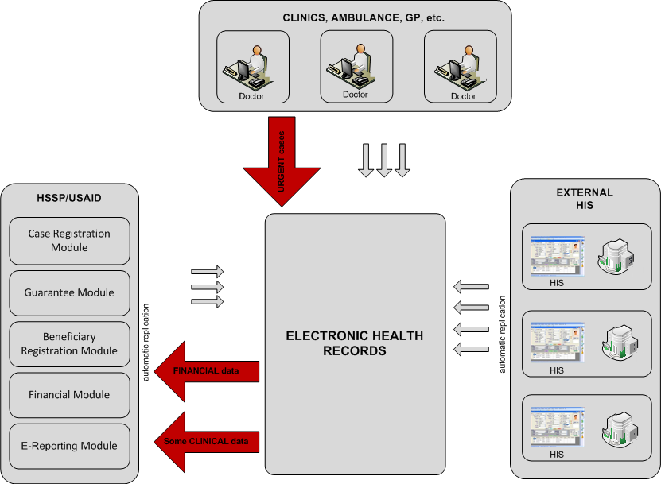
Picture 9. Registration of urgent-case by Class A clinic

Sections 4.2.1.1 и 4.2.1.2 contain the detailed scheme and description of the process.
Table 5. Common requirements to registration process of the urgent-case by Class A clinic
Process name | Urgent Case Registration from EHR
Designation | UrgentCR_A
Users | - Class A clinics  - Doctors (general, emergency) with access to EHR
Data composition for replication | - Clinical information (the whole volume remains in EHR; some information is replicated into HSSP)  - Financial and additional information about the case (is transmitted into HSSP)
Direction of case data replication | EHR -> HSSP
Requirement to main stages of the process | - Case is created in EHR (using EHR Doctor Portal или EHR Mobile Service)  - System automatically connects to HSSP for getting available financial items list (FI)  - EHR user selects FI from the list  - Case information is replicated automatically into HSSP  - HSSP user gets the access to related information using Information Portal or Case Registration Module interface

Process scheme UrgentCR_A
Picture 10 presents the registration scheme of urgent-case via EHR Doctor Portal interface
Picture 10. Scheme of the process UrgentCR_A with registration via EHR Doctor Portal
Picture 11 presents the registration scheme of urgent-case via EHR Mobile Service interface
Picture 11. Scheme of the process UrgentCR_A with registration via EHR Mobile Service

Process UrgentCR_A description
- The doctor, who has the access to EHR via EHR Doctor Portal or EHR Mobile Service, creates an urgent-case with full information medical service provision to the patient. During this case registration if the source of funding is not the patient, the doctor should be able to specify the financial item to enable the financial account in HSSP / HSSP. The list of available FI is returned by the System which connects to appropriate HSSP service.
- The information entered by the doctor is replicated into HSSP modules. After case creating a doctor should be able to edit the case (as long as the case is closed). If there are any changes in case sections/fields which are stored in HSSP and used in financial calculations, integration EHR module should resends the case into HSSP. The composition of case sections / fields the changes of which leads to repeated replication should be defined at the Project design stage.
Case replication should be performed in the background after business hours. During the replication not entire clinical information might be transferred in HSSP / HSSP modules but only that part which is necessary for case registration in Case Registration Module. The whole volume of financial information should be transmitted in HSSP / HSSP (means financial item).
The validation procedure of received information (references to the directories and classifiers) is described in Section 2.4.5
- HSSP / HSSP system takes clinical and financial information about the case, and stores it in the database of the corresponding modules.
- HSSP / HSSP user uses the information received from EHR in the same way as the information entered directly into HSSP / HSSP (means processes it using the same user interfaces and the same functions).

Registration process of urgent-case by Class B clinic
Table 6 contains the common requirements to urgent-case registration process by Class B clinic. Main purpose of the process is to provide Class B clinics the ability to perform the registration of the case in the old way, via HSSP / HSSP interface (with further replication of clinical information into EHR).
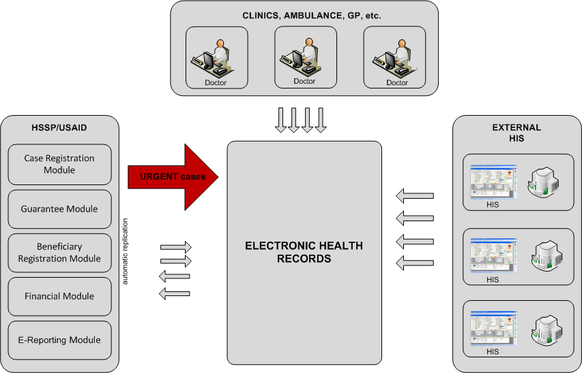
Picture 12. Urgent-case registration by Class B clinic
Sections 4.2.2.1 and 4.2.2.2 contain detailed scheme and process description.
Table 6. Common requirements to registration process of the urgent-case by Class B clinic
Process name | Urgent Case Registration from HSSP
Designation | UrgentCR_B
Users | Class B clinics
Data composition for replication | Clinical information (maximum information available in HSSP foro transmitting into EHR)
Direction of case data replication | HSSP -> EHR
Requirement to main stages of the process | - Case is created in HSSP Case Registration Module  - Case information is automatically replicated into EHR  - EHR gets the case and stores it in database with reference to indicated patient.  - EHR user gets the access to related cases via EHR Doctor Portal or Mobile application

Process UrgentCR_B Scheme
Picture 13 and Picture 14 present the scheme of urgent-case registration process in HSSP with following data transferring into EHR and information displaying via EHR Doctor Portal or EHR Mobile Service.
Picture 13. UrgentCR_B process scheme with information displaying via EHR Doctor Portal

Picture 14. UrgentCR_B process scheme with information displaying via EHR Doctor Portal

UrgentCR_B process description
Doctors/clinics who do not have access to EHR should be able to continue to register urgent-cases in HSSP.
- Doctor (or clinic administrator) performs urgent-case registration in HSSP / HSSP using the current interfaces (web-form) and functions in Case Registration Module.
After case registration in HSSP / HSSP the clinical information is transferred to EHR. The clinical information which can be extracted from HSSP modules data base is supposed to be transferred. The structure of these transmitted data should be comply with the requirements described in in section 3.1. Information transferring can be performed both in operated and deferred modes (after working hours).
- EHR takes the clinical information about the case and stores it in a database with reference to related patient. HSSP user has the ability to edit the case (as long as the case is closed). If there are any changes in the case EHR module should resend the case into EHR. The composition of case attributes the changes of which lead to repeated replication should be defined at the Project design stage. If repeated replicated occurs new versions of the object (CDA2 document) should be created in EHR.
Validation procedure of received information (references to directories and classifiers) is described in section 2.4.5.
- EHR user gets the access to received information about the patient via EHR Doctor Portal or EHR Mobile Service.

Urgent-case process registration from external HIS
Table 7 contains the common requirements to urgent-case process registration based on the data received from external HIS of Class A clinic in automated mode. The purpose of the process is provide Class A clinic with the ability to transfer the information about the case registered in HIS clinic into EHR (with followed replication the necessary information into HSSP).
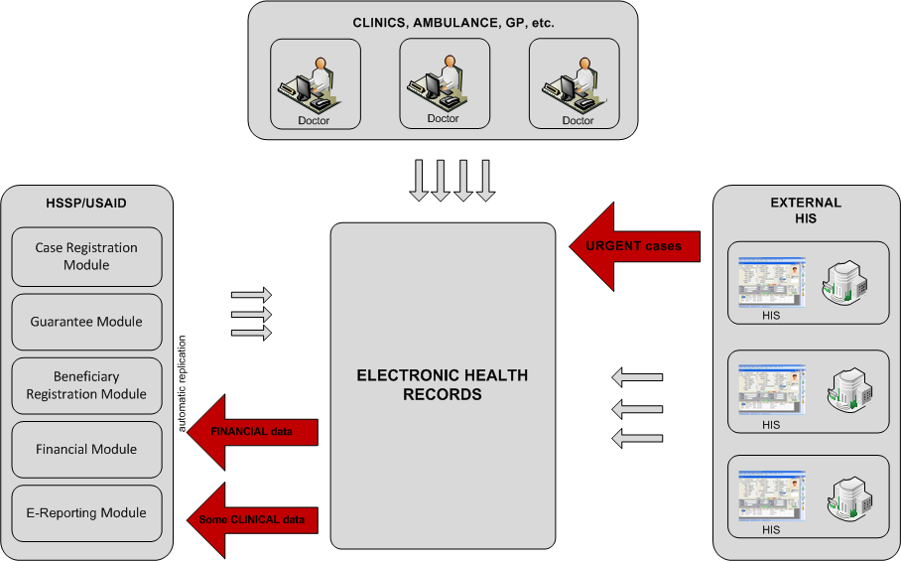
Picture 15. Urgent-case registration from external HIS

Разделы 4.2.3.1 и 4.2.3.2 contains detailed scheme and process description.

Table 7. Common requirements to urgent-case registration process from external HIS
Process name | Urgent Case Registration from External HIS
Designation | UrgentCR_HIS
User name | Class A clinics
Data composition for replication | - Clinical and financial information (goes from HIS into EHR)  - Clinical information (the whole volume remains in EHR; some part is replicated into HSSP)  - Financial and additional information about the case (is transmitted into HSSP)
Direction of case data replication | External HIS -> EHR -> HSSP
Requirement to main stages of the process | - Case is created in external HIS of Class A clinic, connected to EHR  - Case information is replicated into EHR  - Case information is replicated into HSSP (some clinical information and financial information)  - EHR user gets the access to appropriate cases via EHR Doctor Portal or Mobile application  - HSSP user gets the access to appropriate information via Information Portal or Case Registration Module interface.

UrgentCR_HIS process scheme
Picture 16 presents the scheme of urgent-case registration from external HIS with data transferring into EHR and into HSSP.
Picture 16. UrgentCR_HIS process scheme

UrgentCR_HIS process description
For Class A clinics connected to EHR automated data transmission about urgent-case into EHR from own HIS should be possible. The development of HIS service for generating and transmitting data into EHR in the prescribed format is out of scope of current project phase. This HIS service can be developed by the clinic personnel.
The replication mechanism and transmitted data format should be the same as that to be used for case transmission from HSSP into EHR.
- Class A clinic registers urgent-case in own HIS.
- Case information entered by the doctor is replicated into EHR in prescribed format(see section 3.1).
- EHR gets the clinical information about the case and stores it in database with the reference to indicated patient.
- EHR user gets the access to received information about the patient via EHR Doctor Portal or EHR Mobile Service.
To provide billing implementation possibility in HSSP case information should indicate the specific financial item (FI) entered by the clinic via USIAD portal. This information (FI) can be filled as in HIS (and replicated into EHR) or in EHR interface as that happens if the case is created in EHR.
Case information is automatically replicated into HSSP modules. Only the information which is necessary for case registration in Case Registration Module (not the whole volume) can be transmitted into HSSP modules.
- HSSP system gets case information and stores it in database of appropriate modules.
HSSP user uses the information received from EHR in the same way as information entered directly in HSSP / HSSP (processes it using the same user interfaces and the same functions).
If there is not financial component in received case information HSSP / HSSP user enters this information by himself in module interface.
If there are any changes of replicated case HIS integration module provides repeated replication of the case, new versions of corresponding object (CDA2 document) are created in HSSP.

Planned-cases registration processes

Registration process of planned-case by Class A clinic
Table 8 contains the common requirements to registration process of planned-case by Class A clinic. The purpose of the process is to enable Class A clinic case registration via EHR interface with indicating Guarantee No, provided by the patient.
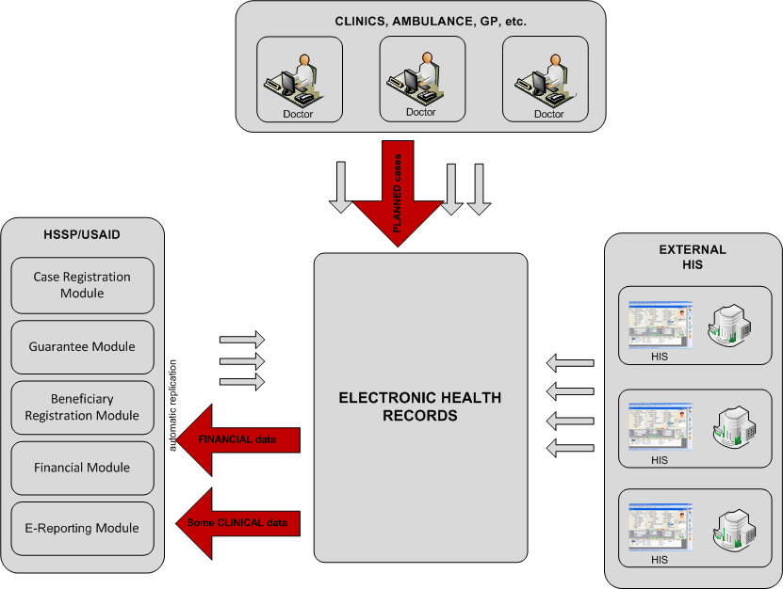
Picture 17. Planned-case registration by Class А clinic
Sections 4.3.1.1 и 1.1.1.1 contain the detailed scheme and process description.
Table 8. Common requirements to planned-case registration process by Class A clinic
Process name | Planned Case Registration from EHR
Designation | PlannedCR_A
Users | - Class A clinic  - Doctors (general, emergency) having the access to EHR
Data composition for replication | - Clinical information (the whole volume remains in EHR; some part is replicated into HSSP)  - Financial and additional information about the case (is transmitted into HSSP)
Direction of case data replication | EHR -> HSSP
Requirement to main stages of the process | - Application for a guarantee is registered by MoLHSA employee in Guarantee Module.  - After application confirmation in Guarantee Module the patient gets Guarantee No and visit the doctor in the clinic  - Doctor created the case with medical service provision and indicates Guarantee No.  - Case is replicated into HSSP  - HSSP user gets the access to corresponding information via Information Portal or Case Registration Module interface.

PlannedCR_A process scheme
Picture 18 presents the scheme of planned-case registration by Class A clinic
Picture 18. PlannedCR_A process scheme

PlannedCR_A process description
- The application for a guarantee is registered by MoLHSA employee in HSSP / HSSP Guarantee Module. Form 100 is filled in where clinical information about the patient is specified (the diagnosis and a set of necessary procedures). The ability of partially 100 Form filling in automated mode should be possible based on patient data existing in EHR database.
Also it is allowed the implementation of an alternative variant when a doctor registered in EHR a case which contains a description of the procedures to be agreed with the Ministry, pushes the button "Create an application in HSSP Guarantee» and then the application with partially filled Form 100 is created in HSSP Guarantee module automatically.
Note: Implementation way is defined at the design stage and agreed with the Customer.
- MoLHSA confirms the application funding in Guarantee Module.
For application approval and confirmation in HSSP the current application procedure should be used. Within current project phase there is no any new functionality for this process automation in HSSP.
- After getting application confirmation and Guarantee No from the Ministry the patient visits the doctor.
The doctor (EHR user) opens and edit the case and enter all clinical information about medical service provision into the case . Besides that the doctor should have the possibility to indicate Guarantee No for case registration in HSSP after the replication into EHR.
- Case information is replicated into HSSP modules.
- After case creating a doctor should be able to edit the case (as long as the case is closed). If there are any changes in case sections/fields which are stored in HSSP and used in financial calculations, integration EHR module should resend the case into HSSP. The composition of case sections / fields the changes of which lead to repeated replication should be defined at the Project design stage.
Only the information which is necessary for case registration in Case Registration Module (not the whole volume) can be transmitted into HSSP modules. The financial information should be transmitted into HSSP entirely (in this case means Guarantee No).
Validation procedure of received information (references to directories and classifiers) is described in section 2.4.5
- HSSP system gets clinical and financial information and stores case information in database of corresponding modules.
- HSSP / HSSP user uses the information received from EHR in the same way as the information entered directly into HSSP / HSSP (means processes it using the same user interfaces and the same functions).

Registration process of planned-case by Class B clinic
Table 9 contains the common requirements to registration process of planned-case by Class B clinic. The pain process purpose is to provide Class B clinic with the possibility of case registration via HSSP interface (with following clinical replication into EHR).
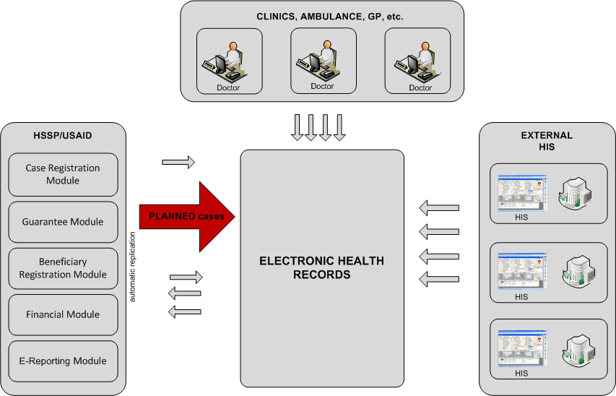
Picture 19. Planned-case registration by Class B clinic

Sections 1.1.1.1 и 4.3.2.2 contain detailed scheme and process description.
Table 9. Common requirements to registration process of planned-case by Class B clinic
Process name | Planned Case Registration from HSSP
Designation | PlannedCR_B
Users | Class B clinics
Data composition for replication | - Clinical information (maximum information available in HSSP for transmission into EHR)
Direction of case data replication | HSSP -> EHR
Requirement to main stages of the process | - Case is created in HSSP Case Registration Module  - Case information is automatically replicated into EHR  - EHR gets the case and stores it in database with reference with indicated patient  - EHR user gets the access to corresponding cases via EHR Doctor Portal or Mobile application.

PlannedCR_B process scheme
Picture 20 и Picture 21 present registration process scheme of planned-case in HSSP with following data transferring into EHR and information displaying in EHR Doctor Portal or EHR Mobile Service.
Picture 20. PlannedCR_B process scheme with displaying data in EHR Doctor Portal

Picture 21. PlannedCR_B process scheme with displaying data in EHR Mobile Service

PlannedCR_B process description
Doctors / clinics who do not have the access to EHR should be able to continue to register planned-cases in HSSP / HSSP.
- Doctor (or clinic administrator) performs a planned-case registration in HSSP / HSSP using the current interfaces (web-forms) and functions in Case Registration Module.
- After case registration in HSSP system the clinical information is transferred into EHR.
The clinical information which can be extracted from database of corresponding HSSP modules should be transferred. The structure of transferring data should comply the requirements described in section 3.1.
Information transferring can be performed both in operated and deferred modes (after working hours).
- EHR system gets clinical information of case and stores it in database with reference to indicated patient.
HSSP user should be able to edit the case (as long as the case is closed). If there are any changes in case integration EHR module should resends the case into EHR. The composition of case attributes the changes of which lead to repeated replication should be defined at the Project design stage.
If repeated case replication occurred new versions of related object (CDA2 document) should be created in EHR.
The validation procedure of received information (references to the directories and classifiers) is described in Section 2.4.5
- EHR user gets the access to received information about the patient via EHR Doctor Portal or EHR Mobile Service.

Registration process of planned-case from external HIS
Table 10 contains the common requirements to registration process of planned-case based on data received in automated mode from external HIS of Class А clinic. The purpose of the process is provide Class A clinic with the ability to transfer the information about the case registered in HIS clinic into EHR (with followed replication the necessary information into HSSP).
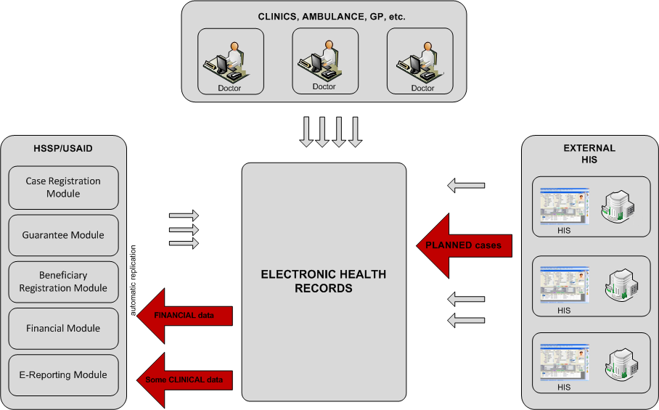
Picture 22. Registration of planned-case from external HIS
Sections 4.3.3.1 and 4.3.3.2 contain detailed scheme and process description.
Table 10. Common requirements to registration process of planned-case from external HIS
Process name | Planned Case Registration from External HIS
Designation | PlannedCR_HIS
Users | Class A clinics
Data composition for replication | - Clinical and financial information (goes from HIS into EHR)  - Clinical information (the whole volume remains in EHR; some information is replicated into HSSP)  - Financial and additional case information (is transferred into HSSP)
Direction of case data replication | External HIS -> EHR -> HSSP
Requirement to main stages of the process | - Case is created in external HIS of Class А clinic connected to EHR  - Case information is automatically replicated into EHR  - Case information is automatically replicated into HSSP (some clinical information and financial information)  - EHR user gets the access to corresponding cases via EHR Doctor Portal or Mobile application)  - HSSP user gets the access to corresponding information via Information Portal or Case Registration Module interface.

PlannedCR_HIS process scheme
Picture 23 presents the registration scheme of planned-case from external HIS with data transferring into EHR and into HSSP.
Picture 23. PlannedCR_HIS process scheme

PlannedCR_HIS process description
For Class A clinics connected to EHR automated data transmission about planned-case into EHR from own HIS should be possible. The development of HIS service for generating and transmitting data into EHR in the prescribed format is out of scope of current project phase. The replication mechanism and transmitted data format should be the same as that to be used for case transmission from HSSP into EHR.
- Class A clinic registers planned-case in own HIS.
- Case information entered by the doctor is replicated into EHR in prescribed format(see section 3.1).
- EHR gets the clinical information about the case and stores it in database with the reference to indicated patient.
- EHR user gets the access to received information about the patient via EHR Doctor Portal or EHR Mobile Service
To provide billing implementation possibility in HSSP case information should have the reference to Guarantee No. Guarantee No can be filled as in HIS (and replicated into EHR) or in EHR interface as that happens if the case is created in EHR.
- Case information is automatically replicated into HSSP modules. Only the information which is necessary for case registration in Case Registration Module and Guarantee Module (not the whole volume) can be transmitted into HSSP modules.
- HSSP system gets case information and stores it in database of appropriate modules.
- HSSP user uses the information received from EHR in the same way as information entered directly in HSSP / HSSP (processes it using the same user interfaces and the same functions).
If there is not financial component in received case information HSSP / HSSP user enters this information by himself in module interface.
If there are any changes of replicated case HIS integration module provides repeated replication of the case, new versions of corresponding object (CDA2 document) are created in HSSP.

Beneficiary visit registration process

Registration process of beneficiary visit by Class A clinic
Table 11 contains the common requirements to registration process of beneficiary visit by Class А clinic. Process purpose is to provide Class A clinic with the ability to register the case via EHR interface (with following replication demanded information into HSSP).
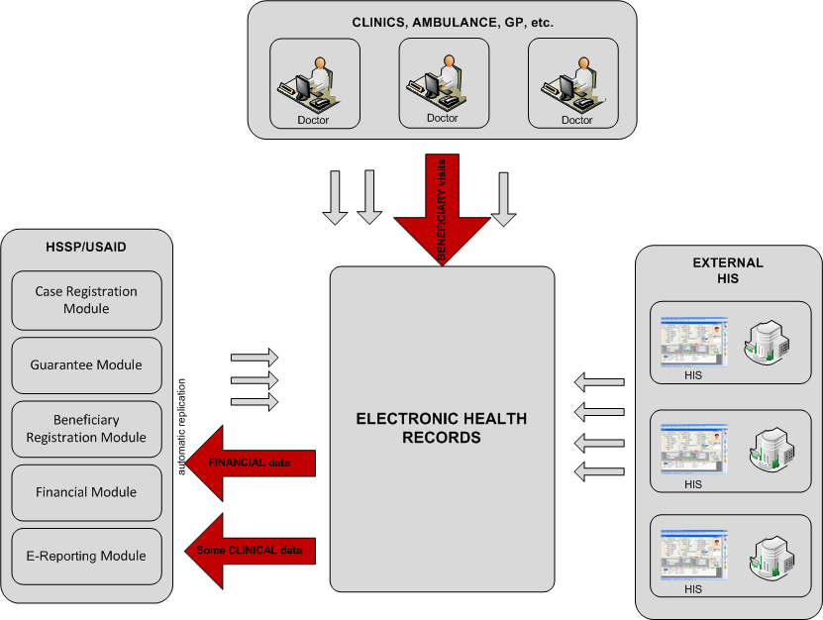
Picture 24. Registration of beneficiary visit by Class A clinic

Sections 4.4.1.1 and 1.1.1.1 contains detailed scheme and process description.
Table 11. Common requirements to registration process of beneficiary visit by Class A clinic
Process name | Beneficiary Visit Registration from EHR
Designation | BenVisitR_A
Users | - Class A clinics  - Doctors (general and emergency) connected to EHR
Data composition for replication | - Clinical information about medical service (the whole volume remains in EHR; some information necessary and sufficient for case account is transferred into HSSP)
Direction of case data replication | EHR -> HSSP
Requirement to main stages of the process | - The doctor registers the patient visit into clinic via EHR DoctorPortal or EHR Mobile Service  - After case completion it is automatically replicated from EHR into HSSP (into E-Reporting for NCDC module)  - HSSP/HSSP gets the access to the information via E-Reporting module interface.

BenVisitR_A process scheme
Picture 25 and Picture 26 present the schemes of registration process of beneficiary visit in EHR with following data transferring into HSSP and information displaying in EHR Doctor Portal or EHR Mobile Service.

Picture 25. BenVisitR_A process scheme with entering information via EHR Doctor Portal
Picture 26. BenVisitR_A process scheme with entering information via EHR Mobile Service

BenVisitR_A process description
- The doctor who gets the access to EHR via EHR Doctor Portal or EHR Mobile Service creates beneficiary visit case which contains entire information about fact of medical service provision.
- After case completion the clinical information entered by the doctor in EHR is automatically replicated into HSSP. Case closing criteria will be defined at the stage of design.
- Case replication should be performed in the background after business hours. During replication not the whole clinical information can be transferred into HSSP / HSSP modules but only that part which is necessary for case registration in E-Reporting Module for NCDC.
- HSSP system gets case information and stores it in database of corresponding module. Validation procedure of received information (references to directories and classifiers) is described in section 2.4.5.
- HSSP user uses received from EHR information as the same way as the information entered directly in HSSP (means operates it with using the same user interfaces and functions).

Registration process of beneficiary visit by Class B clinic
Table 12 contains the common requirements to registration process of beneficiary visit by Class B clinic. Process purpose is to provide Class B clinic with the ability to register the case via HSSP interface (with following replication clinical information EHR).
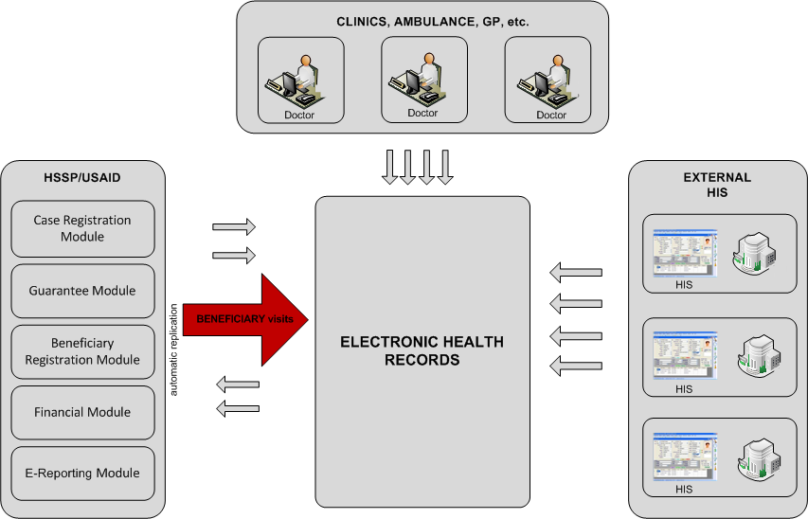
Picture 27. Registration of beneficiary visit by Class B clinic
Sections 1.1.1.1 and 4.4.2.2 contain detailed scheme and process description.
Table 12. Common requirements to registration process of beneficiary visit by Class B clinic
Process name | Beneficiary Visit Registration from HSSP
Designation | BenVisitR_B
Users | Class B clinics
Data composition for replication | - Clinical information (maximum information available in HSSP for transferring into EHR)
Direction of case data replication | HSSP -> EHR
Requirement to main stages of the process | - Case information is entered manually in HSSP e-Reporting for NCDC  - After case completion information is automatically replicated into EHR  - EHR gets the case and stores it in database with reference with indicated patient  - EHR user gets the access to corresponding cases via EHR Doctor Portal or Mobile application

BenVisitR_B process scheme
Picture 28 presents the registration scheme of beneficiary visit from HSSP with transferring information into EHR.
Picture 28. BenVisitR_B Process scheme

BenVisitR_B process description
Doctors / clinics who do not have the access to EHR should be able to continue to register beneficiary visit in HSSP / HSSP.
- Doctor (or clinic administrator) performs a beneficiary visit case registration in HSSP / HSSP using the current interfaces (web-forms) and functions in E-Reporting for NCDC Module.
- After case registration in HSSP system the clinical information is transferred into EHR.
The clinical information which can be extracted from database of corresponding HSSP modules should be transferred. The structure of transferring data should comply the requirements described in section 3.1.
Information transferring can be performed both in operated and deferred modes (after working hours).
- EHR system gets clinical information of case and stores it in database with reference to indicated patient.
The validation procedure of received information (references to the directories and classifiers) is described in Section 2.4.5
- EHR user gets the access to received information about the patient via EHR Doctor Portal or EHR Mobile Service.

Registration process of beneficiary visit from external HIS
Table 13 contains the common requirements to registration process of beneficiary visit based on data received in automated mode from external HIS of Class А clinic. The purpose of the process is to provide Class A clinic with the possibility to transfer the information about the case registered in HIS of clinic into EHR (with following replicated of demanded information into HSSP).

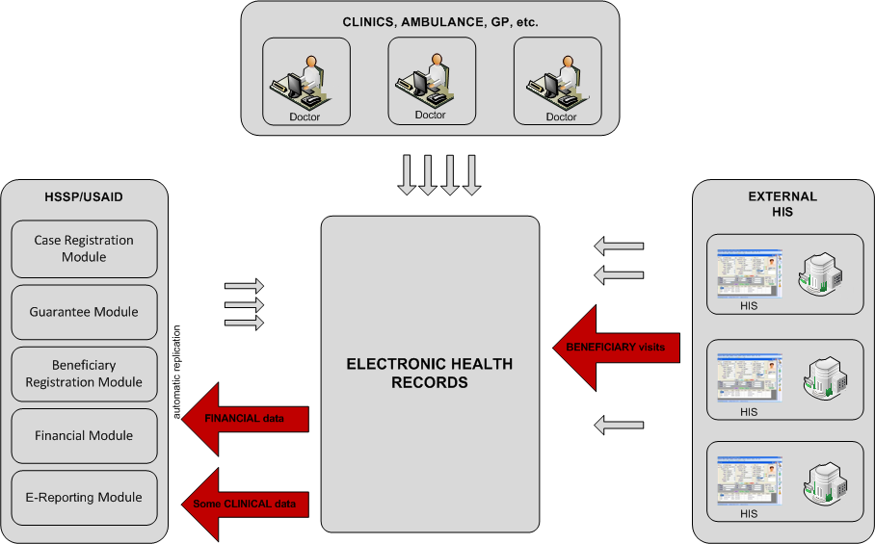
Picture 29. Registration of beneficiary visit from external HIS

Sections 4.4.3.1 and 4.4.3.2 contains detailed scheme and process description.
Table 13. Common requirements to registration process of beneficiary visit from external HIS
Process name | Beneficiary Visit Registration from External HIS
Designation | BenVisitR_HIS
Users | Class A clinics
Data composition for replication | - Clinical information (goes from HIS into EHR)  - Clinical information (the whole volume of information remains in EHR; some information is replicated into HSSP)  - Case information which is necessary and sufficient for case account is transferred into HSSP
Direction of case data replication | External HIS -> EHR -> HSSP
Requirement to main stages of the process | - Doctor of Class А clinic registers patient’s visit via external HIS interface.  - After completion case information is transferred into EHR  - Cases are automatically replicated from EHR into E-Reporting for NCDC module of HSSP  - HSSP/HSSP user gets the access to the information via E-Reporting module interface.

BenVisitR_HIS process scheme
Picture 30 presents the registration process scheme of beneficiary visit from external HIS with data transferring into EHR and following data replication into HSSP.

Picture 30. BenVisitR_HIS process scheme with entering information via external HIS

BenVisitR_HIS process description
For Class A clinics connected to EHR automated data transmission about beneficiary visit into EHR from own HIS should be possible. The development of HIS service for generating and transmitting data into EHR in the prescribed format is out of scope of current project phase. The replication mechanism and transmitted data format should be the same as that to be used for case transmission from HSSP into EHR.
- Class A clinic registers beneficiary visit in own HIS.
- Case information entered by the doctor is replicated into EHR in prescribed format(see section 3.1).
- EHR gets the clinical information about the case and stores it in database with the reference to indicated patient.
- EHR user gets the access to received information about the patient via EHR Doctor Portal or EHR Mobile Service.
- Case information is automatically replicated into HSSP modules.
Only the information which is necessary for case registration in E-Reporting for NCDC Module (not the whole volume) can be transmitted into HSSP modules.
- HSSP system gets case information and stores it in database of appropriate modules.
- HSSP user uses the information received from EHR in the same way as information entered directly in HSSP / HSSP (processes it using the same user interfaces and the same functions).

Information access processes
Picture 31 presents the common scheme of processes for doctors and patients access to case information in EHR. The access should be available via EHR Doctor Portal and via EHR Mobile Service.
Picture 31. Access process scheme to case information

Functional requirements

EHR basic functions requirements

General information
This document contains requirements only for new features EHR, which should be implemented in EHR as part of EHR-HSSP / HSSP integration (part 1).

User functions requirements
The following basic functions should be available for the user:
Creation / editing case of any type via EHR interface
Entering clinical information about the case for storing in EHR
Entering financial information about the case for further automated transferring into HSSP modules (including automate obtain a list of available financial items to select FI in EHR interface)
View information about the cases entered before via EHR interface
View information about the cases loaded into EHR automatically from HSSP modules
View information about the cases loaded into EHR automatically from external HIS of Class A clinics connected to EHR
View information should be available via EHR Doctor Portal and via EHR Mobile Service

Case creation / editing via EHR interface
For doctors working with EHR system should be available to the possibility of case creation (urgent, planned, beneficiary visit). Case creation via EHR Doctor Portal or EHR Mobile Service interfaces should be performed within the relevant business processes:
Registration process of urgent-case via EHR interface (see section 4.2.1)
Registration process of planned-case via EHR interface (see section 4.3.1). Here the doctor should be available to create a case based on related Intent-case replicated from HSSP.
Registration process of beneficiary visit via EHR interface (see section 4.4.1)
The description of each registered case can be consist of 2 main parts: Clinical information and Financial information. ( see sections 5.1.2.2 и 5.1.2.3)

Entering Clinical information about the case
When creating and editing cases (urgent, planned, beneficiary visit) via EHR interface the doctor should be able to enter the whole volume of clinical information in accordance with the model presented in Section 3.1.

Entering Financial information about the case
In EHR system the opportunity to enter financial information of cases supposed to account in HSSP / HSSP system should be implemented . Financial information volume entered in EHR interface about the case should be minimal (means necessary and sufficient the possibility to account the case in HSSP / HSSP relevant modules).
General requirements for Financial information structure are presented in Section 3.2.

View information about the cases
EHR user should be able to view all types of cases (urgent, planned, beneficiary visit) regardless of whether the case is created via EHR interface or replicated from an external HIS or HSSP / HSSP.
View information about the case should be available via EHR Doctor Portal or EHR Mobile Service.

Automated services requirements
In EHR the following automated services should be available:
Replication if clinical information about cases into HSSP modules
Replication if financial information about cases into HSSP modules
Receiving, processing and storing of clinical information about cases derived from HSSP / HSSP modules
Receiving, processing and storing of clinical information about cases from external HIS of Class A clinics connected to EHR

Replication of case information into HSSP modules
In EHR the service for automatic replication of case information into HSSP system should be implemented. This service should perform the following operations:
Creation of data package for further replication
Replication of а created package into HSSP
Getting answer from HSSP about replication results
When package creating the service should include inside only the amount of information that is necessary and sufficient for case registration in HSSP / HSSP. Thus the information contained in the transmitted package will be a subset of a full description of the case presented in EHR.

Processing of obtained clinical information about cases
To obtain information about the case from external HIS or HSSP / HSSP an appropriate service should be implemented in EHR. This service should perform the following operations:
- Getting the package with data from external HIS or HSSP
- Storing received information in EHR database
- Sending a response to transmitting side about replication results

HSSP basic functions requirements

General information
This document contains requirements only for new features EHR, which should be implemented in HSSP / HSSP as part of EHR-HSSP / HSSP integration (part 1) integration.

User functions requirements
Within EHR-HSSP integration ( part 1) additional user functions in HSSP are not required.

Automated services requirements
In HSSP the following automated services should be available:
Replication if clinical information about cases into EHR
Receiving, processing and storing of clinical information about cases from EHR
Receiving, processing and storing of financial information about cases from EHR

Replication of clinical information about cases into EHR
In HSSP / HSSP automatic replication service of clinical information about cases into EHR should be implemented. This service should perform the following operations:
- Creation of data package for replication
- Replication of created package into EHR
- Getting answer from EHR about replication results
During creating the package the service should include the whole clinical information volume available in HSSP.

Processing or received information about cases
To obtain information about cases from EHR the appropriate service should be implemented in HSSP / HSSP. This service should perform the following basic operations:
- Getting package with data from EHR
- Storing received information in database of corresponding HSSP modules
- Sending the response to EHR about replication results
Received from EHR package can contain both clinical and financial information necessary for case registration in HSSP.

Other requirements

User interface requirements
With the implementation of new user functions described in section 5.1.2 is required to follow the principles of the current interface used in the EHR. New forms / interfaces should be intuitive easy to understand and must provide the user with interface elements allowed to enter information about the case (both clinical and financial for transmission to HSSP).

Logging requirements
All functions (described section 5) performed by the user or System should be logged. The system administrator should be able to:
- View log-files
- Start / stop logging operations
- Remove of outdated log-files

Replication procedure is defined at the design stage
Financial information can be entered into own HIS of clinic manually or by means of calling HSSP service
Functional requirements to Mobile applications are in the document «Functional specification MoLHSA. Part 3»
Data Replication procedure is defined at design stage
Urgent, Planned или Beneficiary Visit
Information about performed operations should be written into log-file on the server

