Signed by  ______________________  «___»_________2015 г. | Signed by  ______________________  «___»_________2015 г.

Functional Specification
Collaborative Health Environment (CHE) of Georgia
EMR 2.1

Part 2 (2 from 3)
EHR and HSSP/USAID Integration (Clinical Data Exchange)

49 Pages

Reconciliation sheet
Supplier
Position | Name | Signature | Date

Customer
Position | Name | Signature | Date

Content
Tables 5
Pictures 6
History of changes 7
Glossary 8
1. Overview 9
1.1. Purpose of the document 9
1.2. Main goals and Objectives 9
1.2.1. Project Goals and Objectives 9
1.2.2. Common requirements to the CHE architecture 10
1.2.3. Goals and objectives of EHR-HSSP/USAID integration ( Part 2) 11
1.2.4. Summary scheme of data flows 12
1.3. Current infrastructure description 13
1.3.1. Current infrastructure deficiencies description 13
1.3.2. Current CHE architecture 14
1.3.3. Interaction between clinics and HMIS 15
2. Common requirements to integration 16
2.1. Integration types description 16
2.2. Common requirement to data flows between EHR и HSSP/USAID 16
2.3. Integration stages description 18
2.3.1. Stage 1: Case Management (integration type 1) 18
2.3.2. Stage 2: Clinical information exchange (integration types 2, 3 и 4) 18
2.4. Data structure requirements for replication 19
2.4.1. Directories synchronization and validation of case data 20
3. Requirements to core business processes 21
3.1. Summary table of the processes 21
3.2. Replication processes of clinical data from HSSP/USAID to EHR 22
3.2.1. Data replication process Dialysis Program -> EHR 22
3.2.2. Data replication process from BRM Psychiatry Program to EHR 25
3.2.3. Data replication process from BRM Diabetes into EHR 28
3.2.4. Data replication process from BRM AIDS into EHR 30
3.2.5. Data replication process from Tuberculosis Electronic into EHR 32
3.2.6. Data replication process from Immunization Management into EHR 35
3.2.7. The process of generating, viewing and printing of recipes via EHR interface 38
3.3. Information access processes 39
3.3.1. The process of access to information on the limits of the patient from EHR 39
3.3.2. The process to access to Form 100 from HSSP/USAID Guarantee Module 43
3.3.3. The process to access clinical data received from HSSP/USAID in EHR 44
4. Functional requirements 45
4.1. EHR basic functions requirements EHR 45
4.1.1. General information 45
4.1.2. User functions requirements 45
4.1.3. Automated services requirements 46
4.2. Requirements to basic HSSP/USAID functions 47
4.2.1. General information 47
4.2.2. User functions requirements 47
4.2.3. Automated services requirements 47
4.3. Requirements to basic functions of the prescription print service 47
4.3.1. User functions requirements 47
4.3.2. Automated services requirements 48

Tables
Table 1. Glossary 8
Table 3. Integration types of USAID modules 16
Table 4. Typical case structure 19
Table 5. Summary table of information exchange processes between HSSP/USAID and EHR 21
Table 6. Common requirements for data replication of dialysis process 22
Table 7. Common requirements for data replication of Psychiatry 25
Table 8. Common requirements for data replication of diabetics 28
Table 9. Common requirements for data replication of AIDS 30
Table 10. Common requirements for data replication of treatment and prevention of tuberculosis 32
Table 11. Common requirements for data replication of imminization 35
Table 12. Common requirements to prescriptions printing from EHR 38
Table 13. Common requirements for getting information about patient limits 40

Pictures
Picture 1. Goal CHE scheme 10
Picture 2. Scheme of data flows between EHR and HSSP/USAID (Part 2) 12
Picture 3. Current CHE scheme 14
Picture 4. Обобщенная схема потоков данных между EHR и HSSP/USAID 17
Picture 5. Data replication on peritoneal and hemodialysis 22
Picture 6. DialysisCDR_B process scheme 23
Picture 7. Data replication of Psychiatry 25
Picture 8. Psychiatry_CDR_B process scheme 26
Picture 9. Data replication of diabetics 28
Picture 10. Data replication of AIDS 30
Picture 11. Data replication of treatment and prevention of tuberculosis 32
Picture 12. TuberculosisCDR_B process scheme 33
Picture 13. Data replication about immunization 35
Picture 14. ImmunizationCR_B process scheme 36
Picture 15. Medical appointments (prescriptions) print via Forms printing service 38
Picture 16. Getting information about patient limits 40
Picture 17. PatientLimit _Aprocess scheme 41
Picture 18. Case information access processes scheme 44

History of changes
Version | Date | Author | Comments
1.0 | 25.06.2015 |  | Version 1.0

Glossary
Table 1. Glossary
CHE | Collaborative Health care Environment
EHR/EHR | Electronic Medical Records/ Electronic Health Records
HIS | Health Information System
HMIS | Health Management Information System
HSSP | Health System Strengthening Project
MoLHSA | Ministry of Labor, Health and Social Affairs of Georgia
Mobile Service | Mobile Service is service which is included into Mobile Platform and provides the access to Clinical information in EHR
USAID | United States Agency for International Development
Customer | Ministry of Labor, Health and Social Affairs of Georgia
Case | The fact of medical service provision to the patient ( in the context of this document)
Clinical Information | Medical information about the patients to be stored in EHR

Overview

Purpose of the document
This document contains the description of functional requirements to EHR-HSSP/USAID integration (Part 2). Within this Integration it is demanded to automate clinical data exchange between systems.
The main requirements to the functionality of EHR-HSSP/USAID Integration (Part 2) are presented in the next sections:
Section 1.2.3 contains the description of the goals and objectives of integration
Section 1.2.4 presents general scheme of information flow between EHR and HSSP/USAID within EHR-HSSP/USAID integration (Part 2)
Section 2 contains the whole description of Integration requirements
Section 3 contains the description of business process
Section 4 user functions requirements and automated functions.
  - Main goals and Objectives
    - Project Goals and Objectives
Project main goals:
- Defining of HMIS information strategy development (as a whole and its individual parts), taking into account the features of the current infrastructure of the Customer and the needs of key members of the Health system of Georgia
- Improving the efficiency of information management
elimination of data and data entry duplication
improving the quality of stored information through the use of common standards and classifiers
optimization of data streams
Reporting Information
- Implementation of quick access to the required information (medical, financial, etc.) in the required format for all users of a collaborative information environment

To achieve these goals the following main objectives need to be addressed:
- Development the common HMIS software architecture including existing and planned modules.
- Development of proposals for a partial restructuring of existing processes and data flows within HMIS based on the analysis of functional modules and the details of modules interaction.
- Integration between USAID and EHR modules and partial adjustment of processes and HMIS subsystems functionality
- HMIS technical architecture clarification
- Development of HMIS new modules connections, the description of the main requirements to plug-ins (to standards, interfaces, etc.).

    - Common requirements to the CHE architecture
На Picture 1 Generalized CHE target scheme, which must be implemented within the current phase of the project.
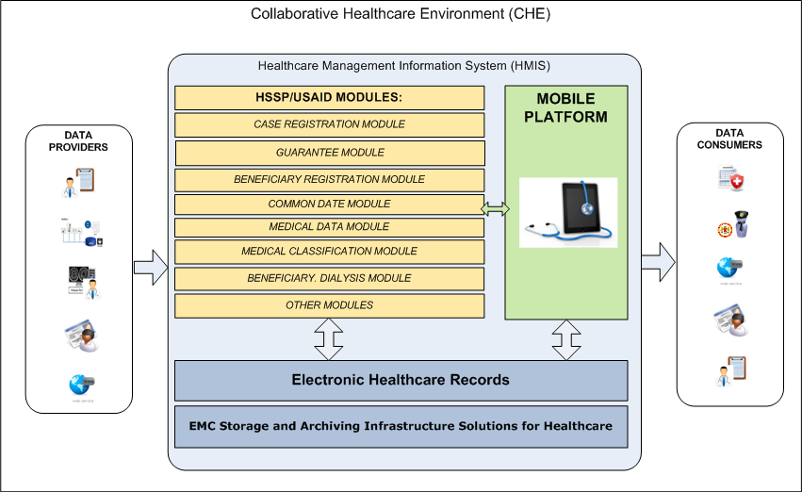
Picture 1. Goal CHE scheme

Goals and objectives of EHR-HSSP/USAID integration ( Part 2)
Main goals of Part 2:
Speeding up the process of filling EHR database by replicating of clinical information from HSSP / USAID modules
The consolidation of the maximum amount of information about patients in EHR, including information about written prescriptions for drugs and limits for financing government programs
To achieve these goals the following main objectives need to be addressed:
Implementation of clinical data replication services from HSSP / USAID modules into EHR
Implementation services for obtaining and processing of replicated information from HSSP / USAID in EHR
Expansion of EHR functionality for displaying additional information about patients (limits on financing, etc.)

Picture 2 in section 1.2.4 presents the common scheme describing main data flows between EHR and HSSP/USAID within EHR-HSSP/USAID Integration (Part 2).

Summary scheme of data flows

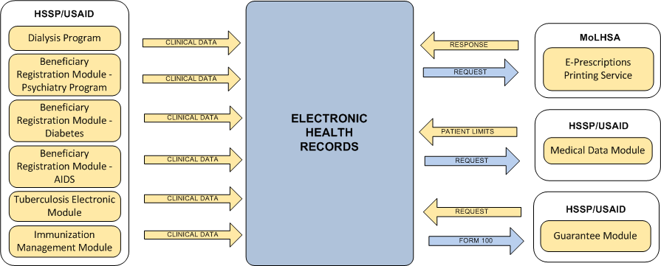
Picture 2. Scheme of data flows between EHR and HSSP/USAID (Part 2)

  - Current infrastructure description
Currently MoLHSA operates Health Management Information System (HMIS), which includes a wide range of information modules that perform the registration and processing of information in the field of public health in Georgia. HMIS enables information exchange between key players in the health care system of Georgia, such as the Ministry of Health, Labor and Social Affairs of Georgia, hospitals, insurance and pharmaceutical companies, as well as Georgia citizens. The bulk of the existing software modules was implemented in the framework of USAID Health System Strengthening Project and has more than 20 modules.
In addition to the modules within the HMIS a single register of health records (EHR) was implemented which is integrated with HIS. Along with EHR the WEB-portals, allowing access to information for doctors, Ministry employees and the citizens of Georgia were implemented.
Due to various circumstances, development of modules HMIS carried out in the absence of a unified architecture that would define the basic components of the System, the order of their interaction, data flows, strategy of the major subsystems development, and each module in particular, the procedure for the exchange of information with external stakeholders (suppliers and consumers of health information ).

Current infrastructure deficiencies description
The lack of a unified architecture and fragmentation of HMIS subsystems has led to the following consequences:
Clinical information contained in HSSP / USAID modules is not transmitted to EHR. As a result, EHR database filling does not happen fast enough.
When clinics enter the information into EHR, it is not made available from the HSSP / USAID. As a result, clinics have to enter data twice: at first clinical information into EHR, and then financial and the part of clinical information into HSSP / USAID.
This in turn leads to an increase in overhead and duplication of data errors, as well as an inefficient use of information processing and analysis.
Picture 3 Section 1.3.2 contains the common scheme of current CHE.

Current CHE architecture

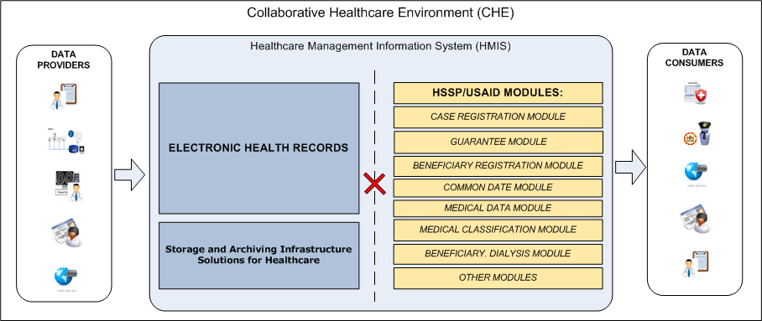
Picture 3. Current CHE scheme

Interaction between clinics and HMIS
All clinics interacting with HMIS, should be divided into two classes:
Clinics - Class A
Clinics have the technical capacity to work with EHR, they address directly to respective interfaces (Doctor Portal and so on.) They are the main information providers for EHR. The order of interaction these clinics with USAID modules should be adjusted (see details in Section 1.3.3.1).
Clinics - Class B
Clinics, do not have the technical ability to work with EHR, they continue to work with USAID modules without changes (see Section1.3.3.2).

Clinics Class A
Currently urgent-case managing is carried out by the Case Registration Module. For Class A clinics the opportunity to work with urgent-case via EHR interface should be implemented. EHR interface should provide the ability to enter the whole necessary case information, including clinical and financial (with the subsequent transferring of the necessary information to the appropriate USAID modules in automatic mode). The work of the employees of these clinics with other USAID modules should be unchanged (through USAID interfaces).

Clinics Class B
Class B clinics should be able to continue to work with USAID modules. AT the same time the clinical information from separate modules should automatically be transferred into EHR. Some modules should be capable to receive the auxiliary information from EHR to improve the efficiency of experts work with the modules.

Common requirements to integration

Integration types description
EHR and USAID functional modules Integration is one of the highest priorities in the context of building a collaborative health environment (CHE). Each USAID module implements a specific functionality and operates an array of specific information. EHR-HSSP/USAID integration should be implemented taking into account the specifics of each particular module.

Common requirement to data flows between EHR и HSSP/USAID
Table 3. Integration types of USAID modules

Type | Description | Modules
1 | Intelligent Integration (case management).  Class A clinics which are working directly with EHR, should provide the way to interact with HSSP / USAID modules via Doctor Portal. | Case Registration Module
1 |  | Guarantee Module
1 |  | e-Reporting Module
1 |  | Healthcare Programs Financing Module
2 | Transfer the data into EHR.  These modules contain information that needs to be accumulated in EHR. It is necessary to implement the ability to transfer data from HSSP / USAID and receive in EHR. | Dialysis Program
2 |  | Beneficiary Registration Module - Psychiatry Program
2 |  | Beneficiary Registration Module – Diabetes
2 |  | Beneficiary Registration Module - AIDS
2 |  | Immunization Management Module
2 |  | Tuberculosis Electronic Module
3 | Modules are used in EHR as directories.  These HSSP / USAID modules contain supporting information that can be used for displaying in EHR user interfaces. | Medical Data Module
3 |  | Common Data Module
3 |  | Medical Classifications Module
3 |  | Pharmaceutical Products Module
3 |  | Pharmaceutical Module
3 |  | Providers Directory
4 | Do not participate in integration.  These modules are not changed in functionality as well as data flows (incoming and outgoing) | Stock Management Module
4 |  | Dashboard
4 |  | Information Portal
4 |  | E-reporting Module For Insurance Companies
4 |  | User Management Module
4 |  | Vital Registration Module
4 |  | Mediation Module
4 |  | ePrescription Module
4 |  | Medical Staff Certification/Accreditation Module
4 |  | Healthcare Facilities Licensing/Permitting Module

Picture 4 illustrates the requirements to the main data flows between EHR USAID modules

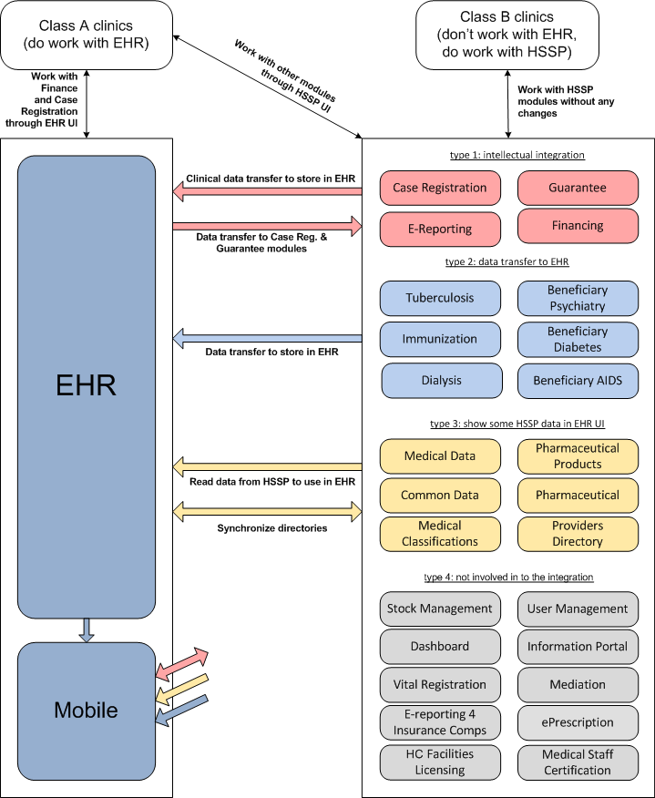
Picture 4. Обобщенная схема потоков данных между EHR и HSSP/USAID

Integration stages description
EHR and HSSP / USAID integration work are carried out within the framework of the current project should be divided into two stages:
Stage 1: Case Management (integration type 1)
The description of functional requirements to Stage 1 of EHR-HSSP/USAID Integration is presented in separate document «Functional specification . MoLHSA. Part 1».
Stage 2: Clinical information exchange (integration types 2, 3 and 4). This document contains functional requirements description to EHR-HSSP/USAID integration stage 2

Stage 1: Case Management (integration type 1)
During the Stage 1 the integration of type 1 (see sections 2.1 и 2.2) should be implemented. During this type of integration the Registration process for the next types of cases should be automated:
Urgent-cases (integration with modules HSSP/USAID Case Registration Module)
Planned-cases (integration with modules HSSP/USAID Guarantee Module)
Cases for providing services to beneficiaries (integration with module HSSP/USAID E-Reporting Module for National Center for Disease Control and Public Health)
The requirements for the automation of the relevant business processes are presented in separate document «02. TR-FS. MoHLSA EMR 2.1 Functional Specification. Part 1. Case management».

Stage 2: Clinical information exchange (integration types 2, 3 и 4)
On the stage 2 it is necessary to implement the integration with other HSSP / USAID modules, containing the data for transferring to EHR, and vice versa, which require the access to the information containing in EHR to improve working efficiency.
Requirements for the automation of key business processes are presented in Section3. Section4 describes the functional requirements. The functionality of the user interface and business processes logic can be adjusted at the Project stage of design and development as agreed.

Data structure requirements for replication
As part of processes automation described in Chapter 3 for the exchange of clinical information between HSSP / USAID and EHR the same case structure, as it used for the exchange of clinical cases, will be used..
Table 4. Typical case structure
Patient | Information about the patient (Patient ID, Patient demographics). Demographic information about the patient is taken from Civil Registry
Diagnose | Diagnose (according to classifiers used in MoLHSA, encoding ICD10)
Procedure | Procedures (according to classifiers used in MoLHSA, encoding NCSP)
ClinicalObservation | Observation results – text doctor’s comments related with the fact of medical service provision.
HCOrganisation | Information about the clinic providing the service
HCProfessional | Information about the doctor providing the service
Address | Address of service provision

Note: The requirements for case structure and composition described in this section are preliminary and can be adjusted at the design stage of the project by agreement with the Customer.

Directories synchronization and validation of case data
To provide the exchange of cases containing the information about the clinic (ProviderId) and the doctor (DoctorId) corresponding directories should be synchronized. For example if the case is replicated from EHR into USAID the value “ProviderId” should be known for USIAD financial module for billing with a reference to a particular clinic. During reverse replication EHR system should also bind the case to the corresponding objects in its database related to the relevant clinic and doctor.
The procedure and method for synchronizing data about clinics and doctors should be defined at the design stage. It is admitted a one-time relevant data download by using text (XML, or XLS) files filled with information from USAID database. When getting the case each system involved in the exchange of information should validate data for compliance with directory values (clinics, doctors, basic classifications - ICD10, NCSP, etc.). In case of unsuccessful validation the receiving system should return an error message that contains a brief description of reasons of case refusal.
Further synchronization of directories should be carried out manually. Automatic synchronization and validation of information of clinics and doctors is possible only if appropriate national level directories exist (similar to the CRA).
Detailed description of case validation in both systems should be performed at the design stage.

Requirements to core business processes

Summary table of the processes
Table 5 contains the summary description of the automated business processes for information exchange between HSSP/USAID and EHR. Related scheme is presented on Picture 2 in section 1.2.4.
Table 5. Summary table of information exchange processes between HSSP/USAID and EHR
Process | ePrescription_A | DialysisCDR_B | Psychiatry _CDR_B | Diabetes CDR_B | AIDS_CDR_B | TuberculosisCDR_B | ImmunizationCDR_B | PatientLimit _A | Guarantee_ Form100
Data source (the place of the original data entry) | EHR | HSSP/USAID Dialysis Program | HSSP/USAID BRM Psychiatry Program | HSSP/USAID BRM Diabetes | HSSP/USAID BRM AIDS | HSSP/USAID Tuberculosis Electronic | HSSP/USAID Immunization Management | HSSP/USAID Medical Data Module | EHR
Replication direction | EHR <-> Printing Service | HSSP/USAID -> EHR |  |  |  |  |  | EHR calls USAID online | USAID calls EHR online
Data composition for replication | Prescription Form number | Clinical information on dialysis | Clinical information on accounting psychiatric patients | Clinical information on accounting patients with diabetes | Clinical information on accounting AIDS-infected patients | Clinical information on accounting patients of tuberculosis clinics | Clinical information on immunization | Financial information about the patient | Form 100
Section with detailed description | 3.2.7 | 3.2.1 | 3.2.2 | 3.2.3 | 3.2.4 | 3.2.5 | 3.2.6 | 3.3.1 | 3.3.2

Replication processes of clinical data from HSSP/USAID to EHR

Data replication process Dialysis Program -> EHR
Table 6 contains the common requirements to data replication process from HSSP/USAID Dialysis Program module into EHR. Process purpose is to ensure the existence of information about the facts of patient services provision for peritoneal dialysis and hemodialysis in EHR.

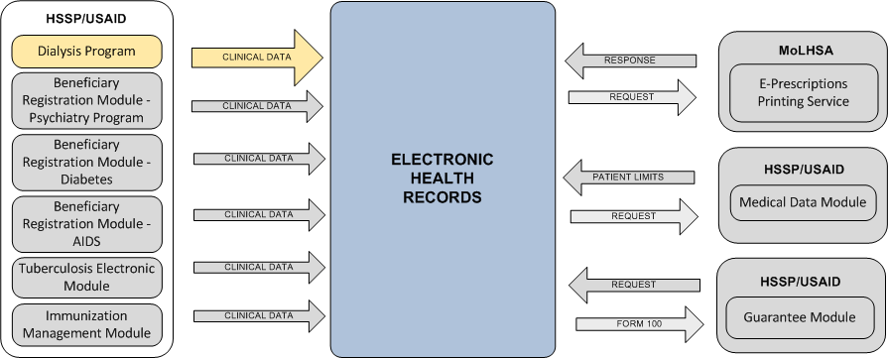
Picture 5. Data replication on peritoneal and hemodialysis

Sections 3.2.1.1 и 3.2.1.2 contains detailed scheme and process description.

Table 6. Common requirements for data replication of dialysis process
Process name | Dialysis Clinical Data Replication to EHR
Designation | DialysisCDR_B
Users | - MoLHSA specialists or doctors of Class B clinics -HSSP/USAID users  - EHR users who get the access to medical history of patient care
Data composition for replication | Clinical information about dialysis procedures (maximum information available in HSSP/USAID for transferring into EHR)
Direction of case data replication | HSSP/USAID -> EHR
Requirement to main stages of the process | - Case (with information about dialysis procedure) is created / edited/ closed in HSSP/USAID BRM Dialysis Program module  - Case information is automatically replicated into EHR  - EHR user gets the access to corresponding cases via EHR Doctor Portal or Mobile application

DialysisCDR_B process scheme
Picture 6 presents data replication scheme on dialysis in EHR from HSSP/USAID.
Picture 6. DialysisCDR_B process scheme

DialysisCDR_B process description
- Doctor or (MoLHSA specialist) creates a new case on dialysis in HSSP/USAID system using current interfaces (web-forms) and functions in Beneficiary Registration Module – Dialysis Program.
- After registration in HSSP/USAID system the clinical information about the case is transferred into EHR.
Clinical information which can be extracted from data base of related HSSP/USAID modules is supposed to be transferred. The structure of transferring data should comply with requirements presented in section 2.4.
Information transferring can be performed both in operated and deferred modes (after working hours).
- EHR system gets clinical information about the case and stores it in database with reference to indicated patient.
- EHR user gets the access to patient information via EHR Doctor Portal or EHR Mobile Service.

Data replication process from BRM Psychiatry Program to EHR
Table 9 contains the common requirements to data replication process from HSSP/USAID BRM Psychiatry Program modules into EHR. Process purpose is to ensure the existence of information about the facts of patient services provision in the direction of Psychiatry in EHR.

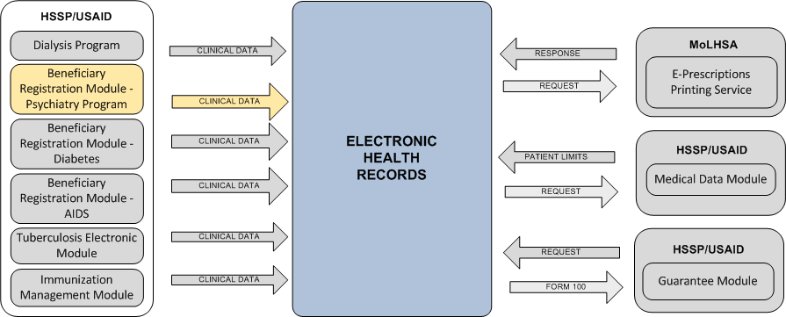
Picture 7. Data replication of Psychiatry

Sections 3.2.4.1 and 3.2.4.1 contain detailed information and process description.

Table 7. Common requirements for data replication of Psychiatry
Process name | Dialysis Clinical Data Replication to EHR
Designation | Psychiatry _CDR_B
Users | - MoLHSA specialists or doctors of Class B clinics -HSSP/USAID users  - EHR users who get the access to medical history of patient care
Data composition for replication | Clinical information about Psychiatry procedures (maximum information available in HSSP/USAID for transferring into EHR)  In the absence of information about the diagnosis of the patient and performed procedures a concise version of case can be transmitted into EHR. This version contains only patient identity data and patient belonging to citizen category who are registered in a psychiatric clinic.
Direction of case data replication | HSSP/USAID -> EHR
Requirement to main stages of the process | - Clinical information is saved in HSSP/USAID BRM Psychiatry Program module  - Information from this module is combined into package for replication onto EHR (data from other BRM modules can be combined into single package for transferring into EHR)  - Package (Case) is automatically replicated into EHR  - EHR user gets the access to corresponding cases via EHR Doctor Portal or Mobile application

Psychiatry _CDR_B process scheme
Picture 8 presents data replication scheme of Psychiatry into EHR from HSSP/USAID.
Picture 8. Psychiatry_CDR_B process scheme

Psychiatry_CDR_B process description
- A doctor (MoLHSA) specialist creates a new case in HSSP / USAID using the current interfaces (web-forms) and functions in module Beneficiary Registration Module - Psychiatry Program.
- After registration in HSSP/USAID system clinical information about the case is transferred into EHR.
Only the clinical information which can be extracted from database of corresponding modules are supposed to be transferred. The structure of transferred data should comply with the requirements described in section 2.4.
In the absence of information about the diagnosis of the patient and performed procedures a concise version of case can be transmitted into EHR. This version contains only patient identity data and patient belonging to citizen category who are registered in a psychiatric clinic.
Information transferring can be performed both in operated and deferred modes (after working hours).
- EHR gets clinical information about the case and stores it in database with reference to indicated patient.
- EHR user gets the access to received information about the patient via EHR Doctor Portal or EHR Mobile Service.

Data replication process from BRM Diabetes into EHR
Table 9 contains the common requirements to data replication process from HSSP/USAID BRM Diabetes modules into EHR. Process purpose is to ensure the existence of information about patients suffered from diabetics.

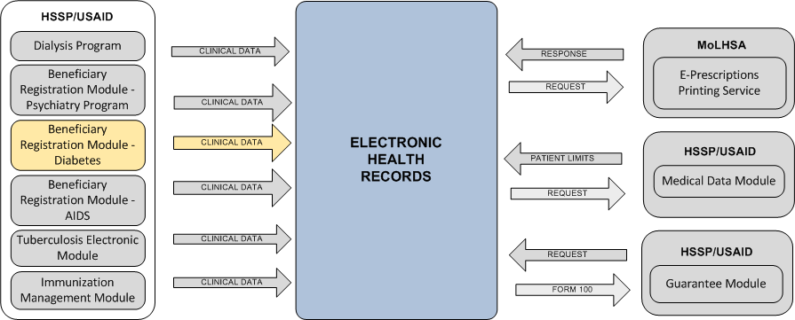
Picture 9. Data replication of diabetics

Sections 3.2.4.1 and 3.2.4.1 contains detailed scheme and process description.

Table 8. Common requirements for data replication of diabetics
Process name | Psychiatry, Diabetes and AIDS Clinical Data Replication to EHR
Designation | Psychiatry_Diabetes_AIDS_CDR_B
Users | - MoLHSA specialists or doctors of Class B clinics -HSSP/USAID users  - EHR users who get the access to medical history of patient care
Data composition for replication | Clinical information about patients suffered from diabetics  In the absence of information about the diagnosis of the patient and performed procedures a concise version of case can be transmitted into EHR. This version contains only patient identity data and patient’s diabetics status
Direction of case data replication | HSSP/USAID -> EHR
Requirement to main stages of the process | - Clinical information is saved in HSSP/USAIDBRM Diabetes module  - Information from this module is combined into package for replication onto EHR (data from other BRM modules can be combined into single package for transferring into EHR)  - Package (case) is automatically replicated into EHR  - EHR user gets the access to corresponding cases via EHR Doctor Portal or Mobile application

Diabetes_CDR_B process scheme
Data replication process scheme from BRM Diabetes module is similar to data replication scheme from BRM Psychiatry, presented in section 3.2.2.1.

Diabetes_CDR_B process description
- A doctor (MoLHSA) specialist creates a new case in HSSP / USAID using the current interfaces (web-forms) and functions in module Beneficiary Registration Module - Diabetics.
- After registration in HSSP/USAID system clinical information about the case is transferred into EHR.
Only the clinical information which can be extracted from database of corresponding modules is supposed to be transferred. The structure of transferred data should comply with the requirements described in section 2.4.
In the absence of information about the diagnosis of the patient and performed procedures a concise version of case can be transmitted into EHR. This version contains only patient identity data and patient’s diabetic status.
Information transferring can be performed both in operated and deferred modes (after working hours).
- EHR gets clinical information about the case and stores it in database with reference to indicated patient.
- EHR user gets the access to received information about the patient via EHR Doctor Portal or EHR Mobile Service.

Data replication process from BRM AIDS into EHR
Table 9 the common requirements to data replication process from HSSP/USAID BRM AIDS modules into EHR. Process purpose is to ensure the existence of information about AIDS – infected patients.

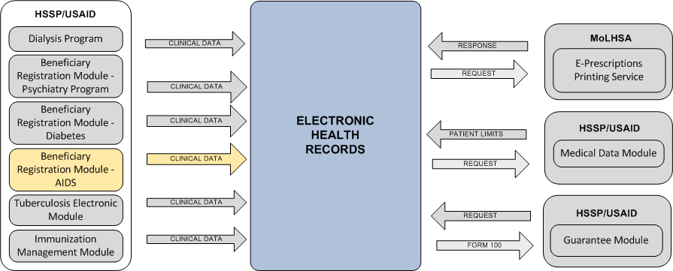
Picture 10. Data replication of AIDS

Sections 3.2.4.1 and 3.2.4.1 contains detailed information and process description.

Table 9. Common requirements for data replication of AIDS
Process name | AIDS Clinical Data Replication to EHR
Designation | AIDS_CDR_B
Users | - MoLHSA specialists or doctors of Class B clinics -HSSP/USAID users  - EHR users who get the access to medical history of patient care
Data composition for replication | Clinical information about AIDS –infected patients  In the absence of information about the diagnosis of the patient and performed procedures a concise version of case can be transmitted into EHR. This version contains only patient identity data and patient’s AIDS status
Direction of case data replication | HSSP/USAID -> EHR
Requirement to main stages of the process | - Clinical information is saved in HSSP/USAID BRM AIDS module  - Information from this module is combined into package for replication onto EHR (data from other BRM modules can be combined into single package for transferring into EHR)  - Package (case) is automatically replicated into EHR  - EHR user gets the access to corresponding cases via EHR Doctor Portal or Mobile application

AIDS_CDR_B process scheme
Data replication process scheme from BRM Diabetes module is similar to data replication scheme from BRM Psychiatry module presented in section 3.2.2.1.

AIDS _CDR_B process description
- A doctor (MoLHSA) specialist creates a new case in HSSP / USAID using the current interfaces (web-forms) and functions in module Beneficiary Registration Module - AIDS.
- After registration in HSSP/USAID system clinical information about the case is transferred into EHR.
Only the clinical information which can be extracted from database of corresponding modules is supposed to be transferred. The structure of transferred data should comply with the requirements described in section 2.4.
In the absence of information about the diagnosis of the patient and performed procedures a concise version of case can be transmitted into EHR. This version contains only patient identity data and patient’s AIDS status.
Information transferring can be performed both in operated and deferred modes (after working hours).
- EHR gets clinical information about the case and stores it in database with reference to indicated patient.
- EHR user gets the access to received information about the patient via EHR Doctor Portal or EHR Mobile Service.

Data replication process from Tuberculosis Electronic into EHR
Table 10 contains the common requirements содержит to data replication process from HSSP/USAID Tuberculosis Electronic module into EHR. Process purpose is to ensure the existence of information about the facts of services provision to the patients suffered from tuberculosis.
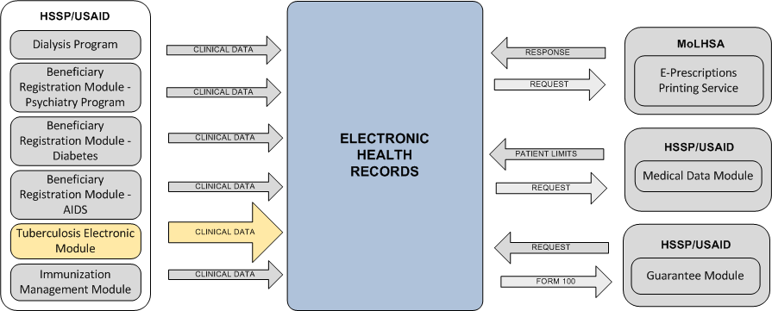
Picture 11. Data replication of treatment and prevention of tuberculosis

Sections 3.2.5.1 and 3.2.5.2 contain detailed information and process description.

Table 10. Common requirements for data replication of treatment and prevention of tuberculosis
Process name | Tuberculosis Clinical Data Replication to EHR
Designation | TuberculosisCDR_B
Users | - MoLHSA specialists or doctors of Class B clinics -HSSP/USAID users  - EHR users who get the access to medical history of patient care
Data composition for replication | Clinical information on accounting patients of tuberculosis clinics (the maximum volume available in the HSSP / USAID for data transmission into EHR).  In the absence of information about the diagnosis of the patient and performed procedures a concise version of case can be transmitted into EHR. This version contains only patient identity data and patient belonging to citizen category who are registered in a tuberculosis clinic.
Direction of case data replication | HSSP/USAID -> EHR
Requirement to main stages of the process | - Case with information about the patient registered in tuberculosis clinic is created/ edited/closed in HSSP/USAID Tuberculosis Electronic module  - Information about the case is automatically replicated into EHR  - EHR user gets the access to corresponding cases via EHR Doctor Portal or Mobile application

TuberculosisCDR_B process scheme
Picture 12 presents data replication scheme of medical services provision to the patients suffered from tuberculosis.

Picture 12. TuberculosisCDR_B process scheme

TuberculosisCDR_B process description
- A doctor (MoLHSA) specialist creates a new case in HSSP / USAID using the current interfaces (web-forms) and functions in module Tuberculosis Electronic.
- After registration in HSSP/USAID system clinical information about the case is transferred into EHR.
Only the clinical information which can be extracted from database of corresponding modules is supposed to be transferred. The structure of transferred data should comply with the requirements described in section 2.4.
In the absence of information about the diagnosis of the patient and performed procedures a concise version of case can be transmitted into EHR. This version contains only patient identity data and patient belonging to citizen category who are registered in a tuberculosis clinic.
Information transferring can be performed both in operated and deferred modes (after working hours).
- EHR gets clinical information about the case and stores it in database with reference to indicated patient.
- EHR user gets the access to received information about the patient via EHR Doctor Portal or EHR Mobile Service.

Data replication process from Immunization Management into EHR
Table 11 contains the common requirements содержит to data replication process from HSSP/USAID Immunization Management module into EHR. Process purpose is to ensure the existence of information about vaccinations received by patients.
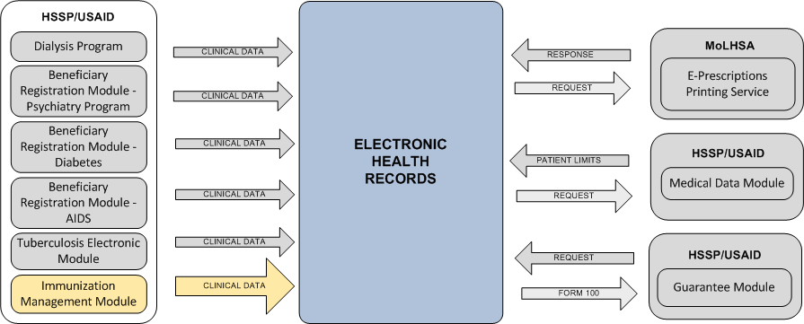
Picture 13. Data replication about immunization

Sections 3.2.6.1 and 3.2.6.2 contain detailed information and process description.
Table 11. Common requirements for data replication of imminization
Process name | Immunization Clinical Data Replication to EHR
Designation | ImmunizationCDR_B
Users | - MoLHSA specialists or doctors of Class B clinics -HSSP/USAID users  - EHR users who get the access to medical history of patient care
Data composition for replication | Clinical information about immunization of citizens in Georgia (maximum volume of information available in HSSP/USAID modules for data transferring into EHR).
Direction of case data replication | HSSP/USAID -> EHR
Requirement to main stages of the process | - Case with information about the patient received immunization service is created/ edited/closed in HSSP/USAID Immunization module  - Information about the case is automatically replicated into EHR EHR user gets the access to corresponding cases via EHR Doctor Portal or Mobile application

ImmunizationCDR_B process scheme
Picture 14 presents data replication scheme of immunization

Picture 14. ImmunizationCR_B process scheme

ImmunizationCDR_B process description
- A doctor (MoLHSA) specialist creates a new case in HSSP / USAID using the current interfaces (web-forms) and functions in module Immunization.
- After registration in HSSP/USAID system clinical information about the case is transferred into EHR.
Only the clinical information which can be extracted from database of corresponding modules is supposed to be transferred. The structure of transferred data should comply with the requirements described in section 2.4.
Information transferring can be performed both in operated and deferred modes (after working hours).
- EHR gets clinical information about the case and stores it in database with reference to indicated patient.
- EHR user gets the access to received information about the patient via EHR Doctor Portal or EHR Mobile Service.

The process of generating, viewing and printing of recipes via EHR interface
Table 12 contains general requirements for the printing process of the medical prescriptions via EHR interface by Class A clinic. Within this process automation the integration with existing MoLHSA service of forms prescriptions printing (MoLHSA ePrescription Forms Printing Service) should be implemented for getting the next number of the form. The process prescriptions generation with following its storing should be moved into a new platform EHR 2.1. EHR system should also support the ability of accounting numbers (the necessity to transfer this function from MoLhSA ePFSR will be defined at the design stage).
The main purpose of the process is to allow Class A clinics to print a medical prescriptions (specified in the relevant patient / case section in EHR) on forms approved by the Ministry.
Under the current Project phase it is not expected a full-featured implementation of the electronic prescription management module in EHR / wHospital.
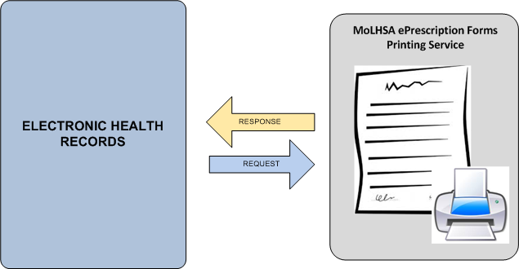
Picture 15. Medical appointments (prescriptions) print via Forms printing service

Table 12. Common requirements to prescriptions printing from EHR
Process name | ePrescription Print from EHR
Designation | ePrescription_A
Users | Doctors of Class A clinics (EHR users), who create cases (with filling prescriptions section)
Data composition for replication | Prescription text from case in EHR
Direction of case data replication | EHR -> MoLHSA ePrescription Forms Printing Service
Requirement to main stages of the process | - Doctor creates the case and fills in the section related with medical prescriptions  - Press the button “Prescription print”  - EHR system refers to forms print service to get the next form number for the current doctor. DoctorID is transferred as input parameter  - Form printing service returns the Form number  - EHR creates PDF-document based on defined template. The document contains the form number, text prescription and information about the doctor and clinic.  - PDF-document is saved in EHR storage  - The patient and the doctor can open and print this document  - PDF-document is available for viewing via Mobile device interface.

ePrescription_A process description
- The doctor (connected to EHR) via EHR Doctor Portal creates the case about patient visit with filling case prescription section.
- The doctor activates prescription printing.
In EHR interface the ability to connect to MoLHSA ePrescription Forms Printing Service for getting the next form number for this doctor should be implemented (by pressing corresponding button or link).
- EHR should perform an automatic prescription creation in the form of PDF-document which contains:
- Form number
- Doctor and clinic information
- Prescription text
- Created PDF-document should be saved in EHR for following using
- EHR user should be able to get the access to prescription via main EHR interface and via Mobile application. посредством мобильного приложения.
It is allowed that an alternative variant of ePrescription_A process implementation when PDF-document generation will be performed by means of existing MoLHSA ePrescription Forms Printing Service. In this case EHR should transfer the prescription text and doctor information as an input parameter to this service.
The variant of implementation will be defined at the design stage by agreement of the parties.
The Customer is responsible for the operability of this print service forms, as well as for the improvements to the service if they needs

Information access processes

The process of access to information on the limits of the patient from EHR
Table 13 contains the common requirements to the process of access to information about patient’s limits via EHR Doctor Portal for Class А clinics. Process purpose is to provide the access to patient’s financial information via EHR interface to improve the quality of doctor’s decision when making prescriptions.
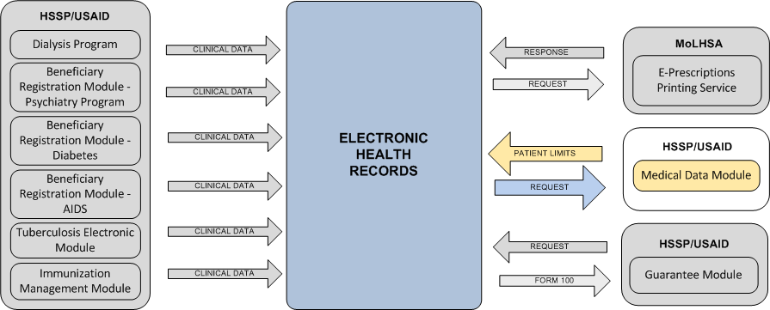
Picture 16. Getting information about patient limits

Sections 3.3.1.1and 3.3.1.2 contains detailed scheme and process description.
Table 13. Common requirements for getting information about patient limits
Process name | Patient Limit from EHR
Designation | PatientLimit _A
Users | Class A clinics (EHR users)
Data composition for replication | Information about patient’s medical limits funded by the state
Direction of case data replication | HSSP/USAID -> EHR
Requirement to main stages of the process | - Doctor works in EHR interface  - Requests the financial information about the patient from HSSP/USAID system (activate the request by pressing corresponding button or link)  - Gets the response from HSSP/USAID (or information unavailable message if the response from the HSSP / USAID has not been received)

PatientLimit _A process scheme
Picture 17 presents the scheme of getting information about patient’s limits form HSSP/USAID for EHR users.

Picture 17. PatientLimit _Aprocess scheme

PatientLimit _A process description
- The doctor connected to EHR via EHR Doctor views or edits the information about medical service provision to the patient.
- The doctor should have the ability to view information about patient’s limits presented in HSSP/USAID Beneficiary Registration Module и Medical Data.
Request for information about limits should be performed in on-line mode by request. EHR user should be able to activate the request for getting financial information about the patient (by clicking on the appropriate button or a link in EHR interface) and get an answer.
Financial information about the patient is displayed in EHR in read-only mode.
- When the financial information request is activated a corresponding EHR automated service should request to HSSP / USAID automated service.
If there is no response from HSSP / USAID for some time in EHR the message about the inaccessibility of patient's limits information should be displayed.

The process to access to Form 100 from HSSP/USAID Guarantee Module
Functional requirements for the ability of automatic filling of Form 100 are described in Functional specification - Part 1, under the description of the process «PlannedCR_A».
The ability to automatically fill Form 100 in USAID should also be available regardless of the process. In other words, USAID user or any other external system user should be able to connect to EHR for getting patient’s Form 100.
This requirement means that in EHR a corresponding service received a patient identifier as input parameter should be implemented.

The process to access clinical data received from HSSP/USAID in EHR
Picture 18 presents the common scheme of the processes of doctor’s and patient’s access to clinical information received form HSSP/USAID modules and stored in EHR. The access should be performed via EHR Doctor Portal and via EHR Mobile Service.
Picture 18. Case information access processes scheme

Functional requirements

EHR basic functions requirements EHR

General information
This document contains requirements only for new features EHR, which should be implemented in EHR as part of EHR-HSSP / USAID integration (part 2).

User functions requirements
The following basic functions should be available for the user:
View information about the cases automatically loaded into EHR from HSSP/USAID (BRM Dialysis Program, BRM Psychiatry Program etc.) modules.
View information about patients limits from HSSP/USIAD Medical Data module.
Generation, view and printing of medical prescriptions (in PDF – formats) generated by system in conjunction with the service of forms printing (MoLHSA ePrescription Forms Printing Service).

Information view should be possible via EHR Doctor Portal and via EHR Mobile Service.

Generation, view and printing of electronic prescriptions
The doctor who works in EHR, should have the ability to create PDF-document containing the text of medical prescription (from medications section of current case), form number (obtained from the existing MoLHSA ePrescription Forms Printing Service) and information about doctor and clinic.
Created PDF-document should be available for viewing and sending to the printer.
Description of the process is presented in section 3.2.7.

View information about patient’s limits
When viewing or editing card of the patient (patient's history of service) via EHR interface the doctor should be able to query to HSSP / USIAD system for a brief financial information about the patient (in particular about patient’s limits on receiving medical services within state financing).
The composition of the financial information for this request from HSSP / USAID and display this information in EHR interface will be defined at the design stage.
The description of the corresponding process is shown in section 3.3.1.

View of case information
EHR users should be able to view information about cases replicated in automatic mode from HSSP/USAID modules within the following processes:
DialysisCDR_B (data replication on dialysis), section 3.2.1
Psychiatry_Diabetes, AIDS_CDR_B (data replication on Psychiatry), section 3.2.4
TuberculosisCDR_B (data replication on Treatment and Prevention of Tuberculosis),section 3.2.2
ImmunizationCDR_B. Section 3.2.6
View information about cases should be available via EHR Doctor Portal and EHR Mobile Service.

Automated services requirements
In EHR the following automated services should be available:
Call service MoLHSA ePrescription Forms Printing Service for getting Form number (with transferring prescription text and getting PDF-document)
Request, receive and display information about patient’s limits from HSSP / USAID system
Receiving, processing and preservation of clinical information about cases derived from HSSP / USAID modules

Call service MoLHSA ePrescription Forms Printing Service
In EHR should be implemented the function of calling the service of prescription generation in pdf–format. Pdf – document contains information about prescriptions, from number, and doctor’s and clinic information.
This service should perform the following main functions:
Call service of accounting and printing of forms for the next from number getting
Getting a response from the service
Generation of a prescription as PDF-document with automatic insertion into the body of the document form number, prescription text and information about the doctor / clinic.
Saving PDF-prescription in EHR storage
The description of printing of medical prescription process in EHR is described in section 3.2.7.

Getting information about patient’s limits
To be able to obtain information about patient’s limits from HSSP / USAID in EHR an appropriate service should be implemented. This service should perform the following basic operations:
Sending the request into HSSP / USAID with identity of the patient
Getting the answer with data package containing information about the limit
Sending a response to transmitting side
Display information about the limit in EHR interface or unreachable of financial information from HSSP/USAID
The description this process id presented in section 3.3.1.

Processing received clinical information about cases
To be able to obtain information about the cases from HSSP / USAID system in EHR an appropriate service should be implemented.
This service should perform the following operations:
Getting data package from HSSP/USAID
Saving received information in EHR database
Sending the response to transmitted side about replication results
Process description of getting clinical information from HSSP/USAID is presented in sections 3.2.1, 3.2.4, 3.2.2 and 3.2.6.

Requirements to basic HSSP/USAID functions

General information
This document contains requirements only for new features EHR, which should be implemented in HSSP/USAID as part of EHR-HSSP / USAID integration (part 2).

User functions requirements
Within EHR-HSSP/USAID integration (Part 2) implementation oа additional user functions are not expected.

Automated services requirements
In HSSP/USAID should be available the following automated services:
Replication of clinical information about cases into EHR
Uploading the information about patient’s limits on EHR request

Replication of clinical information about cases into EHR
In HSSP/USAID service of automated replication of clinical information about cases into EHR should be implemented. This service should perform the following operations:
Creation of data package for replication
Replication of created package into EHR
Getting response from EHR about replication results
When data package creating the service should include the whole volume of clinical information available in HSSP/USAID.
The description of clinical information replication processes from HSSP/USAID into EHR is presented in sections 3.2.1, 3.2.4, 3.2.2 and 3.2.6.

Uploading information about patient’s limits
To be able to upload information about patient’s limits on EHR request in HSSP / USAID an appropriate service should be implemented.
This service should perform the following basic operations:
Getting the request with patient identic data from EHR
Creating the package with financial information about the patient
Sending created package into EHR
Getting the response from EHR
The description of this process is presented in section 3.3.1.

Requirements to basic functions of the prescription print service

User functions requirements
Within EHR-HSSP/USAID integration (Part 2) implementation oа additional user functions at prescription print service are not expected.

Automated services requirements
At the side of prescription print service the possibility of receiving the request for the provision of the next form number (which will be used for PDF-prescription generation in EHR) for indicated doctor should be implemented.
Implementation of the feature is performed by the Customer.

Here and further in the document «Case» is a set of clinical information about the fact of medical service provision which entered and stored in data base of any HSSP/USAID module( it might be not Case Registration Module)
ЗHere and further replication procedure should be detailed on design stage

