Signed by  ______________________  «___»_________2015 г. | Signed by  ______________________  «___»_________2015 г.

Functional Specification
Collaborative Health Environment (CHE) of Georgia
EMR 2.1

Part 3 (3 from 3)
EHR and HSSP Integration (Mobile Platform)

45 Pages

Reconciliation sheet

Supplier
Position | Name | Signature | Date

Customer
Position | Name | Signature | Date

Content
1. Overview 8
1.1 Purpose of the document 8
1.2. Main goals and objectives 8
1.2.1. Project goals and objectives 8
1.2.3. Goals and objectives of EHR-HSSP integration ( Part 3) 10
1.2.4. General scheme of data flows for mobile services 11
2. General requirements to Mobile Platform 12
2.1. General requirements to functionality 12
2.2. Summary table of mobile services 12
3. Requirements to core business processes 15
3.1. Processes within mobile services-directories 15
3.1.1. Process of access to medical institutions directory 15
3.1.2. Process of access to a directory of medicines 17
3.1.3. Process of access to a directory of first aid 20
3.2. Processes of passive services of access to EMR 22
3.2.1. Process of access to EMR for patients 22
3.2.2. Process of access to electronic prescriptions for patients 25
3.3. Process of active services of access to EMR 29
3.3.1. Process of access to EMR for doctors 29
3.3.2. Process of access to electronic prescriptions for doctors 32
3.4. Processes of services of operational information 35
3.4.1. Process of access to basic financial indicators 35
3.4.2. Process of access to statistics 36
3.4.3. Process of access to EHR loading information 37
4. Functional requirements 40
4.1. Requirements to the basic functions for patients 40
4.2. Requirements to the basic functions for doctors 42
4.3. Requirements to the basic functions for Ministry specialists 45
Tables
Table 1. Glossary 7
Table 2. Summary table of mobile services description 13
Table 3. Common requirements to process of access to medical institutions directory 15
Table 4. Common requirements to process of access to directory of medicines 18
Table 5. Common requirements to process of access to a directory oа first aid 21
Table 6. Common requirement to process of access to EMR for patients 23
Table 7. Common requirements for process of access to elecronic prescriptions for patients 25
Table 8. Common requirements of process of access to EMR for doctors 29
Table 9. Common requirements to process of access to electronic prescription for doctors 33
Table 10. Common requirements to process of access to financial indicators 35
Table 11. Common requirements to process of access to statistics 36
Table 12. Common requirements to process of access to EHR loading 38
Table 13. Description of User forms and functions available for patients 41
Table 14. Description of User forms and functions available for doctors 43
Table 15. Description of User forms and functions available for Ministry specialists 45

Pictures
Picture 1. Goal CHE scheme 9
Picture 2. Scheme of dat aflows for mobile services 11
Picture 3. Data flows of the process of access to medical institutions directory 15
Picture 4. Common scheme of process of access to medical institution directory 16
Picture 5. Data flows of process of access to the directory of medicines 18
Picture 6. Common scheme of process of access to directory ofmedicines 19
Picture 7. Data flows of process of access to a directory oа first aid 21
Picture 8. Data flows of process of access to EMR for patients 23
Picture 9. Common scheme of access to EMR for patients 24
Picture 10. Data flow of process of access to elecronic prescriptions for patients 25
Picture 11. Common scheme of process of access to elecronic records for patients 27
Picture 12. Data flows of process of access to EMR for doctors 29
Picture 13. Common scheme of process of access to EMR for doctor 31
Picture 14. Data flows of process of access to electronic prescription for doctors 33
Picture 15. Common scheme of porcess od acccess to electronic records for doctors 34
Picture 16. Data flows of process of access to financial indicators 35
Picture 17. Data flows of process of access to statistics 36
Picture 18. Data flows of process of access to EHR loading 38
Picture 19. Sequence of forms available for patients – Mobile services users 40
Picture 20. Sequence of forms available for doctors – Mobile services users 42
Picture 21. Sequence of forms available for Ministry specialists 45

History of changes
Version | Date | Author | Comments
1.0 | 22.06.2015 |  | Version 1.0

Glossary
Table 1. Glossary
CHE | Collaborative Health care Environment
EHR/EHR | Electronic Medical Records/ Electronic Health Records
HIS | Health Information System
HMIS | Health Management Information System
HSSP | Health System Strengthening Project
MoLHSA | Ministry of Labor, Health and Social Affairs of Georgia
Mobile Service | Mobile Service is service which is included into Mobile Platform and provides the access to Clinical information in EHR
Customer | Ministry of Labor, Health and Social Affairs of Georgia
Case | The fact of medical service provision to the patient ( in the context of this document)
Clinical Information | Medical information about the patients to be stored in EHR

Overview

Purpose of the document
This document contains the description of functional requirements to EHR-HSSP integration (Part 3). Within this Integration it is demanded to implement the access to clinical and reference information via Mobile devices.
The main requirements to the functionality of EHR-HSSP Integration (Part 3) are presented in the next sections:
Section 1.2 contains the description of the goals and objectives of mobile services implementation
Section 2 presents general description of requirements to mobile platform
Section 3 contains the description of business process requirements
Section 4 contains user functions requirements and automated functions

Main goals and objectives

Project goals and objectives
Project main goals:
- Defining of HMIS information strategy development (as a whole and its individual parts), taking into account the features of the current infrastructure of the Customer and the needs of key members of the Health system of Georgia
- Improving the efficiency of information management
elimination of data and data entry duplication
improving the quality of stored information through the use of common standards and classifiers
optimization of data streams
Reporting Information
- Implementation of quick access to the required information (medical, financial, etc.) in the required format for all users of a collaborative information environment

To achieve these goals the following main objectives need to be addressed:
- Development the common HMIS software architecture including existing and planned modules.
- Development of proposals for a partial restructuring of existing processes and data flows within HMIS based on the analysis of functional modules and the details of modules interaction.
- Integration between HSSP and EHR modules and partial adjustment of processes and HMIS subsystems functionality
- HMIS technical architecture clarification
- Development of HMIS new modules connections, the description of the main requirements to plug-ins (to standards, interfaces, etc.)

    - Common requirements to the CHE architecture
Picture 1 Generalized CHE target scheme, which must be implemented within the current phase of the project
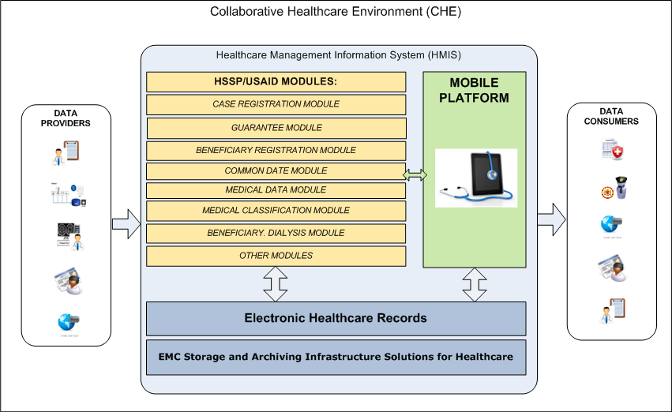
Picture 1. Goal CHE scheme

Goals and objectives of EHR-HSSP integration ( Part 3)
Main goals of Part 3:
Ensure the access of Collaborative Healthcare Environment (CHE) participants to basic information (medical, financial and etc.) controlled by HMIS from mobile devices
Improving the quality of health care by providing rapid access to clinical information for patients and for doctors.
Improving of subsystem of electronic prescriptions extracting by providing access to prescriptions from mobile devices that will provide quick and easy purchasing of essential drugs at the pharmacy.
Raising awareness about the available health facilities pharmacies and medicines
Improving the quality of the health system in Georgia by providing real-time access to financial and statistical reports to relevant MoLHSA specialists.
To achieve these goals need to be addressed the following tasks:
To develop a unified mobile platform providing a set of functional services for different user roles: patients, doctors, MoLHSA specialists
To implement a mobile application containing the necessary functional services, depending on the user's role.
To provide an extensibility of mobile platform with the ability of adding new functional services providing access to a wide range of information processed in HMIS subsystems.

General scheme of data flows for mobile services
Picture 2 presents the general scheme illustrated the direction of main data flows demanded for mobile services operation.
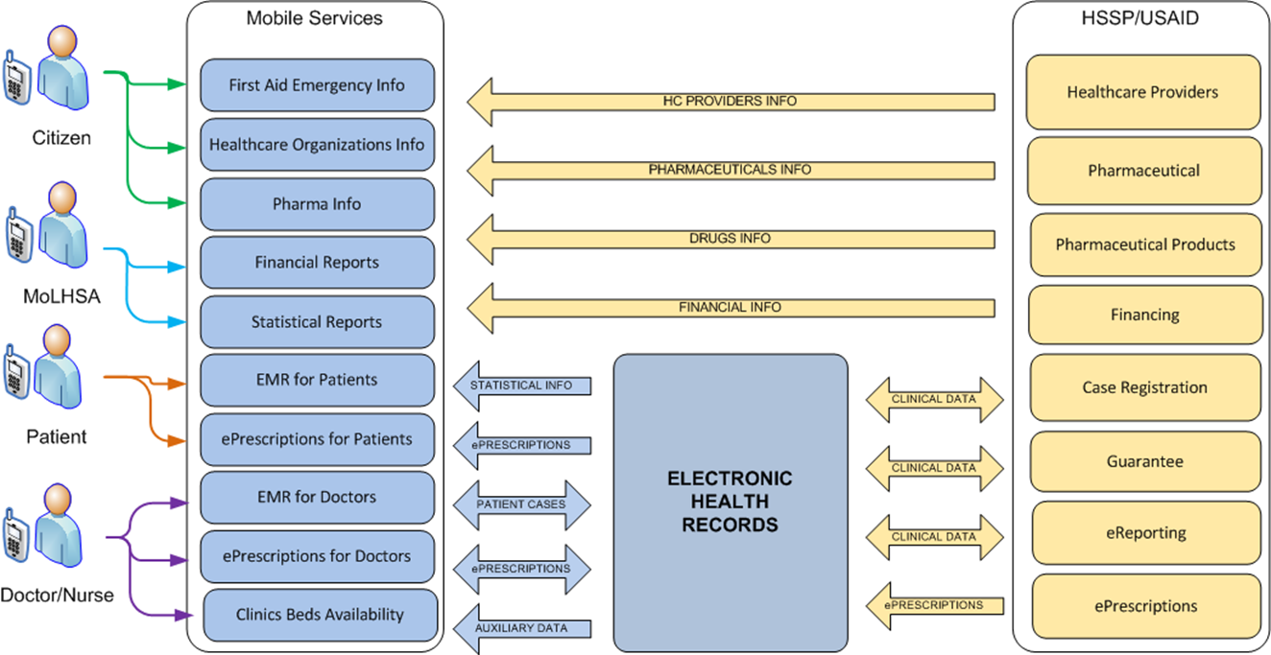
Picture 2. Scheme of dat aflows for mobile services
Presented scheme is preliminary and can be adjusted at the platform design stage.

General requirements to Mobile Platform

General requirements to functionality
Mobile platform should provide the access to basic Georgia health care system from mobile devices for citizens, employees of medical institutions and MoLHSA employees:
Mobile Platform should ensure the access of patients (Georgian citizens) to the information contained in electronic health records
Mobile platform should provide access of doctors to electronic medical records of patients with whom they work. Access to patient information should be provided with the consent of patients to have access to their clinical data (Patient Consent)
Mobile Platform should ensure the access of citizens of Georgia to reference information about medical institutions, pharmacies and medicines.
Mobile platform should provide the access for MoLHSA employees to financial and statistical reports

Summary table of mobile services
All mobile services can be divided into 4 main types:
Type 1Т- directories
These services provide reference information to a wide range of users. This type of service does not require deep integration with existing modules, as the information provided by users is essentially static and rarely changed. General guide to the medical institutions of Georgia relates to such directory type.

Type 2 – passive services for the access to electronic medical records
These services enable users to obtain information about the patients, but do not allow to change this information. This type of services requires integration with EHR, but only for reading. An example of this type of service is a service of access to EMR for the patient.
Type 3 – active services for the access to electronic medical records
These services enable users to obtain information about the patient and to edit it. This type of services requires integration with EHR for reading and editing. An example of this type of service is a service of access to EMR for doctors.
Type 4 – mobile services of operational information
This type of service enables users to receive various reports generated by the various modules. Unlike directories such services provide operational information about data state in different modules. This type of service requires integration with EHR or with the appropriate module which generates reports. An example of this type of services is a service of access to financial indicators for MoLHSA employees.

Table 2 contains summary description of mobile services. The reference to detailed description of each process is given in 1-st column of the table. Appropriate scheme of data flows is presented on Picture 2 section 1.2.4.
Table 2. Summary table of mobile services description
Service type | Mobile service name | Users | Description | Section
Type 1 | Healthcare Organizations Info | All Georgia citizens | Service allows to get information about medical institutions in Georgia | 3.1.1
Type 1 | Pharma Info | All Georgia citizens | Service allows to get information about medication | 3.1.2
Type 1 | First Aid Emergency Info | All Georgia citizens | Service allows get information on first aid in emergency situations | 3.1.3
Type 2 | EMR for Patients | Georgian citizen registered as patients – users of mobile services | Service allows patients to view information about the history of visits to medical institutions of Georgia (information is contained in the EHR) | 3.2.1
Type 2 | ePrescriptions for Patients | Georgian citizen registered as patients – users of mobile services | Service allows patients to view information about the doctor's prescription (information is contained in the EHR) | 3.2.2
Type 3 3 | EMR for Doctors | Employees of medical agencies providing health services to patients and having access to mobile services | Service allows doctors to view, edit and register information about the history of patient visits into medical institutions of Georgia (information is contained in the EHR) | 3.3.1
Type 3 3 | ePrescriptions for Doctors | Employees of medical agencies providing health services to patients and having access to mobile services | Service allows doctors to view, edit and register the prescriptions for patients ( information is contained in the EHR) | 3.3.2
Type 4 | Financial Reports | Ministry specialists | Service allows to get financial reports | 3.4.1
Type 4 | Statistical Reports | Ministry specialists | Service allows to get statistical reports | 3.4.2
Type 4 | EHR data loading control | Ministry specialists | EHR loading | 3.4.3

Requirements to core business processes

Processes within mobile services-directories

Process of access to medical institutions directory
Picture 3 and Table 3 contain the common requirements to the process of access to medical institutions (located in Georgia) directory. Online access to medical institutions directory should allow Georgian citizens to receive information about the medical institution location and contact information with the possibility of calling to this health facility.
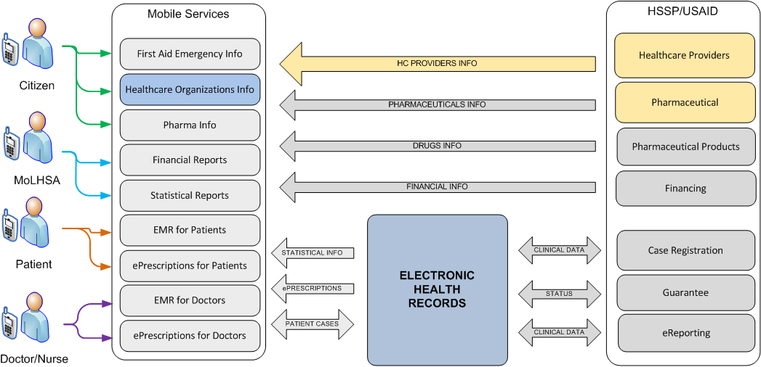
Picture 3. Data flows of the process of access to medical institutions directory
Sections 3.1.1.1 and 3.1.1.2 contain detailed information and process description.
Table 3. Common requirements to process of access to medical institutions directory
Process name | Healthcare Organizations Info Mobile Service
Designation | HCOrgInfo_Mobile
Users | All Georgia citizens
Requirement to main stages of the process | - User starts Mobile application  - Specifies the search criteria of medical institutions ( example: type - clinic / pharmacy / hospital) or chooses an option to view the nearby facilities without defining search conditions  - In response to an inquiry system shows a summary of found institutions  - User can view detailed information about the institution (address, phone, etc.) with the possibility of calling to the medical facility.

HCOrgInfo_Mobile process scheme
Picture 4 presents the sequence diagram for the process of accessing to medical institutions directory.
Picture 4. Common scheme of process of access to medical institution directory

HCOrgInfo_Mobile process description
The access to medical institutions directory should be provided for Mobile Platform users without the need of authorization. To generate data that the service will operate the information from the following modules HSSP should be used:
- Healthcare Facilities Licensing/Permitting Module
- Pharmaceutical Module
The service if necessary may use other sources of information (Financing Module for example). The sources and data composition for using in the service will be specified at the design stage. Ensuring the availability of required directories and update information in these directories is the responsibility of the Customer.
It is allowed to store the data (the whole volume or part of) that are to be displayed in the service interface in Mobile device memory. Procedure for synchronizing data in Mobile device memory with the information source should be configurable. Data editing at the Mobile application is not permitted. Therefore the synchronization will be always in one direction: from data source into mobile device memory.
Requirements for data synchronization (mode: operational or background, frequency, etc.) will be specified at the design stage.
The service should support the offline-mode (no network access). In this mode, the service should show at least basic information about medical facilities, such as emergency centers, trauma centers and major hospitals. Filling and updating directories is provided by the Customer.
The service should provide the user with the following functions:
- Viewing the nearest medical institutions
- Search institution by the name
- Search institution by using filters (type, specialization, etc.).
- View institution card containing basic information (name, address, phone, etc.)
- Making an outgoing call to desired institution
The list of available functions can be specified at the design stage.

Process of access to a directory of medicines
Picture 5 and Table 4 contain the common requirements to the process of access to a directory of medicines. Process purpose is to provide Georgian citizens with online access to actual database of medicines allowed and circulated in the country
For medicine the following information should be available: the active ingredient, release form of medicine, indications/contraindications, side effects, dosage and method of ingestion, the average price in pharmacies

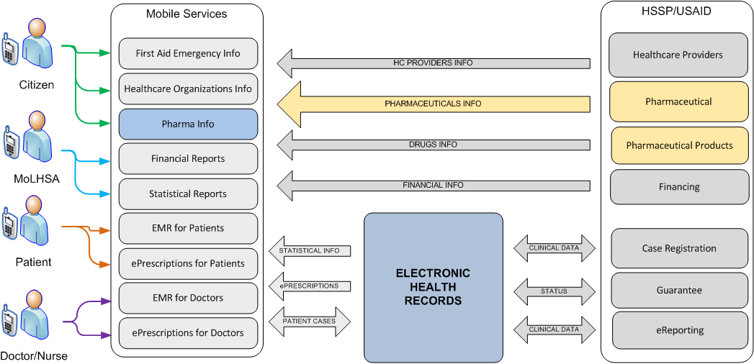
Picture 5. Data flows of process of access to the directory of medicines

Sections 3.1.2.1 and 3.1.2.2 contain the detailed information and process description.

Table 4. Common requirements to process of access to directory of medicines
Process name | Pharma Info Mobile Service
Designation | PharmaInfo_Mobile
Users | All Georgian citizens
Requirement to main stages of the process | - User specifies the search criteria of medicine ( example: type of active ingredient, commercial name)  - In response to an inquiry system shows a summary of found medicines  - User can select the medicine and view detailed information

PharmaInfo_Mobile process scheme
Picture 6 presents the sequence diagram for the process of accessing to directory of medicines.

Picture 6. Common scheme of process of access to directory ofmedicines

PharmaInfo_Mobile process description
The access to directory of medicines should be provided for Mobile Platform users without the need of authorization. To generate data that the service will operate the information from the following modules HSSP should be used:
- Pharmaceutical Products Module
- Pharmaceutical Module
The service if necessary may use other sources of information (EHR database for example). The sources and data composition for using in the service will be specified at the design stage. Ensuring the availability of required directories and update information in these directories is the responsibility of the Customer.
The service should support the ability to display medicines filtered by categories, as well as indicating the categories available for specific pharmacies (based on relevant information from HSSP modules).
It is allowed to store part of medicine data in Mobile device memory. It can be a summary of available medicines (name, active ingredient, etc.) with the ability to search by category. Detailed information on relevant medicines should be transferred form the server by a request.
Procedure for synchronizing data in Mobile device memory with the information source should be configurable. Data editing at the Mobile application is not permitted. Therefore the synchronization will be always in one direction: from data source into mobile device memory.
Requirements for data synchronization (mode: operational or background, frequency, etc.) will be specified at the design stage.
The service should support the offline-mode (no network access). In this mode, the service should show at least basic information about medicine. Filling and updating directories is provided by the Customer.
The service should provide the user with the following functions:
- Search medicine by the name
- Sorting of medicines by categories
- View medicine short description
- View the card of medicine with detailed information
The list of available functions can be specified at the design stage.

Process of access to a directory of first aid
Picture 7 and Table 5 contain the common requirements to the process of access to a directory of first aid. Process purpose is to provide Georgian citizens with online access to set of instructions to provide first aid while waiting for the arrival of the ambulance. The application should also allow to make a call to the ambulance service.

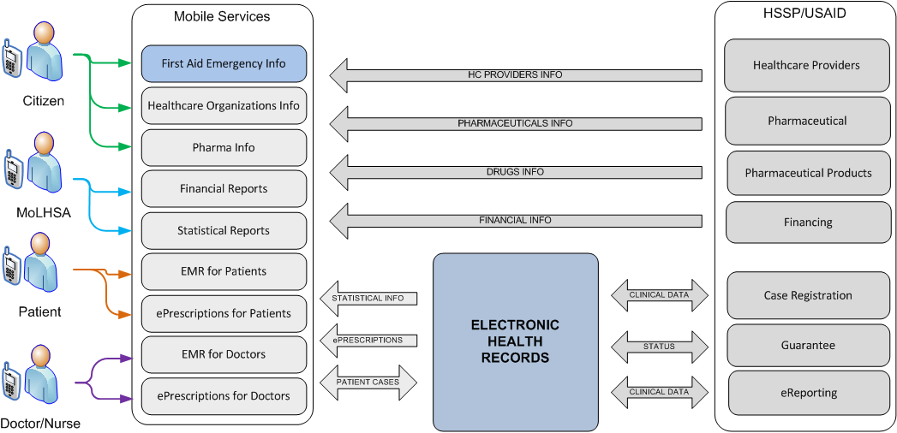
Picture 7. Data flows of process of access to a directory oа first aid

Table 5. Common requirements to process of access to a directory oа first aid
Process name | First Aid Mobile Service
Designation | FirstAid_Mobile
Users | All Georgian citizens
Requirement to main stages of the process | - User starts Mobile application  - User specifies the criteria of instructions search, indicating the nature of damage and the patient's condition. This mobile application should contain a set of basic instructions, available without the need to specify search conditions (for example, instructions for the implementation of artificial respiration, tourniquet, etc.).  - Mobile application displays the instruction (text and graphics) to implement the recommended actions for the first aid to the victim  - Regardless of the search and reading the instructions, the user should be able to make a call to a single ambulance service

FirstAid_Mobile process description
The access to directory of first aid should be provided for Mobile Platform users without the need of authorization.
Service should provide quick access to reference information provided in the form of cards containing clear instructions on first aid in certain situations. For example, the instruction on the implementation of procedures of artificial respiration, tourniquet, burn treatment etc.). Each card can contain the instructions in the following formats:
- text with clear instructions for action
- graphical information (pictures, diagrams, etc.)
All information which this mobile service is operated with should be stored Mobile device memory. Lack of access to the mobile network / wi-fi should not be an obstacle to the instructions.
Filling and updated the directory is provided by the Customer.
In addition, the service should allow to make outgoing call to the emergency services. The user should be relieved from having to dial the number. Call to the emergency service should be performed automatically by pressing the appropriate button in this service interface.
The service must provide the user with the following functions:
- Search instructions by keywords ("broken" for example)
- View cards containing text and visual instructions on first aid
- Make calls to emergency services
The list of available functions can be specified at the design stage.

Processes of passive services of access to EMR

Process of access to EMR for patients
Picture 8 and Table 6 contain the common requirements to the process of access to EMR for patients. The process should allow to Georgian citizens to receive on-line information about the history of theirs visits to medical institutions. Patients have the right to view only their history, they cannot change existing or create new entries. To gain access to their history, patients should first get an account in EHR. Patients should have the access to information about all corresponding cases regardless of the way of entering the case ( in HSSP modules or directly to the EHR).

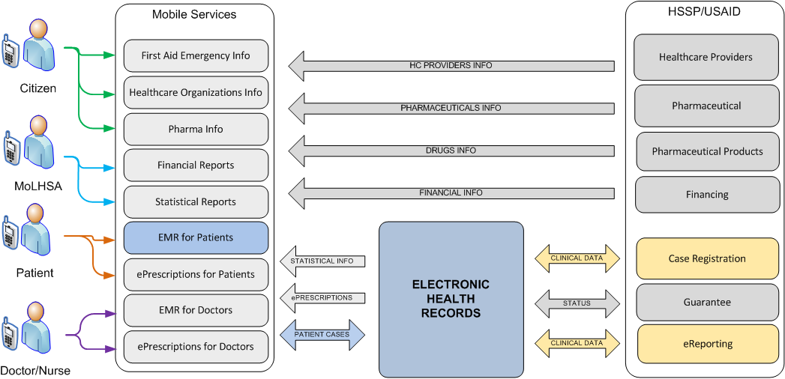
Picture 8. Data flows of process of access to EMR for patients
Sections 3.2.1.1 and 3.2.1.2 contained detailed information and process description.
Table 6. Common requirement to process of access to EMR for patients
Process name | Patient EMR Cases Mobile Service
Designation | PatientEMRInfo_Mobile
Users | Citizens of Georgia registered as patients –users of mobile access to the electronic medical record
Requirement to main stages of the process | - User starts Mobile application  - Enters login and password for authentication  - System authenticates the user as a registered user with access to personal electronic medical record  - User requests an electronic history (medical institutions) of visits to hospitals and get a list of registered cases  - After case selection the user gets detailed information about the case

PatientEMRInfo_Mobile process scheme
Picture 9 presents the sequence diagram for the process of accessing to EMR for the patients.
Picture 9. Common scheme of access to EMR for patients

PatientEMRInfo_Mobile process description
Access to EMR can be available only after the user's authorization. Each patient should have the access only to his records stored in EHR. Access to the records of other patients is not allowed.
Storing information in Mobile device memory is not supposed for this service. All information is displayed via service interface, it should be transferred on-line from EHR database. The user should not be able to edit the information received from the server.
The service should provide the user with the following functions:
- Getting the maintenance history in Medical Institutions (case list)
- Filtering case list by date (by specifying a period "from-to") and by status (open / closed)
- View information available in EHR related the case
- View prescriptions / appointments created by the doctor related to the case
The list of available functions may be specified at the design stage.

Process of access to electronic prescriptions for patients
Picture 10 и Table 7 contain the common requirements to the process of electronic prescriptions for patients The process should allow patients to quickly receive information about prescriptions prescribing by the doctors while treatment. Patients should be able to view only those prescriptions that have been written for them. Patients should not be able to modify existing or create new prescriptions.

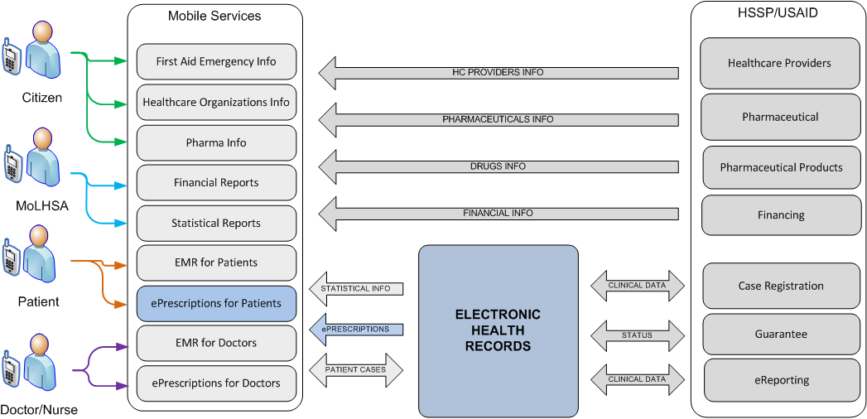
Picture 10. Data flow of process of access to elecronic prescriptions for patients
Sections 3.2.2.1 and 3.2.2.2 contain detailed information and process description.
Table 7. Common requirements for process of access to elecronic prescriptions for patients
Process name | Patient ePrescriptions Mobile Service
Designation | PatientePrescriptions_Mobile
Users | - Citizens of Georgia registered as patients –users of mobile access to the electronic medical record
Requirement to main stages of the process | - User starts Mobile application  - Enter login and password  - Gets the list of registered cases (see. 3.2.1)  - Patient requests the list of prescriptions written for defined case  - After prescription selection the patient can view the details (type and quantity of medicines)

PatientePrescriptions_Mobile process scheme
Picture 11 presents the sequence diagram for the process of accessing to electronic records for the patients.
Picture 11. Common scheme of process of access to elecronic records for patients

PatientePrescriptions_Mobile process description
View information about prescriptions / appointments should be performed at the same user interface as the patient views his medical records (EMR). The description of process of access is presented in section 3.2.1.

Process of active services of access to EMR

Process of access to EMR for doctors
Picture 12 и Table 8 contain the common requirements to the process of access to EMR for doctors. The process should allow doctors to receive on-line information about the history of patients’ visits to medical institutions. To gain the access to patients’ history doctors should first get an account in EHR. Except for view of existing records doctors have the ability to edit existing and create new records about the patients.

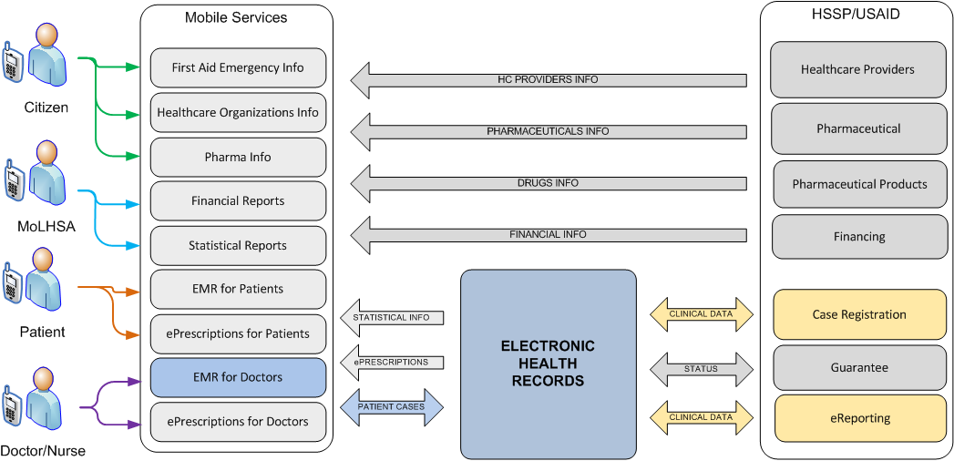
Picture 12. Data flows of process of access to EMR for doctors
Sections 3.3.1.1 and 3.3.1.2 contain detailed information and process description.
Table 8. Common requirements of process of access to EMR for doctors
Process name | Doctor EMR Cases Mobile Service
Designation | DoctorEMR_Mobile
Users | Employees of medical institutions registered as users of mobile access to e-patient records
Requirement to main stages of the process | - User starts Mobile application  - User enters login and password for identification, and enters the code of medical institution on behalf of which he will access to electronic patient records  - The system authenticates the user as a registered user with access to the electronic patient records  - The user identifies the patient : enters Civil Registration Number or Name / Surname / Date of birth  - In response System displays the demographic information about the patient and if available a photo of the patient, so the doctor can make sure that this patient just the person he is currently working with.  - Doctor requests an electronic history of visits to hospitals and gets a list of registered cases in accordance with the policy oа cases availability based on Patient consent.  - After choosing the case doctor receives detailed information about the case.  - Doctor has the ability to edit case information and save the changes in EMR.  - The doctor has the ability to create a new record of the case and save the changes in EMR.

DoctorEMR_Mobile process scheme
Picture 13 presents the sequence diagram for the process of accessing to EMR for doctors.
Picture 13. Common scheme of process of access to EMR for doctor

DoctorEMR_Mobile description process
The access to the patient's EMR can be available only after doctor’s authorization as well as particular doctor permissions to view / edit the records related to the patient. Once authorized the doctor should be able perform identification of the patient by using patient’s unique identifier (Civil Registration Number) or patient’s name and date of birth.
Interface of view of the history of patient’s visits should be similar to the interface of patient’s access to his own medical history (see section 3.2.1). However within DoctorEMR_Mobile service the ability to edit the current cases, as well as creating new ones should be implemented.
This service is not intended to store information in Mobile device memory. All information displayed in service interface should be transferred on-line from EHR database.
Service Is to provide the user with the following functions:
- Search EMR patient (list of cases for the patient
- Filtering the list of cases by date (by specifying a period of "from-to") and by status (open / closed)
- View information available in EHR about the case
- View prescriptions / appointments created by the doctor for this case
- Editing case
- Creating a new case with filling mandatory fields
The list of available functions may be specified at the design stage.

Process of access to electronic prescriptions for doctors
Picture 14 и Table 9 contain the requirements to the process of electronic prescriptions for doctors. The process should allow doctors to receive information about prescriptions prescribing for the patient.

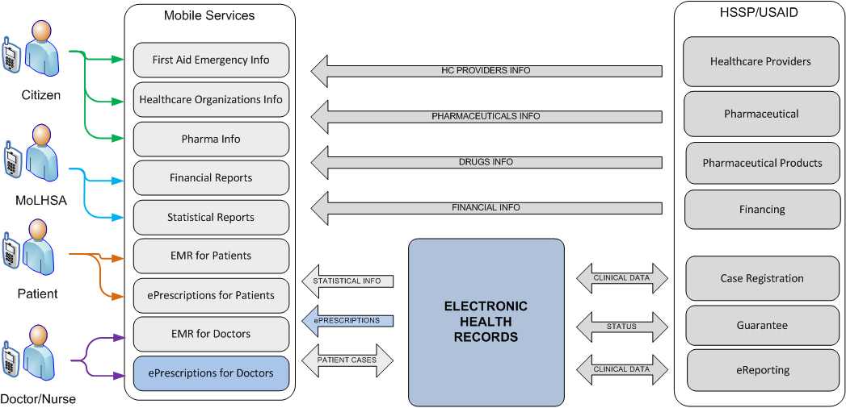
Picture 14. Data flows of process of access to electronic prescription for doctors
Sections 3.3.2.1 and 3.3.2.2 contain detailed information and process description.
Table 9. Common requirements to process of access to electronic prescription for doctors
Process name | Doctor ePrescriptions Mobile Service
Designation | DoctorePrescriptions_Mobile
Users | Employees of medical institutions registered as users of mobile access to e-patient records
Requirement to main stages of the process | - User starts Mobile application  - User enters login and password for identification, and enters the code of medical institution on behalf of which he will access to electronic patient records  - The system authenticates the user as a registered user with access to the electronic patient records  - The user identifies the patient : enters Civil Registration Number or Name / Surname / Date of birth  - Doctor gets the access to the history cases  - For working with electronic prescriptions the doctor should select existing or create a new case  - Doctor requests the list of existing e-prescriptions for selected case  - Having selected the prescription the doctor can view detailed information about prescription and edit it  - The doctor can create a new prescription for selected case  - If necessary the doctor can view detailed information about all written prescriptions  - To work with another patient the doctor needs to perform patient’s identification procedure

DoctorePrescriptions_Mobile process scheme
Picture 15 presents the sequence diagram for the process of accessing to electronic prescriptions for doctors.
Picture 15. Common scheme of porcess od acccess to electronic records for doctors

DoctorePrescriptions_Mobile process description
View Information about prescriptions / appointments should be performed at the same user interface in which a doctor views / edits patient’s medical records (EMR). The description of the access to patient’s EMR is presented in section 3.3.1..

Processes of services of operational information

Process of access to basic financial indicators
Picture 16 and Table 10 contain the common requirements to the process of access to basic financial indicators in terms of public financing programs of medical services provided to Georgian citizens. Process purpose is to allow on-line access to medical finance statistics grouped by period, types of expenses, etc. for Ministry specialists.

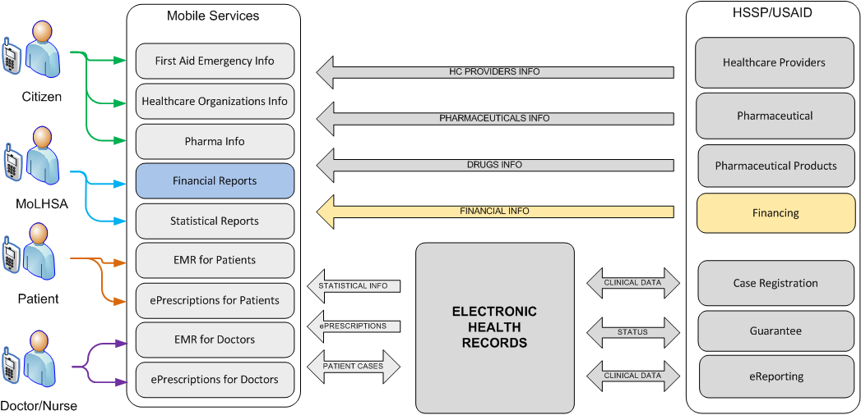
Picture 16. Data flows of process of access to financial indicators

Table 10. Common requirements to process of access to financial indicators
Process name | Financial statistics Mobile Service
Designation | FinStat_Mobile
Users | Ministry specialists
Requirement to main stages of the process | - User starts Mobile application  - Enters login and password for identification  - System displays the list of standard reports containing a summary of the main financial indicators for different time periods and types of expenses  - User opens the report and view detailed information

Comments to FinStat_Mobile process
The access to the financial information will be given only after user authorization and confirmation of the required level of his competence. Financial statistics should be provided in the form of reports, suitable for viewing on a mobile device, and contain textual and graphical information.
The composition, content and appearance of the reports will be defined at the design stage. As part of this service implementation not more than 3 standard reporting forms will be developed.
The content of the reports should be based on the information (financial and clinical) from the database of HSSP modules. Storing information in Mobile device memory is not intended for this service. The whole information displayed via this service interface should be received on-line from a server. The user should not be able to edit the information received from the server.
The service should provide the user with the following functions:
- Getting a list of reports
- View the selected report
- Sending the report by email in PDF or HTML
The list of available functions will be specified at design stage.

Process of access to statistics
Picture 17 and Table 11 contain the common requirements to the process of access to statistics on Georgia health care system. Process purpose is to allow on-line access to statistics of medical service provisions based on cases registered in HSSP and EHR for Ministry specialists.

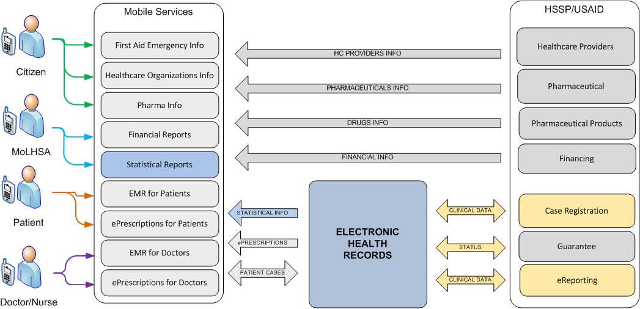
Picture 17. Data flows of process of access to statistics
Table 11. Common requirements to process of access to statistics
Process name | Healthcare statistics Mobile Service
Designation | HCStat_Mobile
Users | Ministry specialists
Requirement to main stages of the process | - User starts Mobile application  - Enters login and password for identification  - System displays the list of standard reports containing statistics in different sections  - User opens the report and view detailed information

Comments to HCStat_Mobile process
The access to statistics will be given only after user authorization and confirmation of the required level of his competence. Statistics should be provided in the form of reports, suitable for viewing on a mobile device, and contain textual and graphical information.
The composition, content and appearance of the reports will be defined at the design stage. As part of this service implementation not more than 3 standard reporting forms will be developed.
The content of the reports should be based on the information from the database of HSSP modules. Storing information in Mobile device memory is not intended for this service. The whole information displayed via this service interface should be received on-line from a server. The user should not be able to edit the information received from the server.
The service should provide the user with the following functions:
- Getting a list of reports
- View the selected report
- Sending the report by email in PDF or HTML
The list of available functions will be specified at the design stage.

Process of access to EHR loading information
Picture 18 and Table 12 contain the common requirements to the process of access to EHR loading information. Process purpose is to provide Ministry specialists with the ability to control the process of filling EHR database with information about the facts of the provision of health services to patients.
Service should represent the dynamics National EHR of data loading and to identify the facts of no- activity in EHR by the connected clinics.
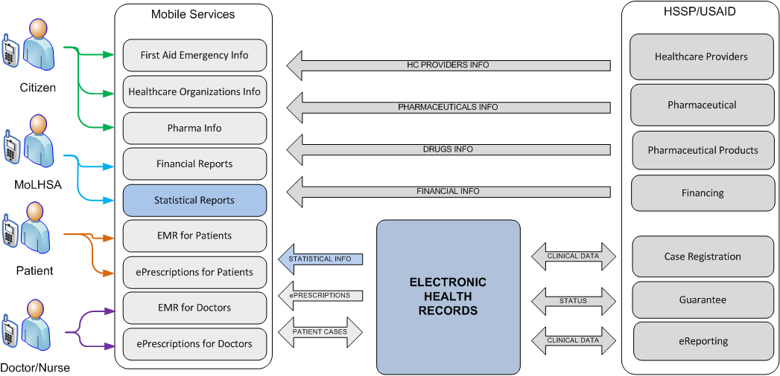
Picture 18. Data flows of process of access to EHR loading

Table 12. Common requirements to process of access to EHR loading
Process name | EHR data loading control Mobile Service
Designation | EHRLoading_Mobile
Users | Ministry specialists
Requirement to main stages of the process | - User starts Mobile application  - Enters login and password for identification  - System displays the list of standard reports containing statistic information about EHR loading in different sections  - User opens the report and view detailed information

Comments to EHRLoading_Mobile process
The access to statistics will be given only after user authorization and confirmation of the required level of his competence. Statistics should be provided in the form of reports, suitable for viewing on a mobile device, and contain textual and graphical information.
The composition, content and appearance of the reports will be defined at the design stage. As part of this service implementation not more than 3 standard reporting forms will be developed.
Each report should provide information in a certain section (for example the number of cases grouped by hospitals, the number of cases by month, etc.)
The content of the reports should be based on the case information from the database of HSSP modules. Storing information in Mobile device memory is not intended for this service. The whole information displayed via this service interface should be received on-line from a server. The user should not be able to edit the information received from the server.
The service should provide the user with the following functions:
- Getting a list of reports
- View the selected report
- Sending the report by email in PDF or HTML
The list of available functions will be specified at the design stage.

Functional requirements

Requirements to the basic functions for patients
All services available for patients should be implemented through filling out the forms with fields on Mobile device screen and call the functions available in these forms. Picture 19 presents the sequence of forms available for patients – Mobile services users. Yellow marked forms require the access to EHR (for electronic medical patient’s records access). The other forms are either the forms for desired function selection or the forms provided the access directories.

Picture 19. Sequence of forms available for patients – Mobile services users

Table 13 contains user forms and functions available for patients.

Table 13. Description of User forms and functions available for patients
Form / Function name |  | Description
Login |  | Login form - the user enters information about his login and password
Main Menu |  | Main menu of service – contains the tools for all basic functions call
 | My Medical Records | Function call of list of cases for the patient
 | My Prescriptions | Function call of list of prescriptions for the patient
 | Drugs Info | Function call of Medicines directory
 | Closest Clinics/Pharma | Function call of directory of medical institutions
Registered Cases List |  | Form containing the list of cases registered for the patient
 | Search/Filter/Sort | Functions of settings search / filter / sort of displayed cases list
 | Case Details | Function call of form of detailed information about the case
Detailed Case |  | Form containing detailed information about the case
 | Related Prescriptions | Function Call of “Detailed Prescription” form with information on electronic prescriptions associated with the case
Prescriptions List |  | Form displaying a list of e-prescriptions registered for the patient
 | Search/Filter/Sort | Functions of settings search / filter / sort of prescriptions list
 | Case Details | Function call of form of detailed information about the prescription
Detailed Prescription |  | Form containing detailed information about the prescription
 | Drug Details | Function call of form of detailed information about the medicine contained in the e-prescription
Drugs List |  | Form containing the list of medicines
 | Search/Filter/Sort | Functions of settings search / filter / sort of medicines
 | Drug Details | The function call of form of detailed information about the medicines selected in “Drugs List” form
HC Organizations Map |  | Form displaying a map with information about found medical institutions, their location on the map and the current position of Mobile device user.
 | Search/Filter/Sort | Functions of settings search / filter / sort of medical institutions displayed on “HC Organizations Map “
 | Make a phone Call | Function of phone call to the selected medical institution
Note: The list of Forms and Functions available for the user can be specified at design stage by agreement with the Customer.

Requirements to the basic functions for doctors
All services available for doctors should be implemented through filling out the forms with fields on Mobile device screen and call the functions available in these forms. Picture 20 presents the sequence of forms available for doctors. Yellow marked forms require the access to EHR the other forms are either the forms for desired function selection or the forms provided the access directories.

Picture 20. Sequence of forms available for doctors – Mobile services users

Table 14 contain the description of user forms and functions available for doctors

Table 14. Description of User forms and functions available for doctors
Form / Function name |  | Description
Login |  | Login form - the user enters information about his login and password and medical institution code on behalf of which the doctor will get the access to electronic patient records.
Main Menu |  | Main menu of service – contains the tools for all basic functions call
 | Patient EMR | Function of access to electronic patient records
 | Drugs Info | Function call of Medicines directory
 | Closest Clinics/Pharma | Function call of directory of medical institutions
Set Patient |  | Form of patient identification - allows to specify search criteria and get detailed information about the patient for verification
 | Patient Medical Records | Function call of list of cases for the patient
 | Patient Prescriptions | Function call of list of prescriptions for the patient
Registered Cases List |  | Form containing the list of cases registered for the patient
 | Search/Filter/Sort | Functions of settings search / filter / sort of displayed cases list
 | New/Edit Case | Function call of form for editing information about the case
 | Another Patient | Function call of “Set Patient” form for new patient selection
Detailed Case |  | Function call of form of detailed information about the case and allowing to edit it
 | Set/Update Diagnose | Function call of “Set Diagnose” form for diagnose selection
 | Set/Update Procedure | Function call of “Set Procedure” form for procedure selection
 | Submit Case | Function of saving data about the case and return to “Registered Cases List” form
 | Add/Edit Prescriptions | Function Call of “Detailed Prescription” form with ability to create a new / edit existing prescription associated with the case
Set Diagnose |  | Form allows to select a diagnosis by code
Set Procedure |  | Form allows to select a procedure by code
Prescriptions List |  | Form displaying a list of e-prescriptions registered for the patient
 | Search/Filter/Sort | Functions of settings search / filter / sort of prescriptions list
 | Case Details | Function call of form of detailed information about the prescription
Detailed Prescription |  | Form containing detailed information about the prescription and allowing to edit it
 | Add/Replace Drug | Function Call of “Set Drug” form for medicine selection
 | Submit Prescription | Function of saving data about the case and return to “Prescriptions List” form
 | Drug Details | The function call of form of detailed information about the medicine containing in e-prescription
Set Drug |  | Form for selection of medicine in prescription
 | Drug Details | The function call of form of detailed information about selected medicine
Drugs List |  | Form containing the list of medicines
 | Search/Filter/Sort | Functions of settings search / filter / sort of medicines
 | Drug Details | The function call of form of detailed information about the medicines selected in “Drugs List” form
HC Organizations Map |  | Form displaying a map with information about found medical institutions, their location on the map and the current position of Mobile device user.
 | Search/Filter/Sort | Functions of settings search / filter / sort of medical institutions displayed on HC Organizations Map
 | Clinic Status | Function call of “Clinic Status” form for view information about the clinic (for example availability of beds)
 | Make a phone Call | Function of phone call to the selected medical institution
Clinic Status |  | Form containing detailed information about medical institution

Note: The list of Forms and Functions available for the user can be specified at design stage by agreement with the Customer.

Requirements to the basic functions for Ministry specialists
Picture 21. Sequence of forms available for Ministry specialists

Table 15. Description of User forms and functions available for Ministry specialists
Form / Function name |  | Description
Login |  | Login form - the user enters information about his login and password
Main Menu |  | Main menu of service – contains the tools for all basic functions call
 | Financial indicators | Function call of financial indicators reports
 | Healthcare statistics | Function call of statistical reports on healthcare
 | EHR Loading | Function call of EHR loading reports
 | Expenses control | Function call of expenses control reports
Financial indicators |  | Form with the list of financial reports
 | Report details | Function of view the report
 | Send by email | Function of sending the report by email
Healthcare statistics |  | Form with the list of statistical reports
 | Report details | Function of view the report
 | Send by email | Function of sending the report by email
EHR Loading |  | Form with the list of EHR loading reports  Форма со списком отчетов о наполняемости EHR
 | Report details | Function of view the report
 | Send by email | Function of sending the report by email
Note: The list of Forms and Functions available for the user can be specified at design stage by agreement with the Customer.

