Solution Architecture
Collaborative Health Environment (CHE) of Georgia
EMR 2.1

Part 1 (1 from 2)
Case management

Tbilisi, 2015
Reconciliation sheet

Supplier
Position | Name | Signature | Date

Customer
Position | Name | Signature | Date

1 Tables 6
2 Pictures 7
3 General information 8
3.1 Terms and acronyms 8
3.2 Document purpose 9
4 HMIS 2.1 architecture 10
4.1 CHE/HMIS schema 11
4.2 Main HMIS components description 12
4.3 Detailed HMIS components schema 13
4.4 The scope of the Part 1: Case management 14
4.5 Software description 15
5 EHR architecture 16
5.1 EHR general components schema 16
5.2 EMC HIP architecture 17
5.3 Lutech wHospital architecture 19
5.4 wHospital – HIP integration architecture 23
5.5 Healthcare data providers and EHR interaction 25
5.6 Healthcare data consumers and EHR interaction 26
6 HSSP Modules architecture 27
6.1 General HSSP Modules components schema 27
6.2 HSSP Modules UI 27
7 EHR-HSSP Modules general integration concepts 28
7.1 General integration schema 28
7.2 Integration schema (part 1: Case management) 29
7.3 Data flows description (part 1: Case management) 30
7.4 Integration mechanism description 32
7.5 EHR Integration components implementation (wHL7Gateway) 32
7.5.1 XDS_Repo 33
7.5.2 HL7_In 33
7.6 HSSP Modules Integration components implementation 37
7.7 Standards and formats for the clinical data replication 39
7.8 Patients management (ADT messages) 39
8 EHR-HSSP Modules integration Part 1: Case management 39
8.1 Clinical Case description 39
8.2 Case management in the HSSP Modules s 40
8.3 Case management in the EHR 41
8.4 General replication logic description 42
8.4.1 EHR to HSSP replication steps 42
8.4.2 HSSP to EHR replication steps 43
8.5 Directories and classifiers synchronization 44
8.5.1 Medical classifiers (ICD10, NCSP etc.) 44
8.5.2 Healthcare providers and Doctors directories 44
8.6 EHR - Billing (USAID) integration 44
8.6.1 Financial Units managements 45
8.6.2 Guarantee No. 46
8.6.3 EHR UI and data model enhancements 48
8.7 USAID-EHR Form 100 exchange 50
8.7.1 General schema 50
8.7.2 Data exchange mechanism description 50
9 EHR Security 51
9.1 Data security administration in HMIS 51
9.2 Basic user access roles 51
9.3 Authentication / autorization 52
9.4 Patient data & consent management 53
9.5 Digital signature 54
10 Appendixes 56
10.1 CDA2-templates for clinical data replication 56
10.1.1 In-Patient CDA2 template 56
10.1.2 Out-Patient CDA2 template 58
10.2 EHR data model description (regarding to the Cases) 60
10.2.1 In-Patient data model 60
10.2.2 Out-Patient Data Model 61
10.3 HSSP Modules modules data description 62
10.3.1 HSSP Modules Case Registration module. Clinical data description 62
10.3.2 HSSP Modules e-Reporting. Clinical data description 64

Tables
Table 1. HMIS main components description 12
Table 2. EMC Healthcare Integration Portfolio Software 15
Table 3. wHospital Software 15
Table 4. HSSP Software 15
Table 5. wHospital Windows & WCF services 20
Table 6. Data flows description 30
Table 7. HSSP integration components description 37
Table 8. EHR to HSSP replication steps 42
Table 9. Classifiers 44
Table 10. Directories 44
Table 11. Form 100 generator service description 50
Table 12. In-Patient Clinical Case CDA2 template sections 56
Table 13. Out-Patient Clinical Case CDA2 template sections 58
Table 14. Case Registration Module data mapping to CDA2 63

Pictures
Figure 1. Common CHE/HMIS 2.1 schema 11
Figure 2. HMIS components schema 13
Figure 3. HMIS components (part 1: case management) 14
Figure 4. EHR components schema 16
Figure 5. EMC HIP architecture 17
Figure 6. EMC HIP main components 17
Figure 7. Lutech wHospital architecture 19
Figure 8. wHospital Framework 20
Figure 9. wHospital engine deployment schema 21
Figure 10. wHospital services deployment schema 22
Figure 11. wHospital - HIP integration schema 23
Figure 12. Provide and Register document 25
Figure 13. Query and Retrieve document 26
Figure 14. Common HSSP module architecture schema 27
Figure 15. EHR-HSSP Modules data exchange 28
Figure 16.EHR-HSSP Modules data exchange (part 1: case management) 29
Figure 17. EHR-HSSP general integration schema 32
Figure 18. HL7_In connection schema 34
Figure 19. wHospital HIS-HL7 available transactions 35
Figure 20. WHL7Gateway XDS Stub Sequence diagram 35
Figure 21. HSSP integration components 37
Figure 22. Cases source description on HSSP side 40
Figure 23. Case management in EHR 41
Figure 24. Financial units processing 45
Figure 25. cForm with Financial Units control 46
Figure 26. cForm with Guarantee No. control 47
Figure 27. Form 100 response/request 50
Figure 28. User authentication schema 52
Figure 29. Digital signature schema 55
Figure 30. wHospital In-Patient data model subset (related to Case) 60
Figure 31. wHospital Out-Patient data model subset (related to Case) 61
Figure 32. Case Registration module data model subset 62

General information

Terms and acronyms
ADT | Admit Discharge Transfer  Patient Administration (ADT) messages are used to exchange the patient state within a healthcare facility. HL7 ADT messages keep patient demographic and visit information synchronized across healthcare systems.
CHE | Collaborative Healthcare Environment
CDA | Clinical Document Architecture
EMR/EHR | Electronic Medical Records/ Electronic Health Records
HIS | Health Information System
HL7 | Health Level-7 or HL7 refers to a set of international standards for transfer of clinical and administrative data between software applications used by various healthcare providers.
HMIS | Health Management Information System
HSSP | Health System Strengthening Project
ICD-10 | International Classification of Diseases (ICD)
ICPC2 | International Classification of Primary Care, Second edition (ICPC-2)
IHE | Integrating the Healthcare Enterprise
MoLHSA | Ministry of Labour, Health and Social Affairs of Georgia
NCSP | Nomesco Classification of Surgical Procedures
XDS | Cross-Enterprise Document Sharing
Customer | Ministry of Labour, Health and Social Affairs of Georgia
Clinical data | Clinical/Medical information (diagnosis, procedures, etc.) about the patients, which is subject to storing in EHR

Document purpose
The current document describes the EHR 2.1 Solution Architecture and contains the following main sections:
- Section 4 contains the general overview of the HMIS 2.1 architecture
- Section 5 gives description of the EHR Solution Architecture as the main component of the HMIS
- In Section 6 the HSSP Modules Solution Architecture is presented
- Section 7 is one of the main sections in the document and defines the concepts of the integration between the EHR and the HSSP Modules
- Section 8 specifies the details of the Part 1 integration regarding to the Case management (clinical cases replication)
- In Section 10, there are several Appendixes presenting the information about the Case structure and data model on both sides – EHR and HSSP.

Besides the current document, the following documents will be developed within the MoLHSA EHR 2.1 project scope:
- Technical requirements towards Healthcare Environment data Providers and Consumers
- The strategy and universal mechanism for the data interchange between EHR and HSSP Modules

HMIS 2.1 architecture
The health system of Georgia includes a large number of healthcare information providers and consumers. It is a high priority of the Ministry of Labour, Health and Social Affairs of Georgia (MoLHSA) to develop the Collaborative Healthcare Environment (CHE) to enable these providers and consumers to exchange information as effectively as possible, using the new national Electronic Health Records (EHR) system.
The core component of the Collaborative Healthcare Environment is HMIS - Health Management Information System, which contains the following subsystems:
- EHR – Electronic Medical Records
- HSSP Modules
- Mobile Platform
The Figure 1 contains the general schema of the CHE and its components.
The main activities for the current phase:
- EHR and HSSP integration within the new technology platform
- EHR functionality enhancements
- Mobile platform/services implementation
- Users experience improvements by offering access to the existing functionality on mobile devices
The first two points - EHR and HSSP integration and EHR functionality enhancements – splits to two following parts:
- Part 1: Case management
- Part 2: Clinical data exchange
The current document describes Solution Architecture for the Part 1.

CHE/HMIS schema
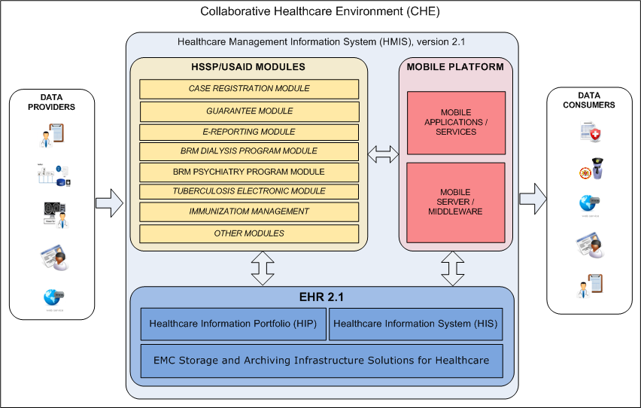
Figure 1. Common CHE/HMIS 2.1 schema

Main HMIS components description
The Table 1 contains description of the main HMIS components.
Table 1. HMIS main components description
Subsystem | Purpose | Architecture description in section
Electronic Health Record (EHR) | Georgian National EHR.  The collection of electronic health information about the population (patients). | 5
HSSP Modules | Health System Strengthening Project.  The HSSP Modules system is comprised of a set of modules developed by USAID.  During the Part 1 of the integration between EHR and HSSP Modules the replication of the Clinical Cases will be implemented. There are following modules, which process the Clinical Cases on the HSSP side:  - Case Registration Module  - E-Reporting Module  The description of the Clinical Case on HSSP side is given in section 8.2. | 6
Integration Subsystem:  EHR <-> HSSP Modules | In order to implement bidirectional Clinical Cases replication between EHR and HSSP Modules according integrational components will be configured/developed on both sides.  The main aim for these integrational components is to be able to send/receive HL7-messages with encapsulated CDA2-document (Case). | 7
Mobile Platform | Mobile Platform provides Patients, Doctors and MoLHSA specialists access to medical, financial, and statistical information, which manages by the components of the HMIS. | See MoLSA EHR 2.1 Solution Architecture. Part 3: Mobile Platform
Integration Subsystem:  Mobile Platform <-> EHR and HSSP Modules | This integration component implements the data exchange between the Mobile Platform and HMIS components to enable mobile users to view and edit the information.

Detailed HMIS components schema
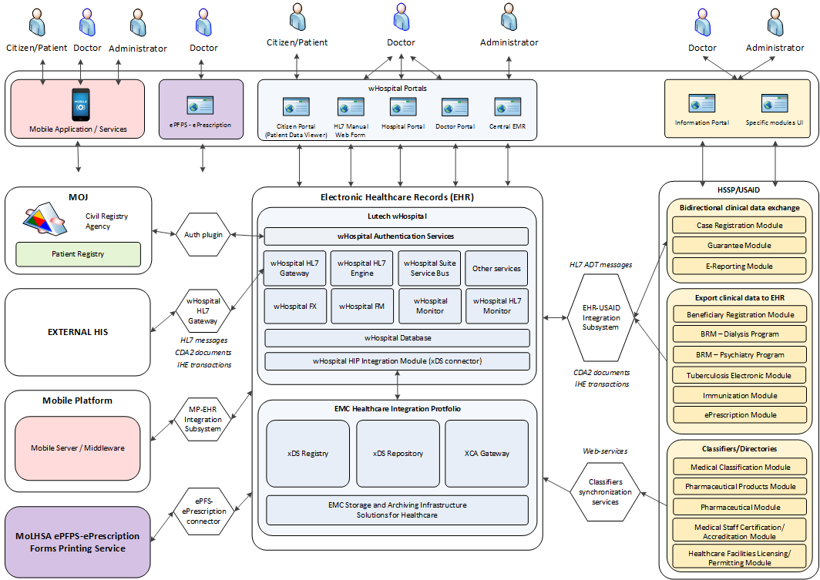
Figure 2. HMIS components schema

The scope of the Part 1: Case management
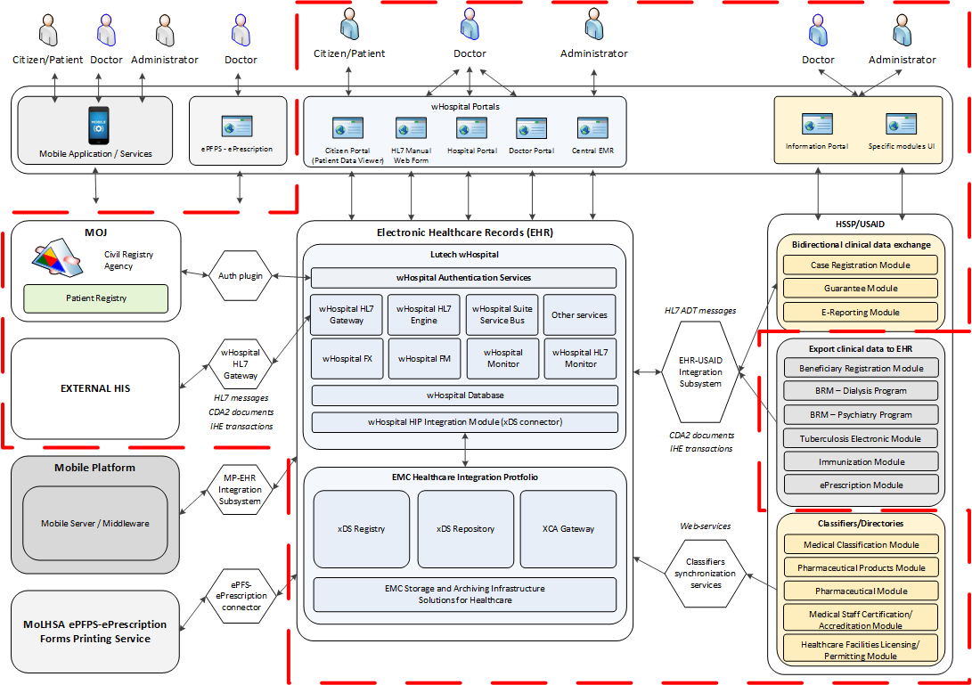
Figure 3. HMIS components (part 1: case management)

Software description
The following tables contain the information about the versions of the main applications involved in EHR-HSSP integration project.
Table 2. EMC Healthcare Integration Portfolio Software
EMC Healthcare Integration Portfolio Software Description
Software | Version | Description
XDS Registry | 1.7 | Provides a central directory for a healthcare community that contains information about patient healthcare records.
XDS Repository | 1.7 | Records management and data storage
XCA Gateway | 1.7 | Acts both as an initiating and responding integration gateway. As an initiating gateway, enables healthcare providers to access patient healthcare records that reside outside of their healthcare community. As a responding gateway, enables outside communities to access local patient healthcare records.

Table 3. wHospital Software
wHospital Software Description
Software | Version | Description
wHospital Framework Services | 4.133.20130829.763  or upper. | Provides wHospital basic functionality
wHL7Gateway | 4.133.20130829.763  or upper. | Provides wHospital integration capabilities
wHospital XDS Publisher | 4.133.20130829.763  or upper. | Provides cross domain sharing capabilities for CDA2 documents
wHospital Engine | 4.133.20130829.763  or upper. | Provides end-user access to wHospital web applications

Table 4. HSSP Software
HSSP Software Description
Software | Version
HSSP Case registration module | ?
HSSP Guarantee module | ?
HSSP E-Reporting module | ?
HSSP Dialysis Module | ?
HSSP Tuberculosis Module | ?
HSSP Immunization Module | ?
Other modules | ?

EHR architecture
An electronic health record (EHR), or electronic medical record (EMR), is a systematic collection of electronic health information about an individual patient or population. It is a record in digital format that is theoretically capable of being shared across different health care settings. In some cases this sharing can occur by way of network-connected, enterprise-wide information systems and other information networks or exchanges. EHRs may include a range of data, including demographics, medical history, medication and allergies, immunization status, laboratory test results, radiology images, vital signs, personal statistics like age and weight, etc.
Central EHR of Ministry of Labor, Health and Social Affairs of Georgia is implemented with wHospital framework using EMC HIP as a clinical data storage. Implementation details can be found below.

EHR general components schema
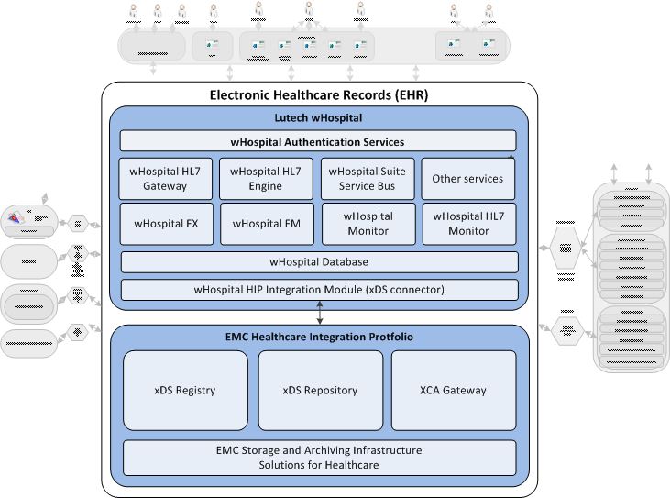
Figure 4. EHR components schema

EMC HIP architecture
Healthcare Integration Portfolio (HIP) aimed to share patient medical records stored on a Documentum Repository. It implements the industry standard IHE XDS.b transactions that allow hospitals and organizations to submit and consume medical records of patients.
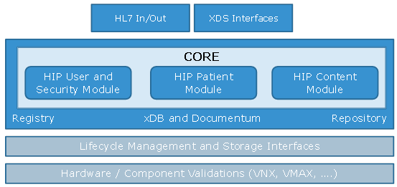
Figure 5. EMC HIP architecture
Full EMC HIP components diagram can be found below.
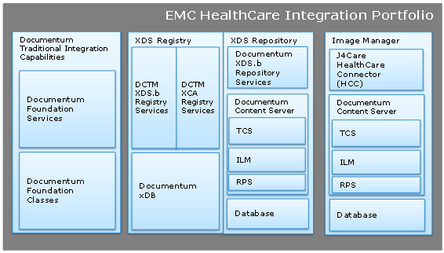
Figure 6. EMC HIP main components

Within the current project only 3 main Healthcare Integration Portfolio functional modules are used:
- HIP xDS Registry
- HIP xDS Repository
- HIP XCA Gateway

HIP XDS Registry Server provides a central directory for a healthcare community that contains information about patient healthcare records. The registry does not store the records themselves, but instead contains information about each record, such as the patient ID, the document type, the name of the physician, the procedure involved, and the location of the record. Healthcare providers query the registry to obtain a list of patient healthcare records and their locations.
The XDS Repository Server uses the HIP Healthcare Information Model to manage the records and information residing in the Documentum Healthcare repository.
HIP Cross Community Access (XCA) Gateway enables healthcare providers to integrate their healthcare systems with providers from different healthcare communities. It implements the IHE XCA profile which provides message routing and mediation for the cross-community exchange of patient healthcare records. Healthcare records include administrative records (patient information) and patient medical records (X-rays, doctor reports, lab results and so on).
XCA Gateway acts both as an initiating and responding gateway. As an initiating gateway, XCA Gateway enables healthcare providers to access patient healthcare records that reside outside of their healthcare community. As a responding gateway, XCA Gateway enables outside communities to access local patient healthcare records.

Lutech wHospital architecture
wHospital is a pluggable web framework to build Electronic Health Records (EHR) web applications. Designed to fit requirements for clinical data management it guarantees privacy and data integrity. A customizable authentication layer prevents unauthorized access and provides functionality of setting configurable security policies to patient clinical information. An EHR system can be configured and integrated with the Hospital Information System (HIS) throughout HL7/XDS Engine.
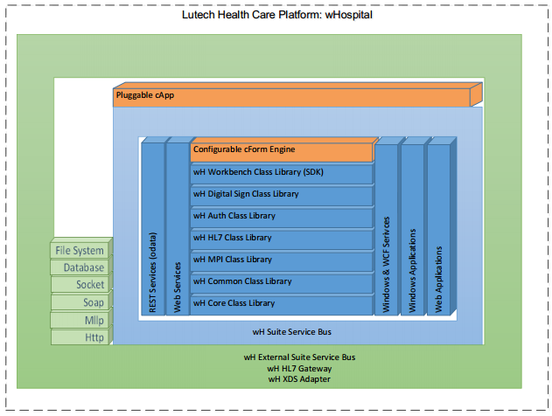
Figure 7. Lutech wHospital architecture

The API Manager add-on is the software development kit that can be used to build application extension modules that can be plugged to the framework.
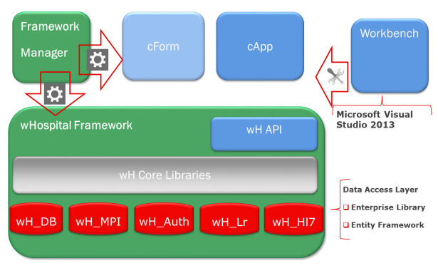
Figure 8. wHospital Framework
wHospital Windows & WCF services list can be found in a table below:
Table 5. wHospital Windows & WCF services
Service name | Service description
WHESB | WHESB: wHospital External Service Bus
WHSSB | WHSSB: wHospital Suite Service Bus
WHL7G | WHL7G: wHospital HL7 Gateway
WHL7S | WHL7S: wHospital HL7 Service
WHAES | WHAES: wHospital Alert-Engine-Service
WHERT | WHERT: wHospital Exam-Result-Tracker
WHPBS | WHPBS: wHospital PDF-Backup-Service
WHPRS | WHPRS: wHospital Print-Service
WHSPS | WHSPS: wHospital Subscriber/Publisher Services
WHSGN | WHSGN: wHospital Sign Engine
WHWFM | WHWFM: wHospital Workflow Manager
Following wHospital web applications are used in described solution:
- wHospital Framework Manager
- wHospital cEMR Portal
- wHospital Citizen Portal
- wHospital GP portal
- wHospital Hospital Portal
- wHospital Help Online
The wHospital Engine deployment schema for current solution can be found below.
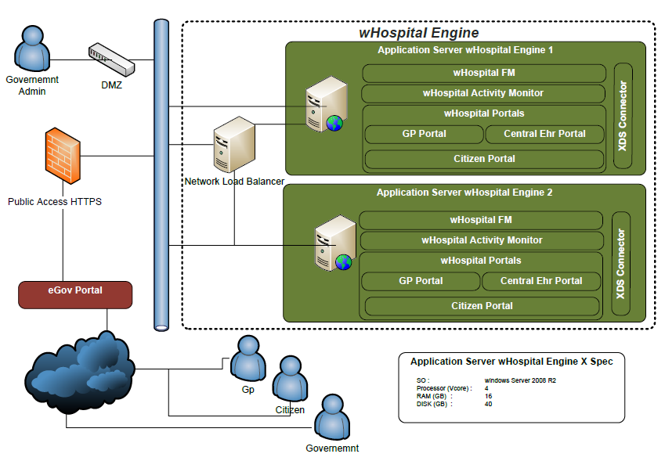
Figure 9. wHospital engine deployment schema

The wHospital Services deployment schema for current solution can be found below.
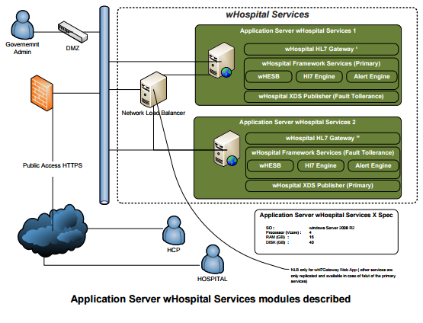
Figure 10. wHospital services deployment schema

wHospital – HIP integration architecture
The wHospital as a framework designed to build EHR data structure and provide end user web applications to operate with EHR uses EMC HIP as a clinical data storage, so the whole integration wHospital and HIP can be considered as a Central EMR itself. The figure below shows the integration modality between wHospital and HIP in the specific cEMR implementation.
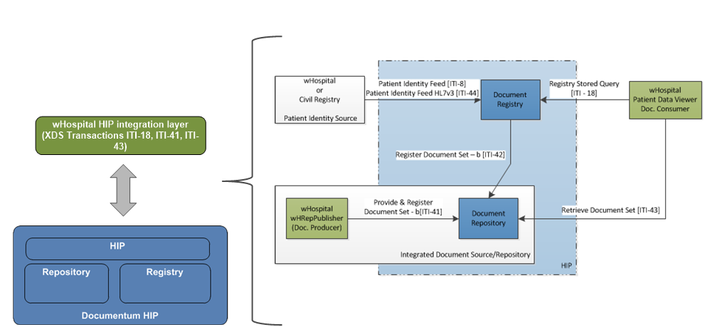
Figure 11. wHospital - HIP integration schema

The wHospital integration components implementation description can be found in 7.5
EHR – HSSP integration will be implemented as CDA2 documents exchange. Current EHR – HIP integration considers all incoming CDA2 documents as a common clinical documents and keeps it in the HIP. Complete description of EHR - HSSP integration using CDA2 documents can be found in section 7.

Healthcare data providers and EHR interaction
Cross Enterprise Document Sharing (XDS) and integrational capabilities of EMR allows to build the whole healthcare document exchange ecosystem around it. In this ecosystem, cEMR is able to perform both a data provider and data consumer roles.
Healthcare clinical data can be provided to the EHR in following ways:
- Through the cEMR user interface (wHospital web application)
- Data migration from USAID Case Registration Module and other modules
- Through the mobile platform doctor user interface
- Data migration from the external HIS owner by Hospitals connected to EHR
CDA (Clinical Document Architecture) xml-based clinical data template is going to be used as a main data integration template format. Complete description of used CDA2 templates can be found in par. 10.1
XDS transactions ITI-41 and ITI-42 can be used during document receiving: document source can submit documents to the repository by means of a Provide and Register document Set-b [ITI-41] transaction. Once the document has been published the repository notifies the registry by means of the Register Documents Set-b [ITI-42] transaction.

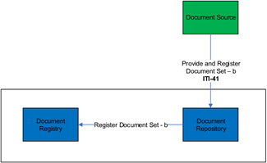
Figure 12. Provide and Register document

Healthcare data consumers and EHR interaction
As stated previously, EHR can be not only data consumer but also can play a data provider role in a clinical data exchange.
A document consumer can enquire a registry in order to search patient’s documents by means of Registry Stored Query transaction [ITI-18]. The registry returns repository id and document id so that the consumer can download via Retrieve Document Set [ITI-43] transaction.

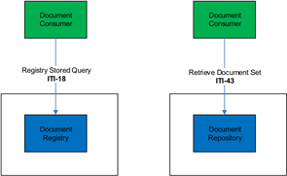
Figure 13. Query and Retrieve document

Healthcare clinical data from the EHR can be accessed in following ways:
- Through the cEMR user interface (wHospital web application)
- Data migration to USAID modules
- Through the mobile platform user interface (both patient and doctor roles)

HSSP Modules architecture
Complete description of HSSP modules architecture is out of scope of current Solution Architecture, but brief common modules architecture schema is provided below to describe modules integrational capabilities.

General HSSP Modules components schema
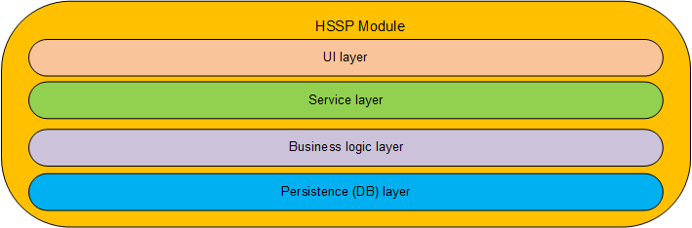
Figure 14. Common HSSP module architecture schema
Common HSSP module high-level architecture shown on Figure 14. Module service layer implements facade pattern and allows to loose coupling of business functionality consumer (UI, external system, etc.) and business functionality itself. Described architecture allows to implement integration with third-party systems (like cEMR) using HSSP modules service layer.

HSSP Modules UI
During the current project stage no UI enhancements on the HSSP Modules side is required.

EHR-HSSP Modules general integration concepts

General integration schema
The Figure 15 shows the main data flows between the EHR and HSSP modules.
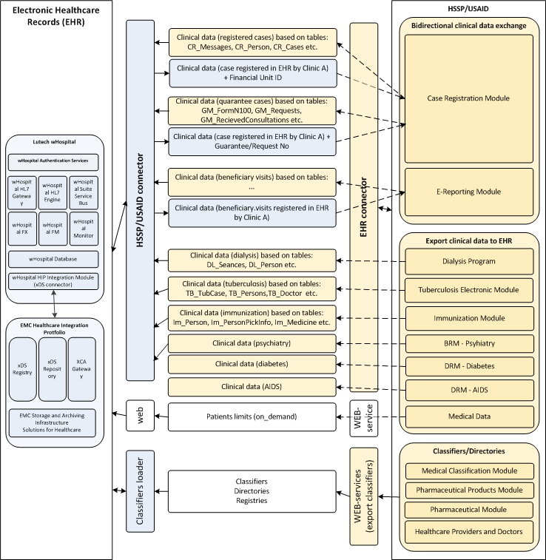
Figure 15. EHR-HSSP Modules data exchange

Integration schema (part 1: Case management)
The Figure 16 shows the data exchange scope, which is corresponds to the “Part 1: Case management” of the whole integration project. The replication of the Clinical data (Cases) between the EHR and HSSP Case Registration Module and e-Reporting for NCDC Module is the main aim of the integration and will cover the most of clinical data, which will be replicated between the systems.
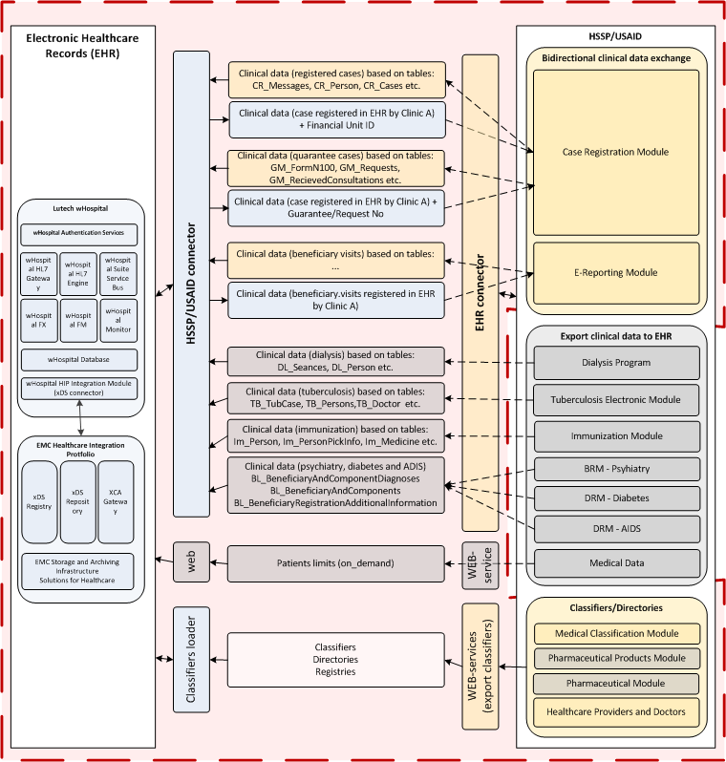
Figure 16.EHR-HSSP Modules data exchange (part 1: case management)

Data flows description (part 1: Case management)
Table 6. Data flows description
Source | Target | Data description | Data format and replication mechanism | Replication algorithm
HSSP Case Registration Module | EHR | Clinical cases, entered by the clinics through the HSSP Portal (see chapter 8.2).  First replication:  - Case status = New/Opened  Following replications:  - The clinical data updated  Final replication:  - Case status = Closed | Clinical Data format:  - CDA2 document (see chapter 10.1)  Replication mechanism:  - HL7 message with encapsulated CDA2 to the wHL7Gateway | - HSSP integration module generates the Case (CDA2 document ) for replication  - Call wHL7Gateway by sending the HL7-message  - wHL7Gateway parse the CDA document, store the data to the DB attributes, store CDA “as is” to the xDSRepository  - response to HSSP integration module (result code, wHospital object ID)  - Every replicated Case must be saved in EHR as separate version.
EHR | HSSP Case Registration Module | Clinical cases, entered by the clinics through the EHR UI (see chapter 8.2) + financial info for the billing (see chapter 8.6).  First replication:  - Case status = New/Opened  Following replications:  - The clinical data updated  Final replication:  - Case status = Closed | Clinical Data format:  - CDA2 document (see chapter 10.1), contained, particularly, Financial Unit ID or Guarantee No.  Replication mechanism:  - HL7 message with encapsulated CDA2 to the HSSP integration module | - wHL7Gateway generates the Case (CDA2 document ) for replication  - Call HSSP integration module by sending the HL7-message  - HSSP integration module parse the CDA document and the metadata to the DB for the Case Registration Module, Financing Module (optional)and Guarantee Module (optional)  - Response to wHL7Gateway (result code, HSSP case ID)
HSSP e-Reporting Module | EHR | Clinical info about the Beneficiary visits.  First and Final replication:  - Case status = Closed | Clinical Data format:  - CDA2 document (see chapter 10.1)  Replication mechanism:  - HL7 message with encapsulated CDA2 to the wHL7Gateway | - HSSP integration module generates the Case (CDA2 document ) for replication  - Call wHL7Gateway by sending the HL7-message  - wHL7Gateway parse the CDA document, store the data to the DB attributes, store CDA “as is” to the xDSRepository  - response to HSSP integration module (result code, wHospital object ID)
EHR | HSSP e-Reporting Module | Clinical info about the Beneficiary visits, entered by the clinics through the EHR UI (see chapter 8.2).  First and Final replication:  - Case status = Closed | Clinical Data format:  - CDA2 document (see chapter 10.1)  Replication mechanism:  - HL7 message with encapsulated CDA2 to the HSSP integration module | - wHL7Gateway generates the Case (CDA2 document ) for replication  - Call HSSP integration module by sending the HL7-message  - HSSP integration module parse the CDA document and the metadata to the DB for the e-Reporting Module  - Response to wHL7Gateway (result code, HSSP case ID)
HSSP  Healthcare Providers and Doctors | EHR | Information about the Healthcare Providers and Doctors currently managed by Financing Module. | Clinical Data format:  - XML  Replication mechanism:  - One-time manual data upload | XML structure:  <Providers>  <provider>  <id>…</id>  <title>…</title>  …  <Doctors>  <doctor>  …  </doctor>  </Doctors>  </provider>  </Providers>

Integration mechanism description
The integration between the EHR and HSSP Modules will be implemented using Web-services implemented on both sides. From the EHR side the wHL7Gateway will handle an HL7 messages (Inbound and Outbound), containing the Clinical Case (CDA2 document). The main endpoints which implements IHE HIS transactions and perform publishing and sharing the clinical documents on the EHR side are:
- XDS_Stub.asmx
- HL7_In.asmx
On the HSSP side, the similar integration module will be implemented, responsible for sending and receiving the Clinical Cases.
Auxiliary web-services will be implemented on both sides to handle requests for additional information. For example, EHR must call HSSP web-service to get the list of Financial Units to give the EHR user to select one and associate it with the current Case to be replicated to HSSP using wHL7Gateway. From the HSSP side the “get Form 100” request can occur towards EHR database to use received Form 100 in according processes.
The Figure 17 shows the general interaction schema between the EHR and HSSP.
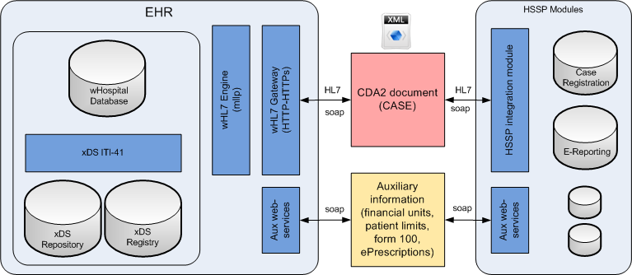
Figure 17. EHR-HSSP general integration schema
The wHL7Gateway contains an internal queue management components, which are manage the Inbound and Outbound HL7-messages and guarantee the processing of the Cases. If web-services on the HSSP side are unavailable, the message remains in the internal queue and will be processed again in a configured period of time. The HSSP integration module will implement the similar logic.

EHR Integration components implementation (wHL7Gateway)
wHL7Gateway is the main wHospital gateway used for integration with third-party solutions using CDA2 documents and HL7 messages. wHL7Gateway will be used from the EHR site to implement the EHR – USAID integration. Integration exchange will use special CDA2 document template, which will be implemented to meet specific integration requirements. Corresponding CDA2 document instances will be transported through wHL7Gateway.
wHL7Gateway is a software layer exposed on the WEB that allow external sources to submit HL7 or XDS messages to the Central EMR.
wHL7Gateway exposes 2 main Web-Services:
- XDS_Repo
- HL7_In

XDS_Repo
XDS_Repo acts as a stub/proxy for the underline XDS Repository web service (Documentum HIP).
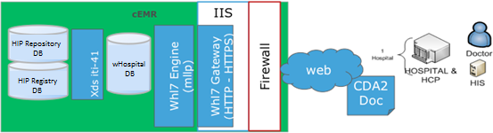
HCP will provide data to the cEMR by means of wHL7Gateway web services exposed at:
https://cEmr.molhsa.org:80443/wHl7Gateway/XDS_Stub/XDS_Repo.asmx
Note: definitive production url address will be defined later during production phase
HTTPS will guarantee encryption at transport layer
SSLv3 + Mapping Client Certificate on Domain Use with mutual authentication will guarantee authentication and prevent unauthorized access.
XDS_Repo wsdl has been designed to be IHE XDS compliant so the layer is totally transparent for a client but allow wHospital engine to analyze data and metadata from the message immediately in order to extract information and fill the patient’s central EMR dataset. XDS_Stub returns to the client responses obtained from the underline XDS repository with references to the Repository Unique Identifier of the document submitted.

HL7_In
The HL7_In web-service acts as a stub/proxy for the underline wHL7engine in order to receive HL7 v2.5 messages also from external sources (not in the same network) under a security https layer.
The HL7_In connection schema is presented in the figure below.
Figure 18. HL7_In connection schema
Figure 19. wHospital HIS-HL7 available transactions

WHL7Gateway XDS Stub Sequence diagram
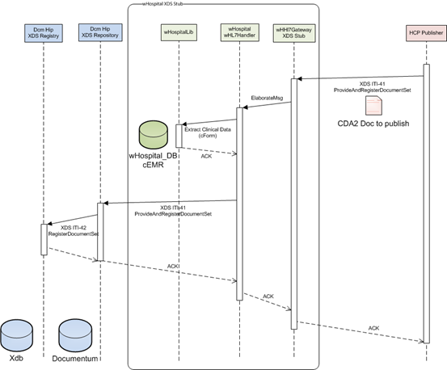
Figure 20. WHL7Gateway XDS Stub Sequence diagram
WHL7Gateway will:
- Receive CDA2 doc and metadata
- Check security & privacy policy
- Check HCP authorization to publish documents to the cEMR
- Check Patient Consent to be treated in the cEMR
- Parse CDA2 doc to retrieve both metadata (information about author and patient,…) and clinical data
- For each CDA2 sections split relevant clinical information in cEMR Database
- Publish doc to HIP by means of XDS-ITI41 messages
CDA2 document mentioned above is a Clinical Case described in section 8.1.

HSSP Modules Integration components implementation
The integration subsystem on the HSSP side will contains the following main components:
- HSSP HL7 Gateway
- Case processing Handler
- Specific business logic subcomponents, related to specific HSSP modules
- Aux web-services
Figure 21 below shows the schema of the integration components on the HSSP side.
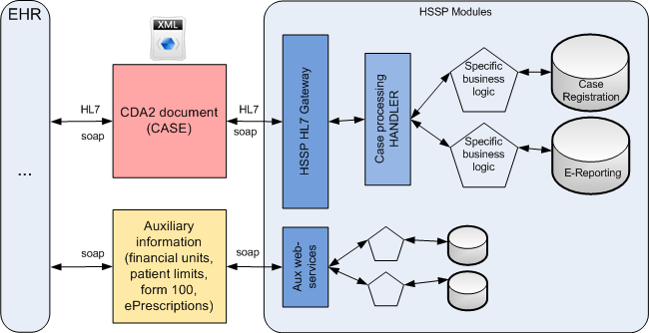
Figure 21. HSSP integration components
The Table 7 describes the functionality of the main HSSP integration components.
Table 7. HSSP integration components description
Component | Responsibility
HSSP HL7 Gateway | Handle Inbound and Outbound HL7-messages, which contains encapsulated CDA2-document (Case).  Interacts with the “Case processing Handler” to exchange CDA2-documents
Case processing Handler | Construct the CDA2-documents, using the data from specific HSS module by interacting with according “Specific business logic subcomponents”.  Transfers constructed CDA2-document to “HSSP HL7 Gateway” to send to the EHR.  Accepts CDA2-document received from the EHR by the “HSSP HL7 Gateway”, parse this document and save the data to the HSSP module database through “Specific business logic subcomponents”. If CDA2-document contains financial information (financial unit ID or Guarantee No.) the Handler call specific component, associated with HSSP Financing and Guarantee Modules in order to process the Case in terms of billing.
Specific business logic subcomponents | Extract the data from the HSSP module database to transfers it to the “Case processing Handler” as a source for CDA2-document.  Parse received from the “Case processing Handler” CDA2-document to get and save the data to appropriate database tables/attributes of the HSSP module.
Aux web-services and handlers | Implements specific business logic for auxiliary data exchange between the HSSP Modules and EHR:  - “WS_HSSP_FIN_UNITS_LIST” web-service returns the list of available financial units on demand (see chapter 0)  - “WS_HSSP_PATIENT_LIMITS” web-service returns the patient limits info on demand  - “HANDLER_FORM_100_FROM_EHR” handler requests EHR auxiliary web-service to get the Form 100 object (CDA2-document) to use it locally.

Standards and formats for the clinical data replication
The main object to replicate between the EHR and HSSP Modules is Clinical Case. The Clinical Case is CDA2-document, which contains the general clinical information about treatment of the one given Patient. This CDA2-document is similar to Discharge Letter CDA2 template for In-Patient and to Consultancy Note CDA2 template for Out-Patient, but contains extra section/attributes with information, specific to the Georgian EHR. Particularly, this section can contain financial information (financial unit or Guarantee No.) needed for billing.
The section 10.1 contains description of the CDA2 template(s) used to construct the Clinical Case to replicate it between the systems.
Replication of the CDA2-document will be handled by sending HL7-messages between the wHL7Gateway (EHR) and HSSP HL7 Gateway (see chapter 7.4).
The feasibility of the clinical data synchronization will be ensured by using the common classifiers and identifiers of the:
- Healthcare Provider
- Doctor
- Patient
See chapter 1.1 for details regarding to the classifiers/directories synchronization.

Patients management (ADT messages)
No ADT-messages will be used to transfer the data about the patients between the EHR and HSSP. All the actions regarding to the patients management on EHR side will be performed by wHL7Gateway based on information, received with HL7-messages (with encapsulated CDA2-document). wHL7Gateway will do the following:
- Use received patient demographics data to search the Patient in EHR
- If the Patient is absent, create the Patient in EHR
- Then save received clinical data related to this Patient
In other words, HSSP should not care about existence the Patient in the EHR while replicating the CDA2-document as a Case of the Patient treatment.

EHR-HSSP Modules integration Part 1: Case management

Clinical Case description
Clinical Case is the main entity, which we will operate within EHR and HSSP integration. This entity is a set of clinical data about the fact of Patient treatment at any Hospital in Georgia. Every fact of Patient treatment will be packaged into single Case - an XML file conformed to HL7 CDA2 standard. According CDA2 templates are described in section 10.1.
The description of what “Case” means on EHR side is given in section 8.3.
The “Case” in HSSP Modules is represented as set of clinical data in Case Registration Module and e-Reporting Module. The section 10.3 contains description of these HSSP modules tables and attributes which will be used to construct the Case (CDA2 document) for replication to EHR database.

Case management in the HSSP Modules s
As mentioned above the main sources for the Clinical Cases on the HSSP side are:
- Case Registration Module
- E-Reporting Module
The figure below contains the schema, which describes the sources (modules) of the clinical data for In- and Out-Patient cases.

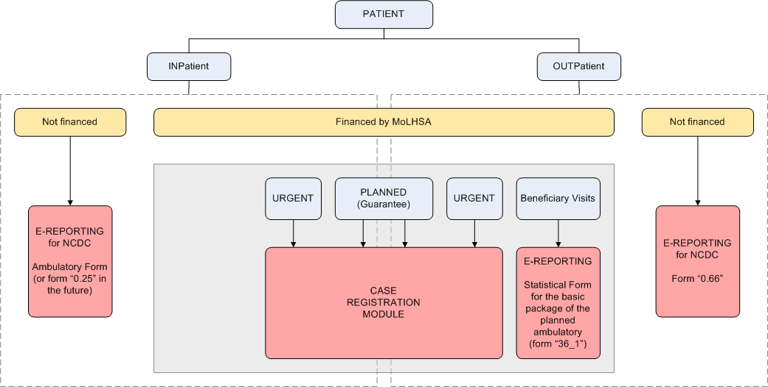
Figure 22. Cases source description on HSSP side

Case management in the EHR
HSSP and EMR Cases have completely different data structures. Due to this fact, additional case structure unification required to be able to exchange data with HSSP and EMR at the cases level. EMR case structure is described below.
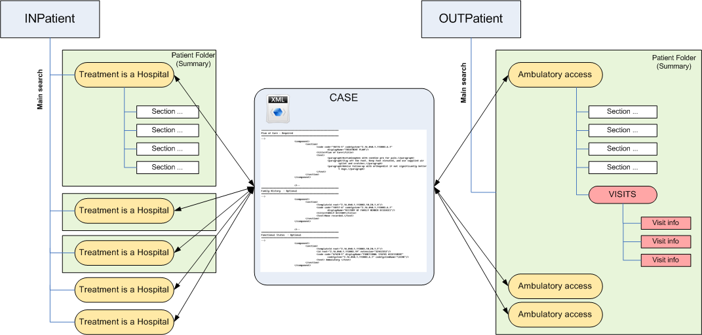
Figure 23. Case management in EHR
EHR case management consist of:
- In-Patient cases management
- Out-Patient cases management
In-Patient case can be considered as a patient hospitalization to the hospital ward also can be considered as a container for all clinical information (diagnosis, medical procedures, e.t.c.) obtained during hospitalization.
Out-Patient case can be considered as a patient access to the ambulatory. Patient access divides on so-called “visits” (to the different ambulatory doctors/specialists).

General replication logic description
The data replication will be bidirectional. I.e. the Clinical Cases will be synchronized in EHR and HSSP databases. The following subsections contains the main replication steps.

EHR to HSSP replication steps
The following table contains the main steps description of the process of Cases replication from the EHR to HSSP.
Table 8. EHR to HSSP replication steps
Steps |  | Step description
EHR | HSSP | Step description
STEP 1: Define the clinical data for replication | - | wHospital case processing Handler will be configured to be able to define (select from the DB) the Accesses/Treatments, which are ready to be replicated to HSSP Modules.  Selected objects will be put to internal queue, where they wait for processing/replication.
STEP 2: Case construction and validation | - | (for each Access/Treatment)  wHospital Handler processes objects in the queue one-by-one and construct the Case (CDA2 document) for each Access/Treatment.  The constructed Case must conform to according CDA2-template (see section 10.1).
STEP 3: Replicate the Case | - | (for each Access/Treatment)  wHL7Gateway construct the HL7-message with encapsulated CDA2-document and sends it to HSSP integration module (web-service).
- | STEP 4: Accept the Case | (for each Access/Treatment)  HSSP HL7 Gateway gets and HL7-message with CDA2-document
- | STEP 5: Process the Case | (for each Access/Treatment)  HSSP case processing Handler validates the Case data against the classifiers, directories, checks the data consistency and data duplication (by using the ProviderID, DoctorID and PatientID).
- | STEP 6: Store the data to the DB | (for each Access/Treatment)  If the validation is done successfully the Handler extract the data from the CDA2-document and store it in according tables/attributes of the HSSP Modules.  If not, corresponding fault message will be send as a response.
- | STEP 7: Send response | (for each Access/Treatment)  HSSP HL7 Gateway sends response with “result code”, “hssp_case_id” and other system parameters.
- | STEP 8: Post processing | (for each Access/Treatment)  HSSP Handler marks the Case as “is_replica” and store the EHR object ID in according attribute.
STEP 9: Get HSSP response | - | wHL7Gateway waits/gets response from the HSSP integration module with “result code”, “hssp_case_id” and other system parameters.
STEP 10: Perform post-replication tasks | - | wHospital Handler store the received data to wHospital Database and mark according Access/Treatment as “replicated”.

HSSP to EHR replication steps
The main steps for HSSP to EHR data replications are similar to the steps described in section 8.4.1 above.

Directories and classifiers synchronization

Medical classifiers (ICD10, NCSP etc.)
Within the previous phase of the Project the general medical classifiers were loaded to EHR database. Within the current phase these classifiers will be re-loaded in order to make sure EHR database contains the latest ones.
Table 9. Classifiers
Classifier | Provider | Replication type | Schedule
ICD10 | HSSP Medical Classification Module | Manual | One-time loading
NCSP | HSSP Medical Classification Module | Manual | One-time loading
ICPC2 | HSSP Medical Classification Module | Manual | One-time loading
Laboratory | HSSP Medical Classification Module | Manual | One-time loading
Vermin | HSSP Medical Classification Module | Manual | One-time loading

Healthcare providers and Doctors directories
In order to synchronize the Cases between the EHR and HSSP databases not only the general classifiers must be synchronized (see section 8.5.1) but also the directory of Healthcare Providers and Doctors must be synchronized, otherwise the system which receives the replicated Case will not be able to link it to appropriate Provider/Doctor in their database.
The data about an actual Healthcare Providers and Doctors can be taken from the HSSP Financial Module and loaded to EHR database. The data loading will be performed once manually. Subsequent directories synchronization will be performed by responsible specials (EHR Administrator).
Table 10. Directories
Classifier | Provider | Replication type | Schedule
Healthcare Providers | HSSP Financial Module | Manual | One-time loading
Doctors | HSSP Financial Module | Manual | One-time loading

EHR - Billing (USAID) integration
Financial data management on EHR site means using a financial unit or guarantee No. attributes as a primary key for a billing integration. A detailed description of implementing financial unit and guarantee approaches can be found below.

Financial Units managements
Financial units, available to select for specific input parameters (specific hospital, patient diagnosis, medical procedure, etc.), obtained by EHR from the web-service implemented on a billing site, which implement the whole business-logic of specific financial units availability. EHR means financial units as a dictionary data only.
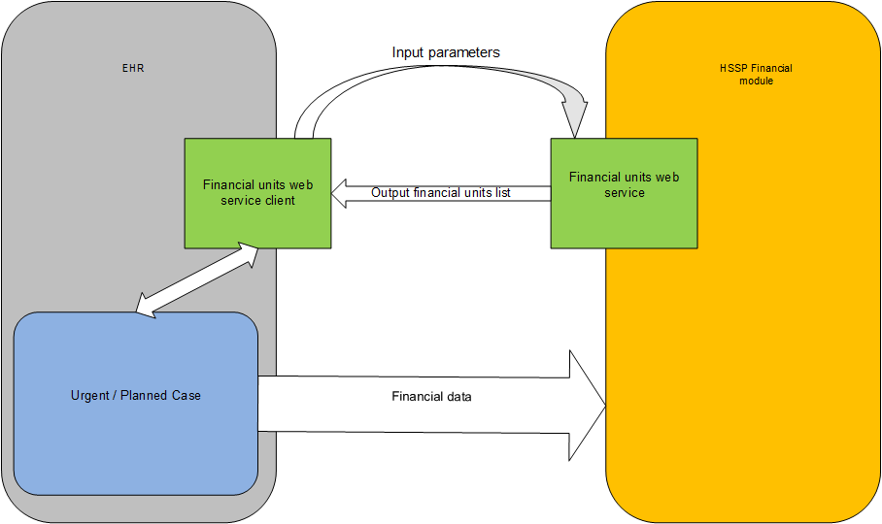
Figure 24. Financial units processing
On the EHR site, financial unit management can be implemented on Payers section cForm using wHospital specific DropDownTelerik control, which can use external third-party web service as a data source.
Service name | WS_HSSP_FIN_UNITS_LIST
Service type | Soap 1.1 & 1.2 Web Service
Input parameters | - ProviderID  - DiagnosisID  - ProcedureID
Output SOAP Envelope data fragment | …  <FinUnits>  <FinUnit ID=’<GUID>’ Label=’<Label>’/>  …  </FinUnits>  …
Incoming data validation rules  (USAID side) | - ProviderID validity check  - DiagnosisID validity check (must be valid ICD10 code)  - ProcedureID validity check (must be valid NCSP or other code system code)  In case of unsuccessful data validation attempt SOAP fault must be returned
Output SOAP Envelope validation rules  (EHR side) | - Financial unit ID must be a valid GUID  - Financial unit Label must be a non-empty string  - Financial units list can be empty
UI behavior | User interacts with a dropdown list contains result of web service invocation. In case of getting SOAP Fault or a empty list dropdown list control must be disabled with corresponding error message label visible

Web service related attributes of DropDownTelerik control listed in a table below.
Web service related attributes of DropDownTelerik control
Attribute name | Attribute type | Attribute description
Web Service Method | String | External web service method name
Web Service Path | String | URL of external web service

Example of financial units management on Payers section cForm can be found on a screenshot below.
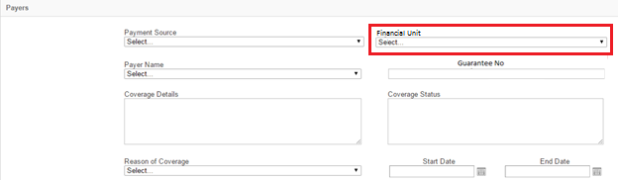
Figure 25. cForm with Financial Units control

Guarantee No.
In contradistinction to financial unit management, Guarantee No. can be managed without implementation of additional dictionary. On a EHR site guarantee no management can be implemented on Payers section cForm using a TextBox control. In this case the guarantee no can be presented as a string.
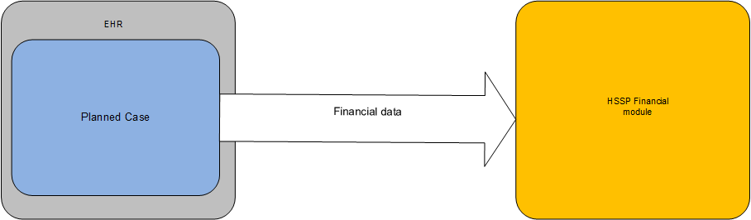
Example of guarantee no management on Payers section cForm can be found on a screenshot below.
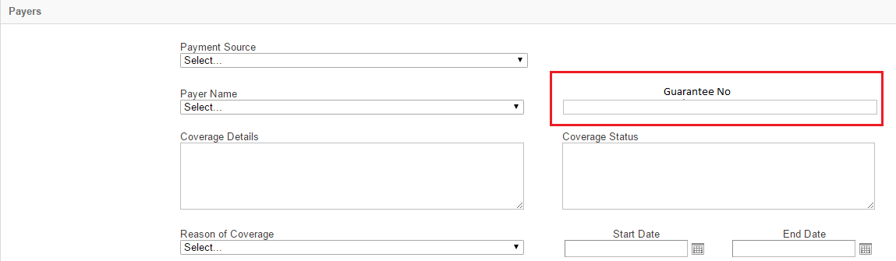
Figure 26. cForm with Guarantee No. control

EHR UI and data model enhancements
Case classification by the suitable billing integration primary key described in a table below.
Case type | Urgent | Planned
Billing integration primary key | Financial Units | Guarantee No.

In case of urgent cases and using a financial units as a primary key following UI controls will be used on a GUI form to interact with end user:
Control name | Control type | Control and dependency description
Urgent / Planned case | Radiobutton | “Urgent” value of the control enables mentioned below “Payment source” and “Financial unit” controls. “Planned” value disables it.
Payment source | Dropdown list | Provides possible case payment sources to be selected by user. Selected value used as a one of parameters to get available financial units with the web service invocation.
Financial unit | DropDownTelerik | Provides possible financial units to be selected by user. Use described above web service as a data source.

In case of planned cases and using a guarantee No. as a primary key following UI controls will be used on a GUI form to interact with end user:
Control name | Control type | Control and dependency description
Urgent / Planned case | Radiobutton | “Planned” value of the control enables mentioned below “Guarantee No.” control. “Urgent” value disables it.
Guarantee No. | TextBox (String) | Intendet to enter a Guarantee No. as a string.

New Case data model attributes required for billing integration implementation described in a table below.
Attribute name | Data type | Is required | Description
CaseType | Enum | Required | Possible values: “Urgent”, “Planned”
PaymentSource | String | Required for urgent cases | Additional input parameter for financial unit choice
FinancialUnit | GUID | Required for urgent cases | Primary key for billing integration for urgent cases
GuarenteeNo | String | Required for planned cases | Primary key for billing integration for planned cases
IsReplica | Boolean | Required for cases replicated from HSSP | Flag shows whether specific case is a replica from HSSP, or not
ExternalCaseId | GUID | Required for cases replicated from HSSP | ID of replicated case from HSSP
CaseReplicationDate | DateTime | Required for cases replicated from HSSP | Date and time of case replication from HSSP

USAID-EHR Form 100 exchange
EHR Form100 Generator Web Service is implemented on EHR site. Service designed to generate the Form 100 for the specific patient using EHR clinical data and transmit it to the invoker (HSSP Modules or other Consumer). Complete service description can be found below.

General schema
EHR Form 100 Generator Web Service expect patient id as a mandatory parameter. Form 100 generation by web service means read only access to the patient’s complete clinical data available in EHR.
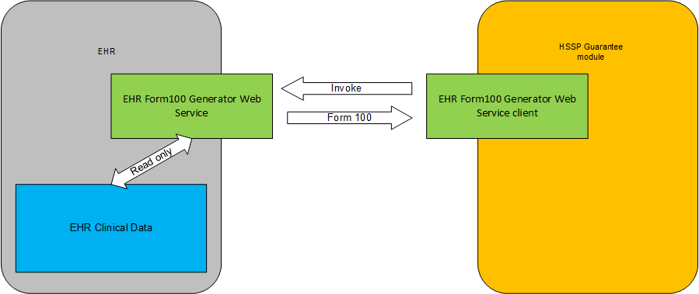
Figure 27. Form 100 response/request

Data exchange mechanism description
Table 11. Form 100 generator service description
Service name | EHR_Form100_Generator_Service
Service type | Soap 1.1 & 1.2 Web Service
Input parameters | - PatientID
Output SOAP Envelope data fragment | …  <Form100 PatientID=’GUID’>  <…patient clinical data…>  …  </Form100>  …
Incoming data validation rules  (EHR side) | - PatientID validity check  In case of unsuccessful data validation attempt SOAP fault must be returned
UI behavior | Service doesn’t have UI

EHR Security

Data security administration in HMIS
cEMR security aims:
- Authentication (Only authenticated users can access the system)
- Digital Signature (Authors will not repudiate documentation)
- Consent and Authorization (Grant patient privacy)
cEMR patient data access conditions:
- Patient must give consent to be treated in cEMR database (with paper signed document)
- Patient can modify (grant or revoke) his consent and authorization policy
- Only authorized people can access Patient Data
- Authorization must be explicit
- Citizen can protect some personal documents/events (Obscuration Info) and only few doctors will access those information

Basic user access roles
General system roles:
- Patient (Citizens)
- Doctors
- MoLHSA
Doctor access:
- Family doctor - must have an easy access to the patient
- Specialists - shall access patient data based on explicit patient authorization
- Hospitals - Inpatiet cases
- Emergency - “break the glass” cases

Authentication / autorization
The wHospital (central EMR-Portal, GP-Portal, and Citizen-Portal) integrated with the Georgian ID-Card by means of Eid Applet Authentication feature provided CRA following this UML sequence diagram.
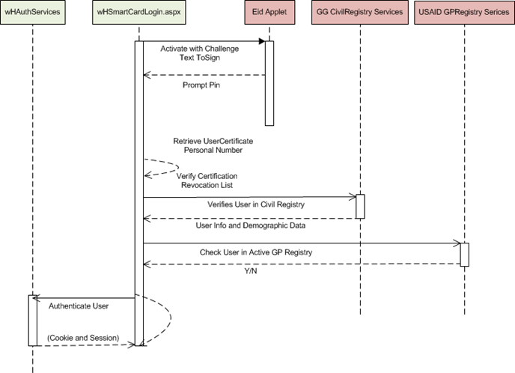
Figure 28. User authentication schema
When user access the portal he is redirected to the wHSmartCardLogin.aspx page that will embed the EID-Applet provided by CRA.
- At page load the system will generate a challenge text to be signed by the user.
- Applet prompt users to type the pin to unlock the certificate and sign the challenge text
- Applet submits user’s certificates, the signed challenge text.
- System retrieves user’s personal identification number (11 digit).
- System verifies user data in the Civil Registry by means of DEA web services
- System checks if the user is in the local GP Registry
- If the user is a valid GP it will be redirected to the GP portal home page
- If the user is a simple citizen it will be redirected to the citizen Portal Homepage

Patient data & consent management
- Doctors are able to search patients by means of the following patient’s fields:
  - Family Name
  - Given Name
  - Birthdate
  - Gender
  - PersonIdNumber (11digit civil register identifier)
- PersonIdNumber and Birthdate will be mandatory only in case of patients not previously associated to the doctor.
- System will verify a special constraint in order to prevent random access to patient demographic data.
If PersonIdNumber inserted is not compatible with Birthdate doctor will not be able to identify the patient and no demographic data will be shown.
- Doctors will be able to identify patients by means of the GEO-ID-Card
  - Plugging the patient’s GEO ID-Card in the lector and typing the user pin, the System will retrieve data from user’s certificate and enquiry the civil register
- Once the patient has been identified, the system will check the patient’s consent to the central EMR data management.
- Patient chooses about 2 level of patient consent:
  - Central EMR data management
  - Central EMR data management and Document sharing across community
- Patient will be able to Grant or Revoke the consent or change the consent level as well
- Every change will be tracked on the Central EMR Database
- For family doctors system will generate special token that authorize doctors to access patient’s documents submitted to the Central EMR Repository and Central EMR Data populated by other doctors
- Doctors (even not family doctors) will be able to access patient’s documents and Central EMR Data following this steps:
  - Patient gives to the doctor his own GEO-ID-Card
  - Patient digital signs a Token Generation Document
  - System generates a temporary token that grant doctor access all Patient’s data for a limited (configurable) period
- Emergency Access will be available for Doctors with special privileges
  - Users in role “Emergency Operator” will be able to generate an emergency token that grant patient’s data access for a limited (configurable) period
  - Every emergency access will be logged and tracked so that Citizens can obtain information about accesses to their own EMR data

Digital signature
wHospital (Central-Portal, GP-Portal, Citizen Portal) is integrated with the Georgian ID-Card by means of Eid Applet with Digital Signature Feature provided CRA.
Digital Signature feature will be integrated following steps below:
- Doctor logs onto the system
- Doctor selects a patient and access to the patient’s EHR page
- Doctor creates or edits a document (i.e. a referral)
- Doctor clicks Sign-Button
- System generates a document to sign “DocToSign” (PDF, TXT…)
- System Redirects to Sign-Page
- System prompts user for Obscuration-Info/Confidentiality Code selection
- System generates “DAO” (Document of Authorization and Obscuration) hard-linked to the doc to sign with the hash of the “DocToSign” itself
- In the sign page user will see 2 “DocToSign” (referral and DAO)
- System prompts user for entering digital-signature pin. (twice)
- System verifies digital signatures save referral and DAO and redirects the user back again to the EHRPAGE.

Figure 29. Digital signature schema

Appendixes

CDA2-templates for clinical data replication
The Clinical Case is CDA2-document, which contains the general clinical information about treatment of the one given Patient. This CDA2-document is similar to Discharge Letter CDA2 template for In-Patient and to Consultancy Note CDA2 template for Out-Patient, but contains extra section/attributes with information, specific to the Georgian EHR. Particularly, this section can contains financial information (financial unit or Guarantee No.) needed for billing.
The following sections contain the CDA2 templates description for In-Patient (section 10.2.1) and Out-Patient (see chapter 1.1.1) cases.

In-Patient CDA2 template
The Table 12 contains description of the section of the CDA2 template, which will be used for In-Patient clinical data replication between the EHR and HSSP Modules.
Table 12. In-Patient Clinical Case CDA2 template sections
Section Name | R/O | Code | Description
Allergies | R | 48765-2 | Contains data on the substance intolerances and the associated adverse reactions suffered by the patient
Family History | O | 10157-6 | Contains information about the genetic family members, to the extent that they are known, the diseases they suffered from, their ages at death, and other relevant genetic information
Functional Status | O | 47420-5 | Provides information about the capability of the patient to perform acts of daily living
History Of Present Illness | O | 10164-2 | Contains information about the sequence of events preceding the patient's current complaints
Hospital Course | R | 8648-8 | Contains information about of the sequence of events from admission to discharge in a hospital facility
Hospital Discharge Diagnosis | R | 11535-2 | Describes the conditions that need to be monitored after discharge from the hospital and those that were resolved during the hospital course
Hospital Discharge Medications | R | 10183-2 | Section defines a patient’s current medications and pertinent medication history
Hospital Discharge Physical | O | 10184-0 | Contains a narrative description of the patient’s physical findings
Hospital Discharge Studies Summary | O | 11493-4 | Contains the results of observations generated by laboratories, imaging procedures, and other procedures
Immunizations | O | 11369-6 | Section provides a patient’s pertinent immunization history
Past Medical History | O | 11348-0 | Section describes the past medical history for the patient. It may contain information about past procedures or other illnesses that might have a bearing on the patient’s current illness
Payers | O | 48768-6 | Contains data on the patient’s payers, whether a “third party” insurance, self-pay, other payer or guarantor, or some combination of payers, and it defines which entity is the responsible fiduciary for the financial aspects of a patient’s care
Plan of Care | R | 18776-5 | Contains data defining pending orders, interventions, encounters, services, and procedures for the patient
Procedures | O | 47519-4 | Section is optional because the information contained in it may also appear in the Past Medical History section or the History of Present Illness section
Problem | O | 11450-4 | Section lists and describes all relevant clinical problems at the time the Discharge Summary is generated. At a minimum, all pertinent current and historical problems should be listed
Reason For Visit / Chief Complaint | O | 29299-5 /  10154-3 / 46239-0 | Section records the patient's chief complaint (the patient’s own description) and/or the reason for the patient's visit (the provider’s description of the reason for visit)
Review of Systems | O | 10187-3 | Review of systems is a relevant collection of symptoms and functions systematically gathered by a clinician
Social History | O | 29762-2 | Defines the patient’s occupational, personal (i.e., lifestyle), social, environmental history, and health risk factors, as well as administrative data such as marital status, race, ethnicity, and religious affiliation
Vital Signs | O | 8716-3 | Contains measured vital signs at the time of the examination
Customer specific | R | - | Contains Customer specific information such as:  - Financial unit ID  - Guarantee No.  - Case ID in external system  - HSSP Module name (Case Registration or e-Reporting)  - other specific info

Note: “required/optional” characteristic of the sections can be changed on development stage.

Out-Patient CDA2 template
The Table 12 contains description of the section of the CDA2 template, which will be used for Out-Patient clinical data replication between the EHR and HSSP Modules.
Table 13. Out-Patient Clinical Case CDA2 template sections
Section name | R/O | Code | Description
Allergies | O | 48765-2 | Contains data on the substance intolerances and the associated adverse reactions suffered by the patient
Assessment And Plan | R | 51847-2 | Contains information about the assessment of the patient's condition and expectations for care including proposals, goals, and order requests for monitoring, tracking, or improving the condition of the patient
Diagnostic Results | O | 30954-2 | Contains the results of observations generated by laboratories, imaging procedures, and other procedures
Family History | O | 10157-6 | Contains information about the genetic family members, to the extent that they are known, the diseases they suffered from, their ages at death, and other relevant genetic information
General Status | O | 10210-3 | Describes general observations and readily observable attributes of the patient, including affect and demeanor, apparent age compared to actual age, gender, ethnicity, nutritional status based on appearance, body build and habitus (e.g., muscular, cachectic, obese), developmental or other deformities, gait and mobility, personal hygiene, evidence of distress, and voice quality and speech
History Of Past Illness | O | 11348-0 | Contains data about problems the patient suffered in the past
History Of Present Illness | R | 10164-2 | Contains information about the sequence of events preceding the patient's current complaints
Immunizations | O | 11369-6 | Section provides a patient’s pertinent immunization history
Medications | O | 10160-0 | Contains information about the relevant medications for the patient. At a minimum, the currently active medications should be listed
Physical Exam | R | 29545-1 | Contains information describing the physical findings
Plan of Care | R | 18776-5 | Contains data defining pending orders, interventions, encounters, services, and procedures for the patient
Problem | O | 11450-4 | Section lists and describes all relevant clinical problems at the time the Discharge Summary is generated. At a minimum, all pertinent current and historical problems should be listed
Procedures | O | 47519-4 | Section is optional because the information contained in it may also appear in the Past Medical History section or the History of Present Illness section
Reason For Referral | R | 42349-1 | Contains information about the reason that the patient is being referred
Review Of Systems | O | 10187-3 | Contains information describing patient responses to questions about the function of  various body systems
Social History | O | 29762-2 | Defines the patient’s occupational, personal (i.e., lifestyle), social, environmental history, and health risk factors, as well as administrative data such as marital status, race, ethnicity, and religious affiliation
Vital Signs | O | 8716-3 | Contains measured vital signs at the time of the examination
Customer specific | R | - | Contains Customer specific information such as:  - Financial unit ID  - Guarantee No.  - Case ID in external system  - HSSP Module name (Case Registration or e-Reporting)  - other specific info

Note: “required/optional” characteristic of the sections can be changed on development stage.

EHR data model description (regarding to the Cases)
Due to the fact that EHR have two separate data models for InPatient and OutPatient (entity-relation diagrams can be found below), there are also two separate CDA2 templates to be able to transmit corresponding InPatient and OutPatient cases.
Both InPatient and Outpatient CDA2 templates are described in section 10.1. The general description of the cases in wHospital is given in section 1.1.

In-Patient data model
The Figure 30 contains the wHospital data model subset schema. The object named “PatientTreatment” corresponds to the Clinical Case for In-Patient treatments. That means wHL7Gateway/Handler will construct Case (CDA2 document) by reading the data from the PatientTreatment and related objects. And vise-versa when wHL7Gateway will receive the In-Patient Case from the HSSP Modules it will parse it and store the metadata in the objects showed on figure below.
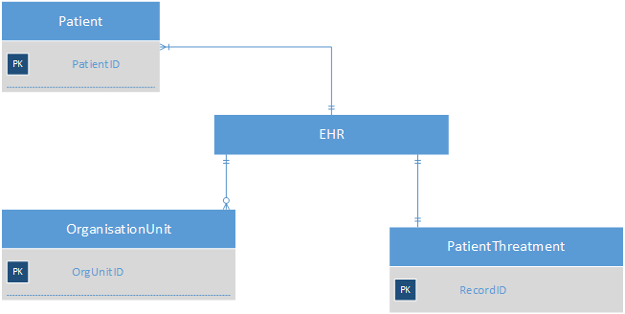
Figure 30. wHospital In-Patient data model subset (related to Case)

Out-Patient Data Model
The Figure 31 contains the wHospital data model subset schema. The object named “Access” corresponds to the Clinical Case for Out-Patient treatments. That means wHL7Gateway/Handler will construct Case (CDA2 document) by reading the data from the Access and related objects. And vise-versa when wHL7Gateway will receive the Out-Patient Case from the HSSP Modules it will parse it and store the metadata in the objects showed on figure below.

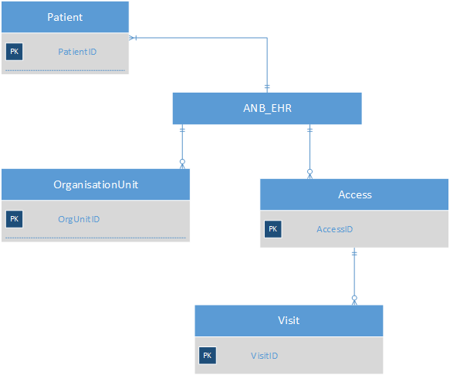
Figure 31. wHospital Out-Patient data model subset (related to Case)

HSSP Modules modules data description

HSSP Modules Case Registration module. Clinical data description
The following figure shows the subset of the Case Registration Module data model, which contains the clinical data for Clinical Case (CDA2 document) construction.
Figure 32. Case Registration module data model subset

Data mapping between the module data and CDA2 template sections
The following table contains data mapping between Case Registration data model and CDA2 template structure.
Table 14. Case Registration Module data mapping to CDA2
Case Registration fields | Title | CDA2 section
CR_Persons |  | CDA Header
-Type (int) |  | CDA Header
-PersonalID (nvarchar (50)) |  | CDA Header
-FirstName (nvarchar (50)) |  | CDA Header
-LastName (nvarchar (50)) |  | CDA Header
-BirthDate (datetime) |  | CDA Header
-Gender (nvarchar (50)) |  | CDA Header
CR_Cases
-CaseID
-DisplayID (nvarchar (50))
-OrganizationID (uniqueidentifier)
-GuaranteeNo (nvarchar (100))
-RequestId (uniqueidentifier)
BL_Providers
-
CR_Messages
-CaseID (uniqueidentifier)
-CaseStatus (int)
-PatientPersonID (uniqueidentifier)
-PatientReceiveDate (datetime)
-Comment (nvarchar (MAX))
-CaseType (int)
-DoctorPersonalID (nvarchar (255))
-DoctorPosition (nvarchar (255))
-MedicineHistoryNo (nvarchar (100))
-PatientArrival (int)
-RequiredTransfer (int)
-DestOrgID (numeric (18, 0))
-SourceOrgID (numeric (18, 0))
-SourceTransport (nvarchar (255))
-DestTransport (nvarchar (255))
-SourceProviderID (uniqueidentifier)
-DestinationProviderID (uniqueidentifier)
CR_MessageDiagnosis
-MessageID (uniqueidentifier)
-OrderIndex (bigint)
-Type (nvarchar (50))
-NosologyIClassCode (nvarchar(400))
-NosologyIClassName (nvarchar(400))
-TreatmentStartDate (datetime)
-TreatmentEndDate (datetime)
-Program
CR_MessageDiagnosisICD10ToNCSP
-MessageDiagnosisId (uniqueidentifier)
-NCSPCode (nvarchar (50))
-NCSPName (nvarchar (1400))
CR_MessageDiagnosisICD10ToICPC2
-MessageDiagnosisId (uniqueidentifier)
-Icpc2Code (nvarchar (50))
-Icpc2Name (nvarchar (1400))

Data replication logic

Data validation rules

HSSP Modules e-Reporting. Clinical data description

Data mapping between the module data and CDA2 template sections

Data replication logic

Data validation rules

See also EMC Documentum XDS Registry Release Notes and EMC XDS Repository Connector for Documentum Release Notes.
See also wHospital FX White Paper.
The Cross-Enterprise Document Sharing (XDS) Integration Profile is part if the IHE IT Infrastructure technical framework. Full list and description on used XDS Transactions can be found in the IHE IT Infrastructure technical framework documentation.
Required / Operational
LOINC code

