Solution Architecture
Collaborative Health Environment (CHE) of Georgia
EMR 2.1

Part 2 (2 from 2)
Other modules

Tbilisi, 2015
Reconciliation sheet

Supplier
Position | Name | Signature | Date

Customer
Position | Name | Signature | Date

1 Tables 5
2 Pictures 5
3 General information 6
3.1 Terms and acronyms 6
3.2 Document purpose 7
4 HMIS 2.1 architecture 8
4.1 CHE/HMIS schema 9
4.2 Main HMIS components description 10
4.3 Detailed HMIS components schema 11
4.4 The scope of the Part 2: Other modules 12
4.5 Software description 13
5 EHR architecture 14
6 HSSPHSSP architecture 15
6.1 General HSSPHSSP components schema 15
6.2 HSSP Modules UI 15
7 EHR-HSSPHSSP general integration concepts 16
7.1 General integration schema 16
7.2 Integration schema (part 2: Other modules) 17
7.3 Data flows description (part 2: Other modules) 18
7.4 Integration mechanism description 20
7.5 HSSPHSSP Integration components implementation 20
7.6 Standards and formats of the data replication 20
8 EHR-HSSPHSSP integration Part 2: Other modules 21
8.1 Clinical Case exchange approach 21
8.2 Clinical data in the HSSPHSSP 21
8.3 General replication logic description 21
8.4 Directories and classifiers synchronization 21
8.5 EHR – MoLHSA ePFPS integration 22
8.5.1 General schema 22
8.5.2 Data flows and integration mechanism description 22
8.6 EHR – HSSPHSSP Medical Data integration (Patient limits) 23
8.6.1 General schema 23
8.6.2 Data flows and integration mechanism description 23
9 EHR Security 24
9.1 Data security administration in HMIS 24
10 Appendixes 25
10.1 CDA2-templates used for clinical data replication 25
10.2 HSSPHSSP modules data description 25
10.2.1 HSSPHSSP Dialysis Program Clinical data description 25
10.2.2 HSSPHSSP BRM Psychiatry Program Clinical data description 28
10.2.3 HSSPHSSP BRM Diabetes Clinical data description 28
10.2.4 HSSPHSSP BRM AIDS. Clinical data description 28
10.2.5 HSSPHSSP Immunization Management Module Clinical data description 28
10.2.6 HSSPHSSP Tuberculosis Electronic Module Clinical data description 31

Tables
Table 1. HMIS main components description 10
Table 2. EMC Healthcare Integration Portfolio Software 13
Table 3. wHospital Software 13
Table 4. HSSP Software 13
Table 5. Data flows description 18
Table 6. ePFPS data flow 22
Table 7. Patient limits data flow 23
Table 8. Dialysis module data mapping 26
Table 9. Immunization module data mapping 29

Pictures
Figure 1. Common CHE/HMIS 2.1 schema 9
Figure 2. HMIS components schema 11
Figure 3. HMIS components (part 2: Clinical Data) 12
Figure 4. EHR components schema 14
Figure 5. Common HSSP module architecture schema 15
Figure 6. EHR-HSSP Modules data exchange 16
Figure 7. EHR-HSSP Modules data exchange (part 2: Clinical Data) 17
Figure 8. ePFPS integration schema 22
Figure 9. Patient limits processing 23
Figure 10. Dialysis module data model subset 25
Figure 11. Immunization module data model subset 28
Figure 12. Tuberculosis module data model subset 31

General information

Terms and acronyms
ADT | Admit Discharge Transfer  Patient Administration (ADT) messages are used to exchange the patient state within a healthcare facility. HL7 ADT messages keep patient demographic and visit information synchronized across healthcare systems.
CHE | Collaborative Healthcare Environment
CDA | Clinical Document Architecture
EMR/EHR | Electronic Medical Records/ Electronic Health Records
HIS | Health Information System
HL7 | Health Level-7 or HL7 refers to a set of international standards for transfer of clinical and administrative data between software applications used by various healthcare providers.
HMIS | Health Management Information System
HSSP | Health System Strengthening Project
ICD-10 | International Classification of Diseases (ICD)
ICPC2 | International Classification of Primary Care, Second edition (ICPC-2)
IHE | Integrating the Healthcare Enterprise
MoLHSA | Ministry of Labour, Health and Social Affairs of Georgia
NCSP | Nomesco Classification of Surgical Procedures
XDS | Cross-Enterprise Document Sharing
Customer | Ministry of Labour, Health and Social Affairs of Georgia
Clinical data | Clinical/Medical information (diagnosis, procedures, etc.) about the patients, which is subject to storing in EHR

Document purpose
The current document describes the EHR 2.1 Solution Architecture and contains the following main sections:
- Section 4 contains the general overview of the HMIS 2.1 architecture
- Section 5 gives description of the EHR Solution Architecture as the main component of the HMIS
- In Section 6 the HSSP Modules Solution Architecture is presented
- Section 7 is one of the main sections in the document and defines the concepts of the integration between the EHR and the HSSP Modules
- Section 8 specifies the details of the Part 2 integration regarding to the Case management (clinical cases replication)
- In Section 10 there are several Appendixes presents the information about the CDA2 templates structure and HSSP modules descriptions and data mappings.

Besides the current document the following documents will be developed within the MoLHSA EHR 2.1 project scope:
- Technical requirements towards Healthcare Environment data Providers and Consumers
- The strategy and universal mechanism for the data interchange between EHR and HSSP Modules

HMIS 2.1 architecture
The health system of Georgia includes a large number of healthcare information providers and consumers. It is a high priority of the Ministry of Labour, Health and Social Affairs of Georgia (MoLHSA) to develop the Collaborative Healthcare Environment (CHE) to enable these providers and consumers to exchange information as effectively as possible, using the new national Electronic Health Records (EHR) system.
The core component of the Collaborative Healthcare Environment is HMIS - Health Management Information System, which contains the following subsystems:
- EHR – Electronic Medical Records
- HSSP Modules
- Mobile Platform
The Figure 1 contains the general schema of the CHA and its components.
The main activities for the current phase:
- EHR and HSSP integration within the new technology platform
- EHR functionality enhancements
- Mobile platform/services implementation
- Users experience improvements by offering access to the existing functionality on mobile devices
The first two points - EHR and HSSP integration and EHR functionality enhancements – splits to two following parts:
- Part 1: Case management
- Part 2: Clinical data exchange
The current document describes Solution Architecture for the Part 2.

CHE/HMIS schema
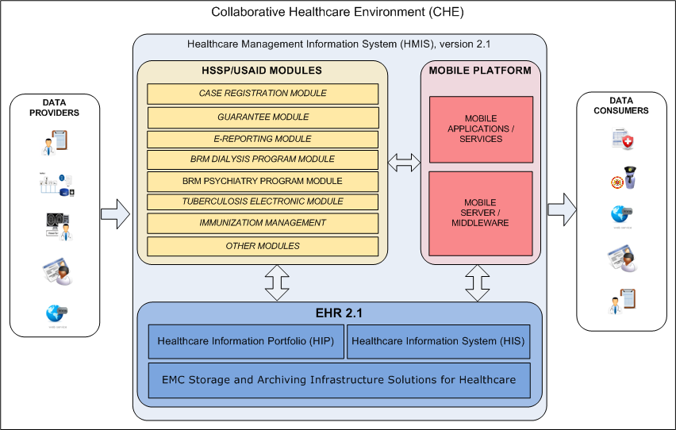
Figure 1. Common CHE/HMIS 2.1 schema

Main HMIS components description
Table 1. HMIS main components description
Subsystem | Purpose | Architecture description in section
Electronic Health Record (EHR) | Georgian National EHR.  The collection of electronic health information about the population (patients). | 5
HSSP Modules | Health System Strengthening Project.  The HSSP Modules system is comprised of a set of modules developed within HSSP.  During the Part 2 of the integration between EHR and HSSP Modules the one way replication of the Clinical Data will be implemented. There are following modules, which process the Clinical Data on the HSSP side:  - HSSP Beneficiary Registration Module Dialysis Program  - HSSP Beneficiary Registration Module Psychiatry Program  - HSSP Beneficiary Registration Module Diabetes Program  - HSSP Beneficiary Registration Module AIDS Program  - HSSP Immunization Management Module  - HSSP Tuberculosis Electronic Module | 6
Integration Subsystem:  HSSP Modules -> EHR | In order to implement one way Clinical Data replication from HSSP Modules to EHR according integrational components will be configured/developed on both sides.  The main aim for these integrational components is to be able to send/receive HL7-messages with encapsulated CDA2-document (Clinical Data). | 7
Mobile Platform | Mobile Platform provides Patients, Doctors and MoLHSA specialists access to medical, financial, and statistical information, which manages by the components of the HMIS. | See MoLHSA EHR 2.1 Solution Architecture. Part 3: Mobile Platform
Integration Subsystem:  Mobile Platform <-> EHR and HSSP Modules | This integration component implements the data exchange between the Mobile Platform and HMIS components to enable mobile users to view and edit the information.

Detailed HMIS components schema
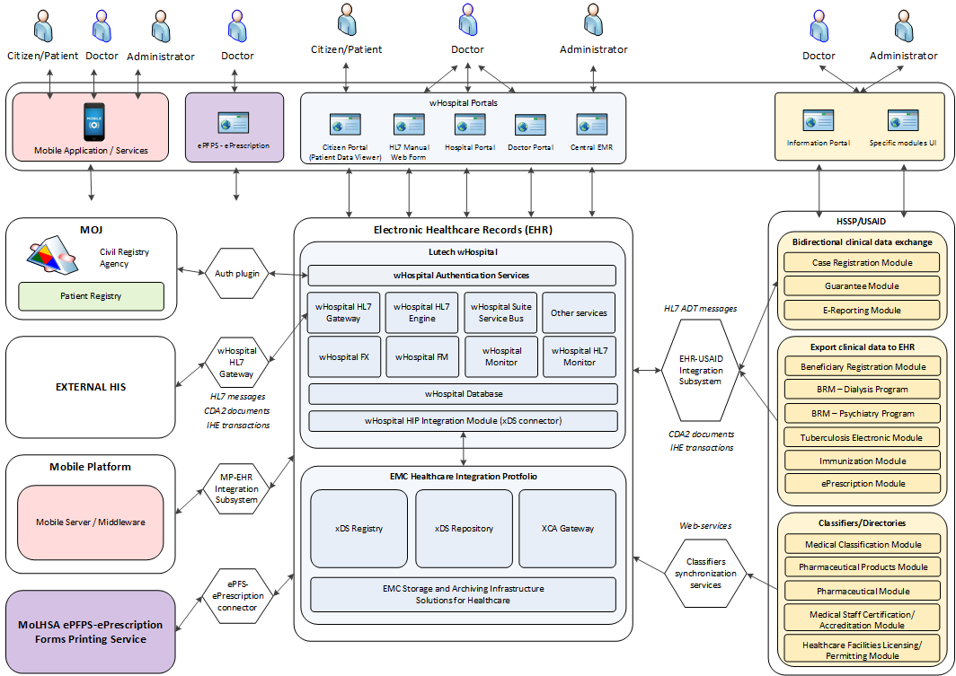
Figure 2. HMIS components schema

The scope of the Part 2: Other modules
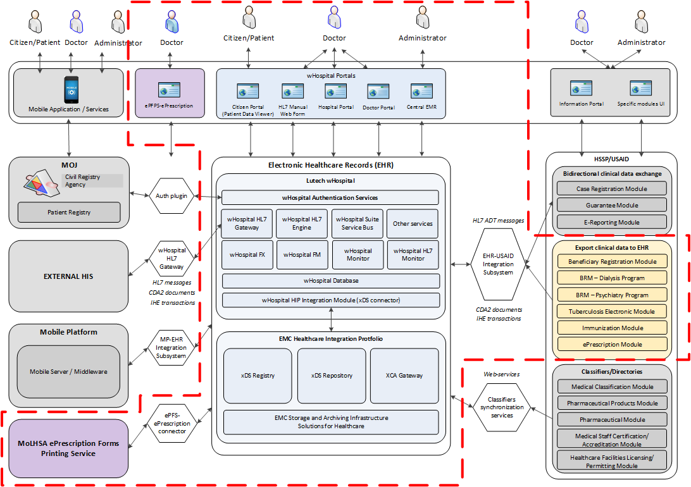
Figure 3. HMIS components (part 2: Clinical Data)

Software description
The following tables contain the information about the versions of the main applications involved in EHR-HSSP integration project.
Table 2. EMC Healthcare Integration Portfolio Software
EMC Healthcare Integration Portfolio Software Description
Software | Version | Description
XDS Registry | 1.7 | Provides a central directory for a healthcare community that contains information about patient healthcare records.
XDS Repository | 1.7 | Records management and data storage
XCA Gateway | 1.7 | Enables healthcare providers to integrate their healthcare systems with providers from different healthcare communities

Table 3. wHospital Software
wHospital Software Description
Software | Version | Description
wHospital Framework Services | 4.133.20130829.763  or upper. | Provides wHospital basic functionality
wHL7Gateway | 4.133.20130829.763  or upper. | Provides wHospital integration capabilities
wHospital XDS Publisher | 4.133.20130829.763  or upper. | Privodes cross domain sharing capabilities for CDA2 documents
wHospital Engine | 4.133.20130829.763  or upper. | Porvides end-user access to wHospital web applications

Table 4. HSSP Software
HSSP Software Description
Software | Version
HSSP Case registration module | ?
HSSP Guarantee module | ?
HSSP E-Reporting module | ?
HSSP Dialysis Module | ?
HSSP Tuberculosis Module | ?
HSSP Immunization Module | ?
Other modules | ?

EHR architecture
An electronic health record (EHR), or electronic medical record (EMR), is a systematic collection of electronic health information about an individual patient or population. It is a record in digital format that is theoretically capable of being shared across different health care settings. In some cases this sharing can occur by way of network-connected, enterprise-wide information systems and other information networks or exchanges. EHRs may include a range of data, including demographics, medical history, medication and allergies, immunization status, laboratory test results, radiology images, vital signs, personal statistics like age and weight, etc.
General EHR components schema can be found below.
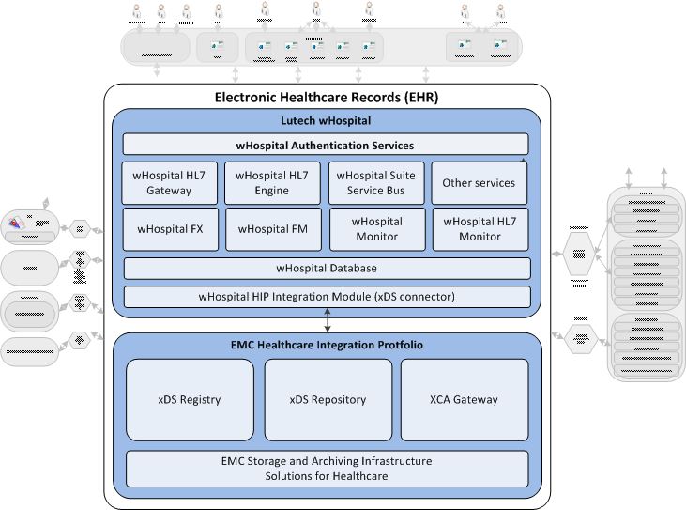
Figure 4. EHR components schema
Complete cEMR (EMC HIP and Lutech wHospital) architecture description can be found in MoLHSA HER 2.1 Solution Architecture, Part 1.

HSSPHSSP architecture
Complete description of HSSP modules architecture is out of scope of current Solution Architecture, but brief common modules architecture schema is provided below to describe modules integrational capabilities.

General HSSPHSSP components schema
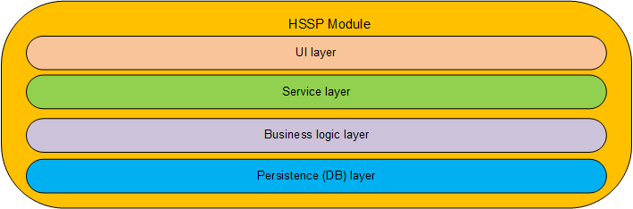
Figure 5. Common HSSP module architecture schema

Common HSSP module high-level architecture shown on Figure upper. Module service layer implements facade pattern and allows to loose coupling of business functionality consumer (UI, external system, etc.) and business functionality itself. Described architecture allows to implement integration with third-party systems (like cEMR) using HSSP modules service layer.

HSSP Modules UI
During the current project stage no UI enhancements on the HSSP Modules side is required.

EHR-HSSPHSSP general integration concepts

General integration schema
The Figure below shows the main data flows between the EHR and HSSP modules.
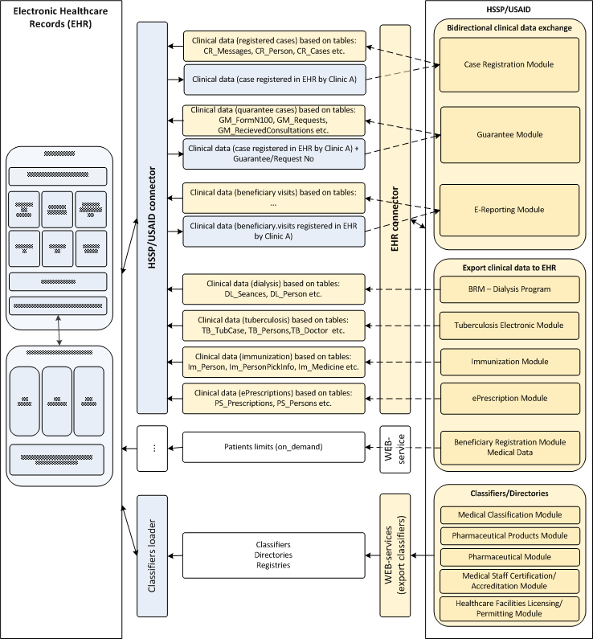
Figure 6. EHR-HSSP Modules data exchange

Integration schema (part 2: Other modules)
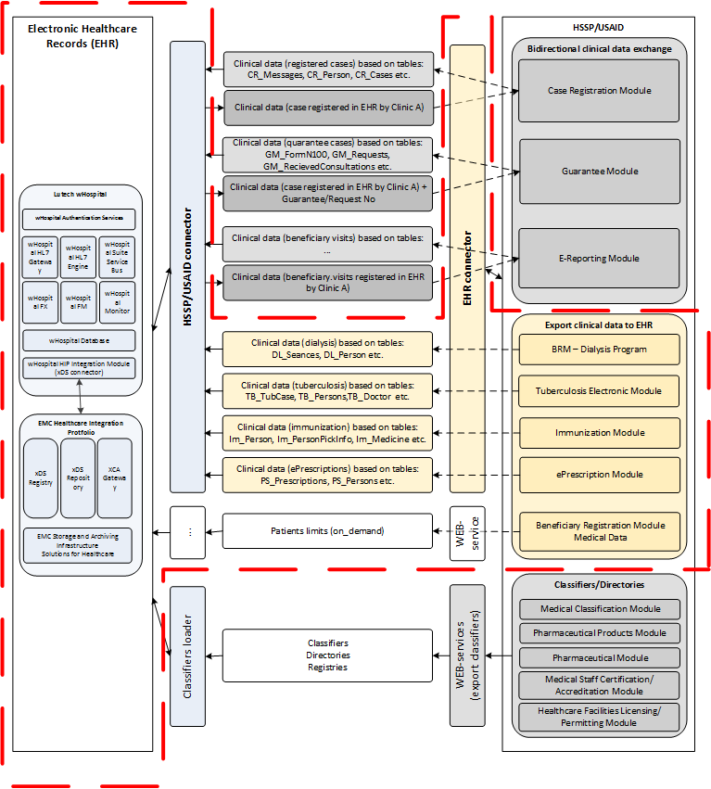
Figure 7. EHR-HSSP Modules data exchange (part 2: Clinical Data)

Data flows description (part 2: Other modules)
Table 5. Data flows description
Source | Target | Data description | Data format and replication mechanism
HSSP Beneficiary Registration Module – Dialysis Program | EHR | Clinical information about patient dialysis procedures  Replications:  - The clinical data added | Clinical Data format:  - CDA2 document (see chapter 10.1)  Replication mechanism:  HL7 message with encapsulated CDA2 to the wHL7Gateway
HSSP Beneficiary Registration Module – Psychiatry Program | EHR | Patient psychiatry clinical data  Replications:  - The clinical data added | Clinical Data format:  - CDA2 document (see chapter 10.1)  Replication mechanism:  HL7 message with encapsulated CDA2 to the wHL7Gateway
HSSP Beneficiary Registration Module – Diabetes | EHR | Patient diabetes clinical data  Replications:  - The clinical data added | Clinical Data format:  - CDA2 document (see chapter 10.1)  Replication mechanism:  HL7 message with encapsulated CDA2 to the wHL7Gateway
HSSP Beneficiary Registration Module – AIDS | EHR | Patient AIDS clinical data  Replications:  - The clinical data added | Clinical Data format:  - CDA2 document (see chapter 10.1)  Replication mechanism:  HL7 message with encapsulated CDA2 to the wHL7Gateway
HSSP Tuberculosis Electronic Module | EHR | Patient tuberculosis clinical data  Replications:  - The clinical data added | Clinical Data format:  - CDA2 document (see chapter 10.1)  Replication mechanism:  HL7 message with encapsulated CDA2 to the wHL7Gateway
HSSP Immunization Management Module | EHR | Clinical info about the patient immunizations.  Replications:  - The clinical data added | Clinical Data format:  - CDA2 document (see chapter 10.1)  Replication mechanism:  HL7 message with encapsulated CDA2 to the wHL7Gateway
HSSP Beneficiary Registration Module – Medical data | EHR | Information about patient financial limits.  EHR invokes corresponding HSSP web service on demand | Clinical Data format:  - XML  Replication mechanism:  SOAP Web service invocation

Integration mechanism description
The integration between the EHR and HSSP Modules will be implemented using Web-services implemented on both sides. From the EHR side the wHL7Gateway will handle an HL7 messages (Inbound and Outbound), containing the Clinical Case (CDA2 document). Complete description of integration mechanism can be found in part 1 of current solution architecture document. Integration components described in part 1 are going to be reused for implementation of integration tasks described in the current part of solution architecture description.
Also specific xml based web services will be implemented to integrate with electronic prescriptions printing service and to request patient limits information.

HSSPHSSP Integration components implementation
The integration subsystem on the HSSP side will contains the following main components:
- HSSP HL7 Gateway
- Case processing Handler
- Specific business logic subcomponents, related to specific HSSP modules
- Aux web-services
Complete description of HSSP integration component implementation can be found in part 1 of current solution architecture document. As it was mentioned earlier, integration components described in part 1 are going to be reused for implementation of integration tasks described in the current part of solution architecture description. Corresponding integration components can also be reused to implement further possible tasks of replication any clinical data between EHR and any third-party medical system due to the flexible architecture of integration components based on global vendor-neutral medical data exchange standards.

Standards and formats of the data replication
The main object to replicate between the EHR and HSSP Modules is Clinical Case. The Clinical Case is CDA2-document, which contains the general clinical information about treatment of the one given Patient. This CDA2-document is similar to Discharge Letter CDA2 template for In-Patient and to Consultancy Note CDA2 template for Out-Patient, but contains extra section/attributes with information, specific to the Georgian EHR. Particularly, this section can contain additional clinical information (for example, about immunization or dialysis procedures), but the common CDA2 template is the same.

EHR-HSSPHSSP integration Part 2: Other modules

Clinical Case exchange approach
As it was mentioned earlier, the main object to replicate between the EHR and HSSP Modules is Clinical Case. The Clinical Case is CDA2-document, which contains the general clinical information about treatment of the one given Patient. For modules mentioned below the common CDA2 template is the same, but some specific fields will be added or will be left blank.

Clinical data in the HSSPHSSP
As mentioned above the main sources for the Clinical data on the HSSP side are:
- HSSP Beneficiary Registration Module Dialysis Program
- HSSP Beneficiary Registration Module Psychiatry Program
- HSSP Beneficiary Registration Module Diabetes Program
- HSSP Beneficiary Registration Module AIDS Program
- HSSP Immunization Management Module
- HSSP Tuberculosis Electronic Module
Complete data migration matrix for modules listed above can be found in section 10.2

General replication logic description
The data replication for modules described in this part of solution architecture will be one-directional. I.e. the Clinical Cases will be replicated from HSSP to EHR database. Complete replication logic description can be found in part 1 of current solution architecture description.

Directories and classifiers synchronization
Within the previous phase of the Project the general medical classifiers were loaded to EHR database. Within the current phase these classifiers will be re-loaded in order to make sure EHR database contains the latest ones. Complete list of classifiers and dictionaries can be found in part 1 of current solution architecture description.

EHR – MoLHSA ePFPS integration
The schema below describes EHR integration with existing ePFPS service. Integration means no input parameters and a new prescription id. In output payload.

General schema
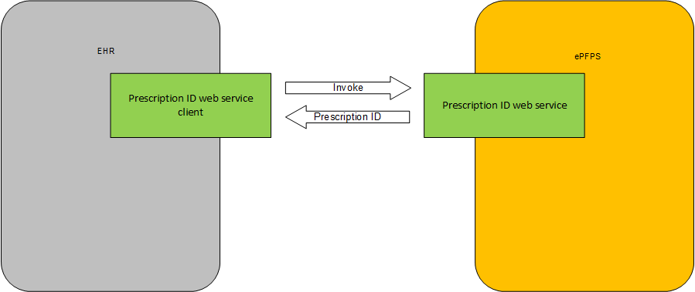
Figure 8. ePFPS integration schema

Data flows and integration mechanism description
Table 6. ePFPS data flow
Service name | WS_ePFPS_PRESCRIPTION_ID
Service type | Soap 1.1 & 1.2 Web Service
Service payload | XML
Input parameters | None
Output SOAP Envelope data fragment | …  <Prescription ID=’<Generated Prescription ID>’>  …  SOAPFault returns in case of any internal ePFPS exceptions during generation of new prescription id.
Incoming data validation rules  (ePFPS side) | None
Output SOAP Envelope validation rules  (EHR side) | - Prescription ID must exist and must not be empty (in case of non-fault response)

EHR – HSSPHSSP Medical Data integration (Patient limits)
Patient Limits Web Service will be implemented on HSSP site. Service designed to return existing patient limits. Complete service description can be found below.

General schema
Patient limits web service expect patient id. as a mandatory parameter.
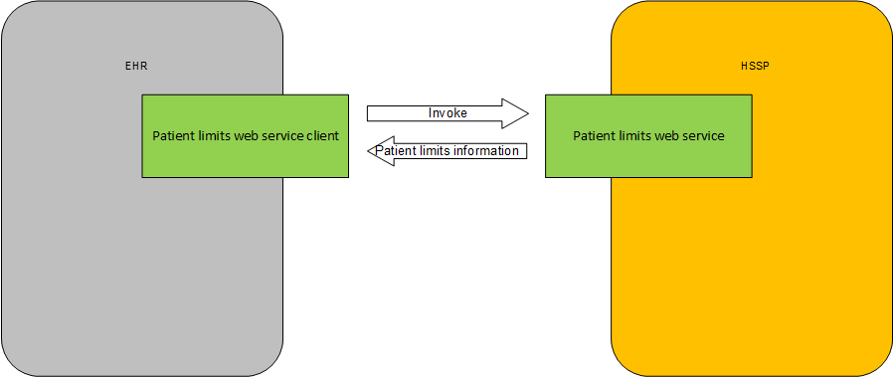
Figure 9. Patient limits processing

Data flows and integration mechanism description
Table 7. Patient limits data flow
Service name | WS_HSSP_PATIENT_LIMITS
Service type | Soap 1.1 & 1.2 Web Service
Service payload | XML
Input parameters | - PatientID
Output SOAP Envelope data fragment | <PatientLimits PatientID=’<GUID>’>  <Limit LimitType=’<String>’ Amount=’<Amount>’/>  </PatientLimits>
Incoming data validation rules  (HSSP side) | - PatientID validity check  In case of unsuccessful data validation attempt SOAP fault must be returned
Output SOAP Envelope validation rules  (EHR side) | - PatientLimits must exist (in case of non-fault response)  - PatientLimits list can be empty

EHR Security

Data security administration in HMIS
cEMR security aims:
- Authentication (Only authenticated users can access the system)
- Digital Signature (Authors will not repudiate documentation)
- Consent and Authorization (Grant patient privacy)
cEMR patient data access conditions:
- Patient must give consent to be treated in cEmr database (with paper signed document)
- Patient can modify (grant or revoke) his consent and authorization policy
- Only authorized people can access Patient Data
- Authorization must be explicit
- Citizen can protect some personal documents/events (Obscuration Info) and only few doctors will access those information
Complete description of EHR Security can be found in Part 1 of current solution architecture description.

Appendixes

CDA2-templates used for clinical data replication
CDA2-document used as main integration template is similar to Discharge Letter CDA2 template for In-Patient and to Consultancy Note CDA2 template for Out-Patient, but contains extra section/attributes with information, specific to the Georgian EHR. Particularly, this section can contain additional clinical information (for example, about immunization or dialysis procedures), but the common CDA2 template is the same. Complete CDA2 template description can be found in part 1 of current solution architecture description.

HSSPHSSP modules data description

HSSPHSSP Dialysis Program Clinical data description
Figure 10. Dialysis module data model subset

Data mapping between the module data and CDA2 template sections
Table 8. Dialysis module data mapping
Dialysis fields | Title | CDA2 section
Dl_Persons | Common registry of persons registered in the system | CDA Header
ID | Unique id | CDA Header
PersonalID | Person’s personal id | CDA Header
IdentificationDocumentTypeID | Identification document type Unique id | CDA Header
IdentificationDocumentNumber | Identification document | CDA Header
FirstName | Name | CDA Header
LastName | Surname | CDA Header
Dl_Seances | Patient sessions table (Conducted haemodialysis sessions) | TBD
ID | Unique id | TBD
BeneficiaryID | Beneficiary unique id | TBD
ServiceProviderID | Provider unique id | TBD
SeasnceTime | Session time | TBD
SeanceTypeID | Session type | TBD
Dl_Visits | Patient visits table (conducted peritoneal dialysis) | TBD
ID | Unique id | TBD
BeneficiaryID | Beneficiary unique id | TBD
VisitDate | Visit date | TBD
ServiceProviderID | Provider unique id | TBD
DateCreated | Creation date | TBD
DateChanged | Edition date | TBD
DateDeleted | Deletion date | TBD
FinancialAttributeID | Financial attribute unique id | TBD
IsLateVisit | If the visit is late | TBD
UnicPostNumber | Visit unique # | TBD
DifferenceTime | Time interval between peritoneal dialysis conduction time and recording time in the module | TBD

Data replication logic
TBD

Data validation rules
TBD

HSSPHSSP BRM Psychiatry Program Clinical data description
TBD

HSSPHSSP BRM Diabetes Clinical data description
TBD

HSSPHSSP BRM AIDS. Clinical data description
TBD

HSSPHSSP Immunization Management Module Clinical data description
Figure 11. Immunization module data model subset

Data mapping between the module data and CDA2 template sections
Table 9. Immunization module data mapping
Immunization fields | Title | CDA2 section
Im_Person |  | CDA Header
ID | Unique id | CDA Header
PersonalID | Personal id | CDA Header
FirstName | Name | CDA Header
LastName | Surname | CDA Header
BirthDate | Birthdate | CDA Header
Gender | Gender | CDA Header
MobileIndexID | Mobile phone index unique id | TBD
Mobile | Mobile phone number | TBD
Phone | Home phone number | TBD
Email | Email | TBD
RegisteredAreaID | Legal address unique id | TBD
RegisteredAddress | Legal address | TBD
ActualAreaID | Factual address unique id | TBD
Address | Factual address | TBD
Im_PersonPrickInfo | Person prick | TBD
ID | Unique id | TBD
PrickDate | Prick date | TBD
PrickTime | Prick time | TBD
DoseAmount | dosage | TBD
VaccineID | Vaccine id | TBD
ResponsiblePrickN | Personal number of the responsible person | TBD
SolventID | Solvent id | TBD
UserID | User unique id | TBD
ProviderID | Unique id of the system user | TBD
VaccineSeriesN | Serial number of vaccine | TBD
ValidityVaccine | Vaccine validity date | TBD
SolventSeriesN | Solvent serial number | TBD
ValiditySolvent | Solvent validity date | TBD
SyringeName | Syringe name | TBD
SyringeName2 | Recovery syringe name | TBD
DateCreated | Entry creation date | TBD
DateChanged | Entry edition date | TBD
DateDeleted | Entry deletion date | TBD
FTI | Thermal indicator of the bottle [vial] | TBD
ProviderName | Provider name | TBD
PaidByState | If state pays the service | TBD
VaccinatorPersonalID | Vaccinator person | TBD
InputMethod | Input method | TBD
PrickDateN | Vaccine date (in text) | TBD
VaccineManufacturerCountry | Vaccine manufacturer country | TBD
SolventManufacturerCountry | Solvent manufacturer country | TBD
DoctorPersonalID | Personal number of the responsible doctor | TBD
VaccinationType | Vaccination type (old field) | TBD
CalendarTypeID | Vaccination type | TBD
VaccinationID | Vaccination id | TBD
PersonID | Personal id | TBD

Data replication logic
TBD

Data validation rules
TBD

HSSPHSSP Tuberculosis Electronic Module Clinical data description
Figure 12. Tuberculosis module data model subset

Data mapping between the module data and CDA2 template sections
TBD

Data replication logic
TBD

Data validation rules
TBD

