MOBILE PLATFORM Architecture
Collaborative Health Environment (CHE) of Georgia
EMR 2.1

Tbilisi 2015
Reconciliation sheet

Supplier
Position | Name | Signature | Date

Customer
Position | Name | Signature | Date

1 Terms and acronyms 7
2 Document purpose 8
3 General information 9
3.1 Purposes of mobile platform 9
3.2 Location of Mobile Platform as part of HMIS 10
4 Technical Architecture of mobile platform 11
4.1 Technical requirements 11
4.1.1 General principles of technical architecture building 11
4.1.2 General hardware placement diagram 11
4.2 Technical recommendations: High Availability, Disaster Recovery, Backup and Restore 13
4.2.1 DR data-center requirements 13
4.3 Supported mobile platforms/devices 13
4.3.1 Supported mobile devices 13
4.3.2 Distribution of client applications of Mobile platform 14
5 Program architecture of mobile platform and Reporting Server 15
5.1 Reporting Server 15
5.2 Review of program architecture of Mobile Platform 16
5.2.1 Client side 16
5.2.2 Server side 16
5.3 Software Requirements 17
5.3.1 System Software 17
5.3.2 Programming languages 17
5.3.3 Application software 17
5.4 Integration capabilities of platform 18
5.5 List of the services divided by type/user role 19
5.6 Information provision of mobile services 19
5.6.1 Principles of data synchronization during MP-ISS communication 19
5.6.2 Use of directories/classifiers 20
5.7 Mobile services features description 36
5.7.1 General requirements for mobile application 36
5.7.2 Modes of operation 36
5.7.3 Requirements for mobile device data consistency 37
5.7.4 Additional requirements 37
5.7.5 Correspondence between services and on-screen forms 38
5.7.6 Healthcare Organizations Info 39
5.7.7 Pharma Info 40
5.7.8 First Aid Emergency 43
5.7.9 EMR for Patients 43
5.7.10 EMR for Doctors 45
5.7.11 ePrescriptions 47
5.7.12 Reports 50
5.8 User and access control 52
5.8.1 Main user roles 52
5.8.2 User authorization/authentication 52
5.8.3 Access permissions 54
5.8.4 Mobile application data security 54
6 User interface 55
6.1.1 General principles of user interface composition 55
6.1.2 Interface features of various mobile devices/platforms 55
6.1.3 Main screen 57
6.1.4 «Pharma Info» on-screen form 57
6.1.5 «Healthcare Info» on-screen form 58
6.1.6 «First Aid Info» on-screen form 58
6.1.7 «My Visits» on-screen form 59
6.1.8 «My Medications» on-screen form 61
6.1.9 «My Profile» on-screen form 64
6.1.10 «Visits» on-screen form 66
6.1.11 «Prescriptions» on-screen form 69
6.1.12 «Reports» on-screen form 70

LIST OF FIGURES
Figure 1. General architecture of mobile platform 10
Figure 2. General diagram of mobile platform hardware placement 11
Figure 3. Reporting Server architecture 15
Figure 4. General Program architecture of Mobile platform 16
Figure 5. Principles of synchronization between MP and ISS 20
Figure 6. First Aid directory data structure 23
Figure 7. First Aid directory article data structure 25
Figure 8. Data flow schema of Healthcare Organizations Info service 40
Figure 9. Data flow schema of Pharma Info service 42
Figure 10. Data flow schema of EMR for Patients service 45
Figure 11. Data flow schema of EMR for doctors service 47
Figure 12. Data flow schema of ePrescriptions service 49
Figure 13. Data flow schema of Reports service 51
Figure 14. Data flow schema of user authorization/authentication 52
Figure 15. Unauthorized user screen 53
Figure 16. Authorization request for a user assigned to the ‘Doctor’ role 53
Figure 17. Interface schema for smartphones 55
Figure 18. Interface schema for tablet PCs 56
Figure 19. Main menu 57
Figure 20. Pharma Info 57
Figure 21. Healthcare Info 58
Figure 22. First Aid Info 59
Figure 23. My Visits 60
Figure 24. Detailed info of the episode 60
Figure 25. Detailed info of the episode (continued) 61
Figure 26. My Medications 62
Figure 27. Prescriptions 63
Figure 28. My Profile 64
Figure 29. Form 100 65
Figure 30. Visits 66
Figure 31. Summary, concerning patient 67
Figure 32. Episode information input forms 67
Figure 33. Episode information input forms (continued) 68
Figure 34. Prescriptions – patient and his prescriptions 69
Figure 35. List of the reports 70

LIST OF TABLES
Table 1. Main Data-center requirements 12
Table 2. DR data-center requirements 13
Table 3. System software requirements 17
Table 4. Mobile services 19
Table 5. First Aid directory description 21
Table 6. First Aid directory data structure 21
Table 7. Article data structure 24
Table 8. The structure of firstaid_group table 26
Table 9. The structure of firstaid_page table 27
Table 10. The structure of firstaid_block table is 27
Table 11. The structure of firstaid_image table 28
Table 12. Medical Institutions directory 29
Table 13. The data structure of healthcare organizations table 30
Table 14. The structure of health_org_type table 31
Table 15. The structure of health_org_type_mapping table 32
Table 16. Medications directory 33
Table 17. Data structure of drugs table 34
Table 18. Data structure of ingredients table 35
Table 19. Data structure of drugs_ingredients_mapping table 35
Table 20. Correspondence between services and on-screen forms 38
Table 21. Description of Healthcare Organizations Info service 39
Table 22. Pharma Info service description 40
Table 23. First Aid Emergency service description 43
Table 24. EMR for Patients service description 44
Table 25. EMR for Doctors service description 45
Table 26. Description of ePrescriptions service 48
Table 27. Reports service description 50
Table 28. Access permissions 54

Terms and acronyms
CHE | Collaborative Healthcare Environment
EMR/EHR | Electronic Medical Records/ Electronic Health Records
HIS | Health Information System
HMIS | Health Management Information System
HSSP | Health System Strengthening Project
MoLHSA | Ministry of Labour, Health and Social Affairs of Georgia
Mobile Service | Mobile Service.  Acronym for mobile service (one of the services of Mobile Platform) which provides users with access to clinical information in HER.
USAID | United States Agency for International Development
Customer | Ministry of Labour, Health and Social Affairs of Georgia
Case/Episode | (in terms of this document) The fact of the provision of medical services to patient
Clinical information / Clinical data | Clinical/Medical information about the patients, which is subject to storing in EHR
MA | Mobile Application
ISS | Intermediate Synchronization Server

Document purpose
This document contains description if functional requirements for development of Mobile Application, providing access to clinical, financial and statistical information from HMIS components.
The document contains following sections:
- Section 4 contains brief description of Technical Architecture of mobile platform. Details on Technical Architecture of full HMIS infrastructure are described in a separate document
- Section 5 contains detailed description of Program Architecture of mobile platform.
- Section 6 contains UI design of mobile application.

General information

Purposes of mobile platform
Mobile platform is intended to provide all Georgia citizens with convenient tool for access to HMIS via portable devices (mobile phones, tablet PCs).
An access to personal information will provide one with the ability to quickly browse appeals and prescriptions.
- Access to information regarding healthcare organizations and medications and first aid instructions.
- Access to HMIS via MA will allow doctors immediately (while working with patient) retrieve information about cases or record information about provided medical services.
- Mobile Service, allowing entering information about Cases, will help to connect to the system those doctors who visit patients at home.
- Rising of quality of medical services by providing quick access to clinical information for patients and doctors.
- Rising of people awareness regarding available healthcare organizations, pharmacies, medications
- Rising of quality of Georgia Healthcare System management by providing quick access to financial and statistical reports for MoLHSA specialists.

Location of Mobile Platform as part of HMIS
Location of Mobile Platform as part of HMIS is presented in Figure 1.

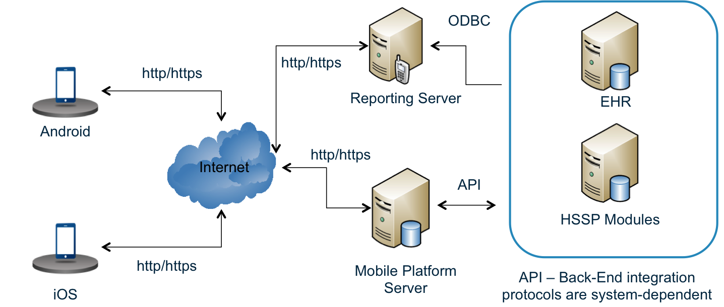
Figure 1. General architecture of mobile platform
Mobile Applications – described in 5.2.1
Reporting Server - described in 5.1
Mobile Platform Server – described in 5.2.2
HMIS Back-end – described in SOLUTION ARCHITECTURE MoLHSA EMR 2.1 PART 1 document

Technical Architecture of mobile platform

Technical requirements

General principles of technical architecture building
General approach for implementation of server-side MoLHSA EHR, including mobile platform, is described in «Technical Architecture for EHR 2.1». Server-side of mobile platform will be deployed on VMware Virtual Servers (Guests) connected to a Storage system.

General hardware placement diagram
General diagram of placement of mobile platform hardware is presented in Figure 2.
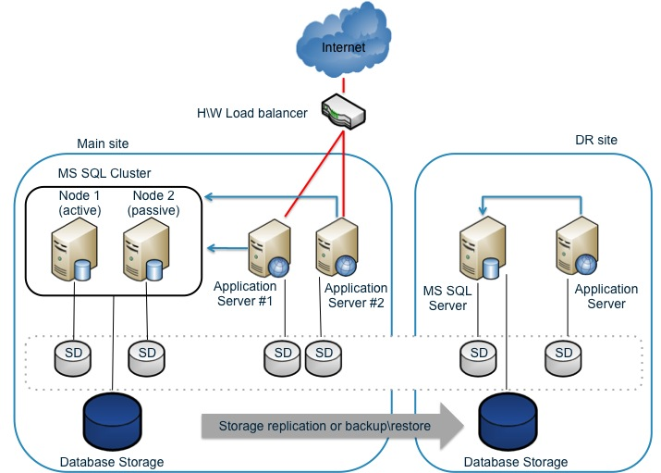
Figure 2. General diagram of mobile platform hardware placement

Virtual servers included in the Mobile platform will be deployed on virtualization platform. Each virtual server will be provided with a partition inside Storage System to store system drive with system software, application software and all required configuration. For MS SQL Server Cluster (in main data-center) and virtual MS SQL Server (in DR-environment) there will also be dedicated partitions for DB storage.

Calculation of requirements for technical means.

Hardware load estimation
Hardware load estimation was made assuming 1000 requests from portable devices per second. Users with “citizen/patient” role generated most of the traffic. Users with “doctor” and “specialist” roles do not generate any significant load compared to “citizens”.
While calculation storage volume it was assumed that Mobile platform does not store patients’ CCD data in own Database. Mobile clients’ requests, concerning CCD information and content, synchronously directed to EHR. Supplemental information (healthcare organizations, medications, first aid instructions) is fully stored in Mobile platform server database.
The calculation also includes expected growth of number of users and volume of data being processed and transferred up to 2017.
Supplemental information (healthcare organizations, medications, first aid instructions) is fully stored in Mobile platform server database. Details concerning Supplemental information are described in section 5.5.2.
Unstructured content, concerning patient’s medical history (PDFs of prescriptions, graphical files and documents containing test results etc.) will not be stored inside Mobile platform Database. Requests for such information will be directed to MoLHSA HMIS modules, which store such content.

Main Data-center requirements
The table below shows the minimal computing and memory resources for each server.
Table 1. Main Data-center requirements
Number of modules | Module type | Resources per server\module
Number of modules | Module type | vCPU | HDD, Gb | RAM, Gb
2 | Application Server node | 4 | 40 | 8
2 | MS SQL Server node | 4 | 40 | 8
1 | MS SQL Storage | n/a | 100 | n/a
Total: 4 virtual servers, 16 vCPU, 32 Gb RAM
Storage for virtual servers HDD: 160 Gb
Storage for MS SQL database: 100 Gb

Network requirements
While working online, Mobile Application should support various network protocols: LTE, 3G, GPRS, Wi-Fi.
Data-center, serving Mobile platform, should have internet connection supporting at least 100 Mb/s connection speed

Technical recommendations: High Availability, Disaster Recovery, Backup and Restore
Currently implementation of High Availability and Disaster Recovery of Mobile Platform is out of scope, because Mobile Platform is considered as a data consumer in most use cases. This circumstance does not allow considering Mobile Platform with implemented current functionality as a mission-critical functional module.
Given the prospect of Mobile Platform and possibility of implementing functionality considered as a data producer (for example, scheduling of doctor’s appointment), which transforms Mobile Platform into mission-critical functional module, for which, in turn, High Availability and Disaster Recovery are completely necessary requirements. In that case, appropriate implementation of these requirements have already been designed and is described below.
High Availability and Disaster Recovery of main data-center’s resources is provided by using coupled application servers with hardware load balancer, and also by using SQL Server cluster which consists of two hot spare nodes.
To provide DR there is a separate resource pool dedicated in the remote data-center. DR-environment does not reckon for additional back-up.
All information that is needed to provide mobile client operability is stored in database. There is no need to back-up system drives of mobile platform virtual servers on a regular basis. While updating system or application software, it is recommended to make back-up of hard drives of mobile platform servers.
Back-up, recovery, DR procedures should be performed as part of cEMR general strategy.

DR data-center requirements
Table below shows the minimum requirements for DR data-center:
Table 2. DR data-center requirements
Number of modules | Module type | Resources per server\module
Number of modules | Module type | vCPU | HDD, Gb | RAM, Gb
1 | Application Server node | 4 | 40 | 8
1 | MS SQL Server node | 4 | 40 | 8
1 | MS SQL Storage | n/a | 800 | n/a
Total: 2 virtual servers, 16 vCPU, 32 Gb RAM
Storage for virtual servers HDD: 80 Gb
Storage for MS SQL database: 800 Gb

Supported mobile platforms/devices

Supported mobile devices
Client applications of Mobile platform are developed for the following mobile devices:
- Apple Smartphones and tablet PCs (iPhone and iPad): all models, operated by iOS, supported at the moment of publication in Apple AppStore (versions supported while this document is being developed: iOS 7.x and iOS 8.x).
- Smartphones and tablet PCs operated by Google Android:
  - Operated by Android 4.0.3 and 5.x (API Level 15 or higher).
  - RAM size, available for application, must meet Android Compatibility Definition Document (for relevant OS version) requirements, but not less then 64MB.
Screen size and resolution supported by Mobile Application:
- Supported screen size: 4 to 14 inches;
- Supported resolution for smartphones: 940x640 to 1920x1080;
- Supported resolution for tablet PC: 1024x768 to 2560x1600.

Distribution of client applications of Mobile platform
Client application for iOS will be distributed via Apple AppStore.
Client application for Android will be distributed via Google Play Store.

Program architecture of mobile platform and Reporting Server

Reporting Server
It is assumed that ArcPlan Enterprise platform will be used for reports generation. Using an enterprise platform allows use of wide capabilities for report visualization:
- Supports more than 30 different visualization methods, including animated diagrams;
- Additional configuration can be done with no need for use of programming tools;
- Supports HTML 5, all reports can be adapted for mobile;
- Reports can be embedded in other HMIS systems;
- Export to pdf, ppt, word, excel;
- Pre-built data source connectors (HSSP, EHR);
- High performance.
Diagram of the components including main information flows, required to build reports, are shown in Figure 3 .
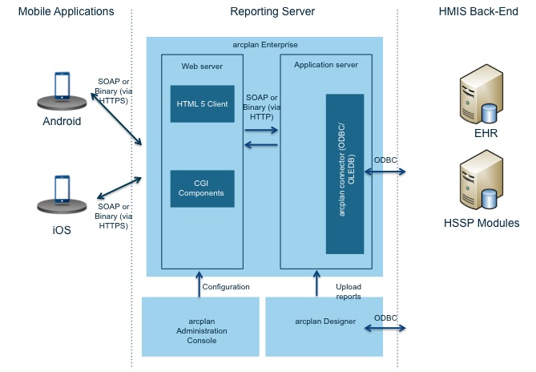
Figure 3. Reporting Server architecture
HMIS Back-end is the Data Source. The ArcPlan interfaces provide two-sided access to data sources for following visualization of the data in on-screen forms.
ArcPlan Application Server – provides data retrieval from data sources, populating on-screen forms with data, makes calculations, allows authentication, provides access rules support.
ArcPlan Application Designer – a tool for development of on-screen forms and toolbars.
Administration Console – allows storing and control over implemented applications.
Web Server – allows on-screen forms retrieval from the application server and transfer to workplaces (Mobile Applications)
User workplaces (Mobile Applications) – allows visualization of data and interaction with user.

Review of program architecture of Mobile Platform
Mobile platform consists of:
- Client side (native mobile applications for iOS and Android)
- Server side
General architecture of Mobile platform is shown in Figure 4.

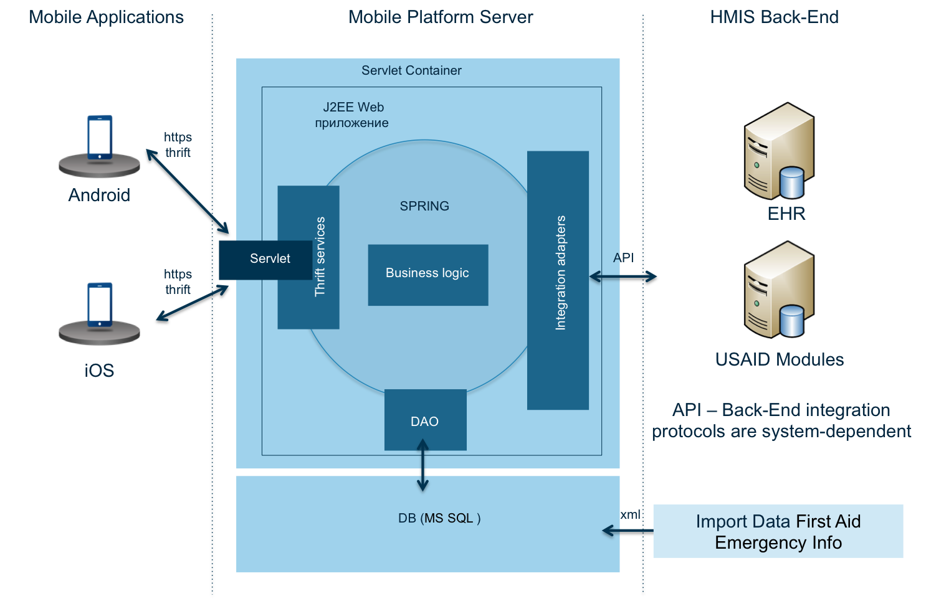
Figure 4. General Program architecture of Mobile platform

Client side
Client side is a complex of applications for iOS and Android. It is assumed that every installation of the Mobile Application is used by single person. Concerning MoLHSA HMIS goals, one can expect up to several million installations of Mobile Application in the following three years.
Client applications of Mobile platform are native applications for iOS or Android. To store required data, MA uses built-in database of mobile platform and file system of mobile application’s sandbox.
For communications with the Mobile platform server, MA will use network facilities (internet connection) provided by mobile OS (iOS, Android).

Server side
Server side of Mobile platform consists of application server and database server.
Application server is processing the requests for information from HMIS, requests for actions (changes) in HMIS, requests for replication of for supplementary data from other HMIS modules into own database of Mobile platform.
Mobile platform database is used to store all data, which is operated by mobile platform (both structured data and content). Most of the data in Mobile platform is a copy/view/compilation of data, retrieved from other HMIS modules, but it is located in own database of Mobile platform for quick access.

Software Requirements

System Software
Table below shows what software is used.
Table 3. System software requirements
Component | Name | Version
Application server
Operating system | Windows Server | 2008 R2 SP1 (64-bit version)
Application server | Apache Tomcat | 7.0.29
Java-machine | Oracle JRE | 7.0 Update 79
Database server
Operating system | Windows Server | 2008 R2 SP1 (64-bit version)
Database server | MS SQL Server | 2008 R2 SP1
Failover | SQL Server Failover Cluster | 2008

Programming languages
Mobile applications will be developed with native development tools:
- Android SDK and JAVA for Android;
- iOS SDK and Objective-C for iOS.

Application software
Following modules will be implemented during Mobile platform development:
- HMIS Mobile Platform Intermediate Synchronization Server: a Java Web-application implementing the server-side logic of Mobile platform.
- HMIS Mobile Client for Android: a native Android application implementing Mobile Platform client for the Android platform.
- HMIS Mobile Client for iOS: a native iOS application implementing Mobile Platform client for the iOS platform.
- First Aid Data Loader Utility: a stand-alone Java program for loading and updating the content of First Aid Emergency Information module of HMIS Mobile Platform.

Integration capabilities of platform
While server-side of Mobile platform is communicating with EHR and HSSP, mobile platform acts as initiator.
For communications with HSSP, web-services implemented on side of HSSP are utilized.
During communication with EHR, data exchange is done in CDA2 format, web-services for exchange are provided by wHl7Gateway.

List of the services divided by type/user role
All mobile services are grouped in 4 types:
Table 4. Mobile services
Service type | Description | List of services | User roles
Type 1 - Dictionaries | Provides wide range of users with supplementary information. Information provided to the users is static and rarely changed | Healthcare Organizations Info  Pharma Info  First Aid Emergency Info | Citizen
Type 2 - passive services of access to electronic medical card | Services allow users to get information regarding patients, but do not allow make changes to it. These services require integration with EHR in read mode. | EMR for Patients  ePrescriptions | Patient
Type 3 - active services of access to electronic medical card | Services allow users to get information regarding patients and make changes to it. These services require integration with EHR in read mode. | EMR for Doctors | Doctor
Type 4 – mobile services of operational reporting | Services allow users to get various reports generated by different modules. These services provide information concerning data in various modules. These services require integration with EHR or modules which generate reports. | Reports | Specialists of the Ministry

Information provision of mobile services

Principles of data synchronization during MP-ISS communication
MP stores in local DB and file system of mobile device last current state of data, retrieved from ISS. Principles of following synchronizations between MP and IS are shown in Figure 5.
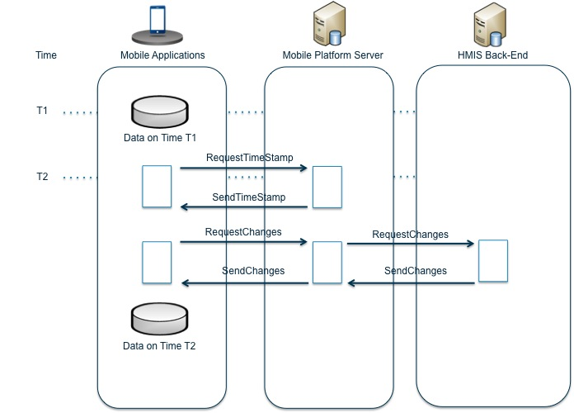
Figure 5. Principles of synchronization between MP and ISS
Synchronization process:
- MP stores data, retrieved from ISS at Т1 time-point.
- MP requests ISS for current time (RequestTimeStamp).
- ISS returns T2 time (SendTimeStamp).
- MP requests ISS for changes, made between T1 and T2 (RequestChanges).
- ISS builds data package which contains information about objects which were changed, added, deleted since last synchronization of this instance of MP (SendChanges). If needed, ISS will send a request to relevant EHR and HSSP services.
- MP makes changes, reflecting new information, to local DB and file system.
- MP saves information that local data has been synchronized at T2 time-point.
Database server provides T1 and T2 time-stamps.
After installation local data at MP will be empty and special “0” timestamp.
Timestamps are treated as 64-bit integer values. Each timestamp is a number of milliseconds «since epoch» - from the beginning of 1970 UTC to current time.

Use of directories/classifiers
MP is using these directories and classifiers:
- First Aid directory;
- Medical Institutions directory;
- Medications directory.

First Aid directory
The directory is described in Table 3:
Table 5. First Aid directory description
Name | First Aid Emergency Info
Storage place | Mobile device database
Initial data is included in application distributive | Yes
Access mode | Offline
Synchronization method | Refresh only changed data (GetChanges) in background
Data source | xml-files. xml-structure is described in (5.6.2.1.1)
Update request frequency | Once every 24 hours
Data description | Two-level directory:  - First Aid directory is divided into sections.  - Each section contains plain list of articles.  Details of data load process and data structure are described in (5.6.2.1.1)
Representation in Mobile Application | See Figure 22

Directory data structure
Data loader tool gets data from set of xml-files and image files: one xml-file describes sections of the directory and what articles belong to which section, contents of each article are described in a separate xml-file, if images are related to an article each of the images gets loaded from image file.
Table below shows the structure of xml-file, containing relations between articles and sections.
Table 6. First Aid directory data structure
Element | Parent element | Data type | Description
firstAidInfo | no | complexType | Root of the xml-file
group | firstAidInfo | complexType | Describes one section of the directory
groupId | group | string | Section ID
groupNameEng | group | string | Name of section in English
groupNameGeo | group | string | Name of section in Georgian
orderBy | group | int | Shows how to order sections. Sections with lower values of orderBy displayed first, if orderBy is the same – sections are ordered by name (using language of Mobile Application).
page | group | complexType | Describes one article of the directory. “group” element can contain any number of “page” elements (minOccurs="1" maxOccurs="unbounded").
pageId | page | string | Article ID. The ID must be unique across all articles of the directory.
detailsXml | page | string | Name of the xml-file (possibly, with absolute or relative path), which contains information about the article.
orderBy | page | int | Shows how to order articles. Articles with lower values of orderBy displayed first, if orderBy is the same – articles are ordered by name (using language of Mobile Application).
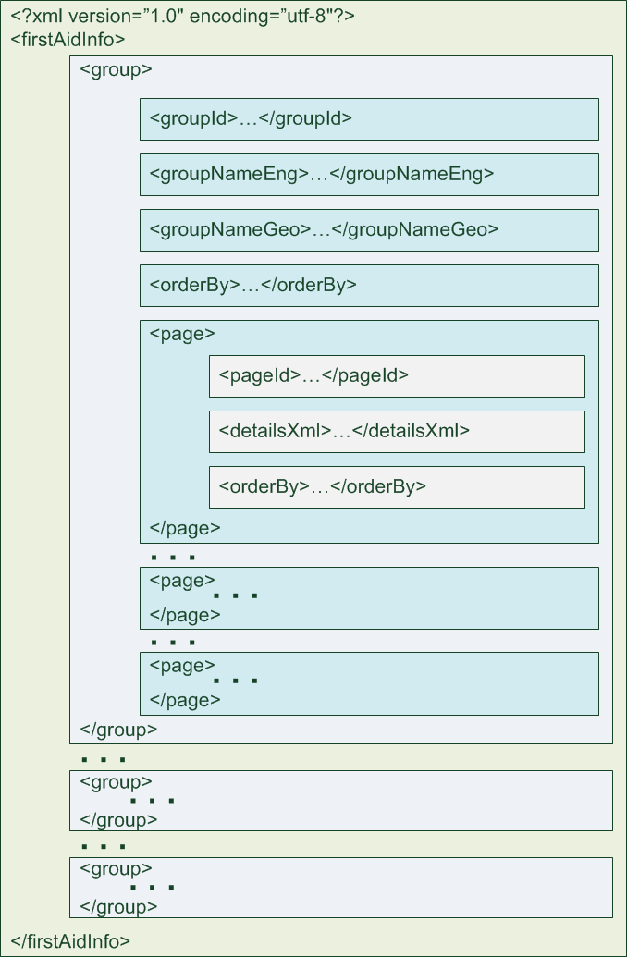
Figure 6. First Aid directory data structure
Structure of the xml-file describing an article is shown in Table 5.
Table 7. Article data structure
Element | Parent element | Data type | Description
page | no | complexType | Root of the xml-file
id | page | string | Article ID
nameEng | page | string | Name of article in English
nameGeo | page | string | Name of article in English
content | page | complexType | Parent element for article contents description. Contains nonempty set of “image”, “localizedImage”, “textBlock” elements
image | content | string | Name of the image file, no need for localization (possibly, with absolute or relative path).
localizedImage | content | complexType | Image, which has different versions in Georgian and English.
imageEng | localizedImage | string | Name of image file for article in English (possibly, with absolute or relative path).
imageGeo | localizedImage | string | Name of image file for article in Georgian (possibly, with absolute or relative path).
textBlock | content | complexType | Text
textEng | textBlock | string | Text of article in English. Html-markup is allowed.
textGeo | textBlock | string | Text of article in Georgian. Html-markup is allowed.

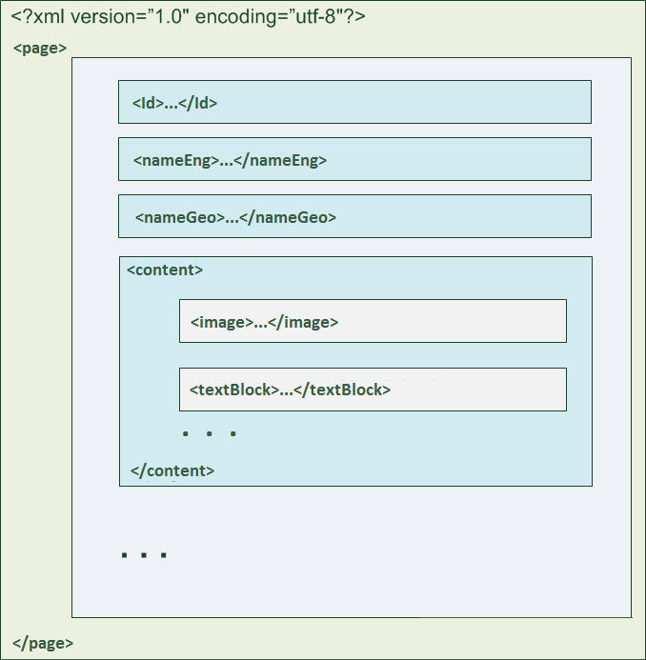
Figure 7. First Aid directory article data structure

PNG-images can be added to an article using data loader tool. It is recommended to use the smallest possible images, grayscale or using as few colors as possible, not wider than 500px. All image file names must be unique across an article. File names can contain uppercase and lowercase Latin letters, numbers (0…9), “-“ (minus) sign, “_” (underscore) sign. There are no special requirements for file path or xml-file names.
In the DB of Mobile platform server the directory is stored in the following tables:
- firstaid_group – directory section
- firstaid_page – directory article
- firstaid_block –block of an article
- firstaid_image – image in an article
The structure of firstaid_group table is described below:
Table 8. The structure of firstaid_group table
Name | Type | Description
id | bigint | Primary key.
external_id | nvarchar | Section ID from the xml-file. Only in used by data loader, not transferred into MA
name_eng | nvarchar | Section name in English
name_geo | nvarchar | Section name in Georgian
order_by | integer | Shows how to order sections
deleted | bit | If 1 then the section has been deleted
modified | datetime | Last modification time

The structure of first aid page table is described below:
Table 9. The structure of firstaid_page table
Name | Type | Description
id | bigint | Primary key.
external_id | nvarchar | Article ID from the xml-file. Only in used by data loader, not transferred into MA
group_id | bigint | Id of the parent Section. External key.
name_eng | nvarchar | Article name in English
name_geo | nvarchar | Article name in Georgian
order_by | integer | Shows how to order articles
order_by | integer | Shows how to order sections
deleted | bit | If 1 then the article has been deleted
modified | datetime | Last modification time (including modifications to blocks and images)
The structure of first aid block table is described below:
Table 10. The structure of firstaid_block table is
Name | Type | Description
id | bigint | Primary key.
page_id | bigint | ID of the parent Article. External key
serial | integer | Number of the block within parent article.
image_id | bigint | If the block contains an image which does not need to be localized, then the image ID, otherwise null. External key.
image_eng_id | bigint | If the block contains an image which needs to be localized, then the English image ID, otherwise null. External key.
image_geo_id | bigint | If the block contains an image which needs to be localized, then the Georgian image ID, otherwise null. External key.
text_eng | nvarchar(max) | If current block is a text, then English text, otherwise null
text_geo | nvarchar(max) | If current block is a text, then Georgian text, otherwise null

The structure of first aid image table is described below:
Table 11. The structure of firstaid_image table
Name | Type | Description
id | bigint | Primary key.
filename | varchar | Name of the image file including extension
Content | varbinary(max) | Image content

Medical Institutions directory
The directory is described below:
Table 12. Medical Institutions directory
Name | Healthcare Organizations Info
Storage place | Mobile device database– Directory of emergency aid organizations  Database of mobile application server – all organizations
Initial data is included in the application distributive | Yes, Directory of emergency aid organizations
Access mode | Offline - Directory of emergency aid organizations  Online – all organizations
Synchronization method | Refresh only changed data (GetChanges) in background.  HSSP includes web-service, which returns information about new, changed, deleted organizations within a given period of time. ISS stores information about last sync time and during following sync it will only request changed data.
Data source | HSSP
Update request frequency | Once every 24 hours
Data description | Medical Institutions directory contains:  - Name  - Type  - Address  - Phone number  - Working hours  - Detailed information  - Geographical coordinates  The data structure of the directory is described in 5.5.2.2.1
Representation in Mobile Application | see Figure 21

The data structure of the directory
The data of Medical Institutions directory is stored in ISS database in these tables:
- health_organization: main table of healthcare organizations, see 5.5.2.2.2;
- health_org_type: general information concerning healthcare organizations types, see. 5.5.2.2.3;
- health_org_type_mapping: “many-to-many” relationship between organizations and types, see. 5.5.2.2.4

Healthcare organizations table
General information about healthcare organizations is located in health_organization table of ISS database. The structure is described below:
Table 13. The data structure of healthcare organizations table
Name | Type | Description
id | bigint | Primary key.
external_id | varchar(36) | GUID of the organization in HSSP (Healthcare Providers module)
is_emergency | bit | A mark that this is an emergency aid organization
name_geo | nvarchar(256) | Institution name in Georgian
name_eng | nvarchar(256) | Institution name in English
address_geo | nvarchar(1024) | Institution address in Georgian. Html-markup is supported.
address_eng | nvarchar(1024) | Institution address in English. Html-markup is supported.
phone | nvarchar(64) | Main phone number
phone2 | nvarchar(64) | Additional phone number. Nullable.
phone3 | nvarchar(64) | Additional phone number. Nullable.
work_hours_geo | nvarchar(1024) | Working hours in Georgian. Html-markup is supported.
work_hours_eng | nvarchar(1024) | Institution address in English. Html-markup is supported.
description_geo | nvarchar(max) | Detailed information in Georgian. Html-markup is supported
description_eng | nvarchar(max) | Detailed information in English. Html-markup is supported
lattitude | decimal(9,6) | Latitude
longitude | decimal(9,6) | Longitude
deleted | bit | If 1 then this has been deleted
modified | datetime | Last modification timestamp

Healthcare organization types
Healthcare organizations types are stored in health_org_type table of ISS database. The structure is described below:
Table 14. The structure of health_org_type table
Name | Type | Description
id | bigint | Primary key
external_id | varchar(36) | GUID of the organization in HSSP (Healthcare Providers module)
name_geo | nvarchar(256) | Name of the type in Georgian
name_eng | nvarchar(256) | Name of the type in English
deleted | bit | If 1 than this has been deleted
modified | datetime | Last modification timestamp

Relationships between organizations and types
Relationships between organizations and types are stored in health_org_type_mapping table of ISS database. The structure is described below:
Table 15. The structure of health_org_type_mapping table
Name | Type | Description
organization_id | bigint | ID of healthcare organization. External key, pointing to health_organizations table.
type_id | bigint | ID of healthcare organization type. External key, pointing to health_org_type table.
Note: there is no deletion mark or modification date for relationships between organizations and types. health_org_type_mapping table always contains latest information about relationships. If data gets changed, health_organization.modified will be updated.

Medications directory
The directory is described in Table 14:
Table 16. Medications directory
Name | Pharma Info
Storage place | Mobile device database – brief information  Mobile application server database – full information
Initial date included in application distributive | No
Access mode | Offline- brief information:  - Name of the medication  - Active substance  Online – Full directory
Synchronization method | Brief information is getting loaded in background after MA is started.  After first load only changed data will be loaded (GetChanges)
Data source | HSSP
Update request frequency | Once every 24 hours
Data description | Medications directory contains:  - Name  - Active substance  - Description  see 5.5.2.3.1
Representation in Mobile Application | see Figure 20

Data structure of the directory
Directory data is stored in these tables:
- drugs: main table with information about medications, see 5.5.2.3.2 ;
- ingredients: information about active substances, see 5.5.2.3.3 ;
- drugs_ingredients_mapping: “many-to-many” relationships between medications and ingredients, see 5.5.2.3.4

Table with information about medications
General information about medications is stored in drugs table of ISS database. See structure below:
Table 17. Data structure of drugs table
Name | Type | Description
id | bigint | Primary key.
external_id | varchar(36) | GUID of the medication in HSSP
name_geo | nvarchar(256) | Name in Georgian
name_eng | nvarchar(256) | Name in English
description_geo | nvarchar(max) | Description in Georgian. Html-markup is supported
description_eng | nvarchar(max) | Description in English. Html-markup is supported
deleted | bit | If 1 then this has been deleted
modified | datetime | Modification timestamp

Information about active substances
Information about active substances is stored in ingredients table of ISS database. See structure below:
Table 18. Data structure of ingredients table
Name | Type | Description
id | bigint | Primary key.
external_id | varchar(36) | GUID of active substance in HSSP
name_geo | nvarchar(256) | Name in Georgian
name_eng | nvarchar(256) | Name in English
deleted | bit | If 1 then this has been deleted
modified | datetime | Modification timestamp

Relationships between medications and active substances
Information about relationships between medications and active substances is stored in drugs_ingredients_mapping table. See structure below:
Table 19. Data structure of drugs_ingredients_mapping table
Name | Type | Description
drugs_id | bigint | ID of medication. External key, pointing to drugs table.
ingridient_id | bigint | ID of active substance. External key, pointing to ingredients table.

Mobile services features description

General requirements for mobile application
In order to be operational, MA needs to be downloaded by user from AppStore or GooglePlat and installed on supported device.

Modes of operation
MA can operate in one of the modes:
- offline mode - no connection to EHR and MA server;
- online mode - connected to EHR and MA server
If an attempt is made to access online functions while not connected to HER and MA server, following message (with “OK” button) will be displayed: «Connection to the server lost. Please check your internet connection and try again later». «OK» button will guide a user to the previous screen.
In offline mode MA should provide a user with ability to use these modules:
- «First Aid Emergency Info» - for all users;
- «My Visits» - only for authorized users;
- «My Medications» – only for authorized users;
- «My Profile» - only for authorized users;
- «Visits» - only for authorized members of ‘Doctor’ role;
- «Prescription» - only for authorized members of ‘Doctor’ role;
- «Reports» - only for authorized members of ‘Specialist of the Ministry’ role
All mentioned modules, except for ‘Reports’, should use latest synchronized data while offline.
No background operations are performer while offline. Initial data load has to be performed to enable working offline.

Requirements for mobile device data consistency
Consistency of MA data, saved on mobile device, is provided by means of mobile device OS.
If work with application is interrupted, all field data should be saved until the device is switched off, with the exceptions described below.
Interruption by a third-party applications and (or) process means (one or more of the following):
- Turning MA to stand-by mode (collapsing MA);
- push-notification from a third-party application while MA is active;
- incoming SMS/MMS or messages from third-party applications;
- incoming calls (including applications which support this functionality, for example skype);
After switching back to MA, a user should see the screen he was working on before interruption.
If MA is started after device reboot or after re-installation of MA, MA will show starting screen and all entered data is lost. If MA is started after some data has been deleted from hard drive, MA will start from the last used screen only if enough data remain in device RAM..

Additional requirements
MA should save battery by:
- Disabling GPS facilities if it is not needed to track user’s location.
- Minimizing network traffic.
- Minimizing device load by background processes of MA (minimizing background activity).
There is no requirement for disc space consumed by MA. MA is developed concerning principles which allow application size decrease for all platforms without graphical quality loss, speed loss or application stability.

Correspondence between services and on-screen forms
Table 20. Correspondence between services and on-screen forms
On-Screen form/Service | Healthcare Organizations Info | Pharma Info | First Aid Emergency Info | EMR for Patients | EMR for Doctors | ePrescriptions | Reports
My Visits |  |  |  | X
My Medications |  |  |  | X |  | X
My Profile |  |  |  | X
Pharma Info |  | X
Healthcare Info | X
First Aid Info |  |  | X
Visits |  |  |  |  | X
Prescriptions |  |  |  |  |  | X
Reports |  |  |  |  |  |  | X

Healthcare Organizations Info
Healthcare Organizations Info service provides quick access to healthcare organizations directory and gives citizens ability to get access to information about organizations, their locations, contact information with an option to make phone calls. Healthcare Organizations Info service is described below.

Description
Service description is presented in Table 19:
Table 21. Description of Healthcare Organizations Info service
Service name | Healthcare Organizations Info
Short description | This service allows one to obtain information about medical organizations of Georgia
Main functions | Browse healthcare organizations nearby  Search by name  Search filters (type, specialization etc.)  View main properties (name, address, phone numbers etc.)  Make phone call
Users (roles) | All Georgia citizens(Citizen)
Requires authorization | No
Access mode | READ
Types of displayed information and how the information is retrieved | List of the displayed information is shown in Figure 21.  The information is displayed in on-screen forms, implemented with standard development tools provided by OS of mobile device (see 5.2.2)  Emergency Aid Institutions directory is stored in the database of mobile device.  Information about all Institutions is stored in the database of mobile application server and can be transferred to the mobile device on demand.
Data, cached at the mobile device | Emergency Aid Institutions directory
offline mode availability (with no network access) | Yes, Emergency Aid Institutions search
Data source | HSSP:  - Healthcare Facilities Licensing/Permitting Module  - Pharmaceutical Module

Schema
The schema of the data flows between MA, MP server and HSSP is shown in Figure 8.
All network communications between MA and MP server is initiated by MA. All network communications between MP server and HSSP is initiated by MP Server.

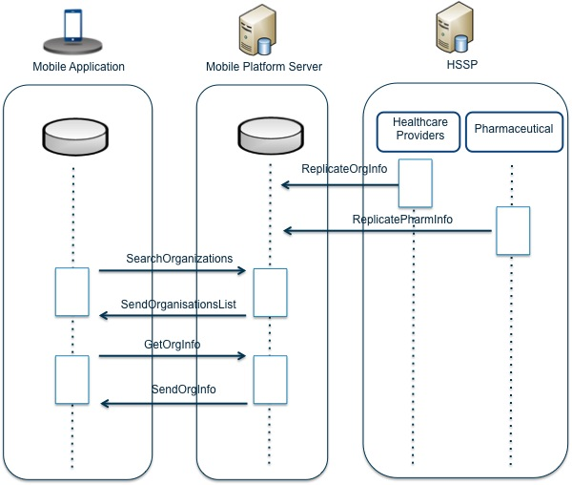
Figure 8. Data flow schema of Healthcare Organizations Info service

Pharma Info
Pharma Info service provides citizens with an ability to access Medications directory. For each medication following information is available: active substance, form, indications / contraindications, side effects, method of using and dosage, average price in pharmacies. Pharma Info service is described below.

Description
The service is described in a table below:
Table 22. Pharma Info service description
Service name | Pharma Info
Short description | Provides one with an ability to get information about medications
Main functions | Search by name  Sort medications using categories  View brief information about medications  View detailed information about medications
Users (roles) | All Georgia citizens (Citizen)
Requires authorization | No
Access mode | READ
Types of displayed information and how the information is retrieved | List of the displayed information is shown in Figure 18.  The information is displayed in on-screen forms, implemented with standard development tools provided by OS of mobile device (see. 5.2.2).  Brief information about medications is stored in the database of mobile device.  Full information about medications is stored in the database of mobile application server and can be transferred to the mobile device on demand.
Data, cached at the mobile device | Brief information about medications (name, ingredients)
offline mode availability (with no network access) | Yes, access to brief information
Data source | HSSP:  - Pharmaceutical Products Module  - Pharmaceutical Module

Schema

The schema of the data flows between MA, MP server and HSSP is shown in Figure 9.
All network communications between MA and MP server is initiated by MA. All network communications between MP server and HSSP is initiated by MP Server
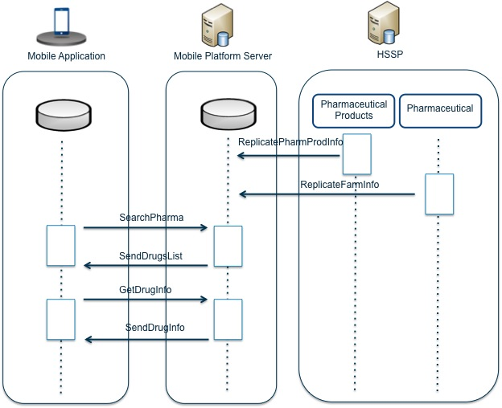
Figure 9. Data flow schema of Pharma Info service

First Aid Emergency
First Aid Emergency service provides access to first aid instructions while waiting for ambulance. It also provides one with an ability to make a phone call to Ambulance. First Aid Emergency service is described below.

Description
The service is described in a table below:
Table 23. First Aid Emergency service description
Service name | First Aid Emergency
Short description | Allows access to first aid instructions in an emergency.
Main functions | Search by keywords  View text and images with first aid instructions  Make phone calls to Ambulance
Users (roles) | All Georgia citizens (Citizen)
Requires authorization | No
Access mode | READ
Types of displayed information and how the information is retrieved | List of the displayed information is shown in Figure 22.  The information is displayed in on-screen forms, implemented with standard development tools provided by OS of mobile device (see. 5.2.2).
Data, cached at the mobile device | First Aid Instructions directory
offline mode availability (with no network access) | Yes, full access to First Aid Instructions directory
Data source | Xml-file which should be uploaded into MA server database. Developer should design directory structure, Customer should populate data

EMR for Patients
EMR for patients service provides citizens with an ability to gain quick access to the history of their visits medical organizations. To gain access to this information, patients have to get an account in EHR. All information is accessible regardless of the source system (HSSP modules or EHR). EMR for patients service is described below.

Description
The service is described in a table below:
Table 24. EMR for Patients service description
Service name | EMR for patients
Short description | Allows citizens to get access to the history of visits to healthcare organizations
Main functions | Get access to the history of visits to healthcare organizations (case list)  Filter case list by date (from, to) and status (open/closed)  Browse information, available in EHR, concerning certain case
Users (roles) | Georgia citizens registered as patients using mobile services (Patient)
Requires authorization | Yes
Access mode | READ
Types of displayed information and how the information is retrieved | List of the displayed information is shown in Figure 24 and Figure 25.  Case list contains:  - DateTime  - Type  - Title  - Author  The information is displayed in on-screen forms, implemented with standard development tools provided by OS of mobile device (see. 5.2.2).  The information is displayed as HTML. HTML structure depends on case type and defined by MP server.
Data, cached at the mobile device | Cases, loaded into mobile device memory are stored in the database of mobile device. In future, only updated information is requested.
offline mode availability (with no network access) | Yes, access to cached cases
Data source | EHR. Information about cases from HSSP gets downloaded to EHR and after that MP will use information, stored in EHR. Download mechanism to EHR is out of scope of MP development.

Schema
The schema of the data flows between MA, MP server and EHR is shown in Figure 10.
All network communications between MA and MP server is initiated by MA. All network communications between MP server and EHR is initiated by MP Server
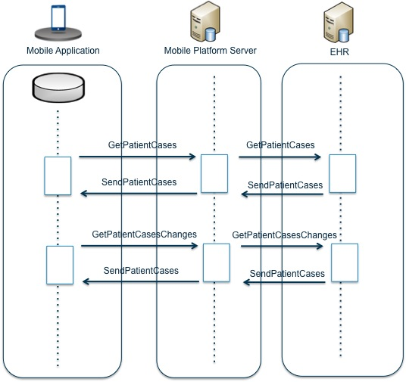
Figure 10. Data flow schema of EMR for Patients service

EMR for Doctors
EMR for Doctors service provides doctors with quick access to the history of patient’s visits to healthcare organizations. To gain access to this information, doctors have to get an account in EMR. Other than browsing existing information about patients, doctors can modify or create new records. EMR for doctors service is described below.

Description
The service is described in a table below:
Table 25. EMR for Doctors service description
Service name | EMR for doctors
Short description | Allows doctors to browse, modify, and add information concerning patients’ visits to healthcare organizations of Georgia.
Main functions | Search patient’s EMR (list of cases)  Filter case list by date (from, to) and status (open/closed)  Browse information available in EHR concerning certain case  Browse prescriptions  Edit case  New case creation with required fields validation
Users (roles) | Doctor
Requires authorization | Yes
Access mode | READ/WRITE
Types of displayed information and how the information is retrieved | List of the displayed information is shown in Figure 29 and Figure 30.  To browse case information, EMR for patients service is utilized. Displayed information is described in 5.6.9.  To edit cases or create a new case, one should fill-in on-screen forms, implemented with standard development tools provided by OS of mobile device.  All case types utilize following typical components:  - String - nvarchar(max)  - Selection from the dictionary  - Multi selection from the dictionary  - Date picker  To transfer data of each form type to EHR, there should be a separate adaptor implemented in ISS
Data, cached at the mobile device | Cases and profiles, loaded into mobile device memory are stored in the database of mobile device. In future, only updated information is requested.  If no update request has been registered for 100 days, obsolete data is deleted from mobile device database.
offline mode availability (with no network access) | Yes, access to:  - Cached information concerning patients’ profiles and cases  - Cases, created using this mobile device
Data source | EHR. Information about cases from HSSP gets downloaded to EHR and after that MP will use information, stored in EHR. Download mechanism to EHR is out of scope of MP development.

Schema
The schema of the data flows between MA, MP server and EHR is shown in Figure 11.
All network communications between MA and MP server is initiated by MA. All network communications between MP server and EHR is initiated by MP Server
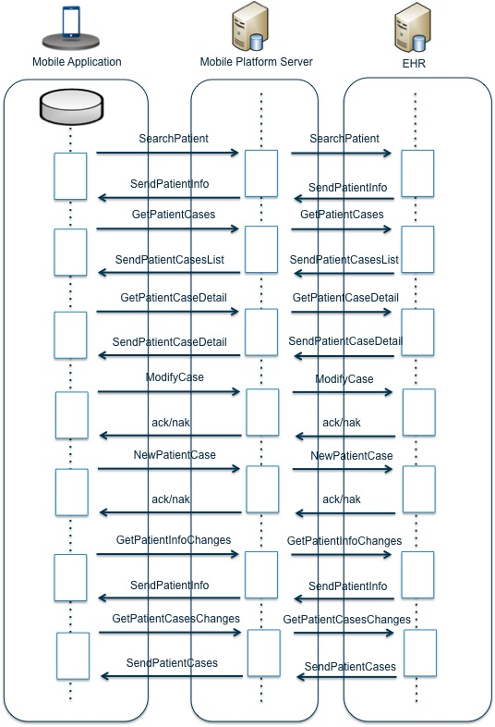
Figure 11. Data flow schema of EMR for doctors service

ePrescriptions
ePrescriptions service provides patients and doctors with quick access to prescriptions. Patients can access own prescriptions regardless of the source system. Doctors can access prescriptions of all patients they have access to.

Description
Service is described in a table below:
Table 26. Description of ePrescriptions service
Service name | ePrescriptions
Short description | Allows patients and doctors access to prescriptions
Main functions | Browse prescriptions
Users (roles) | Citizens of Georgia, registered as patient-users (Patient) and Citizens of Georgia, registered as doctor-users (Doctor)
Requires authorization | Yes
Access mode | READ
Types of displayed information and how the information is retrieved | List of the displayed information is shown in Figure 27.  The information is displayed using on-screen forms, implemented with standard development tools provided by OS of mobile device (see. 5.2.2).  Prescription is presented as PDF-document and displayed with the facilities available for the mobile platform.
Data, cached at the mobile device | Prescriptions, loaded into mobile device memory are stored in the database of mobile device. In future, only updated information is requested.  If no update request has been registered for 100 days, obsolete data gets deleted from mobile device database.
offline mode availability (with no network access) | Yes, access to cached Prescriptions
Data source | EHR

Schema
The schema of the data flows between MA, MP server and EHR is shown in Figure 12.
All network communications between MA and MP server is initiated by MA. All network communications between MP server and EHR is initiated by MP Server
.
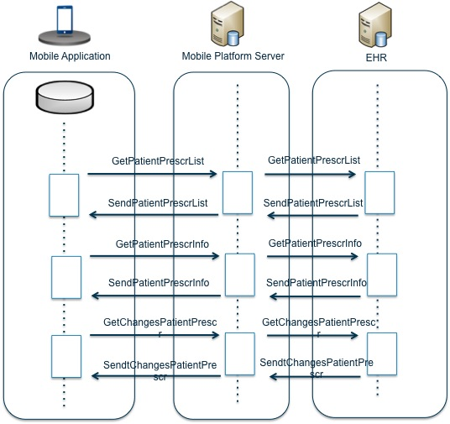
Figure 12. Data flow schema of ePrescriptions service

Reports
Reports service allows specialists of Ministry to gain quick access to general information:
- Financial statistics grouped by period, expense types;
- Statistics concerning services provided to the people, based on information about cases;
- Dynamics of National EHR forming, lack of activity in EHR from connected clinics;
- Data concerning performed payments.

Description
The service is described in the table below:
Table 27. Reports service description
Service name | Reports
Short description | Allows report generation
Main functions | Get the list of available reports  View desired report  Send the report via email as PDF or HTML
Users (roles) | Specialists of the Ministry
Requires authorization | Yes
Access mode | READ
Types of displayed information and how the information is retrieved | Report – is a HTML5 page, graphically presenting the data retrieved from the data sources. Report View block is implemented as WebView control using standard facilities of mobile OS (see. 5.2.2).  List of the reports and output forms will be defined during implementation phase. It is planned to implement not more than 6 reports.
Data, cached at the mobile device | No data caching performed by mobile device
offline mode availability (with no network access) | No
Data source | HSSP  EHR

Schema
The schema of the data flows between MA, MP server and EHR is shown in Figure 13.
All network communications between MA and reports server initiated by MA. All network communications between MP server and HSSP/EHR is initiated by reports server.

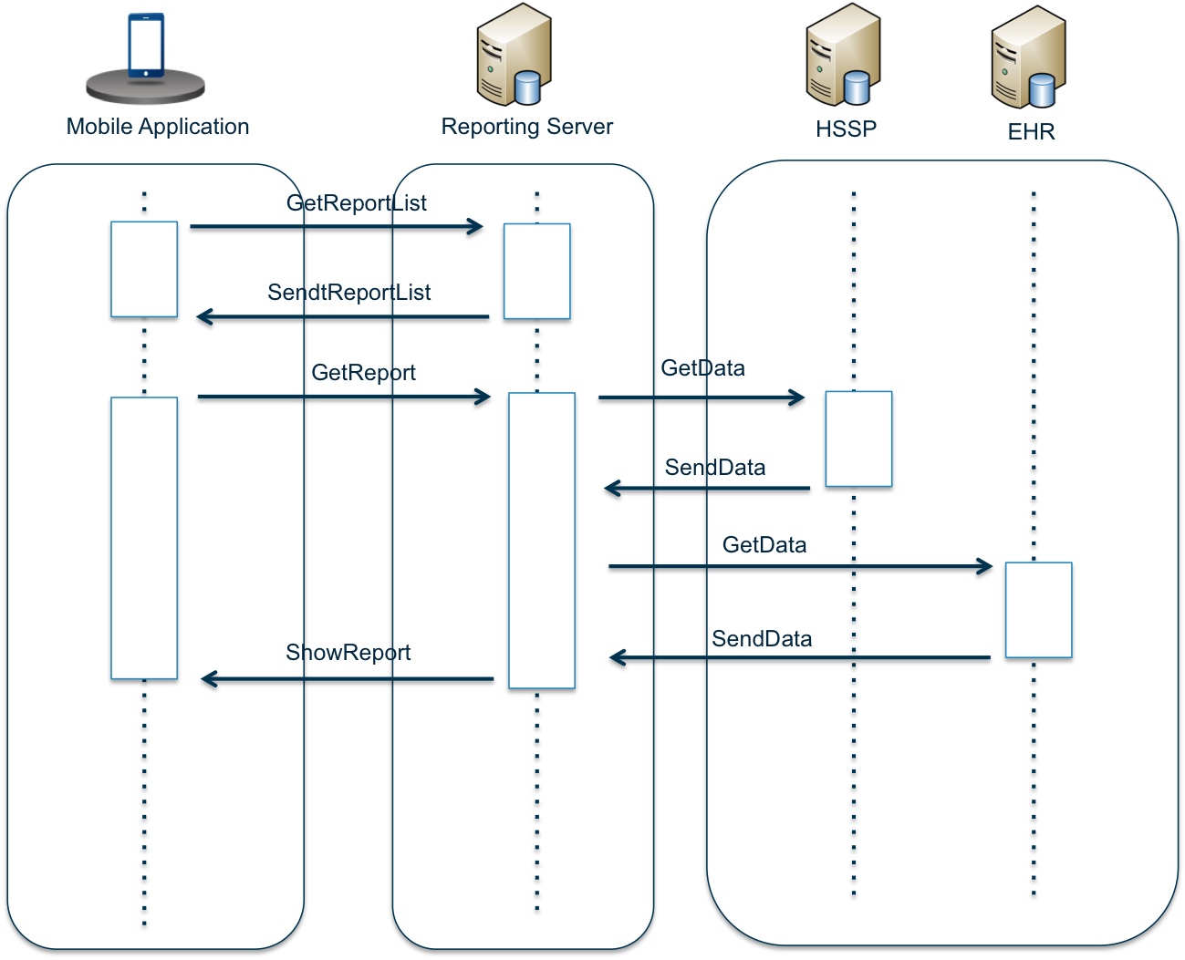
Figure 13. Data flow schema of Reports service

User and access control

Main user roles
MA is a single application for all user roles. Available roles and accessible sections of the application are defined after user authentication in EHR. Sections of the application, accessible for each role are described in 6.1.31.1.1.
MA supports 4 user roles
- Citizen – any citizen of Georgia, who downloaded and installed an application on his mobile device.
- Patient – citizen, authorized in MA.
- Doctor – additionally authorized Patient.
- Specialist of the Ministry – Patient, which has additional permissions to browse relevant sections.
Role model of MP allows role combinations: all users have “Citizen/Patient” role and some of them can also be assigned additional roles – “Doctor” or “Specialist of the Ministry”.

User authorization/authentication
The order of authorization requests is shown in Figure 14.

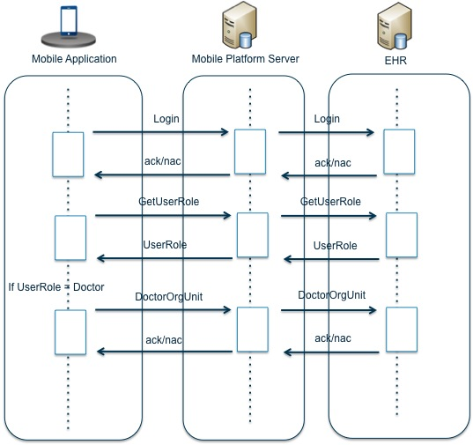
Figure 14. Data flow schema of user authorization/authentication

On application start, splash Logo screen will be displayed.
On first application start, a user will be requested to allow geolocation facilities. If allowed, a user will be able to use ‘next to me’ search in future.
On first application start, a screen will be presented to a user, showing services which are accessible for unauthorized user (Pharma Info, Healthcare Info, First Aid Info), and authorization screen.

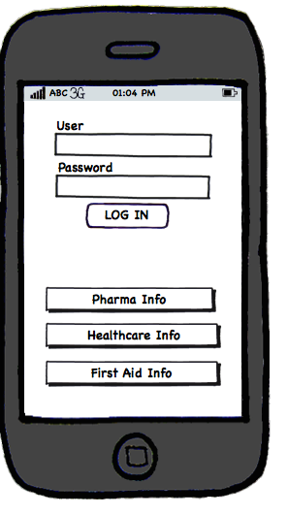
Figure 15. Unauthorized user screen
When a user enters User/Password and submits them by clicking ‘LOG IN” button, an authorization request will be sent to the server. The server will respond with the role, available for the user in the application.
If the combination of User/Password has not been recognized by the server, a user will see the following message: “Unable to log in, please contact MoLHSA”
If ‘Doctor’ role is available for the user, MA will additionally ask him to enter the Organization Unit of the organization he is assigned to (Figure 16).
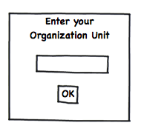
Figure 16. Authorization request for a user assigned to the ‘Doctor’ role

Access permissions
Access permissions are described in the table below.
Table 28. Access permissions
Service | Role | Access level
Healthcare Organizations Info | Citizen | Read
Pharma Info | Citizen | Read
First Aid Emergency Info | Citizen | Read
EMR for Patients | Patient | Read
ePrescriptions for Patients | Patient | Read
EMR for Doctors | Doctor | Read/Write
ePrescriptions for Doctors | Doctor | Read/Write
Financial Reports | Specialist of the Ministry | Read
Statistical Reports | Specialist of the Ministry | Read
EHR data loading control | Specialist of the Ministry | Read
Payments Control | Specialist of the Ministry | Read

Mobile application data security
Preventing of unauthorized data access and data integrity are provided by standard facilities of mobile platforms.

User interface

General principles of user interface composition
Mobile application user interface described in this section is based on current cEMR clinical forms and customer requirements. In case of any changes in cEMR clinical forms or customer requirements mobile application user interface can also be easily changed in new mobile application version due to it’s flexible and extensible architecture.
Interface of the System is based on capabilities of the underlying OS (Apple iOs or Android depending on the user’s mobile device).
Application interface, if technically possible, must provide short response time. IN case of synchronous server requests, MA has to notify the user that there is a long-running operation is in progress (by showing ‘progress bar’ or ‘download progress bar’)
If large amount of data is being loaded from local database of the application, MA will show progress bars in corresponding interface fields. As the load completes loading, the values will be replacing progress bars. While large amount of data is being loaded, MA will inform a user about the number of loaded/processed objects and, if applicable, number of remaining object.
MA will display messages in Georgian and English. Interface languages are Georgian and English. Interface language must be selected by a user on first application start.
All text data, unless different behavior is required, will be displayed in single-line mode. Excessive text will be truncated and replaced with <…>.
Field validation, unless different behavior is required, will follow this scenario: if field is empty or the value is incorrect, the application will show a message: “Fields <field names> are not populated properly” with “OK” button.
“Back” button will guide a user to the previous screen; entered data will not be saved.

Interface features of various mobile devices/platforms
MA supports portrait orientation on mobile phones and landscape orientation on tablet PCs.
Below are the navigation schemas for phone/tablet versions of the application.

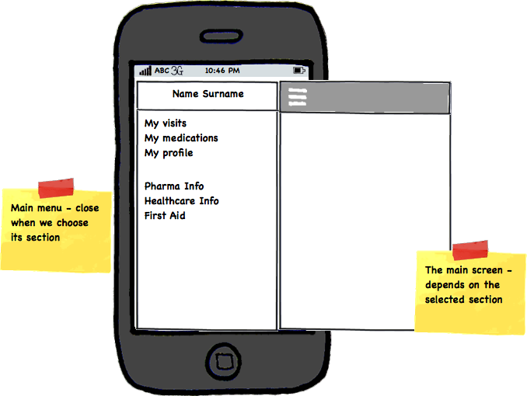
Figure 17. Interface schema for smartphones
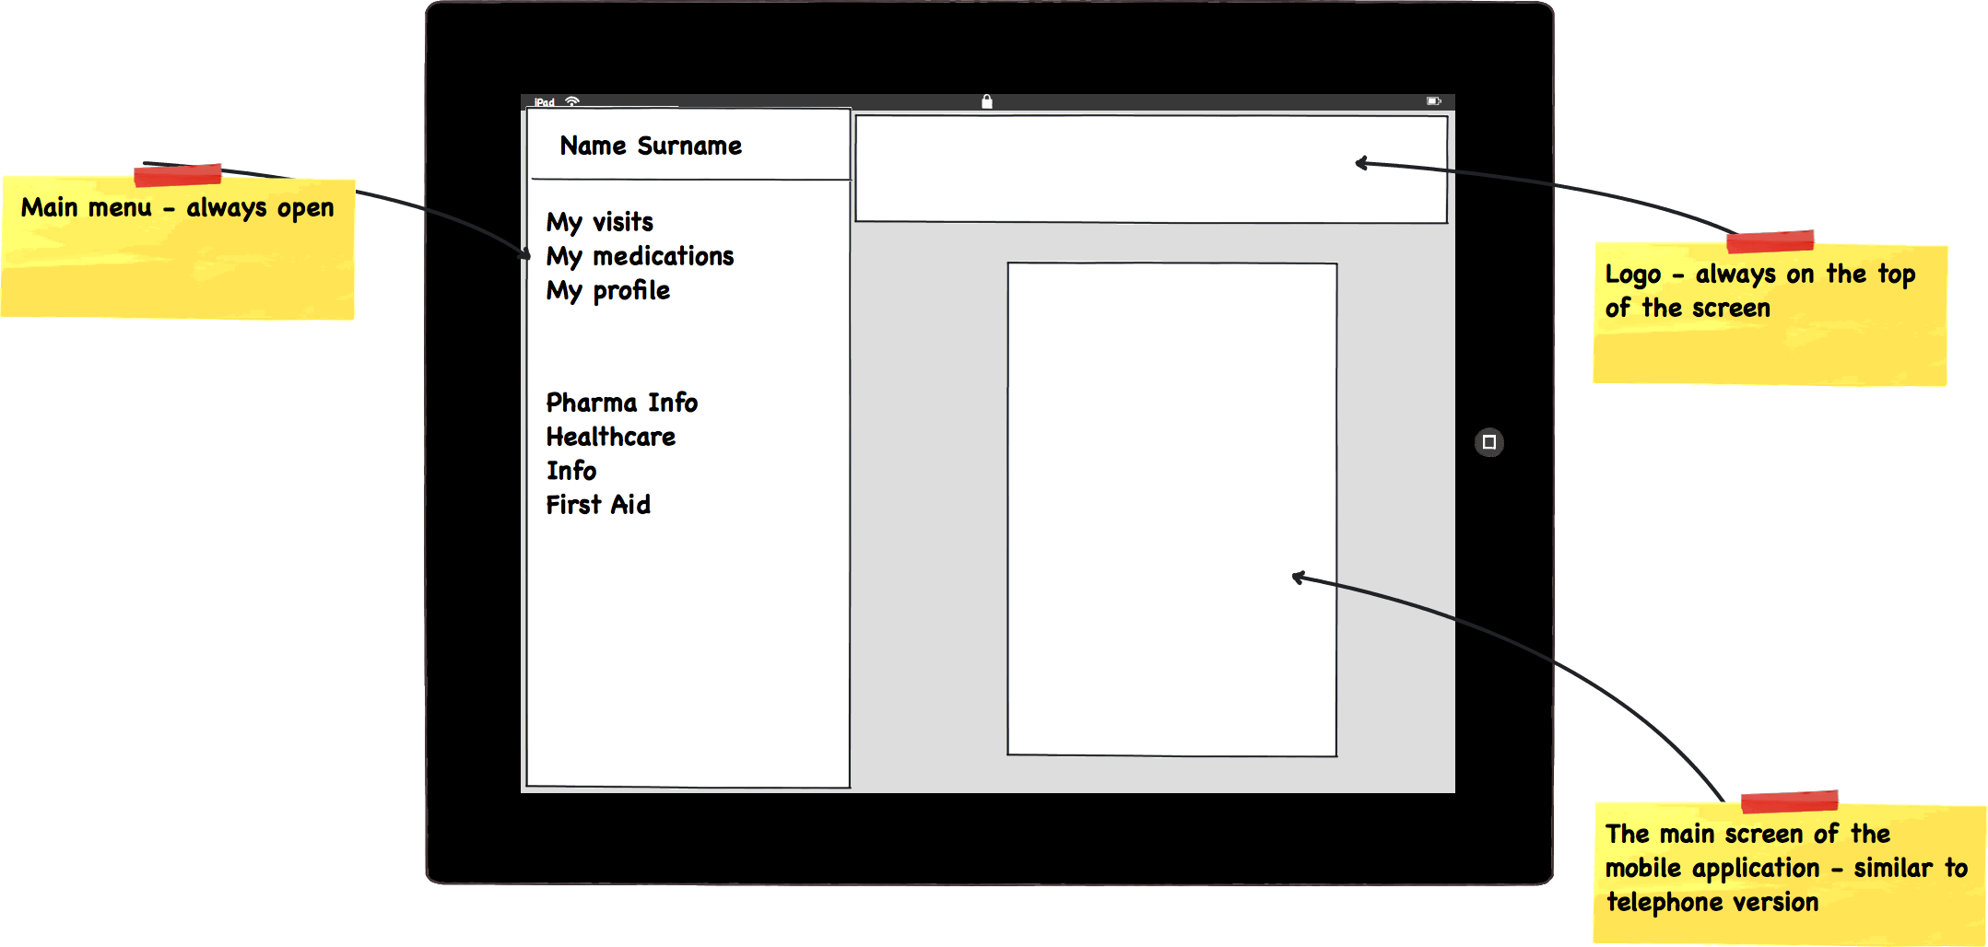
Figure 18. Interface schema for tablet PCs
Menu, screen contents and navigation order is the same for smartphones and tablet PCs – this is why only the interfaces for smartphones will be shown below.

Main screen
Upon authorization completion the user will see the Main menu, which contains sections related to the user role (Figure 19).
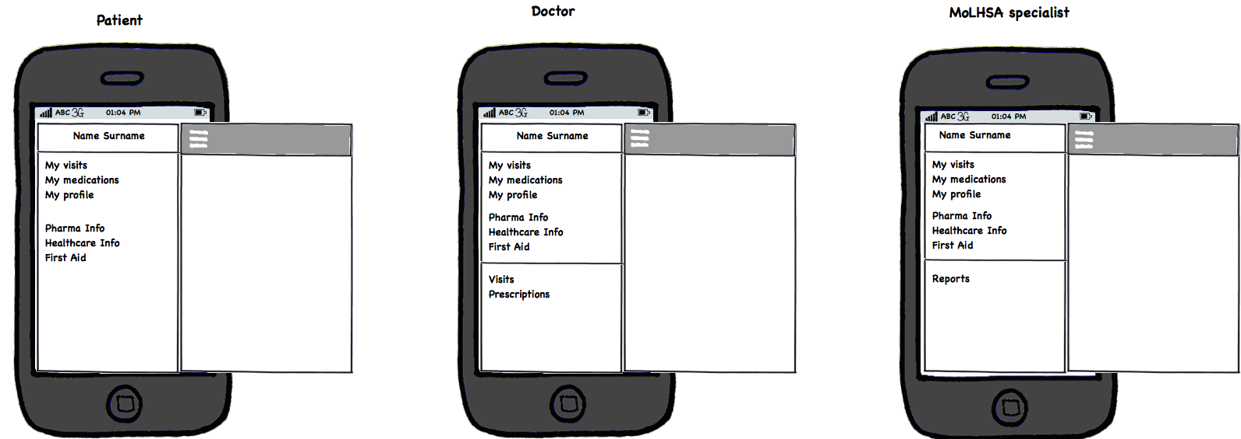
Figure 19. Main menu
There is a “Menu” button on the main screen of each section. When pressed, it will show the list of the Sections of the system. Touching the Section name will guide a user to the selected Section.

«Pharma Info» on-screen form
«Pharma Info» section provides all users of MP with access to Medications directory with no need for authorization.
«Pharma Info» on-screen form is presented below.
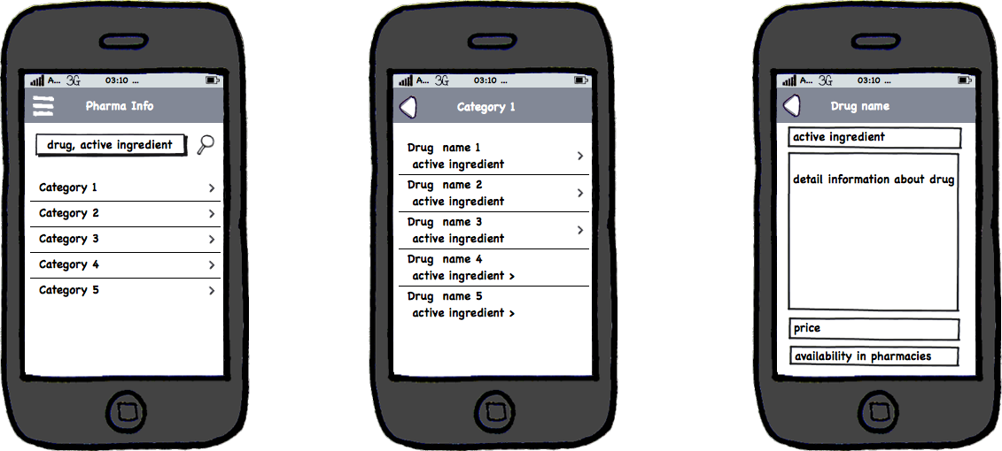
Figure 20. Pharma Info

A user can search by medication name or active substance name by entering desired text into a search field and pressing “Search”. A list of relevant medications will be presented. It is also possible to search by category, after selection a category, the list of relevant medications will be presented. If a medication name is clicked, an information window will be displayed, showing the medication name and description. If available, «price» and «availability in pharmacies» fields will also be populated.

«Healthcare Info» on-screen form
« Healthcare Info » section provides all users of MP with access to Healthcare organizations directory with no need for authorization.
«Healthcare Info» on-screen form is presented below.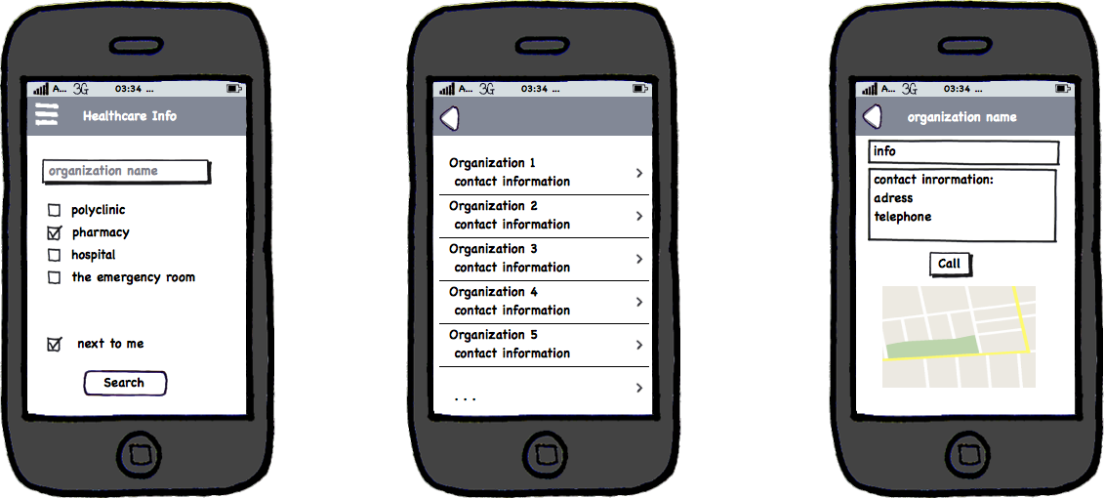
Figure 21. Healthcare Info
A user can search organizations by entering the name and/or selecting the category and/or selecting “next to me” option.
When a user clicks “Search” button, search results will be displayed. Clicking organization name will open an information window with organization details, location and an option to make phone call, if this information is available in EHR.

«First Aid Info» on-screen form
«First Aid Info» section provides all users of MP with access to Healthcare organizations directory with no need for authorization.
«First Aid Info» on-screen form is presented below.
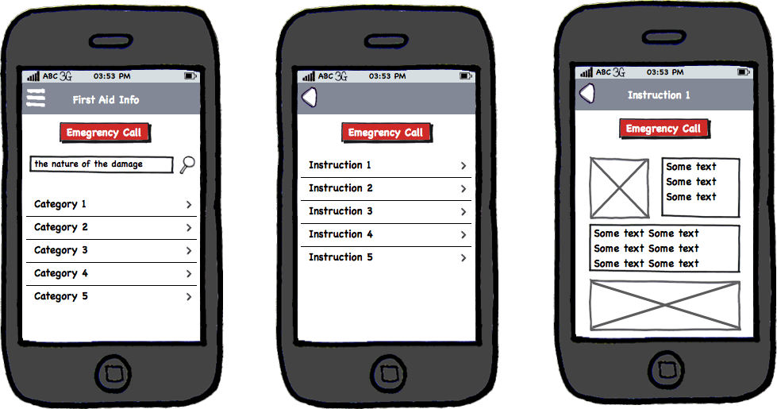
Figure 22. First Aid Info
To search the instructions a user can enter injury keywords and click ‘Search” or browse categories. The list of relevant instructions will be displayed. When the instruction is selected, a window will be displayed showing supplementary information concerning certain case represented as a set of cards.
Each card is transferred to a mobile device as HTML document and can contain instructions in following formats:
- Text containing clear instructions
- Graphical information
All information is stored in mobile device memory.
From every screen on this section a user can make a call to emergency services.

«My Visits» on-screen form
«My Visits» section provides all authorized users of MP with access to the history of visits to the healthcare organizations.
«My Visits» on-screen form is presented below.
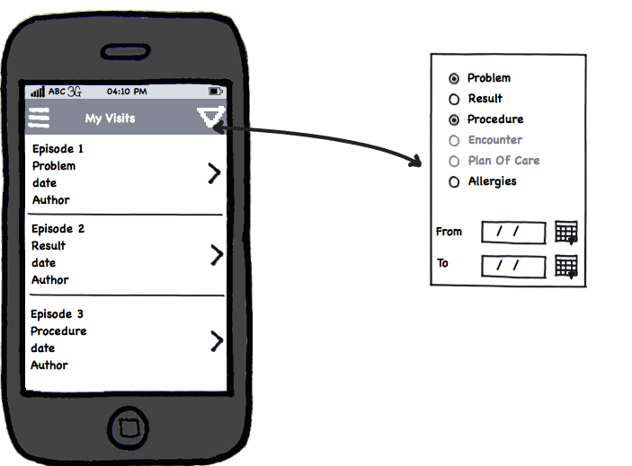
Figure 23. My Visits
In this section, a user can browse information about all his interactions with healthcare organizations of Georgia. Displayed information is ordered by date, last episode displayed on top of the list. Each item in the list shows episode name, type, date, record author. The screen also allows filtering by type and time period by clicking “Filter” button
Clicking the episode will display a window with detailed info, depending on the episode type. Various episode types and relevant filed sets are presented below.
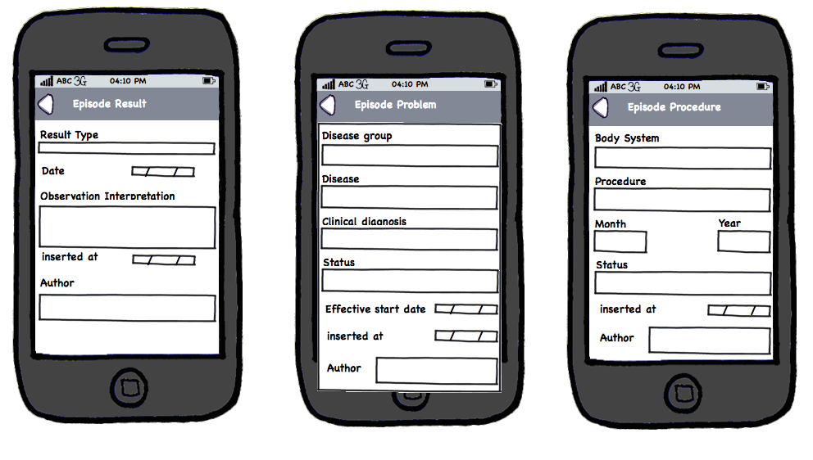
Figure 24. Detailed info of the episode
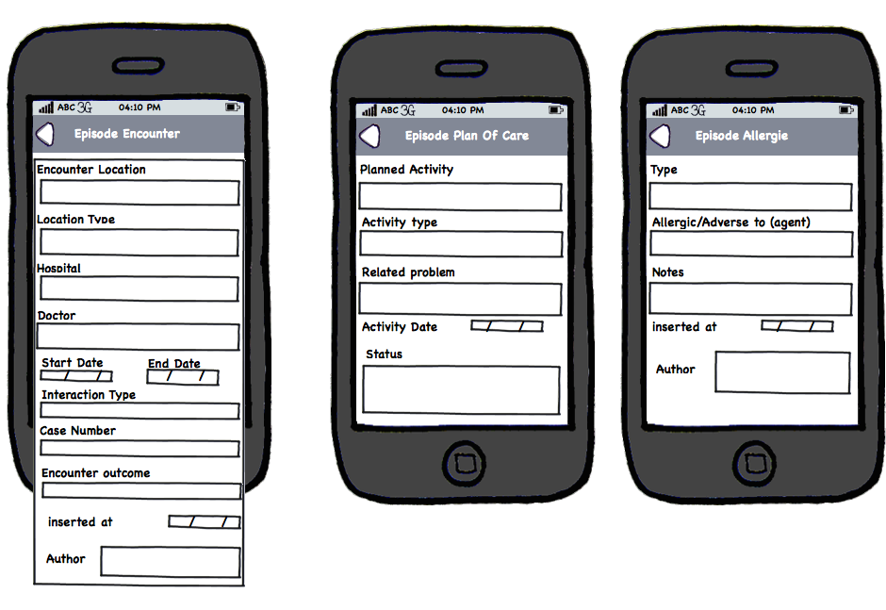
Figure 25. Detailed info of the episode (continued)

«My Medications» on-screen form
«My Medications» section provides all authorized users of MP with access to the prescriptions associated with them.
«My Medications» on-screen form is shown below.
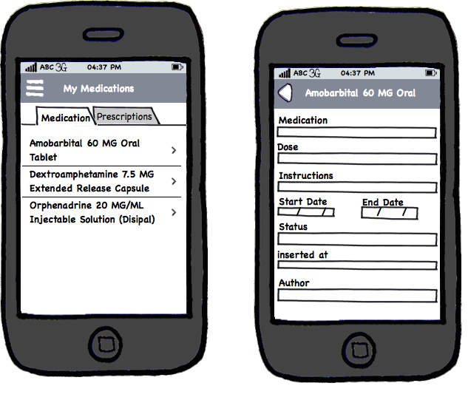
Figure 26. My Medications

On top of the screen there is a switch between Medications and Prescriptions.
On “Medications” screen a user can browse information about all medication appointed to him. Items in the list are ordered by date, latest item is on top of the list.
Clicking an item will display detailed information.
On “Prescriptions” screen a user can see all prescriptions given to him. Items in the list are ordered by date, latest item is on top of the list (Figure 27).

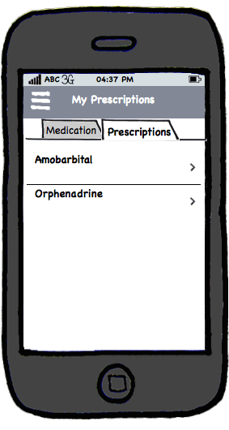
Figure 27. Prescriptions
Clicking an item will display prescription’s PDF.

«My Profile» on-screen form
«My Profile» section provides all authorized users of MP with access to the personal data.
«My Medications» section is presented below.
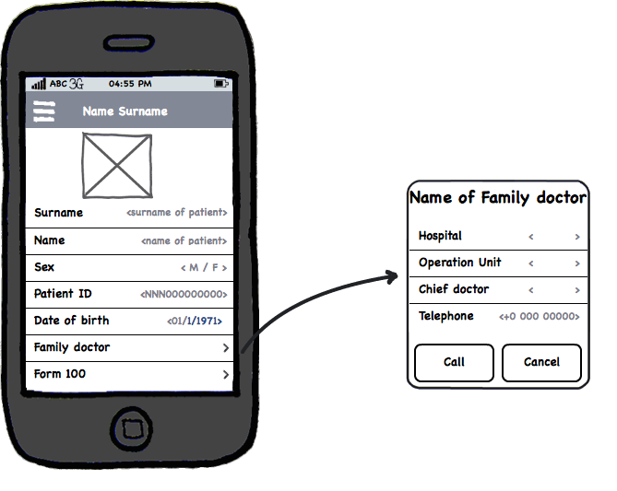
Figure 28. My Profile
In this section a user can see his EHR profile details.
Clicking “Family doctor” will open the details of attending doctor with an ability to make a call to the doctor directly from the application. Clicking “Form 100” will display patients details in the corresponding form. Form fields are presented below.
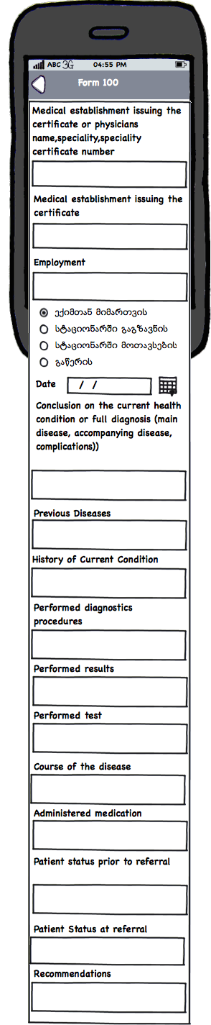
Figure 29. Form 100

«Visits» on-screen form
“Visits” section provides all authorized users of MP assigned a ‘Doctor’ role with access to the information concerning visits of patients to healthcare organizations of Georgia.
«Visits» on-screen form is shown below.
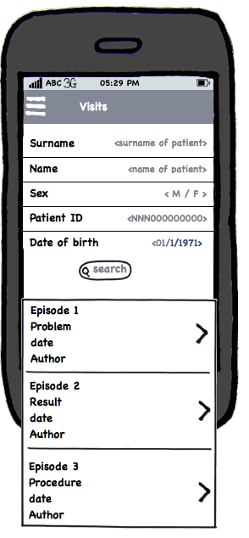
Figure 30. Visits
In this section, a Doctor can search for certain patient or browse episodes (cases) recently created by him.
If desired patient is found, a summary will be displayed, showing patient’s information, his Visits, Medications and Form 100 (Figure 31).
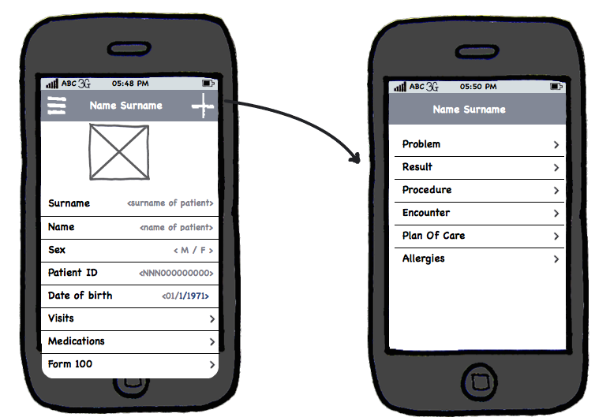
Figure 31. Summary, concerning patient

A doctor can create new episode (case) by clicking “+” button. The list of available episode types will be displayed. When episode type is selected, related input form will be displayed.
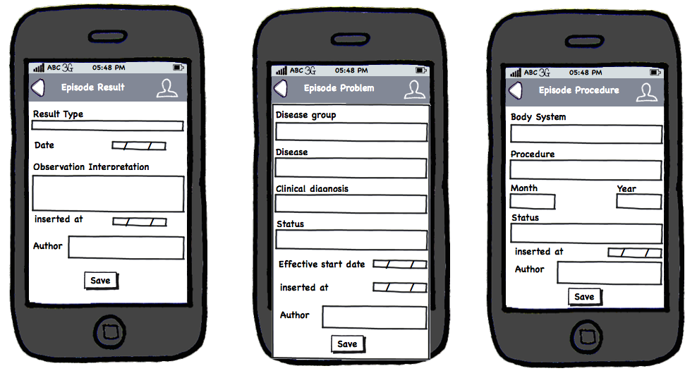
Figure 32. Episode information input forms
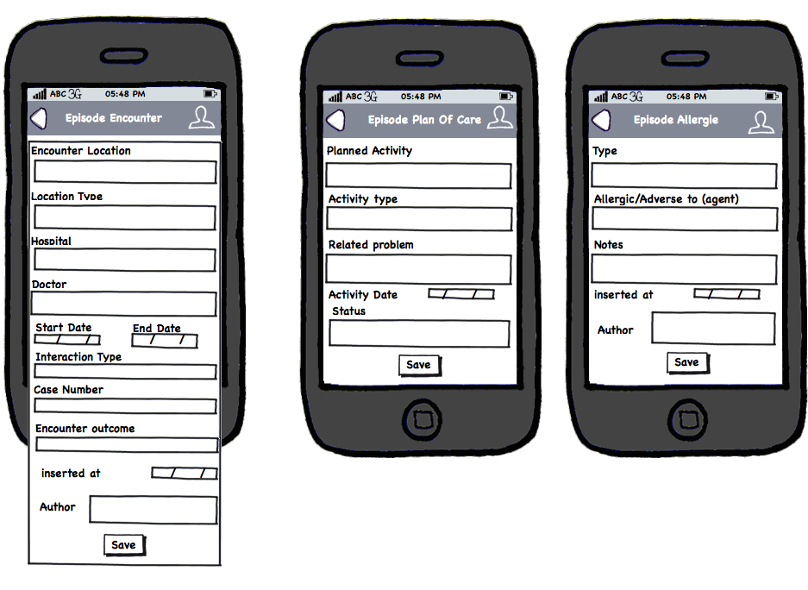
Figure 33. Episode information input forms (continued)

After filling-in the form, the doctor clicks “Save”. If an Episode was selected, some fields can be edited and saved.

«Prescriptions» on-screen form
«Prescriptions» section provides all authorized users of MP assigned a ‘Doctor’ role with access to the information concerning prescriptions written by them.
«Prescriptions» on-screen form is shown below.
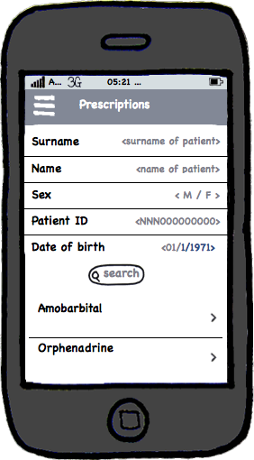
Figure 34. Prescriptions – patient and his prescriptions

In this section, a Doctor can search for certain patient or browse prescriptions) recently created by him.

«Reports» on-screen form
«Reports» section provides all authorized users of MP assigned a ‘Specialist of the Ministry’ role with access to the reporting facilities.
«Reports» form is shown below.

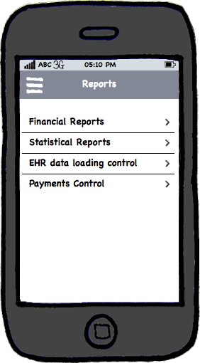
Figure 35. List of the reports

After selecting desired report category, a user will be guided to the analytic system..

