Ministry of Labour, Health and Social Affairs of Georgia

HIS to EHR
clinical data replication manual

Tbilisi

1 Terms and acronyms 3
2 Intended audience 3
3 Document purpose 3
4 Introduction 4
4.1 What is EHR 4
4.2 What is HIS 4
4.3 How the data in EHR can be accessed 5
5 Clinical data replication 8
5.1 What is clinical data and what is CASE 8
5.2 What is CDA 8
5.3 What is xDS 10
5.4 How to send CDA to EHR using xDS 11
5.4.1 HL7 Messages Transport And Security issues 13
5.5 Patients management 13
5.5.1 ADT01 message description 15
6 How to automate the HIS-to-EHR data replication process 18
6.1 Prerequisites 18
6.2 Step 1. Define the data mapping from HIS data model to CDA templates 18
6.3 Step 2. Develop HIS-to-CDA data extractor component (on dev env.) 19
6.4 Step 3. Develop CDA-to-EHR sender component (on dev env.) 19
6.5 Step 4. Test data replication between HIS test and EHR test environments 20
6.6 Step 5. Validate the clinical data on EHR side (together with Ministry) 20
6.7 Step 6. Move developed components to HIS production environment 20
6.8 Step 7. Turn-on data replication between HIS prod and EHR prod environment 20
7 APPENDIXES 21
7.1 In-Patient CDA template (Discharge Summary) 21
7.2 Out-Patient CDA template (Consultancy Note) 21
7.3 CDA data mapping sample 21
7.4 CDA-instance sample 22
7.5 XDS.b_DocumentRepository.wsdl 23
7.6 EHR environments addresses 24
7.7 Contacts for questions and more info 25

Terms and acronyms
CDA | Clinical Document Architecture
Clinical data | Clinical/Medical information (diagnosis, procedures, etc.) about the patients, which is subject to storing in EHR
EHR | Electronic Health Records
HIS | Health Information System
HL7 | Health Level-7 or HL7 refers to a set of international standards for transfer of clinical and administrative data between software applications used by various healthcare providers.
IHE | Integrating the Healthcare Enterprise
MoLHSA | Ministry of Labour, Health and Social Affairs of Georgia
XDS | Cross-Enterprise Document Sharing

Intended audience
This document is for technical specialists who are responsible for HIS-EHR integration implementation.

Document purpose
This document describes the concepts of HIS-EHR integration and contains instructions of how to implement the clinical data replication from any HIS to the National EHR.

Introduction

What is EHR
EHR stands for Electronic Health Records and is used as short name of the Georgian National EHR, the System, which is responsible, particularly, for collecting the history of Patients (Citizens) treatment in Healthcare Organizations of Georgia.
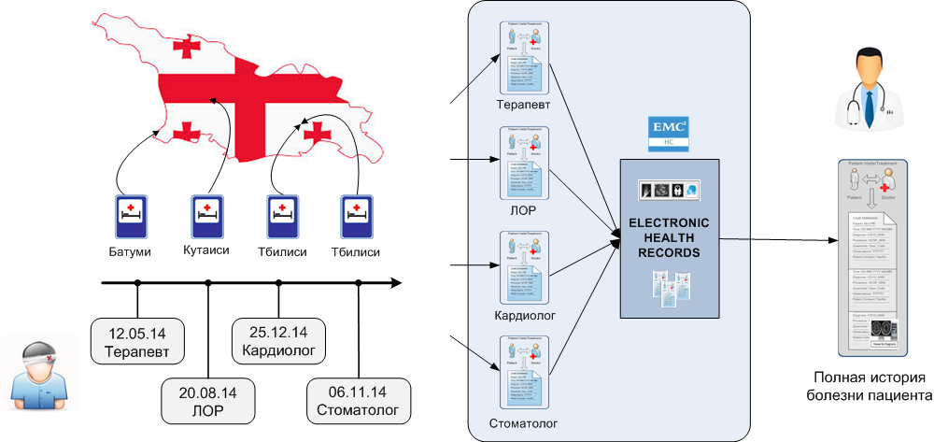
Patients, Doctors and Government specialists work with EHR through WEB-portals and can perform the number of actions on data depending of their rights/responsibilities.
The National EHR is a basis for integration of all the actors of the Healthcare environments: Clinical data providers, Clinical data consumers, Controlling organizations etc.

What is HIS
HIS stands for Health Information System. The current document uses this term to define any Health Information System used in any Hospital in Georgia.
Hospitals use HIS in order to automate their internal processes regarding to the patient treatments. HIS can collect many types of data and, particularly, clinical data about patients (patient demographics, diagnosis, procedures, medications, laboratory results etc.).
The clinical data can and should be replicated from the HIS to EHR.

How the data in EHR can be accessed
Doctors (as well as Patients and other data consumers) can access EHR data through EHR-portal: http://92.51.96.104.
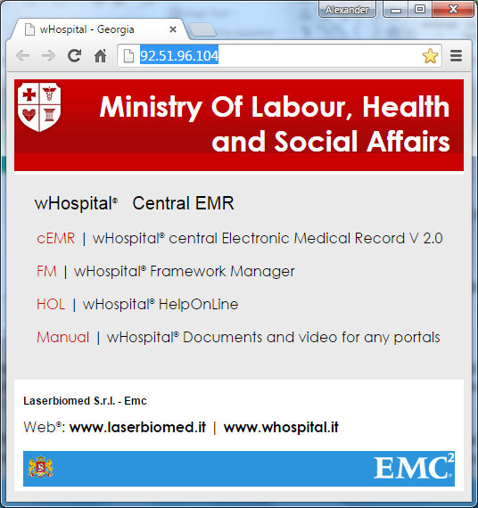
User must enter username and password.
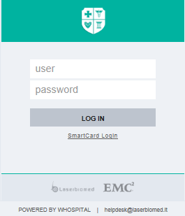
User = Identity Card Number
Password = Identity Card Pin Number
A request for access to the Hospital Portal will be processed by MoLHSA administration personnel and a wHospital user will be created and assigned to the relevant Operational Units.
Authentication is facilitated by using the Identity Card Number and Pin Number of the Health Care professional making the request for access.
Doctor can search Patients:
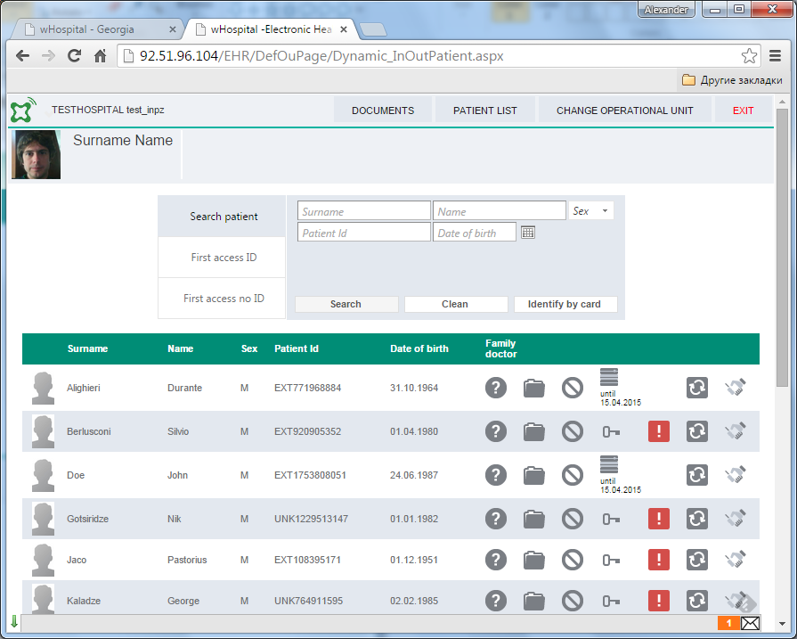
And see the clinical data(particularly Form 100) inside the Patient folder:
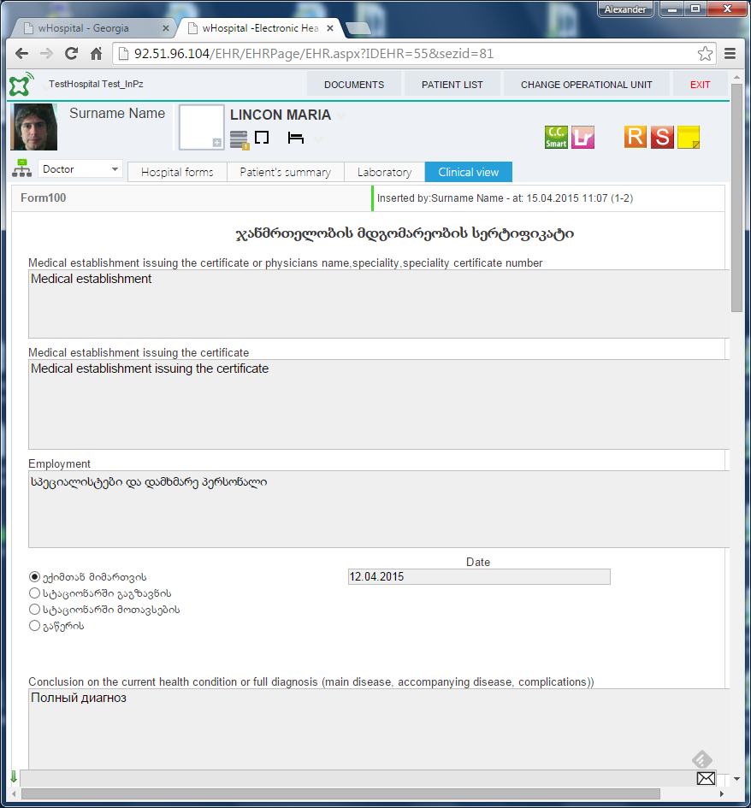

Clinical data replication

What is clinical data and what is CASE
As was stated above the Clinical data is the data about the Patient treatment, containing the information like diagnosis, procedures, medications, etc.
Usually such data is represented in the form of documents:
- Discharge Summary (for In-Patient treatments)
- Consultancy Note (for Out-Patient treatment)
Each fact of Patient treatment (visit) can be called the CASE. For every CASE the Hospital can generates according document.
The unit (entity) of the clinical data replication between the HIS and EHR is CASE.
In other words the CASE is the fact of Patient treatment and it corresponds to Discharge Summary or Consultancy Note depends on treatment type.

What is CDA
CDA stands for Clinical Document Architecture.
http://www.hl7.org/implement/standards/product_brief.cfm?product_id=7
The clinical documents that can be stored in the EHR are the Clinical Document Architecture (CDA) Version 2 released by Health Level 7 (HL7) organization. CDA R2 is a structured document in XML language, which contains clinical information using international code system for addressing clinical concepts and clinical data (clinical concept -> disease, clinical data -> tuberculosis).
A generic section on each CDA R2 document can contains HTML or simple plain text, that represents the human readable representation of the structured data. In the basic case the section is referred to a specific clinical concept by means of a code and the text represent the clinical data. CDA2 documents can be validated using a XSD file that checks if the xml is formatted and compliant to a predefined schema defined by the standard. The basic XSD file is the CDA2.xsd. Any external software application compliant with CDA2 and HL7 can validate the document and analyse it to retrieve structured data by means a matching with the CDA2 template.
An generic external application, for example a laboratory information system (LIS), can easily generates a CDA2 document for a patient’s blood test and send it to the EHR. The EHR will analyses each documents received matching with the defined templates, extracting structured data and populates the application DB and finally uploads the CDA2 documents on the repository.
An XML document in CDA2 format is composed by two main parts: an header and a body section.
The EHR implements 4 different template models:
- Continuity of Care Document: a document to summarize patient data
- Discharge Summary: use when an in-patient case is closed (also named discharge summary)
- Consult note: a document that can be related to a generic encounter for example a patient’s specialist visit
- Lab Result: document specific for laboratory result
Each template XML is indeed related to a single cForm in EHR. The mapping between the data in CDA and cForm fields is defined with placeholders:
- $HospitalPlaceHolder$: generic place holder implemented by wHospital, please refer to wHospital Administration Manual to a complete list of these placeholder. For example the name of the doctor, name or patient, birth date, gender….
- XDTT_cFormFiledName_XDTT: the text inserted in the field
- XDTC_cFormFiledName_XDTC: the code associated to a specific choice (this works for dropdown list and radio button control)
- XDTS_cFormFiledName_XDTS: the value associated to a specific choice (this works for dropdown list and radio button control)
- [XDTX_Child_cFormFieldName_XDTX]: insert the CDA made by a linked child cForm. A child cForm is a form related to the father cForm (where this placeholder is used) by meand of a field in the father cForm. This structure is useful for dynamically adding data to a cForm, refer to wHospital Framework Manual for details. Anytime that this tag is used a comment in the templates describes if the child cForm is configured in the cEMR to retrieve all the data or just the last (not multiversion/multiversion).
- WHPROC 4: if the next value is null than the component section where WHPROC is declared will be deleted from the final CDA
An external HIS has to replace the wHospital placeholders with the clinical data from the HIS database. In most cases the value of the fields is related to a specific code system. The common syntax is the following:
<value xsi:type="CD" code="[XDTC_SituationOfDeath_XDTC]" codeSystem="2.16.840.1.113883.6.3" displayName="[XDTT_SituationOfDeath_XDTT]"/>
<!--Situation of death ICD10 chapter 20-->
Here the ICD10 chapter 20 is used as a possible value set for a situation of death. The code system used is the ICD10.
Another information, that is relevant for any clinical statement, act or results is the effective time. Refer to comment in the templates for ensuring the right formatting. There are several different possible expressions for a date&time:
- YYYY - year
- YYYYMM – year and month
- YYYYMMDD – year month and day
- YYYYMMDDHHMMSS-0500 - – year month day and time, this is used for document creation and signature info

What is xDS
xDS stands for Cross-Enterprise Document Sharing.
http://wiki.ihe.net/index.php?title=Cross-Enterprise_Document_Sharing
It facilitates the registration, distribution and access across health enterprises of patient electronic health records. Cross-Enterprise Document Sharing (XDS) is focused on providing a standards-based specification for managing the sharing of documents between any healthcare enterprise, ranging from a private physician office to a clinic to an acute care in-patient facility and personal health record systems.
These are distinct entities with separate responsibilities:
- A Document Repository is responsible for storing documents in a transparent, secure, reliable and persistent manner and responding to document retrieval requests.
- A Document Registry is responsible for storing information about those documents so that the documents of interest for the care of a patient may be easily found, selected and retrieved irrespective of the repository where they are actually stored.
- Documents are provided by one or more Document Sources
- They are then accessed by one or more Document Consumers
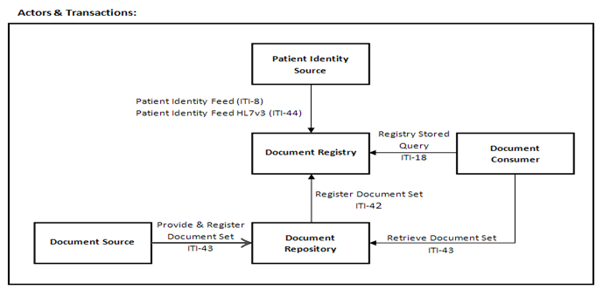

How to send CDA to EHR using xDS
The CDA-document can be sent to EHR Web-Service Gateway by using IHE XDS-b ITI-41 transaction. Address - http://92.51.96.100/wh_HL7/Gateway/XDS_Repo.asmx (see section 7.6 for all environments description).
EHR wHL7Gateway XDS_Stub is responsible for:
- Receiving CDA-documents and metadata
- Check security & privacy policy
- Check HCP authorization to publish documents to the EHR
- Check Patient Consent to be treated in the EHR
- Parse CDA-document to retrieve both metadata (information about author and patient,…) and clinical data
- For each CDA sections split relevant clinical information in EHR Database
- Publish CDA-document to EHR Repository
The following is a sample SOAP 1.2 request and response. The placeholders shown need to be replaced with actual values.
POST /wh_HL7/Gateway/XDS_Repo.asmx HTTP/1.1
Host: 92.51.96.100
Content-Type: application/soap+xml; charset=utf-8
Content-Length: length

<?xml version="1.0" encoding="utf-8"?>
<soap12:Envelope xmlns:xsi="http://www.w3.org/2001/XMLSchema-instance" xmlns:xsd="http://www.w3.org/2001/XMLSchema" xmlns:soap12="http://www.w3.org/2003/05/soap-envelope">
<soap12:Body>
<DocumentRepository_ProvideAndRegisterDocumentSetb xmlns="urn:ihe:iti:xds-b:2007">
<ProvideAndRegisterDocumentSetRequest>string</ProvideAndRegisterDocumentSetRequest>
</DocumentRepository_ProvideAndRegisterDocumentSetb>
</soap12:Body>
</soap12:Envelope>

HTTP/1.1 200 OK
Content-Type: application/soap+xml; charset=utf-8
Content-Length: length

<?xml version="1.0" encoding="utf-8"?>
<soap12:Envelope xmlns:xsi="http://www.w3.org/2001/XMLSchema-instance" xmlns:xsd="http://www.w3.org/2001/XMLSchema" xmlns:soap12="http://www.w3.org/2003/05/soap-envelope">
<soap12:Body>
<DocumentRepository_ProvideAndRegisterDocumentSetbResponse xmlns="urn:ihe:iti:xds-b:2007">
<DocumentRepository_ProvideAndRegisterDocumentSetbResult status="anyURI" requestId="anyURI">
<ResponseSlotList xmlns="urn:oasis:names:tc:ebxml-regrep:xsd:rs:3.0">
<Slot name="string" slotType="anyURI" xmlns="urn:oasis:names:tc:ebxml-regrep:xsd:rim:3.0">
<ValueList xsi:nil="true" />
</Slot>
<Slot name="string" slotType="anyURI" xmlns="urn:oasis:names:tc:ebxml-regrep:xsd:rim:3.0">
<ValueList xsi:nil="true" />
</Slot>
</ResponseSlotList>
<RegistryErrorList highestSeverity="anyURI" xmlns="urn:oasis:names:tc:ebxml-regrep:xsd:rs:3.0">
<RegistryError codeContext="string" errorCode="string" severity="anyURI" location="string" />
<RegistryError codeContext="string" errorCode="string" severity="anyURI" location="string" />
</RegistryErrorList>
</DocumentRepository_ProvideAndRegisterDocumentSetbResult>
</DocumentRepository_ProvideAndRegisterDocumentSetbResponse>
</soap12:Body>
</soap12:Envelope>
XDS ITI-41. ProvideAndRegisterDocumentSet request sample:
<ProvideAndRegisterDocumentSetRequest xmlns:xsi="http://www.w3.org/2001/XMLSchema-instance" xsi:schemaLocation="urn:ihe:iti:xds-b:2007 ../../schema/IHE/XDS.b_DocumentRepository.xsd" xmlns="urn:ihe:iti:xds-b:2007" xmlns:lcm="urn:oasis:names:tc:ebxml-regrep:xsd:lcm:3.0" xmlns:rim="urn:oasis:names:tc:ebxml-regrep:xsd:rim:3.0" xmlns:rs="urn:oasis:names:tc:ebxml-regrep:xsd:rs:3.0">
<lcm:SubmitObjectsRequest>
<rim:RegistryObjectList>
<rim:ExtrinsicObject id="Doc01" mimeType="text/xml"
objectType="urn:uuid:7edca82f-054d-47f2-a032-9b2a5b5186c1“ />
<rim:RegistryPackage id="SubmissionSet01">
<rim:Classification id="cl10" classifiedObject="SubmissionSet01"
classificationNode="urn:uuid:a54d6aa5-d40d-43f9-88c5-b4633d873bdd“
nodeRepresentation=““/>
</rim:RegistryObjectList>
</lcm:SubmitObjectsRequest>
<Document id="Doc01">UjBsR09EbGhjZ0dTQUxNQUFBUUNBRU1tQ1p0dU1GUXhEUzhi</Document>
</ProvideAndRegisterDocumentSetRequest>
CDA Example:
<Document id="Doc01">UjBsR09EbGhjZ0dTQUxNQUFBUUNBRU1tQ1p0dU1GUXhEUzhi</Document>

<?xml version="1.0"?>
<?xml-stylesheet type="text/xsl" href="CDASchemas\cda\Schemas\CCD.xsl"?>
<!-- The following sample document depicts a fictional character’s health summary. Any resemblance to a real person is coincidental. -->
<ClinicalDocument xmlns="urn:hl7-org:v3"
xmlns:voc="urn:hl7-org:v3/voc"
xmlns:xsi="http://www.w3.org/2001/XMLSchema-instance"
xsi:schemaLocation="urn:hl7-org:v3 CDA.xsd">
<!-- ******CDA Header******-->
<typeId root="2.16.840.1.113883.1.3" extension="POCD_HD000040"/>
<templateId root="2.16.840.1.113883.10.20.1"/> <!-- CCD v1.0 Templates Root -->
<id root="db734647-fc99-424c-a864-7e3cda82e703"/>
<code code="34133-9" codeSystem="2.16.840.1.113883.6.1" displayName="Summarization of episode note"/>
<title>Good Health Clinic Continuity of Care Document</title>
<effectiveTime value="20000407130000+0500"/>
<confidentialityCode code="N" codeSystem="2.16.840.1.113883.5.25"/>
<languageCode code="en-US"/> <!--(kat) for Georgian-->
<recordTarget/>
<author/>
<informant/>
<custodian/>
<legalAuthenticator/>
<participant/>
<documentationOf/>
<!-- **CDA Body***-->
<component>
<structuredBody />
</component>
</ClinicalDocument>

HL7 Messages Transport And Security issues
The wHL7Gateway can be exposed on HTTPS with SSLv3 (or later).

Patients management
Every CDA-document must contain the Patient demographics data. Before sending CDA-document to the EHR it’s necessary to make sure such Patient is already exists in EHR.
EHR supports HL7-messaging (particularly ADT-messages). For example, the message ADT^A01 can be used to admit new Patient in EHR and then put the documents (CDA) regarding to that Patient.
http://92.51.96.100/wh_HL7/Gateway/HL7_In.asmx?op=ReceiveV2Msg
Here is the list of supported messages:
ADT^A01 | Patient Admit | An “admit patient” message (A01 “event”) is used for “Admitted” patients only. These messages are sent as a result of patients beginning their stay in the healthcare facility
ADT^A02 | Patient Transfer | An HL7 ADT^A02 event is issued as a result of the patient changing his or her assigned physical location.
ADT^A03 | Patient Discharge | A “discharge patient” or “end visit” message (A03 event) should be sent when an inpatient’s stay in the healthcare facility is ended, or an outpatient or emergency room visit is ended.
ADT^A04 | Register Patient | A “register patient” message (A04 event) signals that the patient has arrived or checked in as an outpatient, recurring outpatient, or emergency room patient.
ADT^A05 | Patient PreAdmit | A “pre-admission” message (A05 event) is sent to notify the interface of a patient pre-admission process
ADT^A08 | Update Visit information | This message (A08 event) is used when any patient information has changed but when no other ADT event has occurred
ADT^A11 | Cancel Admission | For inpatients, the “cancel admission” message ADT (A11 event) is sent when an earlier “admission” message (A01 event) is canceled, either because of an erroneous entry or because of a revised decision to not admit the patient.  For outpatients/ER patients, the message is sent when an earlier “register outpatient” message (A04 event) is canceled for similar reasons. If the patient has orders on file, the patient will be discharged by the application. If no orders are on file, the patient’s record will be deleted.
ADT^A12 | Cancel Transfer | The “cancel transfer” message (A12 event) is intended to reverse an earlier “transfer” message, either because of an erroneous entry or because of a revised decision to not transfer the patient.
ADT^A13 | Cancel Discharge | The ADT “cancel discharge” message A13 event is sent when an earlier “discharge patient” message (A03 event) is canceled, either because of erroneous entry or because of a revised decision to not discharge, or end the visit of, the patient.
ADT^A38 | Cancel Preadmit | The A38 event is sent when an A05 (pre-admit a patient) event is canceled, either because of erroneous entry of the A05 event or because of a decision not to pre-admit the patient after all.

ADT01 message description

ADT^A01 - Segments that compose the message:
0: MSH (Message Header)
1: SFT (Software Segment) optional repeating
2: EVN (Event Type)
3: PID (Patient Identification)
4: PD1 (Patient Additional Demographic) optional
5: ROL (Role) optional repeating
6: NK1 (Next of Kin / Associated Parties) optional repeating
7: PV1 (Patient Visit)
8: PV2 (Patient Visit - Additional Information) optional
9: ROL (Role) optional repeating
10: DB1 (Disability) optional repeating
11: OBX (Observation/Result) optional repeating
12: AL1 (Patient Allergy Information) optional repeating
13: DG1 (Diagnosis) optional repeating
14: DRG (Diagnosis Related Group) optional
15: ADT_A01_PROCEDURE (a Group object) optional repeating
16: GT1 (Guarantor) optional repeating
17: ADT_A01_INSURANCE (a Group object) optional repeating
18: ACC (Accident) optional
19: UB1 (UB82) optional
20: UB2 (UB92 Data) optional
21: PDA (Patient Death and Autopsy) optional

ADT^A01 – MSH segment:
MSH-1: Field Separator (ST)
MSH-2: Encoding Characters (ST)
MSH-3: Sending Application (HD)
MSH-4: Sending Facility (HD)
MSH-5: Receiving Application (HD)
MSH-6: Receiving Facility (HD)
MSH-7: Date/Time Of Message (TS)
MSH-8: Security (ST)
MSH-9: Message Type (MSG)
MSH-10: Message Control ID (ST)
MSH-11: Processing ID (PT)
MSH-12: Version ID (VID)
MSH-13: Sequence Number (NM)
MSH-14: Continuation Pointer (ST)
MSH-15: Accept Acknowledgment Type (ID)
MSH-16: Application Acknowledgment Type (ID)
MSH-17: Country Code (ID)
MSH-18: Character Set (ID)
MSH-19: Principal Language Of Message (CE)
MSH-20: Alternate Character Set Handling Scheme (ID)
MSH-21: Message Profile Identifier (EI)

ADT^A01 – Example
MSH|^~\&|Test|&2.16.840.1.113883.3.37.4.1.1.2.2.1&ISO|Test App|Test Facility|20081204114742||ADT^A01|
123456|P|2.3.1|||ER
EVN|A01|20081204114742
PID|1||1234567890@WH_MPI^^^&1.3.6.1.4.1.21367.2005.3.7&ISO||Vania^Manzelli^Danger^PhD.^Mr.^^L||
19630429|M|||21 Jumpstreet^^Test City^IL^01234^USA^H~21 Jumpstreet^^Test City^IL^01234^USA^H||
012-0001~012-0002^WPN^PH~012-0003^ORN^CP||||ANG||444-555-666|777-888-999^NY|||
Test Place|||GBR|||20093009|Y
NK1|1|Eisner^Helga|SPO|Bahnhofstr. 1^^Testort^^01234^DE|012-8650
PV1|1|I|B1|R||||Herzchirurgie||||||||N|||172008190^^^XREF2005|||||||||||||||||||||||||20040315090000
DG1|1|I10|J09|Vogelgrippe|20040315000000|A|||||||||1
IN1|1||A-666-777|BKK Hoesch||||||||20040101|20141231||||||||||||||||||||||||||||||||||||333-444-555

HL7 Soap Request
POST /wHL7Gateway_Test/Gateway/HL7_In.asmx HTTP/1.1 Host: localhost Content-Type: application/soap+xml; charset=utf-8 Content-Length: length
<?xml version="1.0" encoding="utf-8"?>
<soap12:Envelope xmlns:xsi="http://www.w3.org/2001/XMLSchema-instance" xmlns:xsd="http://www.w3.org/2001/XMLSchema" xmlns:soap12="http://www.w3.org/2003/05/soap-envelope">
<soap12:Body>
<ReceiveV2Msg xmlns="http://whospital.com/">
<sender>string</sender>
<receiver>string</receiver>
<msgID>guid</msgID>
<processingMode>string</processingMode>
<timeStamp>dateTime</timeStamp>
<hl7Version>v23 or v231 or v24 or v25</hl7Version>
<msgType>ADT_A01 or others</msgType>
<formatType>pipe or xml</formatType>
<acceptAckCode>AL or ER or NE</acceptAckCode>
<Hl7RawMsg>string</Hl7RawMsg>
</ReceiveV2Msg>
</soap12:Body>
</soap12:Envelope>

HL7 Soap Response
<?xml version="1.0" encoding="utf-8"?><soap12:Envelope xmlns:xsi="http://www.w3.org/2001/XMLSchema-instance" xmlns:xsd="http://www.w3.org/2001/XMLSchema" xmlns:soap12="http://www.w3.org/2003/05/soap-envelope">
<soap12:Body>
<ReceiveWrappedV2MsgResponse xmlns="http://whospital.com/"> <ReceiveWrappedV2MsgResult>
<sender>string</sender>
<receiver>string</receiver>
<msgID>guid</msgID>
<processingMode>string</processingMode>
<timeStamp>dateTime</timeStamp>
<hl7Version>v23 or v231 or v24 or v25</hl7Version>
<msgType>ADT_A01 or others</msgType>
<formatType>pipe or xml</formatType>
<acceptAckCode>AL or ER or NE</acceptAckCode>
<ResponseRawMsg>string</ResponseRawMsg>
<Errors>
<Error>
<Code>string</Code>
<Description>string</Description>
</Error>
</Errors>
<Warnings>
<Warning>
<Code>string</Code>
<Warning>
</Warnings>
</ReceiveWrappedV2MsgResult>
</ReceiveWrappedV2MsgResponse>
</soap12:Body>
</soap12:Envelope>

How to automate the HIS-to-EHR data replication process

Prerequisites
In order to implement HIS-to-EHR clinical data replication the Hospital must have the following:
- Health Information System (HIS)
Which is collects the In-Patient or Out-Patient (or both) treatment history.

- HIS Development and/or Test environment
Where technical specialists could develop and test new functionality.

- Technical specialist (developer, tester)
Who can develop and test the new HIS functionality (in this case the EHR integration module). The technical specialist must be familiar with:
- Some of the programming language (for example, Java) in order to write the program code
- Basic medicine standards about storing and sharing the information (HL7, CDA, xDS)
- HIS data model

Step 1. Define the data mapping from HIS data model to CDA templates
What is given: the CDA templates (see 7.1 and 7.2) with EHR placeholders
What to do: to extract according data from the HIS and replace the placeholders with this info
The data mapping must define the correspondence between the HIS data model (tables and attributes) and the placeholders, defined in CDA template. The data mapping can be defined in a different ways, for example, as an XML file with (HIS data model)-to-(placeholders) correspondence. Another way to define the mapping is to take an existing CDA templates (see 7.1 and 7.2) and replace the EHR placeholders with the HIS placeholders.
The HIS placeholder format can be defined by the Hospital (by the technical specialist responsible for integration module development). The format could be the following:
$HIS.{tablename}.{attributename}
and
#HIS.{tablename}.{attributename}({secondarytablename}.{secondaryattributename})

where:

$ | Means the direct link to HIS table and attribute from where the value must be taken.
# | Means the link to secondary table by primary key from the main table
{tablename} | The name of the table, where the needed data is located
{attributename} | The name of the attribute, which contains the needed value  or (in case of # placeholder) the primary key to link to the secondary table.
{secondarytablename} | The name of the secondary table, where the needed data is located
{secondaryattributename} | The name of the attribute in secondary table, which contains the value
An example of the CDA-template with the placeholders of external System is given in section 7.3

Step 2. Develop HIS-to-CDA data extractor component (on dev env.)
After the CDA-templates are ready and contains HIS placeholders they can be used to generate CDA-instances (real documents), containing the real data from HIS.
What is given: the CDA templates with HIS placeholders, which linked to the specific HIS data .
What to do next: develop the program module, which will generate CDA-instances (the real CDA documents with the real data from HIS according to the placeholders).
This module (HIS-to-CDA data extractor) should be common for both In- and Out-Patient CDA-template and must extract the data from the HIS and put it into the proper CDA-template in accordance to placeholders.
An example of the CDA-instance is given in section 7.4.

Step 3. Develop CDA-to-EHR sender component (on dev env.)
After the CDA-instance created it can be sent to EHR for permanent storing.
What is given: the HIS-to-CDA extractor developed and can generate the CDA-instances.
What to do next: develop the program module, which will send CDA-instances to the EHR.
This module (CDA-to-EHR sender) also should be common for both In- and Out-Patient CDA-instances and must send the documents to appropriate EHR web-service.
The description of how to send the CDA-document to EHR using xDS protocol is given in section 6.4.
After the document is successfully sent and stored in EHR the HIS must mark according CASE as replicated. If the CASE will be changed later the HIS must generate and send the new CDA to the HIS.
It’s recommended to send the CDA-documents for “closed” CASEes only to avoid multiple sending of the same CASE.

Step 4. Test data replication between HIS test and EHR test environments
What is given: the data mapping is done, the HIS-to-CDA extractor developed, the CDA-to-EHR sender implemented.
What to do next: perform integration testing of the data replication using HIS test environment and EHR test environment.
See EHR test address in section 7.6.
The Ministry must enter and configure the Hospital in EHR database to be able to accept the documents (CASEes) and link them to the right Hospital.

Step 5. Validate the clinical data on EHR side (together with Ministry)
What is given: the data replication process was tested and working properly.
What to do next: validate the replicated data in EHR and write the Report to the Ministry.
The Report should contain the following information:
- Hospital description and contacts
- HIS name and version
- Brief description of replicated data (CASE IDs, Patients names etc.) during the testing
Ministry can use this Report to validate the replicated data and approve (or decline with comments) the HIS integration with the production environment of EHR.

Step 6. Move developed components to HIS production environment
What is given: the replicated data was validated at test EHR, the Ministry approves integration with production EHR.
What to do next: switch HIS integration components to the EHR prod environment, perform test replication for several documents and validate the replicated data.
See EHR prod address in section 7.6.

Step 7. Turn-on data replication between HIS prod and EHR prod environment
After the HIS integration components were switched to HIS prod environment and the data replication is tested and validated, the HIS can be configured to replicate the data automatically.
The automatic data replication can be launched by the special JOB or OS scheduler, which will run according integration components.
The Hospital must notify the Ministry about turning-on the automatic data replication for prod environment.

APPENDIXES

In-Patient CDA template (Discharge Summary)
Discharge Summary CDA-template is given in separate file «Discharge Summary CDA template.xml».

Out-Patient CDA template (Consultancy Note)
Consultancy Note CDA-template is given below and in separate file «Consultancy Note CDA template.xml».

CDA data mapping sample
Below is the part of CDA-template (the section Problems) with mapping to the System “Acme”.
<entry typeCode="DRIV">
<!-- wHospital cForm has to retreive this from sign infos details-->
<act classCode="ACT" moodCode="EVN">
<templateId root='2.16.840.1.113883.10.20.1.27'/>
<!-- Problem act template -->
<id root="Problem" extension ="$Acme.CaseRegistration.CR_Messages.MessageID"/>
<!-- XDTT specific wHospital Tag-->
<code nullFlavor="NA"/>
<effectiveTime>
<low xsi:type="INT" value="$Acme.CaseRegistration.CR_MessageDiagnosis.ThreatmentStartDate"/>
<!-- Years wHtable -->
<high xsi:type="INT" value="$Acme.CaseRegistration.CR_MessageDiagnosis.ThreatmentEndDate"/>
</effectiveTime>

<entryRelationship typeCode="REFR">
<!-- Has to be used also for generic problems no related to specific disease, can include also symptom -->
<observation classCode="OBS" moodCode="EVN">
<id root="Problem_Comment" extension ="XDTT_ID_A_Problems_XDTT"/>
<code code="55607006" codeSystem="2.16.840.1.113883.6.96" displayName="Problem"/>
<value xsi:type="ST">
$Acme.CaseRegistration.CR_MessageDiagnosis.NosologyClassName
</value>
</observation>
</entryRelationship>
<entryRelationship typeCode="SUBJ">
<!-- When it is related to a specific ICD10 diagnosis-->
<observation classCode="OBS" moodCode="EVN">
<templateId root='2.16.840.1.113883.10.20.1.28'/>
<!-- Problem observation template -->
<code code="ASSERTION" codeSystem="2.16.840.1.113883.5.4"/>
<!--<statusCode code="completed"/>-->
<value xsi:type="CD" code="" codeSystem="2.16.840.1.113883.6.3" displayName=""/>
<!--IC10 code system-->
<value xsi:type="CD" code="$Acme.CaseRegistration.CR_MessageDiagnosis.NosologyClassCode"
codeSystem="2.16.840.1.113883.6.3" displayName="$Acme.CaseRegistration.CR_MessageDiagnosis.NosologyClassName"/>
<!--IC10 code system-->
<entryRelationship typeCode="REFR">
<observation classCode="OBS" moodCode="EVN">
<templateId root='2.16.840.1.113883.10.20.1.50'/>
<!-- Problem status observation template -->
<code code="33999-4" codeSystem="2.16.840.1.113883.6.1" displayName="Status"/>
<statusCode code="completed"/>
<value xsi:type="CE" code="55561003" codeSystem="2.16.840.1.113883.6.96" displayName="Active"/>
<!-- Use the value set 2.16.840.1.113883.1.11.20.13 ProblemStatusCode
</observation>
</entryRelationship>
</observation>
</entryRelationship>
</act>
</entry>

CDA-instance sample
Below is an example of CDA-instance’s Medication section:
<component>
<section>
<templateId root="2.16.840.1.113883.10.20.16.2.2"/>
<templateId root="1.3.6.1.4.1.19376.1.5.3.1.3.22"/>
<code codeSystem="2.16.840.1.113883.6.1" codeSystemName="LOINC" code="10183-2"
displayName=" HOSPITAL DISCHARGE MEDICATIONS "/>
<title>HOSPITAL DISCHARGE MEDICATIONS</title>
<text>
<list listType="ordered">
<item><content ID="m1">Lisinopril 5 mg</content> 1 tablet once a day </item>
<item><content ID="m2">Atenolol 25 mg</content> 1 tablet once a day </item>
<item><content ID="m3">Furosemide 40 mg</content> 4 tablets daily in
divided doses </item>
<item><content ID="m4">Gabapentin 300 mg</content> 1 tablet twice a day </item>
<item><content ID="m5">Simvastatin (Zocor) 10 mg</content> 1 tablet once
a day at bedtime </item>
</list>
<paragraph>The patient has just completed a 4 week course of Vanco and
Rifampin for a MRSA UTI.</paragraph>
<paragraph>I note that this patient has been on Prednisone for ? adrenal
insufficiency in the past.</paragraph>
</text>
<entry>
<substanceAdministration classCode="SBADM" moodCode="EVN">
<templateId root="1.3.6.1.4.1.19376.1.5.3.1.4.7"/>
<consumable>
<manufacturedProduct>
<manufacturedLabeledDrug>
<code codeSystem="2.16.840.1.113883.6.88"
codeSystemName="RxNorm" code="203644"
displayName="LISINOPRIL (PRINIVIL)--PO 5MG TAB">
<originalText>
<reference value="#m1"/>
</originalText>
</code>
</manufacturedLabeledDrug>
</manufacturedProduct>
</consumable>
</substanceAdministration>
</entry>
</section>
</component>

XDS.b_DocumentRepository.wsdl
XDS.b_DocumentRepository.wsdl is given below and in separate «XDS.b_DocumentRepository.wsdl» file.
<?xml version="1.0" encoding="utf-8"?>
<!-- This wsdl file is for an XDS.b Document Repository Actor -->
<definitions xmlns:soap="http://schemas.xmlsoap.org/wsdl/soap/"
xmlns="http://schemas.xmlsoap.org/wsdl/" xmlns:xsd="http://www.w3.org/2001/XMLSchema"
xmlns:ihe="urn:ihe:iti:xds-b:2007" xmlns:rs="urn:oasis:names:tc:ebxml-regrep:xsd:rs:3.0"
targetNamespace="urn:ihe:iti:xds-b:2007" xmlns:soap12="http://schemas.xmlsoap.org/wsdl/soap12/"
xmlns:wsaw="http://www.w3.org/2006/05/addressing/wsdl" name="DocumentRepository">
<documentation>IHE XDS.b Document Repository</documentation>

<types>
<xsd:schema elementFormDefault="qualified"
targetNamespace="urn:ihe:iti:xds-b:2007"
xmlns:ihe="urn:ihe:iti:xds-b:2007">
<!-- Include the message schema -->
<xsd:include schemaLocation="../schema/IHE/XDS.b_DocumentRepository.xsd"/>
</xsd:schema>
<xsd:schema elementFormDefault="qualified"
targetNamespace="urn:oasis:names:tc:ebxml-regrep:xsd:rs:3.0"
xmlns:rs="urn:oasis:names:tc:ebxml-regrep:xsd:rs:3.0">
<!-- Include the message schema -->
<xsd:include schemaLocation="../schema/ebRS/rs.xsd"/>
</xsd:schema>
<!-- While no elements are directly used from these schema in the WSDL,
they need to be present here in order for
code generating toolkits to work properly -->
<xsd:schema elementFormDefault="qualified"
targetNamespace="urn:oasis:names:tc:ebxml-regrep:xsd:lcm:3.0"
xmlns:lcm="urn:oasis:names:tc:ebxml-regrep:xsd:lcm:3.0">
<!-- Include the message schema -->
<xsd:include schemaLocation="../schema/ebRS/lcm.xsd"/>
</xsd:schema>
<xsd:schema elementFormDefault="qualified"
targetNamespace="urn:oasis:names:tc:ebxml-regrep:xsd:rim:3.0"
xmlns:lcm="urn:oasis:names:tc:ebxml-regrep:xsd:rim:3.0">
<!-- Include the message schema -->
<xsd:include schemaLocation="../schema/ebRS/rim.xsd"/>
</xsd:schema>

<!-- Importing all schemas within one seems to confuse some parsers
and code-generation tools (and may be invalid)
<xsd:schema elementFormDefault="qualified">
<xsd:import namespace="urn:oasis:names:tc:ebxml-regrep:xsd:rs:3.0"
schemaLocation="../schema/ebRS/rs.xsd"/>
<xsd:import namespace="urn:ihe:iti:xds-b:2007"
schemaLocation="../schema/IHE/XDS.b_DocumentRepository.xsd"/>
</xsd:schema>
-->
</types>

<!---->
<!--<message name="RetrieveDocumentSet_Message">
<documentation>Retrieve Document Set</documentation>
<part name="body" element="ihe:RetrieveDocumentSetRequest"/>
</message>-->
<!--<message name="RetrieveDocumentSetResponse_Message">
<documentation>Retrieve Document Set Response</documentation>
<part name="body" element="ihe:RetrieveDocumentSetResponse"/>
</message>-->
<message name="ProvideAndRegisterDocumentSet-b_Message">
<documentation>Provide and Register Document Set</documentation>
<part name="body" element="ihe:ProvideAndRegisterDocumentSetRequest"/>
</message>
<message name="ProvideAndRegisterDocumentSet-bResponse_Message">
<documentation>Provide And Register Document Set Response</documentation>
<part name="body" element="rs:RegistryResponse"/>
</message>

<portType name="DocumentRepository_PortType">
<!--<operation name="DocumentRepository_RetrieveDocumentSet">
<input message="ihe:RetrieveDocumentSet_Message"
wsaw:Action="urn:ihe:iti:2007:RetrieveDocumentSet"/>
<output message="ihe:RetrieveDocumentSetResponse_Message"
wsaw:Action="urn:ihe:iti:2007:RetrieveDocumentSetResponse"/>
</operation>-->
<operation name="DocumentRepository_ProvideAndRegisterDocumentSet-b">
<input message="ihe:ProvideAndRegisterDocumentSet-b_Message"
wsaw:Action="urn:ihe:iti:2007:ProvideAndRegisterDocumentSet-b"/>
<output message="ihe:ProvideAndRegisterDocumentSet-bResponse_Message"
wsaw:Action="urn:ihe:iti:2007:ProvideAndRegisterDocumentSet-bResponse"/>
</operation>
</portType>
<binding name="DocumentRepository_Binding" type="ihe:DocumentRepository_PortType">
<soap12:binding style="document" transport="http://schemas.xmlsoap.org/soap/http"/>
<operation name="DocumentRepository_ProvideAndRegisterDocumentSet-b">
<soap12:operation soapAction="urn:ihe:iti:2007:ProvideAndRegisterDocumentSet-b"/>
<input>
<soap12:body use="literal"/>
</input>
<output>
<soap12:body use="literal"/>
</output>
</operation>
<!--<operation name="DocumentRepository_RetrieveDocumentSet">
<soap12:operation soapAction="urn:ihe:iti:2007:RetrieveDocumentSet"/>
<input>
<soap12:body use="literal"/>
</input>
<output>
<soap12:body use="literal"/>
</output>
</operation>-->
</binding>
<service name="DocumentRepository_Service">
<port name="DocumentRepository_Port_Soap12" binding="ihe:DocumentRepository_Binding">
<soap12:address location="http://servicelocation/DocumentRepository_Service"/>
</port>
</service>
</definitions>

EHR environments addresses
Environment | IP Web | EHR/Endpoints
Development/Testing | 92.51.96.100  (порты 80/81 соответственно)  Application Server 1 | EHR: http://92.51.96.100/  HL7 Gateway: http://92.51.96.100/wh_HL7/Gateway/HL7_In.asmx  xDS Gateway:  http://92.51.96.100/wh_HL7/Gateway/XDS_Repo.asmx
Production | 92.51.96.104  Application Server 1 | EHR: http://92.51.96.104/  HL7 Gateway: http://92.51.96.105/HL7/Gateway/HL7_In.asmx  xDS Gateway:  http://92.51.96.105/HL7/Gateway/XDS_Repo.asmx

Contacts for questions and more info
Gia Jgarkava, gjgarkava@moh.gov.ge
Michael Janiashvili, mic@moh.gov.ge

The WEB-form with the clinical data
The EHR repository
The EHR Registry
The Discharge Summary and Consultancy Note
The HIS database and documents storage
Hospital (doctors), Patients and other data consumers
http://wiki.ihe.net/index.php?title=Cross-Enterprise_Document_Sharing; http://www.ihe.net/Technical_Frameworks/#IT; http://www.ihe.net/uploadedFiles/Documents/ITI/IHE_ITI_TF_Vol2b.pdf
Admit, Discharge, Transfer. http://www.hl7.org/implement/standards/product_brief.cfm?product_id=92

