Auction Conditions

- Auction term – 45 calendar days from the beginning;
- Subject of lease - Land plot and buildings on 29, Vazha-Pshavela ave. Tbilisi, 0160, Georgia (Cadaster code: 01.10.15.007.081), totally 123,331.62 sq.m. Leased Property does not include:
  - 458.96 sq. m in building # 4, which belongs to Georgian Apostolic Autocephalous Orthodox Church
  - 12.42 sq.m of the building #2, on the technical floor (below the roof) and 10.0 sq.m. - on the roof, which belongs to LTD "Assets’ Management and Development Company"
  - 8 stores, and ground floor in building #2 western, fourth section, 975 sq.m each and building #9, 121 sq.m, totally 8896 sq.m., which remains to Lessor; (Subject to Lease Agreement this exemption may change in case indicated in Schedule #1, remark 2)
- Transfer of the property - Subject to the Lease Agreement upon completion of the New Hospital, that is New Hospital operations starting date, the Tenant shall become the owner of two land plots (Cadaster codes: 01.14.14.008.026 and 01.14.16.012.010) without any additional charge or fee to the Rent Payment (for avoidance of any doubt the Rent Payment is not applicable to these land plots either). The said land plots shall be charged by the obligation of the Tenant and/or the owner to use them only for healthcare services and fulfill other obligations under Lease Agreement;
- Rent Payment – initial amount of Rent Payment: 0.01$ per square meter per month;
Remark: The total amount of each month's initial Rent Payment amounts to 1233.32$. (Rent Payment may change in case indicated in Schedule #1, remark 2)
- Conditions of lease – see the draft of attached lease Agreement with its schedules and the annex #1 to this Auction Conditions;
- Description of the Property to be leased and transferred - see the draft of attached lease Agreement with its schedules and the Annex #2 to this Auction Conditions;
- Qualification requirements
- Bank guarantee (bid bond) for securing participation in the auction shall be presented by Bidder in the amount of 500,000$. Validity period of the bid bond shall exceed ending date of auction for at least 60 calendar days and must be issued by commercial bank, existing in Georgia.
- The Bidder or Management Company (with whom the Bidder has Management Agreement. For avoidance of any doubt Management Agreement is not required if the Bidder itself complies with below mentioned requirements) or owner of 100% of shares in Management Company/Bidder shall prove that:
  - Over the past 3 years, not less than five hospitals have been operated by it continuously at least for 12 months, each hospital at minimum with 200 beds and at least two of them: (i) should have been accredited by the Joint Commission (JC), Joint Commission International (JCI) or similar standard during the period then the said hospitals were operated by the Bidder or Management Company or owner of 100% of shares in Management Company/Bidder; and (ii) shall currently be operated by the Bidder or Management Company or owner of 100% of shares in Management Company/Bidder.
  - It has implemented and operated a one comprehensive health care information system that contains Personal Health Record, Electronic Health Record, Health Information Exchange tool and Health Analytics tool and covers the catchment area with at least 500,000 patients including acute hospitals, primary and secondary outpatient care providers within the catchment area.
Remarks:
The above mentioned participant shall submit:
- Hospital license from the public authority empowered to issue the licenses (apostilled or legalized). The information should include number of beds and scope of services for each hospital.
- Certificate of accreditation for Joint Commission, Joint Commission International or similar standard for each hospital.
- Health care information system - Provide detailed description of information system with the list of vendors that cover following components and developed sub-systems: Personal Health Record, Electronic Health Record, Health Information Exchange tool and Health Analytics. Description shall contain business process architecture, systems architecture, technical architecture, and product delivery architecture. Submit the average number of patients registered in the information system for the last 3 years.
Remark: the Management Agreement shall contain the below mentioned minimum requirements:
  - Duration of Management Agreement – the duration of the agreement shall correspond to the whole period of lease;
  - Subject – Management Agreement shall refer to the management of Leased Property;
  - Obligations of Management Company – The Management Company, the party to the Management Agreement, shall: (i) declare that it fully understands and realizes the goals of the management services that imply the assistance/support the Tenant in fulfillment of Tenant’s obligations on Leased Property under the Lease Agreement; (ii) publicly use the trade mark of the person, which complies with the qualification requirements, in the operation of the New Hospital (including without limitation the usage of sign of the trade mark on the Leased Property) for the duration of the Management Agreement. To prove the ability to fulfil the said obligation, the Management Company shall be itself person, which complies with the qualification requirements, or submit the document (agreement, guarantee letter) that envisages the obligation of the person, which complies with the qualification requirements, to transfer such rights to the Management Company.
- Winner of the auction is obliged to: (i) submit documents proving the compliance with the qualification requirements within 2 weeks from the end of auction; (ii) sign the Lease Agreement within 45 calendar days from the end of auction; and (iii) submit to the Lessor bank guarantee (performance bond) for securing fulfillment of Lease Agreement in the amount of 2,500,000$ before signing the Lease Agreement. Validity period of the performance bond shall exceed scheduled date of fulfillment of secured obligations for at least 90 calendar days and must be issued by commercial bank, existing in Georgia. The performance bond content shall correspond to the attached form; otherwise 500 000$ will be demanded under presented bid bond.
- In no case the Bidder may have right to demand reimbursement auction participation and/or Lease agreement closing costs, including without limitation in the cases when the Lessor at its choice and absolute and sole discretion makes decision to stop/terminate the bidding/auction procces (the Lessor is not obliged to justify the ground and reasons for such stoppage/termination).
- Amount of each bid placement - 0.01$
- Service Charges – According to Lease Agreement „The Tenant shall bear and shall, during the entire Lease Period, be responsible for due and timely expenditure of any and all Service Charges arising in relation to the Property. For avoidance of any doubt any existing Service Charges agreements shall be transferred to the Tenant unless the third person that is party to the said agreement with the Lessor refuses to enter into agreement with the Tenant.”. To this end, the Lessor declares that any agreement (other than agreements for: (i) employment or gas/electricity/water/cleaning and other similar services; (ii) lease of the spaces that are not included in the Leased Property) shall end no later than one year from the starting date of the auction.
- Costs of the Auction – the winner of the auction is obliged to reimburse/pay the costs/commissions of the Auction.
- Governing Law and Dispute Resolution Body – This Auction is governed by the legislation of Georgia and any dispute arising from or in connection with this Auction shall be settled by courts of Georgia.

Remark: the definitions, used in this Auction Conditions, have the same meaning as defined in the Lease Agreement.

Annex #1 to the Auction Conditions

Basic Conditions of the Lease

1. Transfer of Property
1.1. Subject of the lease:
a) the Property (Schedule #1 of the Lease Agreement); and
b) all movable tangible property of every kind and nature (other than consumable/expendable materials selected by Tenant before the Act of Acceptance, transferred at the day of the Act of Acceptance that shall be purchased by the Tenant and paid no later than 3 months after signing of Act of Acceptance for the price set out in Schedule #1) owned and used by the LLC “N. Kipshidze Central University Clinic” (Republican Hospital) in the operation of the Property. The same requirements shall apply to other two clinics’ movable tangible property if accepted by the Tenant during transfer of the said two clinics personnel as per Lease Agreement.

Tenant leases and accepts the Property in its “AS IS, WITH ALL FAULTS” condition existing on the signing date of the Act of Acceptance.

1.2. upon completion of the New Hospital, the Lessor will transfer in the Tenant’s ownership two land plots (Cadaster codes: 01.14.14.008.026 and 01.14.16.012.010) without any additional charge or fee to the Rent Payment (for avoidance of any doubt the Rent Payment is not applicable to these land plots either). The said land plots shall be charged by the obligation of the Tenant and/or the owner to use them only for healthcare services and fulfill other obligations under Lease Agreement (including obligations set out in paragraph 11.3 (this paragraph obliges the Tenant to transfer back Property if the Lease Agreement is terminated because of default) of the Agreement). For avoidance of any doubt Parties agreed that the said land plots shall be considered as Property from the date of transfer and thus all the conditions (other than the obligation of the Tenant set out in paragraph 11.1 of the Agreement) of the Lease Agreement (including obligations set out in paragraph 11.3 (this paragraph obliges the Tenant to transfer back Property if the Lease Agreement is terminated because of default) of the Agreement) shall apply to these land plots mutatis mutandis.
Upon completion of the Lease Period, the Tenant shall transfer the improved Property to the Lessor without compensation by the Lessor, other than defined in the Lease Agreement (Article 11).

2. The Lease Period
The Lease Period shall commence from date of the Act of Acceptance and shall be effective until the day falling on the 30th anniversary from the date of signing of the Lease Agreement.

3. Taxation
The corresponding taxes (including property tax (if applicable)), levies and duties and, in particular, the VAT (or such tax as may replace the same) applicable to the Rent, shall be added to the Rent and shall be payable by the Tenant, at the rates provided by the Applicable Laws.

4. Service Charges.
The Tenant shall bear and shall, during the entire Lease Period, be responsible for due and timely expenditure of any and all Service Charges arising in relation to the Property. For avoidance of any doubt any existing Service Charges agreements shall be transferred to the Tenant unless the third person that is party to the said agreement with the Lessor refuses to enter into agreement with the Tenant.

5. Increased Rent
Increased Rent applies to the spaces used for services set out in Group 2 and Group 3 as defined in Schedule #3. Use of spaces for provision of services set out in Group 1 and Group 2 does not require any approval from the Lessor. As for the provision of services (including by sub-tenant) set out in Group 3, they shall be approved by the Lessor in advance (pre-approved). Monthly Increased Rent on the space used for services set out in Group 2 amounts to: (i) 3 USD, but not less than amount of Rent, per square meter of the occupied building and if the building is renovated and/or demolished the amount of building space existing as for signing date of the Agreement shall be taken into account; (ii) 3 USD, but not less than amount of Rent, USD per square meter of the occupied land if the space where the building is not attached is used, including for the erection of new building, and the amount of space in this new building shall not be taken into account. Increased Rent of the space and land for services set out in Group 3 shall amount to 200% of the Increased Rent for services set out in Group 2.

6. Use and Operations
6.1. The Property shall be used by the Tenant for the operations as per schedule #3 (“Permitted Activities”). The Lessor transfers and assigns to the Tenant all the licenses, permits and other authorisations it holds for the purposes of conducting the Permitted Activities to the fullest extent such licenses may be assigned and/or transferred to the Tenant pursuant to the Applicable Laws. For avoidance of any doubt, if the said transfer and assign of the licenses, permits and other authorisations shall not be permitted by appropriate authorities, the Lessor shall not have any liability for the said transfer and assign of the licenses, permits and other authorisations.

6.2. The Tenant shall make investments (conduct any repair, substitution, re-construction and/or reimbursement of Property), obtain appropriate accreditation, operate and maintain the Property and/or provide the Clinical Services according to Schedule #2. The Tenant may require extension of New Hospital scheduled completion date if, at the same time: (i) obligation set out in paragraph 6.3. is fulfilled by the Tenant; and (ii) the Tenant submitted to the appropriate authority the application and relevant documents within 8 months from the signing date of the Agreement and construction permission is not issued within 12 months from the signing date of the Agreement. In no case, the extension period may exceed the period by which the issuing date of the construction permission exceeds the said 12 months from the signing date of the Agreement.

6.3. The Tenant shall have signed New Hospital Agreements within 12 months from the signing date of the Agreement (other than Management Agreement that shall be signed before signing of the Agreement) and maintain them. These agreements shall correspond to the covenants of the Tenant included in the Schedule #2. For avoidance of any doubt, the said 12 months shall include preparation phase that is the design works and EPC Contractor election process shall be completed.

6.4. The Tenant shall maintain the Management Agreement during the full duration of this Agreement with the service provider that meets the auction (auction for this Agreement) requirements.

6.5. (i) all income obtained through management of the Property in compliance with this Agreement during the Lease Period belongs to the Tenant; and (ii) the Agreement, without prejudice to the liabilities of the Tenant, implies the right of the Tenant to build, renovate, refurbish building(s), subject to Permitted Activities and Tenant’s covenants.

7. Employment by Tenant
7.1. The Tenant shall hire all the employees (other than directors that are persons registered in the Registry of Entrepreneurs and Non-Entrepreneurial (Non-Commercial) Legal Entities as Managers/Official Representatives) of the Lessor (other than LLC “Clinics Development Company”) (the “Transferring Employees”) (subject to consents of such relevant employees) on the following dates:
7.1.1. Employees of LLC “N. Kipshidze Central University Clinic” (Republican Hospital), shall be hired on the date of the Act of Acceptance;
7.1.2. Employees of JSC “Universal Medical Center” (Oncology Hospital) and LLC “Tbilisi Children’s Infectious Disease Hospital” shall be hired on the Actual Completion Date of New Hospital. The Lessor shall not increase personal costs (number of employees, salaries) until scheduled Completion Date without a pre-approval of Tenant.
7.2. the issues related the management of Transferring Employees shall be decided according to the Applicable Laws.

8. Effects of Termination
8.1. The Tenant shall transfer and hand over to the Lessor all the Property including its improvements and new construction (subject to wear and tear) and the Parties shall enter into all documents and instruments reasonably necessary to effect such transfer pursuant to the Applicable Laws. If Termination is based on reasons not envisaged in paragraph 11.1. of the Lease Agreement the Property to be transferred includes the land plots with cadaster codes: 01.14.14.008.026 and 01.14.16.012.010;

8.2. In case any continuing utility service or other similar contracts were entered into by the Tenant with respect to the Property in order to ensure operation of such Property, the Parties shall enter into amendment agreements or assignment agreement as may be necessary under Applicable Laws to ensure transfer of any such contracts to the Lessor;

8.3. The Tenant shall reimburse damages for loss of Property (if any) and lost profit in case the termination is based on the Article 10.1. (event of default of the Tenant). The amount of damages shall be calculated by the following formula: (i) Loss of Property (but not less than zero) = market price of Property existing on the date of Act of Acceptance – market price of Property transferred as per paragraph 8.1; plus (ii) lost profit (but not less than zero) = market price of rent – actually paid Rent – market price of actual improvements;

8.4. After fulfillment of paragraph 8.1, in case the termination is based on the Article 10.2 (event of default of the Lessor), the Tenant may demand reimbursement of damages for lost profit but not more than agreed limit. The amount of agreed limit shall be calculated by the following formula: agreed limit = amount of Tenant’s investment + yearly 8% - actually received overall profit, but not less than zero (total amount of profit – total amount of loss (if any)) – Service Charges not spent according to the Agreement.

9. Governing Law and Arbitration
The Lease Agreement is governed by laws of Georgia. Dispute shall be resolved by international arbitration.

10. The Covenants of the Tenant:
• Create multi-profile hospital of at least 350 beds on the territory of Vaja-Pshavela ave. № 29;
• In a new hospital at least shall be maintained and developed all medical services that are carried out by the following clinics at the time of concluding the Agreement:
LLC “N. Kipshidze Central University Clinic “
JSC “Universal Medical Center”
LLC “Tbilisi Children’s Infectious Clinical Hospital”
• During the Lease Period, constantly deliver all types of medical services carried on by above-mentioned clinics as long as state healthcare program maintains such medical services and accordingly participate in state healthcare program throughout the Lease Period;
• Creation of the teaching and training facilities in the New Hospital;
• No later than 3 years, after conclusion of the Agreement, the New Hospital shall be completed, subject to Article 6.2.1. in the Lease Agreement this period may be extended. The New Hospital shall obtain a JCI (Joint Commission International) accreditation, at least on the above mentioned medical services, no later than 3 years from scheduled completion date of the New Hospital. The said accreditation shall be kept for the entire Lease Period;
• Invest at least $ 50 million (do not include the investment from the incomes of the Clinical Services) for purposes of development of the New Hospital and other supporting service and infrastructure as provided in group 1 and group 2 of schedule 3. To this end EPC Contract shall be concluded and become effective no later than the period defined in the Lease Agreement and investment schedule shall correspond to the expenditures schedule of the New Hospital Agreements. Expenditures shall be confirmed by an audit from the top ten audit companies;
• Employ the staff as defined in Lease Agreement (Article 8.);
• Create staff (both medical and management) training system and plan and implement the said training plan;
• Upon completion of the Lease Period, transfer the improved Property to the Lessor without compensation by the Lessor, other than defined in the Lease Agreement.
• Submit bank guarantee in amount of 5% of investment amount to ensure the fulfillment of the commitment to obtain/maintain JCI accreditation and other liabilities (property protection from damage, etc.). [guaranty amount reduction principles shall be discussed further]
• According to the requirements of the City Hall, the Tenant shall cut and remove dried and diseased trees on the Leased Property.

11. Groups of Services (see paragraphs 5 and 6.1. above)
Group 1
1. All kind of medical services (also services that is connected to medical activities), that is operated by the tenant, or any third party, which will jointly and severally assume all obligations of the tenant under this lease agreement and which will have Management Agreement with the same management company as the Tenant;
2. Sublease to "Georgian Center for Coloproctology". The Tenant takes responsibility to lease not less than 500 square meters of the building to "Georgian Center for Coloproctology" and the rent amount for such lease shall not be higher than the amount of the Rent + 20%. At the same time "Georgian Center for Coloproctology" shall renovate the leased space according to the instructions of the Tenant.

Group 2
The certain auxiliary services, operated by the tenant or sublease, such as sport activities, wellbeing and accommodation services for patients, patients’ relatives, employees and their family members, catering services for employees, patients and visitors (restaurants, coffees etc.), parking for employees, patients and visitors, other services for patients, patients’ relatives, visitors, employees and their family members (such as kindergarten etc.).

Group 3
All kinds of services (including medical services), whether subleased or not, that are not defined in the above mentioned groups 1 and 2.

Annex #2 to the Auction Conditions

Academician N. Kipshidze Central University Clinic LLC

Location: #29, Vazha-Pshavela ave. Tbilisi, 0160, Georgia. Cadaster code: 01.10.15.007.081
Land plot area – 77,035 sq.m
Buildings total area – 67,345 sq.m

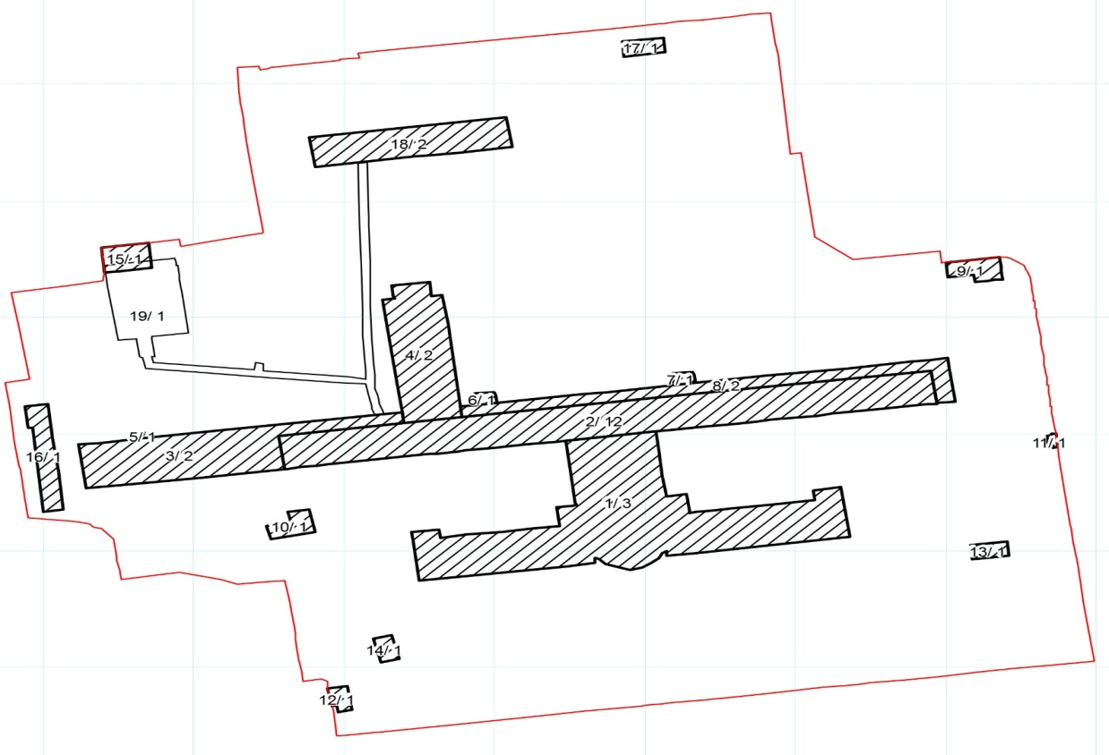

Tbilisi Children’s Infectious Diseases Clinical Hospital LLC.
Location: #14, Chikoveni st. Tbilisi, Georgia. Cadaster code: 01.14.14.008.026
Land plot area – 16,772 sq.m
Buildings total area – 5,931 sq.m

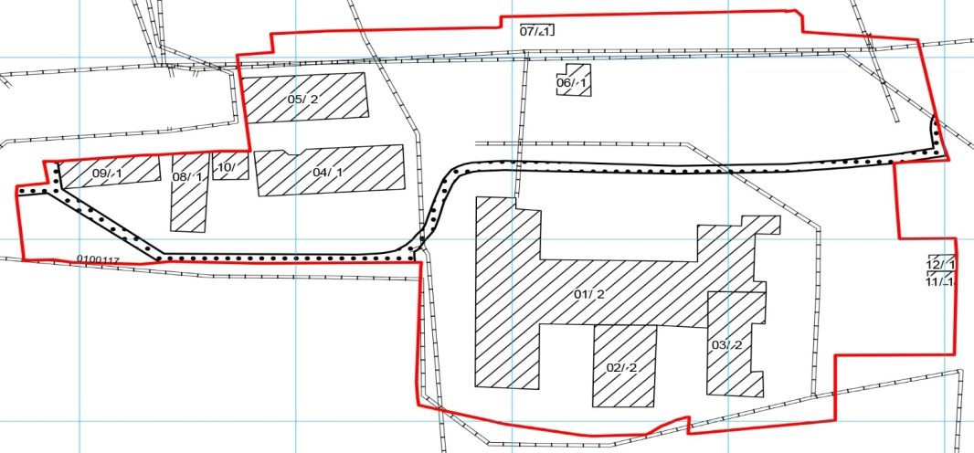

JSC Universal Medical Center
Location: #4, Lisi Lake, Tbilisi, Georgia. Cadaster code: 01.14.16.012.010
Land plot area – 61,852 sq.m
Buildings total area – 31,695 sq.m

