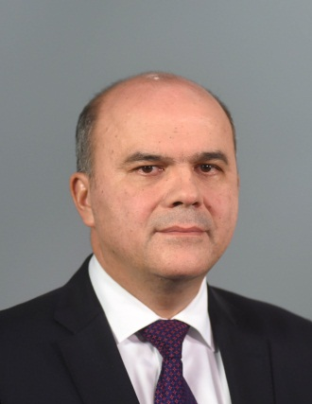
BISER PETKOV - Minister of Labor and Social Policy
Biser Petkov was born on 6th of September, 1963 in the city of Montana, Bulgaria.
He graduated from the University of National and World Economy in Sofia in 1987, and holds a Master’s degree in Economy and Organization of Internal Trade. Petkov has taken part in a number of specializations and trainings, including Business Economics at the University of Vienna, Austria, Public Finance at the University of Leicester, UK, and short-term specializations on Pension Reform organized by the World Bank Institute, Washington DC.
Petkov holds a PhD in Economics.
He started his career in 1988 as a full-time lecturer at the University of National and World Economy, where in 2012 he was appointed Associate Professor. Petkov has over 40 scientific publications, including textbooks, monographs, etc.
In the period of 2002-2003 he served as Chairman of the State Agency for Social Security Supervision at the Council of Ministers.
In March 2003, Petkov was elected by the National Assembly for Deputy Chairperson of the Financial Supervision Commission, in charge of the Social Insurance Supervision Division, and held this position until May 2009.
By decision of the National Assembly of 8 September 2011, he was elected Governor of the National Social Security Institute. On 29 July 2016, the Parliament re-elected him for this position for a new four-year term.
In the period of 2013-2016, Petkov was a member of the Bureau of the International Social Security Association (ISSA).
He was elected Minister of Labor and Social Policy on May 4, 2017 by the 44-th National Assembly.

