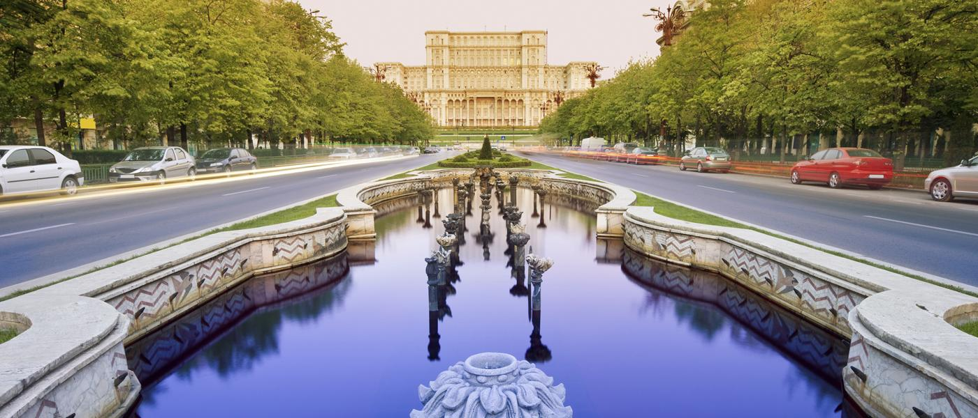

Europe and Central Asia Regional Office
on
Regional Conference on Social Work/ Social Service Workforce Development
Bucharest, Romania, 21-23 November 2018

Dates
The conference will take place from Wednesday, 21 November through Friday, 23 November 2018. Participants should make travel arrangements to arrive in Bucharest by the evening of Tuesday, 20 November. Departures can be planned after the meeting closure on Friday afternoon, or the next day, depending on the travel options.

Accommodation and Meeting Venue
The conference will be held at the Sheraton Hotel located in the centre of Bucharest. The accommodation of the participants is arranged at the same hotel.

Sheraton Hotel Bucharest
Calea Dorobanti 5-7, Bucharest, 010551, Romania
Telephone: (+4021) 201 5000
http://sheratonbucharest.com/

On Wednesday, 21 November the opening plenary and morning sessions will take place at the National Bank of Romania, address below. Transportation from Hotel Sheraton to the National Bank will be organised by bus. Please check the details in the programme agenda.

National Bank of Romania,
25 Lipscani Street, Bucharest 3, 030031 Romania

Hotel Registration
We have made a block reservation of rooms from 20 to 24 November at the Sheraton Hotel at a special rate of 109 Euro for SGL room and 119 Euro for DBL. This price includes Full American Breakfast, WI-FI internet access, access to Sheraton Fitness and Sky View Pool-Spa, city tax and VAT.
In order to benefit from the special rates being offered by the Sheraton hotel for the whole meeting package, it is mandatory for all participants to stay at this hotel. To facilitate the hotel check-in procedure and validate your individual reservation, please make your own booking directly to the hotel following the link below no later than 20 October 2018.
Room Booking to the Regional Conference on Social Work/ Social Service Workforce Development.

After this date the hotel cannot guarantee availability of rooms or the special rate negotiated for our event.

If you require transfer from/to the airport or have special dietary needs, please reflect them in the registration form.

IMPORTANT! As per UNICEF Travel rules, to ensure that there are less than 10 UNICEF passengers per flight– whether inbound or outbound – kindly share your flight details with Andreea Becheru at cbecheru@unicef.org and Elizabeth Platts at eplatts@unicef.org before you purchase the ticket. Travelers beyond 9 on the same flight will be instructed to seek alternative flights or routes.

Meals
As part of the conference package, lunch and coffee-breaks will be arranged during the three conference days.

Payments and DSA
The DSA rate for Bucharest as of September 2018 is 240 USD. Participants are entitled to 90% DSA for 21st, 22^{d} and 23rd of November when lunch is provided and, 100% for non-meeting days (i.e. arrival day).

The participants will settle the cost of accommodation directly with the hotel at the reception. Payments/cards accepted by the hotel are: AMEX, Master card and VISA.

Visa issues
Romania is applying the EU common visa policy. Please do check the visa requirements on the following website of the Consular Services of the Ministry of Foreign Affairs: http://evisa.mae.ro/.
If you need assistance with visa procedures, please let us know as soon as possible. For any clarifications, please contact Ms. Mihaela Marin (mmarin@unicef.org) at the UNICEF Bucharest Country Office.
Currency & exchange
You can exchange your currency into Romanian Lei (called Lei or RON) either at the exchange office of the airport, in the hotel or at any exchange office in town. Please keep in mind that US dollars or Euro are usually not accepted in Bucharest as a currency of payment. The UN exchange rate in September is 3.984 RON/1 USD. There are ATMs everywhere, and you can withdraw local currency bills from any of them using Visa or MasterCard.

Transport from the Airport to the Hotel
You can arrive at Sheraton Bucharest Hotel from the airport, via taxi or via the special Express Bus, the 783. The distance from the Henri Coandă International Airport to the Sheraton Hotel is about 17 km, which takes approximately 30 minutes by car.

We recommend you taking a taxi, the simplest and fastest way from the airport to the hotel. On-demand taxi services are available at Bucharest Henri Coandă International Airport. You may order a taxi car by using the touch screen devices in the public area of the Arrivals Terminal (on the right side after customs). You can then get your taxi-cab right outside the terminal, by showing the ticket issued by the automatic touch screen. The charges vary between 1, 39 lei/km – 3, 50 lei/km.
The cost of the fare from the airport to the hotel should be maximum 50 lei (around 12$).

The Sheraton Hotel can arrange for a transfer for you at the cost of 25 Euro per trip/vehicle, for a maximum number of 3 persons. If you want to avail yourself of this service, please request it when you book the room.

Materials and equipment
In support of the “Greening UNICEF” initiative, there will be no photocopying arrangements at the venue. Electronic versions of the reading materials will be shared in advance of the meeting and participants are requested to print and bring along any documents they would like in hard copy before arrival.

The standard voltage is 220V. You can use your electric appliances in Bucharest, if the standard voltage in your country is in between 220V - 240V (as in Europe, Australia and most of Asia and Africa). Electrical appliances must have European plugs, (i.e. round-tipped, two-pinned) therefore an international adapter is very useful.

Useful information for your stay in Bucharest
Due to its position, Sheraton Bucharest Hotel gives you easy access to the main areas of the city, among the closest tourist attractions being the Old Town famous for its night life and restaurants. Also, Old Town area hosts a significant variety of bars, cafés, restaurants and shops popular both with locals and with tourists alike. The Romanian Athenaeum is 700 m away, while Herastrau, the biggest park of the city, is 2.7 km away. The House of Parliament, the second largest building in the world, is 2.5 km away and visible from selected rooms at the hotel. Victoria Avenue, the most famous shopping street is only 900 m away.

Emergency Numbers
Police/ Fire/ Ambulance: 112

Contact Numbers
UNICEF Country Office in Romania +40-21-201.78.53
Pieter Bult – UNICEF Representative in Romania +40-755.112.996
Mihaela Marin – Executive Assistant +40-741.09.58.18
Andreea Becheru – Programme Associate +40-751.26.55.52
UNICEF ECARO
Elizabeth Platts – Programme Associate +41 (0)22 909 5423

We wish you a pleasant stay in Bucharest!

