The Technical Report has provided sufficient reviews on how countries manage their long term care system. It is believed that such reviews will help other countries, such Indonesia, in which LTC is not yet part of the social security system. Currently, people aged 65+ consist of around 8% of the total beneficiaries of BPJS for Health. Since there is no separate system for LTC in the SSS, the cost of care of these elderly lies on BPJS for Health which count for around 16% of total annual health expenditure in secondary setting.

Table: The proportion of health expenditure of members aged 65+ of BPJS for Health
 | Yr 2016 | Yr 2017 | Yr 2018*
Healthcare cost of members aged 65+ in secondary care per annum (in Trillion IDR) | 8.3 | 10.4 | 3.4
% of total cost in secondary care | 14.88% | 14.91% | 16.11%

Unit cost of out-patients care in secondary care
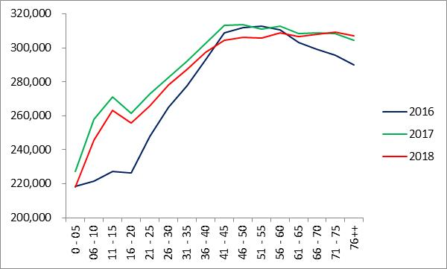
Unit cost of in-patients care in secondary care
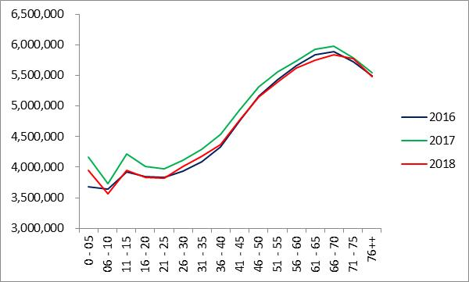

Despite not having a national LTC system, some municipalities in Indonesia offers homecare to their residents which varies in terms of benefits, beneficiaries and funding. There are also government-run nursing homes under the Ministry of Social Affair, however, not only the number is scarce but also their impacts on the quality of life of the elderly are little known.
Having read the Technical Report, the main key take-away for Indonesia in considering LTC would not only the source and the stability of funding, but also the importance of taking small but responsible steps in deciding what benefits to cover. Considering the current situation in which the government is encouraged to take not only evidence based policy but also politically correct ones, Indonesia needs to consider the funding policy which moves toward a predominant reliance on public resources such as tax-funded or top-up for NHI contribution, as opposed to OOP.
Table: The current contribution vs expenditure per beneficiaries per month of the Indonesian NHI scheme
Year | Per Beneficiaries per Month
Year | Cost (IDR) | Contribution (IDR) | Difference (IDR)
2016 | 35,802 | 33,776 | -2,026
2017 | 39,744 | 34,119 | -5,625
2018 | 43,241 | 35,771 | -7,470
Note: current exchange rate 1 USD = IDR 14,228 per March 22, 2019
There is also a challenging step to collaborate with other stakeholders which currently involve in the LTC and to find the most effective way to increase access and quality without compromising budget.

