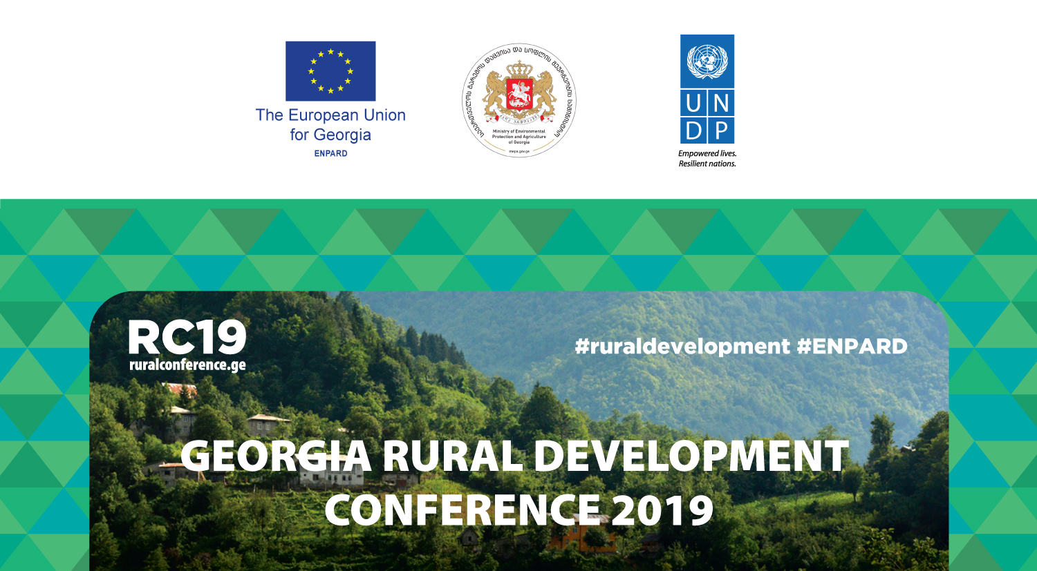
GEORGIA RURAL DEVELOPMENT POLICY 2020+
EU PRACTICE INTO GEORGIAN REALITY

8 APRIL 2019
Expo Georgia - Exhibition Center – 3rd Pavilion
118 Tsereteli Ave. Tbilisi

How can Georgia benefit from the successful European practice in
rural development policy and governance system?

Please confirm your participation before 2 April 2019

ONLINE REGISTRATION

More information about the conference is available at
http://www.ruralconference.ge

For more information about ENPARD visit
http://www.enpard.ge

The Conference is organized by the Ministry of Environmental Protection and
Agriculture of Georgia with the support from the European Union (EU) in
partnership with the United Nations Development Programme (UNDP)

