Dr Hans Henri P. Kluge: biography

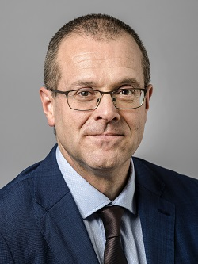

Dr Hans Henri P. Kluge began his term as WHO Regional Director for Europe on 1 February 2020, following his nomination by the WHO Regional Committee for Europe and appointment by the WHO Executive Board.
He has 25 years of experience in medical practice and public health in numerous settings around the world. Having qualified in medicine, surgery and obstetrics from the Catholic University of Leuven in 1994, he began his career as a family doctor in Belgium.

On assignment with Médecins Sans Frontières (MSF) Belgium from 1995, his international experience started in emergencies, working in Liberia and Somalia, coordinating a tuberculosis (TB) control programme and providing medical and public health services in conflict zones. Dr Kluge’s work for MSF in the area of TB control continued with a posting coordinating programmes in prisons in Siberia, and then as the Regional TB Advisor for former Soviet Union countries in Moscow, Russian Federation.
Dr Kluge joined WHO in 1999, as TB and TB-HIV Project Manager at the WHO Country Office in the Russian Federation. During 2004–2009 his focus expanded, as Medical Officer for TB and then becoming Team Leader for the 3 diseases unit (HIV, TB and malaria) at the WHO Country Office in Myanmar, as well as working as a consultant to the Democratic People’s Republic of Korea on TB.
In 2009, Dr Kluge moved to the WHO Regional Office for Europe, and the following year was appointed Director of the Division of Health Systems and Public Health, and Special Representative of the Regional Director to Combat Multi/Extensively Drug-Resistant Tuberculosis. As division director, he led the development of a new WHO European Region vision on health systems for prosperity and solidarity; drove work on a regional study on universal health coverage and financial protection; prioritized a focus on service delivery including integrated and primary health care; and built strong partnerships on health system performance and reforms with the European Commission, Organisation for Economic Co-operation and Development (OECD), World Bank, GAVI, the Global Fund to Fight AIDS, Tuberculosis and Malaria, the European Observatory on Health Systems and Policies, civil society and donors.
A Belgian national, Dr Kluge is fluent in English, French, German and Russian, as well as Dutch. He is married and has two daughters. He enjoys running, cycling and gardening.

