COVID-19 BANK FACILITIATED PROCUREMENT
Laerdal Medical

Laerdal Medical (www.laerdal.com) is an international company headquartered in Norway with more than 1500 employees worldwide. Laerdal Medical is a provider of training and therapy products for lifesaving, emergency and patient care. The company sells products for airway management, spinal motion restriction, resuscitation training, and patient simulation. It also offers a range of training services related to its product offerings.

The products listed below are a global offer.

Offer Expiration Date:
The pricing in this offer will expire on 31 August 2020. You are encouraged to complete this ROI confirming products and quantities needed as soon as possible to be assured of stock. Completion of the ROI does not bind you to entering into a contract.

Once an ROI is received Laerdal will advise the precise lead time (fitting into their production schedule), then the Borrower has 7 days to sign a contract to procure. If after this date the Borrower has not signed the contract, Laerdal will cancel the reservation in their production schedule.

Offered Products:
- Resuscitators (4 options)
- Endotracheal tube holder
- Suction devices (3 options)

Laerdal offers reusable and disposable adult and pediatric resuscitators. Note that reusable resuscitators require disassembly, cleaning, sterilization, and re-assembly between uses.

Laerdal has proposed resuscitators and 2 suction devices that meet or exceed the World Health Organization (WHO) and ECRI (www.ecri.org) developed baseline technical performance specifications that are provided in Appendix A.

In addition, Laerdal has offered a third suction device (Vvac manual suction unit) that provides a lower cost option, but does not meet the minimum technical specifications for at least 500 mmHg vacuum strength, or collection canister capacity of at least 800 ml.

The tables below outline offered models, key features, pricing and contract terms.

Table 1 – Offered Reusable Resuscitators
Device Models | Silicone Resuscitator,  Reusable, Adult | Silicone Resuscitator,  Reusable, Pediatric
Device Models | 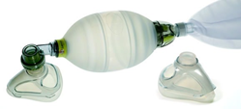 | 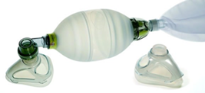
Product Code | #87005140 | #86005140
Intended Use | Adult | Pediatric
Product Description and Inclusions | Silicone Resuscitator Adult, complete in carton, contains adult silicone mask 4-5 w/multi-function mask cover, reusable 2.6 liter oxygen reservoir bag, lip valve, patient valve, expiration diverter (OD 30 mm), and intake reservoir valve | Silicone Resuscitator Pediatric, complete in carton, contains pediatric silicone mask 3-4 w/multi-function mask cover, reusable 600 ml oxygen reservoir bag, lip valve, patient valve, expiration diverte (OD 30 mm), and intake reservoir valve
Lead Time | 4 weeks | 4 weeks
Pricing | USD 216 | USD 216
Warranty | 12 months | 12 months
Shipping | Freight on invoice – estimate advised following ROI | Freight on invoice – estimate advised following ROI
Advanced Payment | Payment on Shipment | Payment on Shipment
Recommended Consumables & Spare Parts | Adult silicone mask 4-5 w/multi-function mask cover, LSR 2.6 liter oxygen reservoir bag, LSR Lip valve, LSR Patient valve, Expiration diverter (OD 30 mm), Intake Reservoir Valve | Pediatric silicone mask 3-4 w/multi-function mask cover, LSR 600 ml oxygen reservoir bag, LSR Lip valve, LSR Patient valve, Expiration diverter (OD 30 mm), Intake Reservoir Valve
Optional PEEP Valve | PEEP Valve Assembly  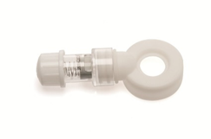 | PEEP Valve Assembly
Product Code | #845240 | #845240
Price | USD 57 (package of 10) | USD 57 (package of 10)
Shipping | Freight on invoice – estimate advised following ROI | Freight on invoice – estimate advised following ROI
Advanced Payment | Payment on Shipment | Payment on Shipment

Table 2 – Offered Disposable Resuscitators
Device Models | The BAG II Resuscitator, disposable,  Adult w/mask #5 | The BAG II Resuscitator, disposable,  Pediatric w/mask #3
Device Models | 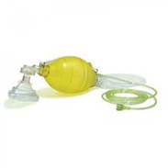 | 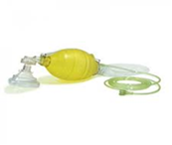
Product Code | #845211 | #845221
Intended Use | Adult (> 20 kg) | Pediatric (10 – 20 kg)
Product Description and Inclusions | Laerdal BAG II Disposable Resuscitator – Adult, complete with bag, mask, reservoir and connecting tubing. | Laerdal BAG II Disposable Resuscitator - Pediatric, complete bag, mask, with reservoir and connecting tubing.
Lead Time | 4 weeks | 4 weeks
Pricing | USD 188 (package of 12) | USD 188 (package of 12)
Warranty | 12 months | 12 months
Shipping | Freight on invoice – estimate advised following ROI | Freight on invoice – estimate advised following ROI
Advanced Payment | Payment on Shipment | Payment on Shipment
Optional PEEP Valve | PEEP Valve Assembly | PEEP Valve Assembly
Product Code | #845240 | #845240
Price | USD 57 (package of 10) | USD 57 (package of 10)
Shipping | Freight on invoice – estimate advised following ROI | Freight on invoice – estimate advised following ROI
Advanced Payment | Payment on Shipment | Payment on Shipment

Table 3 – Offered Endotracheal Tube Holder Summary
Device Models | Thomas Select Tube Holder
Device Models | 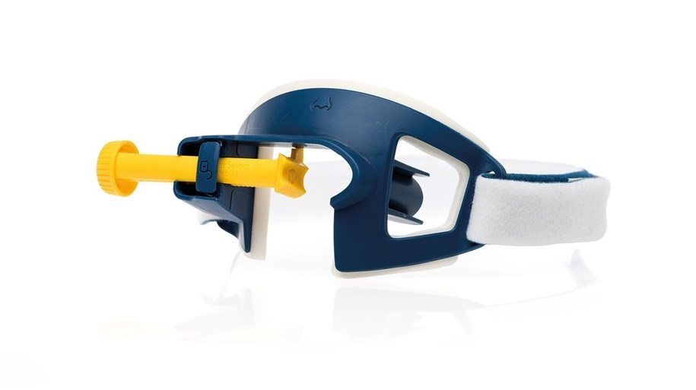
Product Code | #600-40000
Intended Use | Secures an oral endotracheal tube in adult patient without the use of tape and also functions as a bite block to protect the endotracheal tube from the patient’s teeth.
Lead Time | 4 weeks
Pricing | USD 7
Warranty | 12 months
Shipping | Freight on invoice – estimate advised following ROI
Advanced Payment | Payment on Shipment

Table 4 – Offered Suction Devices Summary
Device Models | LSU Laerdal Suction Unit  with Reusable Canister | Compact Suction Unit 4 | Vvac Manual Suction Unit
Device Models | 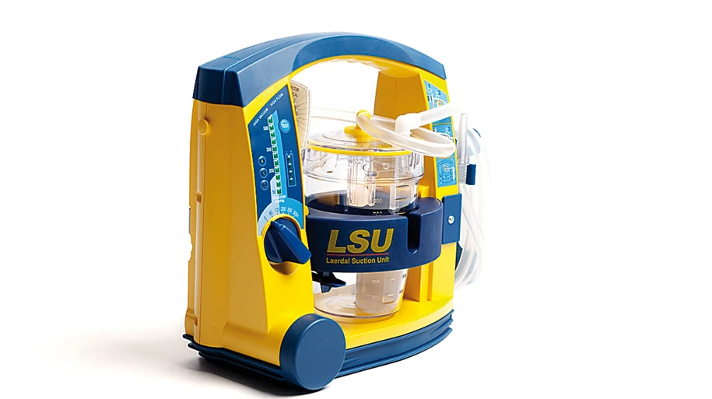 | 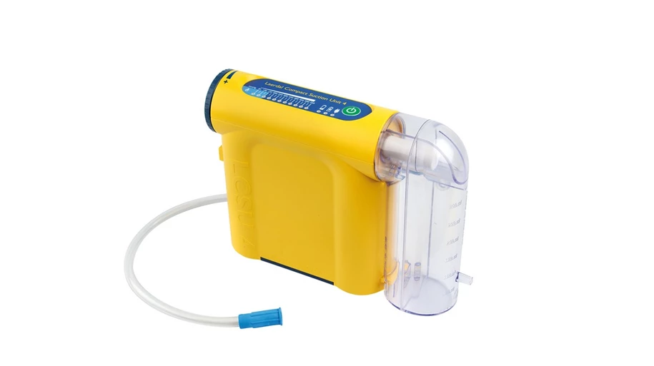 | 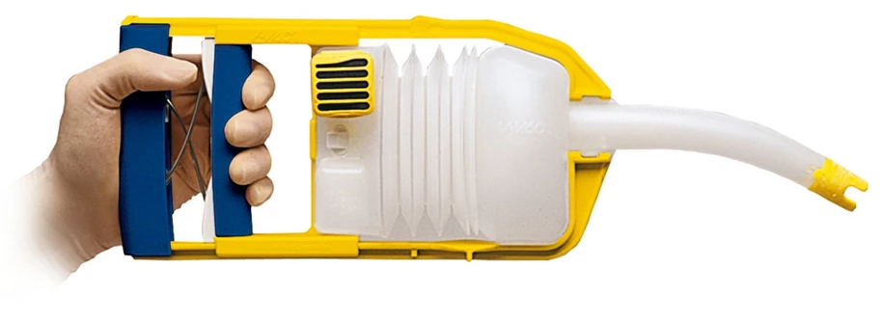
Electric, Manual or vacuum/positive pressure | Electric | Electric | Manual
Adjustable Vacuum Strength Range (mmHg) | 80, 120,200,350, 500+ | 50 to 550  increments of 50 | 170 to 380*
Device Performance Testing | Occlusion  Vacuum Build-Up Efficacy  Maximum Achievable Vacuum | None | None
Free flow (LPM) | 30 | 30 | 70
Collection canister size (milliliters)  Reusable or Disposable | 800 ml, Reusable | 800 ml, Disposable | 425 ml, Disposable*
Battery Backup/ Runtime | NiMH rechargeable  45 minutes of free flow | NiMH rechargeable  45 minutes of free flow | Not Applicable
Automatic Shutoff  with full Cannister | Yes | Yes | Not Applicable
Training | Quick start video, online live training | Quick start video, online live training | Quick start video, online live training
Consumables & Spare Parts | Aerosol filter for LSU reusable canister, suction tube wo/tip LPSU (150cm), disposable patient tubing, LSU reusable canister  suction catheter adapter, vacuum connector tubing filter tubing (30cm), strap for tubing | 800 ml disposable canister with tubing | Vvac replacement cartridge
Price | USD 1100 | USD 541 | USD 155
Warranty | 60 months limited  excludes canister, tubing system and battery | 24 months limited  excludes canister, tubing system and battery | 12 months
Shipping | Freight on invoice – estimate advised following ROI | Freight on invoice – estimate advised following ROI | Freight on invoice – estimate advised following ROI
Lead time | 4-6 weeks depending on quantity | 4-6 weeks depending on quantity | 4 weeks
Advanced Payment | Payment on Shipment | Payment on Shipment | Payment on Shipment
*Simple unit providing a lower cost option and doesn’t meet minimum technical specifications of vacuum strength of at least 500mmHG or Collection Canister size of at least 800ml.

Other Terms:

Pricing: Prices in US dollars. CIP prices to be established once destination and unit volume established. Warranty as outlined.

Payment Payment on shipment

Inspection Pre-shipment inspection: Laerdal will provide the Borrower with either a copy of the recognized regulatory approval (ie US FDA, CE Mark or equivalent) or other documentary evidence of the approval, prior to shipment.

Delivery inspection: The Borrower shall notify Laerdal in writing, within five working days of delivery at the agreed destination, of any short delivery or defects reasonably discoverable on careful examination of the packaging in which the goods are delivered. Laerdal will take such steps as may be necessary to rectify the situation as soon as reasonably practicable.

Delivery Time: 4-6 weeks from signed and funded Contract/Purchase Order.
Training: Quick start video and online training on demand.

Consumables/Spare Parts – Units are operational without the need for any particular consumables. Consumables/Spare parts are available as detailed in the ROI

Service: At various locations, closest venue tbd in Contract/Purchase Order

Manuals: Printed user and service manuals will be provided with each piece of equipment. Electronic copies available
Borrower and Laerdal Next Steps:

- Borrower country identifies the following on the attached Buyer Registration of Interest Form:
  - Quantity of each device required.
  - Single delivery destination.
  - Your country’s accepted contract signing protocols (e.g. e-signature, scanned signature, etc.). Please note that a signature is not required. This request is for the protocol required by your country for signing a contract with a supplier.
- Borrower reviews the standard World Bank Facilitated Procurement contract.
- Laerdal confirms the specific lead times, delivery destination, final CIP price including freight and service details.
- Borrower confirms to the Bank if they wish to proceed (in 24 hours), the Bank Country Procurement Specialist will draft the contract for the Borrower with agreed lead times etc. If the Borrower chooses not to proceed, they need to advise Laerdal immediately so available production capacity can be released to another Borrower.
- Borrower country makes the final purchase decision and signs the contract within 7 days from Laerdal confirmation of lead time, costs and training/servicing details.

Appendix A – Baseline Technical Specifications

Resuscitators

Resuscitators - Adult
The World Bank seeks to procure Resuscitators - Adult that meet the following technical specifications. In your proposal, do not include any advanced features or add-ons beyond the capabilities outlined below. If additional supplies are needed for normal operation that you do not provide, clearly indicate this and provide appropriate distributor information, if available.

The purpose of a Resuscitator – Adult is to manually ventilate a patient by hand. This device is commonly referred to as a “resuscitator bag”. These devices can be either single patient use or useable. Resuscitator bags commonly come in three sizes: adult, pediatric/child, and neonatal/preterm.

Specifications:
- If reusable, the device shall be easy to dis-assemble and re-assemble. If reusable, the device shall be able to undergo at a minimum high-level disinfection and preferably sterilization using common sterilization methodology.
- Resuscitator volume shall be a minimum of 1400 ml.
- Stroke volume with one hand shall be a minimum of 600ml
- Stroke volume with two hands shall be a minimum of 1000ml
- Device must be able to deliver up to 100% oxygen when supplied with 15LPM of oxygen flow.
- Device must be latex free, including the mask.
- Device shall have one attached mask appropriately sized to the resuscitator bag.
- Device must have an available PEEP accessory.
- Device must have the ability to refill and be compressed at a minimum of 20 times a minute
- Patient connector outside shall be 22 mm male
- Patient connector inside shall be 15 mm female
- The valve assembly shall be clear to allow for visualization of foreign material.
- Must be supplied with oxygen supply tubing that is a minimum of 2.1 meters.
Training and Manuals
- User Training: Supplier shall provide in-person or on-line training adequate to meet the needs of all operators. Training shall be available in English, Spanish and French, and shall be available to users within two (2) weeks of equipment delivery.
- User Manuals: Supplier shall provide at least one (1) user manual for each device purchased. Manuals shall provide guidance on the operation of all features of the purchased device, be provided in at a printed format, and be available in English, Spanish and French.
- Service Manuals: Supplier shall provide at least one (1) maintenance manual for each device purchased. Manuals shall provide at least, equipment schematics, parts summaries, preventive maintenance requirements, and troubleshooting guidance, be accessible in printed formats, and be available in English, Spanish and French.

Resuscitators - Child/Pediatric
The World Bank seeks to procure Resuscitators – Child/Pediatric that meet the following technical specifications. In your proposal, do not include any advanced features or add-ons beyond the capabilities outlined below. If additional supplies are needed for normal operation that you do not provide, clearly indicate this and provide appropriate distributor information, if available.

The purpose of a Resuscitator – Child/Pediatric is to manually ventilate a patient by hand. This device is commonly referred to as a “resuscitator bag”. These devices can be either single patient use or useable.
Specifications:
- If reusable, the device shall be easy to dis-assemble and re-assemble. If reusable, the device shall be able to undergo at a minimum high-level disinfection and preferably sterilization using common sterilization methodology.
- Resuscitator volume shall be approximately 625 ml.
- Stroke volume shall be approximately 450ml
- Device must be able to deliver up to 100% oxygen when supplied with 15LPM of oxygen flow.
- Device must be latex free, including the mask.
- Device shall have one attached mask appropriately sized to the resuscitator bag.
- Device must have an available PEEP accessory.
- Device must have the ability to refill and be compressed at a minimum of 20 times a minute
- Patient connector outside shall be 22 mm male
- Patient connector inside shall be 15 mm female
- The valve assembly shall be clear to allow for visualization of foreign material.
- Must be supplied with oxygen supply tubing that is a minimum of 2.1 meters.

Training and Manuals
- User Training: Supplier shall provide in-person or on-line training adequate to meet the needs of all operators. Training shall be available in English, Spanish and French, and shall be available to users within two (2) weeks of equipment delivery.
- User Manuals: Supplier shall provide at least one (1) user manual for each device purchased. Manuals shall provide guidance on the operation of all features of the purchased device, be provided in at a printed format, and be available in English, Spanish and French.
- Service Manuals: Supplier shall provide at least one (1) maintenance manual for each device purchased. Manuals shall provide at least, equipment schematics, parts summaries, preventive maintenance requirements, and troubleshooting guidance, be accessible in printed formats, and be available in English, Spanish and French.

Endotracheal Tube Holder

The purpose of an endotracheal tube holder is to securely fasten the endotracheal tube to the patient without the use of tape. Endotracheal tube holders offer many advantages over taping the tube, including better oral hygiene, reduction of skin breakdown, and prevention of tube occlusion.

Specifications:
- Device must be able to accommodate endotracheal tube sizes ranging from 6.5mm to 9.5mm
- Must be latex free
- Device shall be disposable and intended for no more than 24 hours of use
- Operating temperature of 20°C +/- 5°C
- Must use a Velcro like material to secure the holder to the patient. There should be no tape required with this device.
- Must have large opening to allow for the suctioning of the patient’s oral cavity.
- Must have an integral bite block to prevent the patient clamping down on the endotracheal tube.
- Neck strap must be adjustable to fit a wide range of patients, up to a neck size of 49cm.

Suction Devices

The World Bank seeks to procure portable suction devices/aspirator pumps for countries responding to the COVID-19 pandemic. These devices are used to evacuate secretions and liquids from the nasal cavity or airways to prevent pulmonary aspiration and facilitate breathing for patients suffering respiratory distress. The vendor proposal should include the device, bacteria filter, collection canister, and aspirator tubing kits. In your proposal, please do not include any advanced features or add-ons that requires additional cost beyond the capabilities outlined below.

Technical Specifications
- Model shall be compliant with the applicable part of the latest version of ISO 10079 Medical suction equipment:
  - Part 1: Electrically powered suction equipment
  - Part 2: Manually powered suction equipment
  - Part 3: Suction equipment powered from a vacuum or positive pressure gas source
- Model shall match the voltage and frequency of the purchasing country’s local power grid (e.g., 110-120 VAC at 60 Hz or 220-240 VAC at 50/60 Hz).
- Model shall have a vacuum strength range of 50 to (at least) 500 mmHg and a free flow of no less than 25 LPM.
- Vacuum strength shall be adjustable by the operator.
- The collection canister size shall be no smaller than 800 ml.
- The model shall have a HEPA rated filter (remove 99.97% of airborne particles with a size of 0.3 microns).
- Model shall be capable of resisting high-level disinfection procedures.
- Model may have a battery backup.
  - If the model has a battery backup, the battery shall last 30 minutes under normal operation.
- The model shall have clear indicators for vacuum strength, device failure, and battery life (if included).
- It is recommended that models have tests for occlusions in the suction system, vacuum build-up efficacy of the pump system, maximum achievable vacuum level, and air leaks.
Training and Manuals
- User Training: Supplier shall provide in-person or on-line training adequate to meet the needs of all operators. Training shall be available in English, Spanish and French, and shall be available to users within two (2) weeks of equipment delivery.
- User Manuals: Supplier shall provide at least one (1) user manual for each device purchased. Manuals shall provide guidance on the operation of all features of the purchased device, be provided in at a printed format, and be available in English, Spanish and French.
- Service Manuals: Supplier shall provide at least one (1) maintenance manual for each device purchased. Manuals shall provide at least, equipment schematics, parts summaries, preventive maintenance requirements, and troubleshooting guidance, be accessible in printed formats, and be available in English, Spanish and French.

