Dear Minister Tikaradze,
On behalf of the United Nations Development Programme (UNDP) in Georgia, I would like to express our sincere appreciation to the Ministry of Internally Displaced Persons from the Occupied Territories, Labour, Health and Social Affairs of Georgia for the timely and effective measures implemented to protect the country from the COVID-19 pandemic. We salute the Ministry’s leadership in containing the outbreak and limiting the human costs to a minimum.
We are therefore extremely pleased to be able to respond favorably to your request for capacity development and technical assistance to the Ministry. We appreciate your approach of promoting evidence-based policies and delivering innovative context-specific solutions to the public health sector by elaborating a unified development plan for the state-owned hospitals as well as by introducing a peer review discussion mechanism for improvement of medical treatment quality including on COVID-19 cases. We are delighted to be able to commit the financial and technical support requested through the Swedish-funded Governance Reform Fund (GRF) project.
We believe this initiative will directly increase the country’s medical capacities and contribute to Georgia’s readiness to respond to the current and future pandemic threats.
Let me once again express our deep appreciation to you and the Ministry.

Sincerely,
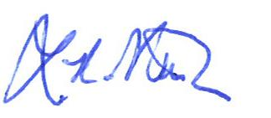

Louisa Vinton
Resident Representative
UNDP Georgia

Ekaterine Tikaradze
Minister of Internally Displaced Persons from the Occupied Territories,
Labour, Health and Social Affairs of Georgia

