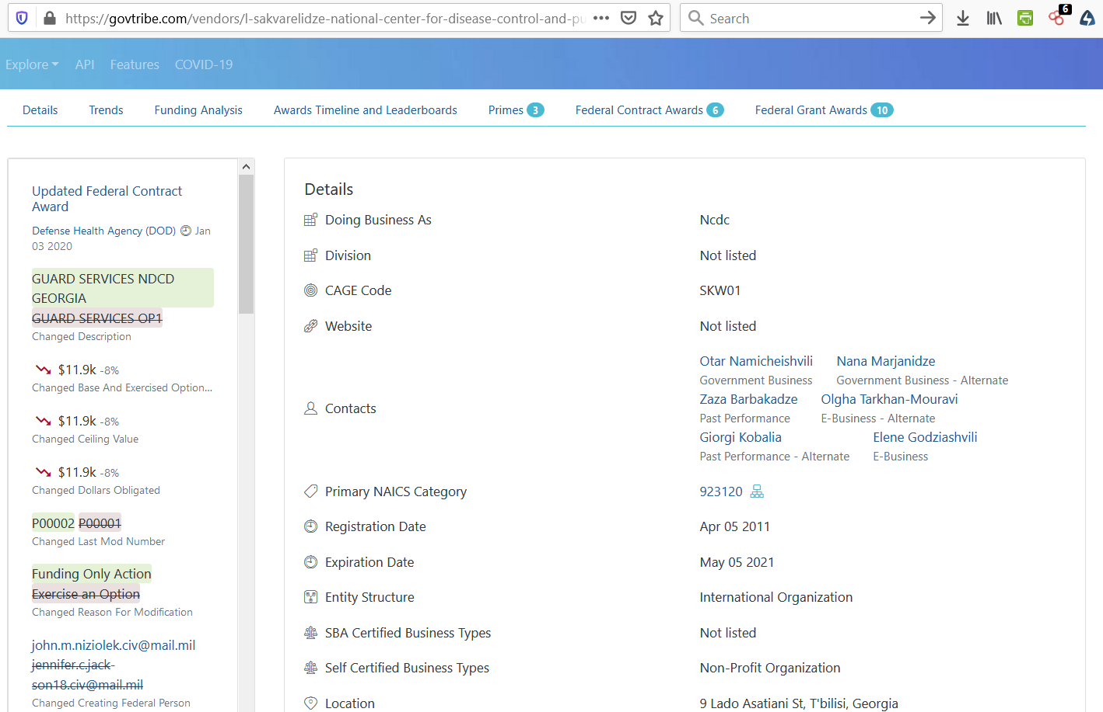

Otar Namicheishvili - o.namicheishvili@ncdc.ge
Nana Marjanidze - nanamarjanidze@yahoo.com
Zaza Barbakadze - zazabarbakadze@ncdc.ge
Olgha Tarkhan-Mouravi - vpd@ncdc.ge
Giorgi Kobalia - g.kobalia@ncdc.ge
Elene Godziashvili - e.godziashvili@ncdc.ge

