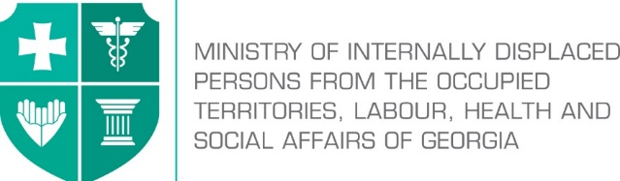

Labour Conditions Inspection Department
Create Together Safe Working Environment!

Annex №1

General Guidance Related to Infection (COVID-19) Caused by Novel Coronavirus (SARS-CoV-2)

Guidance set forth in Annex №1 applies for all sectors of economic activity

Note: In accordance with Order N281/N of the Minster of Internally Displaced Persons from the Occupied Territories, Labour, Health and Social Affairs of Georgia on “the rule for Examination for Short-term Employment Disability and Issuance of Doctors Note”, the Ministry of Internally Displaced Persons from the Occupied Territories, Labour, Health and Social Affairs of Georgia will issue an equivalent document to the doctors excuse note (Medical Certificate) to persons quarantined in order to prevent the spread of coronavirus. The document will serve as the basis to receive monthly payment and therefore, the working days spend in quarantine or in self-isolation will be legitimate and fully paid to the employees. In order to get the certificate, an interested person has to apply to the Ministry of Internally Displaced Persons from the Occupied Territories, Labour, Health and Social Affairs of Georgia at - info@moh.gov.ge.

Table of Contents

Development of Readiness and Response Plan for Infectious Disease 3
Preparation for implementation of basic preventive measures 3
The hierarchy of risk controls 4
Classifying Worker Exposure to COVID -19 5
Very high exposure risk 5
High exposure risk 5
Recommendations for jobs classified at high or very high exposure risk 6
Medium exposure risk 6
Recommendations for jobs classified at medium exposure risk 7
Lower exposure risk 8
Recommendations for jobs classified at lower exposure risk 8

Development of Readiness and Response Plan for Infectious Disease
Employers that have not yet taken special measures must develop readiness and response plan for infectious diseases (emergency response plan), that will facilitate implementation of measures to prevent COVIC -19. It is significant to use guidelines of the Ministry of Internally Displaced Persons from the Occupied Territories, Labour, Health and Social Affairs of Georgia and LEPL L.Sakvarelidze National Center for Disease Control and Public Health and define how to comply with their recommendations.
The plans must envisage and underline the risk level (levels) related to different workplaces and tasks that employees have to do. The issues to be considered may include: where, how and to what sources of COVID-19 the employees may be exposed to, including the contact in public places, customers etc.
Individual risk factors of employees must be taken into consideration (e.g. retirement age, chronicle diseases etc.). If there are such employees in the company, management must take additional control measures necessary to reduce the risks.
The staff must not appear in the workplace if they:
- Left the affected country over the past 14 days;
- Were in close contact with infected person/persons for the past 14 days (they must be self-isolated/quarantined as per the rule);
- Have symptoms of respiratory infection (coughing, temperature, sneezing, difficulty in breathing, general weakness etc.);
- Are among the ones who have high risk of getting infected with COVID -19 or serious complications: over 70 of age, people suffering from chronicle diseases (cardio-vascular diseases, diabetes, bronchial asthma and other respiratory diseases.

Preparation for implementation of basic preventive measures
All the employers must ensure relevant hygiene and infection control practices, including by:
- Promoting frequent and thorough hand washing;
- Providing the staff and third parties with a place to wash their hands;
- In case there is no possibility to wash hands, 70% alcohol-based hand disinfectant must be used;
- Encouraging the staff stay at home if they are sick;
- Encouraging respiratory etiquette, including covering coughs and sneezes;
- Ensuring disposable tissue paper and waste bins for customers and the society;
The employer must develop a policy and procedures for immediate isolation of persons who have signs and/or symptoms of COVOD-19 and employees must be trained to take necessary measures.
The employer must ensure the development and introduction of flexible working regime, provision of information, introduction of flexible leave policy for sick employees and their compliance with social healthcare guidelines. Companies must be provided with information about the significance of requesting

the employees to stay at home or introducing measures to use encouraging policy to the employees, giving them possibility to use the leave, work in rotating shifts and/or do teleworking.
The employer, as far as practicable, must develop a flexible policy enabling the staff stay at home and care for their families.

The hierarchy of risk controls
In order to ensure safety control in the workplace, companies must be guided by the hierarchy of control measures. The best way to exercise control is to systematically eliminate hazards from the workplace. The employer must at first take engineering control measures (e.g. safety barriers etc.) administrative control measures (instructions, training, ensuring means for disinfection, development of action plan in the state of emergency) and finally, apply personal protective equipment (face masks, goggles, gloves, gowns). Each level of control measure has advantages and disadvantages considering the simplicity, efficiency and costs of their implementation. In most cases, the use of combination of control mechanisms will be necessary to prevent employees from COVID-10 exposure.
While selecting relevant hierarchy of risk controls, the employer, considering the characteristics of existing work environment, must prioritize the first level of control mechanism (elimination of hazard). But, if due to substantial technological reasons, it is impossible to fully follow the control hierarchy, the employer may be guided by the scheme following top to bottom direction, i.e. from primary control measure to the final level.
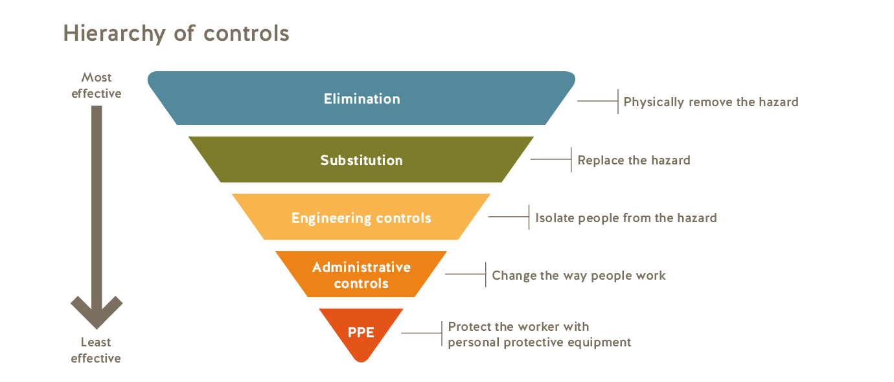
Control measures represents changes in work policy or procedures, aimed to eliminate hazards. Some examples of control measures related to COVIC-19 are:
- Encouraging the infected employees to stay at home;
- minimizing the contact of employees and customers by switching to teleworking mode;
- Establishing alternating days or extra shifts that reduce the total number of employees in a facility at a given time, allowing them to maintain distance from one another while maintaining a full onsite work week.
- Providing the employees with updated information and training them on COVID-19 risk-factors and control measures (e.g. coughing etiquette and treatment of personal protective equipment);
- Training the employees on proper use of personal protective equipment and their further use/disposal.
- Ensuring the simplicity of training materials and its provision the way to be understandable to the trainees.
Despite the fact that engineering and administrative control measures are considered to be more effective to reduce COVID-19 exposure, PPEs may also be necessary to be used for this purpose. Although PPEs may prevent some type of exposure, they must not replace other strategies for prevention.
PPEs are: gloves, googles, face shields, face masks and respirators.
It is necessary that all types of PPEs must be:
- Selected in accordance with the job performed by an employee;
- Ensured to properly fit to the employee and be suitable for the job (e.g. respirators);
- Used in accordance with the instructions;
- Regularly inspected for suitability, in case of necessity, technical maintenance must be provided and if found faulty, they must be replaced on time.
The employers are obliged to provide the employees with PPEs, which is necessary for their safety of work performance.
Trainings related to respirators must include the issues of their selection, use (wearing and fitting), disposition or disinfection, examination for damage.

Classifying Worker Exposure to COVID -19

Worker risk of occupational exposure to COVID-19 may vary from very high to high, medium, or lower (caution) risk. The level of risk depends in part on the industry type. Occupational risk pyramid shows the four exposure risk levels.

Very high exposure risk
Very high exposure risk jobs include: specific medical, or laboratory facilities. Workers in this category are healthcare workers (e.g., doctors, nurses, dentists, paramedics, emergency medical technicians) laboratory workers collecting specimen from known or suspected COVID-19 patients.

High exposure risk
High exposure risk jobs are those with high potential for exposure to known or suspected sources of COVID-19. Workers in this category include: doctors, nurses, and other hospital staff, who must enter to known or suspected COVID-19 patients: Mortuary workers involved in preparing the bodies of people who are known to have, or suspected of having, COVID-19 at the time of their death.

Recommendations for jobs classified at high or very high exposure risk

Engineering Controls Measures
Ensure that appropriate air-handling systems are installed and maintained in healthcare facilities. According to recommendations, patients with known or suspected COVID-19 (i.e., person under investigation) should be placed in an airborne infection isolation room (AIIR), if available.
Use isolation rooms when available for performing aerosol-generating procedures on patients with known or suspected COVID-19 (airborne infection and isolation room)
Use special precautions associated with biosafety measures when handling specimens from known or suspected COVID-19 patients.

Administrative controls
If working in a healthcare facility, follow existing guidelines and facility standards of practice for identifying and isolating infected individuals and for protecting workers.
Develop and implement policies that reduce exposure, such as cohorting (i.e.,grouping) COVID-19 patients when single rooms are not available.
Provide all workers with job-specific education and training on preventing transmission of COVID-19, including initial and routine/refresher training to make sure that the workers have appropriate knowledge and skills.
Ensure that psychological and behavioral support is available to address employee stress.

Safe work practices
Emergency response action plan must be developed.

Personal protective equipment (PPE)
Most workers at high or very high exposure risk likely need to wear gloves, a gown, a face shield or goggles, and either a face mask or a respirator, depending on their job tasks and exposure risks.
Those who work closely with patients known to be, or suspected of being, infected with COVID-19, and perform aerosol-generating procedures should wear respirators.

PPE ensembles may vary, especially for workers in laboratories or morgue/mortuary facilities who may need additional protection against blood, body fluids, chemicals, and other materials to which they may be exposed. Additional PPE may include medical/surgical gowns, fluid-resistant coveralls, aprons, or other disposable or reusable protective clothing.
NOTE: Workers who dispose of PPE and other infectious waste must also be trained and provided with appropriate PPE.

Medium exposure risk
Medium exposure risk jobs include those that require frequent and/or close contact with (i.e., less than 2 meters) other people who are not infected or suspected to be infected with COVID-19. Such places include schools, crowded workplaces as well as some retail shopping centres or other places where people gather.

Recommendations for jobs classified at medium exposure risk

Engineering controls
Install physical barriers, such as clear plastic sneeze guards, where feasible.

Administrative controls
Consider offering face masks to sick employees and customers to contain respiratory secretions until they are able leave the workplace. In the event of a shortage of masks, a reusable face shield that can be decontaminated may be an acceptable method of protecting against droplet transmission.
Keep customers informed by posting signs about COVID-19 in stores where sick customers may visit (e.g. pharmacies and stores).

Periodically, several times a day, ensure ventilation of closed spaces/rooms, and clean and disinfect restrooms in the workplaces.
Install disinfection barriers in entrances with appropriate mandatory signs.
Position hand hygiene solutions and instructions for their use in a visible place.

Dispose of used hygiene products in sealed containers and ensure their timely removal from the building, together with municipal waste, by an appropriate person/service.
If appropriate, restrict admission of customers and public to the workplace, or allow them only in a designated work area.
Consider minimizing personal contact (such as arranging service without getting out of the car, communicating by phone, or teleworking).

To maintain the distance, use obligatory conventional signs (using appropriate stickers/drawings)

Personal protective equipment (PPE)
When selecting PPEs, consider factors such as function, fit, decontamination ability, and disposal.
Each employer must select the combination of PPEs considering the workplace of the employee.
Workers with medium exposure risk may need to wear some combination of gloves, a gown, a face mask, and/or a face shield or goggles.

Lower exposure risk

Lower exposure risk jobs are those that do not require contact with people known to be, or suspected of being, infected with COVID-19 nor frequent close contact with the general public. Workers in this category have minimal occupational contact with the public and other coworkers.

Recommendations for jobs classified at lower exposure risk

Engineering controls
Additional engineering controls are not recommended for workers in the lower exposure risk group. Employers should ensure that engineering controls, if any, used to protect workers from other job hazards continue to function as intended.

Administrative controls
Monitor public health communications about COVID-19 recommendations and ensure that workers have access to that information.
Ensure accessibility of hand washing equipment or at least 70% alcohol based hand disinfectant must be used;

Personal Protective Equipment
Additional PPE is not recommended for workers in the lower exposure risk group.

