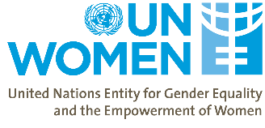

Meeting Note – UN Women Meeting with the Deputy Minister of IDPs from Occupied Territories, Labor, Health and Social Affairs, Tamila Barkalaia
Tuesday, 19 February, 2019l 10:00 – 11.00 am
Venue – MoIDPOTLHSA Office

Follow up Actions / Agreements Reached

# | Action / Agreement | Parties Responsible | Deadline
1 | PGA in MoIDPOTLHSA | UN Women | April 2019
2 | UN Women will be invited as an observer at working group meetings of the Tripartite commission. Working group meeting will be dedicated to assessment of the possible ratification of ILO Conventions (183, 156, 189) | MoIDPOTLHSA, UN Women | March 2019
3 | MoIDPOTLHSA and UN Women agreed on number of issues as the areas of potential cooperation – the details are described in item 4 of Summary of Discussion | MoIDPOTLHSA, UN Women | -

Summary of Discussion

- Participatory Gender Audit in the Ministry with the focus on departments of Labor and Employment Policy, Labor Inspection and Social Policy has been agreed. The auditors will start the desk review in March 2019, although the interviews in MoIDPOTLHSA will be scheduled in mid-April.
- EPIC (Equal Pay International Coalition)
- Deputy Minister’s committed to attend the Side Event “Equal pay for work of equal value” of the the Regional Forum on Sustainable Development to be held in Geneva in March 2019 to indicate Georgia’s potential interest joining the EPIC;
- UN Women will invite the other relevant partners to form the Georgian delegation (Gender Equality Council, MoESD).
- Tripartite Commission / Ratification of the ILO Conventions (183, 156, 189)
- The meetings of the tripartite commission are closed, but UN Women can join as an observer to the working group meetings;
- At the next commission working group meeting, UN Women will be invited to present the findings of the study on the Causes of Women’s Economic Inactivity and Engagement in the Informal Sector in Georgia
- The best way to proceed forward with the assessment of the possibilities of Convention’s ratification will be to dedicate the working group’s meeting to assessing the possibilities of ratification and presenting the newest UN Women data to support the evidence-based discussion.
- Activities the UN Women can support in cooperation with the MoIDPOTLHSA:
- The methodology of assessment of hazardous occupations for pregnant women in Georgia; MoIDPOTLHSA will prepare share the draft TOR with the UN Women. After agreeing on TOR, UN Women will announce the consultancy;
- An assessment of the prospective ratification of ILO Convention No. 183 (Maternity Protection), No. 156 (Workers with Family Responsibilities) and No. 189 (Domestic Workers) and the support of the ratification process.
MoIDPOTLHSA and UN Women will agree on TOR of Regulatory Impact Assessment and UN Women will commission it – the priority will be the C183 (Maternity Protection) however all three conventions should be presented as a complete package;
- To develop an assessment matrix to conduct mapping of existing social protection floors based on ILO standards (1) access to essential health care, including maternity care; (2) basic income security for children, providing access to nutrition, education, care and any other necessary goods and services; (3) basic income security for persons of active age who are unable to earn sufficient income, in particular in cases of sickness, unemployment, maternity and disability; and (4) basic income security for older persons;
UN Women will provide the additional information to the Ministry about this activity and discuss ways forward;
- Equal Pay for Work of Equal Value;
GTU in partnership with the ILO is working on developing the methodology for equal pay of the work of equal value. UN Women will wait for this methodology and discuss best ways for building on it, one option may be development of an assessment tool for the companies on Equal Pay for the Work of Equal Value (sign of quality) and start cooperation with the WEPS signatory companies as well as business associations to disseminate it;
- Supporting policy development or implementation related with the assessment of the labor market regulations (eg minimum wage, Pay Gap);
The regulatory amendments are currently discussed in Parliamentary Gender Equality Council in scope of the working group on labour regulations. UN Women will be invited to join the group and further cooperation will build on the agreements achieved within the working group;
- To support the generation of gender-disaggregated data and evidence on strategic priority issues for improved policymaking for women’s economic empowerment including the development of gender-disaggregated policy targets and indicators;
MoIDPOTLHSA will complete the internal assessment of the available data sources and mapping of the existing data gaps in April 2019. Based on the assessment results, UN Women will support the data generation and/or the analysis of the existing data as necessary.
- AOB
- Memorandum of Understanding – UN Women together with UNFPA has the valid MoU with the Ministry which includes the issues related to gender-based violence. After the PGAs are completed, the MoU will be amended to include the Women’s Economic Empowerment agenda;
- UN Women will meet with the Delegation of the European Union to build the synergies;
- Possible expansion of the labor inspection mandate (soft issues, labor rights issues, sexual harassment) can be discussed as an area of cooperation in future.

Note Prepared by: Nani Bendeliani

Annex #1: Meeting Agenda

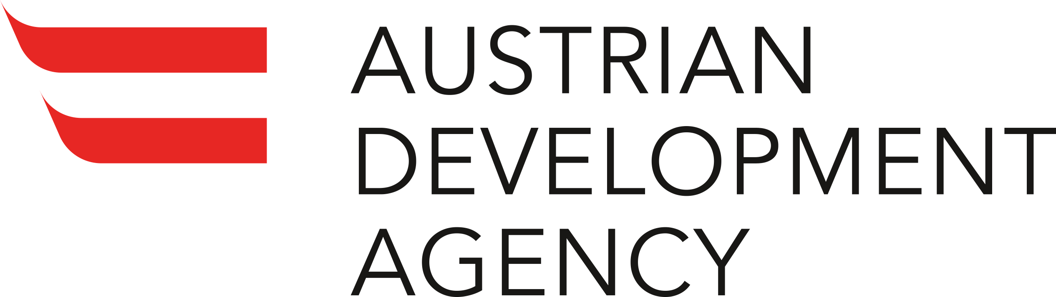 | 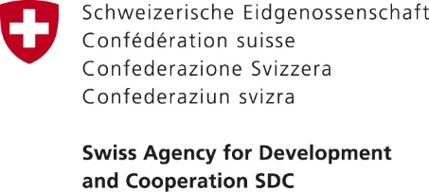 | 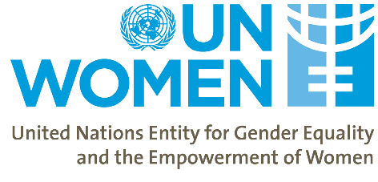

Women’s Economic Empowerment in the South Caucasus
First Main Phase

Meeting with the Ministry of IDPs from Occupied Territories, Labor, Health

And Social Affairs
10:00am – 19 February 2019

Agenda

- Participatory Gender Audit in the Ministry with the focus on departments of Labor and Employment Policy, Labor Inspection and Social Policy
  - Confirmation from the Ministry
  - What to Expect during the PGA
  - What to expect after the PGA (the list based on PRODOC)

- EPIC
  - UN Women’s work on equal pay (pay gap)
  - Side-event in March and Deputy Minister’s commitment to go to Geneva
  - Georgia’s delegation for the side event (Gender Equality Council, MOSED)
  - Activities UN Women can support the Ministry regarding the EPIC

- Tripartite Commission / Ratification of the ILO Conventions (183, 156, 189)
  - Request of formal invitation of UN Women to attend the Tripartite commission meetings and the reports / minutes of the commission for the last two years
  - The best way to proceed forward with the assessment of the possibilities of Convention’s ratification
- AOB

Annex #2: List of Participants

      - Tamila Barkalaia, the Deputy Minister of IDPs from Occupied Territories, Labor, Health and Social Affairs;
      - Lika Klimiashvili, the Head of Social Partnership Division at the Labour and Employment Policy Department;
      - Tamar Sabedashvili, Deputy Country Representative, UN Women;
      - Mehjabeen Alarakhia, Programme Specialist, Project Manager Women’s Economic Empowerment in the South Caucasus, UN Women
      - Nani Bendeliani, Project Analyst, UN Women

Annex #3: Other shared materials as relevant

      - UN Women Study on Women’s Economic Inactivity and Informal Employment in Georgia
      - UN Women Study on Assessment of the Labour Market Regulations in Georgia
      - EPIC criteria for engagement
      - The list of activities UN Women can support

Annex #4 The list of activities the UN Women can support in cooperation with the MoIDPOTLSHA:

- To develop the methodology of assessment of hazardous occupations for pregnant women in Georgia;
- In close collaboration with respective national institutions, organize around an assessment of the prospective ratification of ILO Convention No. 183 (Maternity Protection), No. 156 (Workers with Family Responsibilities) and No. 189 (Domestic Workers) and support the ratification process where appropriate;
- To develop an assessment matrix to conduct mapping of existing social protection floors based on ILO standards (1) access to essential health care, including maternity care; (2) basic income security for children, providing access to nutrition, education, care and any other necessary goods and services; (3) basic income security for persons of active age who are unable to earn sufficient income, in particular in cases of sickness, unemployment, maternity and disability; and (4) basic income security for older persons;
- The Equal Pay International Coalition (EPIC) is led by the ILO, UN Women and the OECD and is a multi-stakeholder coalition to contribute to the achievement of SDG target 8.5 focusing on equal pay between women and men for work of equal value. The Government of Georgia could consider joining this coalition for increased support and visibility of Georgia’s commitment;
- Support in targeting the vulnerable and socially excluded women in regions (especially the regions of the WEESC project – Kvemo Kartli, Samtskhe-Javakheti, Kakheti);
- Equal Pay for Work of Equal Value – UN Women can support with developing the methodology;
- Supporting policy development or implementation related with the assessment of the labor marker regulations (eg minimum wage, Pay Gap);
- To support the generation of gender-disaggregated data and evidence on strategic priority issues for improved policymaking for women’s economic empowerment including the development of gender-disaggregated policy targets and indicators.

