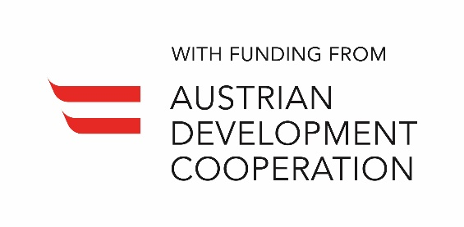

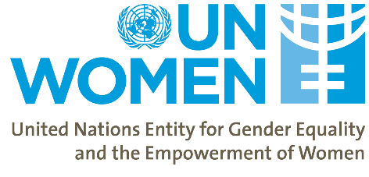
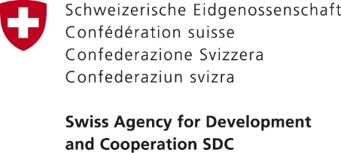
Women’s Economic Empowerment in the South Caucasus

Workshop on Gender and Economics
Conducted by Dr Ipek Ilkkaracan, Professor of Economics at Istanbul Technical University (ITU),
Visiting Scholar at Sapienza University of Rome, co-Author of UN Women Gender and Economics Training Manual

Agenda (Provisional)
July 22, 2019, Hotel Radisson Blue Iveria, Room #6
09:30 – 10:00 | Welcome Coffee
10:00 – 10:30 | Opening  - The Deputy Minister of the Economic and Sustainable Development of Georgia (TBC)  - Deputy Minister of the Labor and Social Affairs of Armenia (TBC)  - UN Resident Coordinator in Georgia (TBC)  - UN Women  Participants’ Introductions
10:30 – 11:30 | Introduction to Gender-aware Economics
11:30 – 11:50 | Tea/Coffee Break
11:50 – 13:00 | Labor Markets and Gender Inequalities
13:00 – 14:00 | Lunch
14:00 – 15:30 | Unpaid Work, Time- and Income-Poverty
15:30 – 15:50 | Tea/Coffee Break
15:50 – 17:30 | Gender and Macroeconomics
17:30 – 18:00 | Closing

