Annual Development Partnership Forum
29 January 2020
Scene Setter
Background
The third Annual Donor Coordination Forum will be held under the chairmanship of the Prime Minister of Georgia, Mr. Giorgi Gakharia. The forum is aimed at enhancing the coordination of external aid provided to the country, harmonizing the assistance according to priorities of the state and strengthening the development cooperation between the Government of Georgia, authorized entities of donor countries, and international donor organizations.
Participants: Ministers, deputy ministers, ambassadors, representatives of international organizations, development partners and international financial institutions.
Media: the representatives of media will be invited in order to cover the event highlighting the importance of external aid provided to the country as well as success of the ongoing reforms. Government representatives as well as development partners will be interviewed.
Location set-up: The theatre set up will be arranged where all the guests will be sitting. Speeches will be delivered from the Stage. PM, RC, and Minister of Finance and First Deputy Minister of Foreign Affairs will be seated on stage.
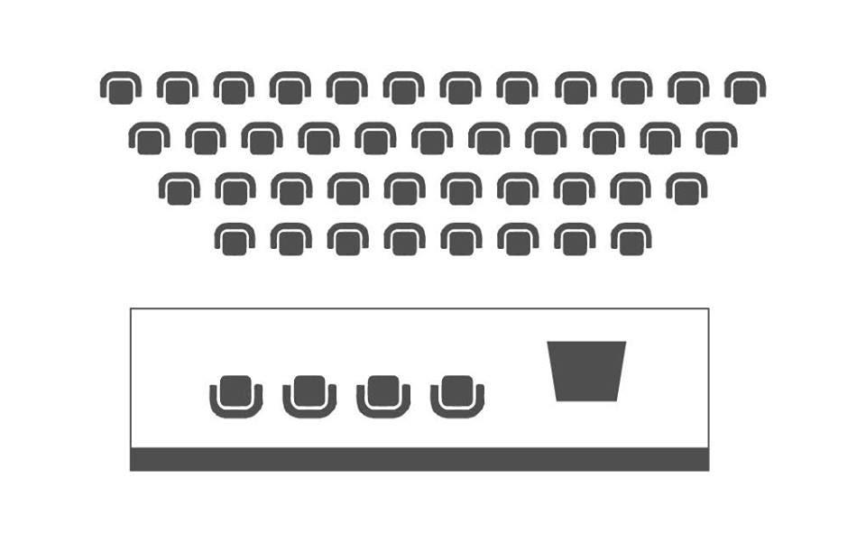
Summary
The Chairman of the Forum: Mr. Giorgi Gakharia, Prime Minister of Georgia
The Co-chair and Moderator: Ms. Sabine Machl, UN Resident Coordinator in Georgia
The Sequence:
- The Prime Minister of Georgia will open the event and deliver the speech.
- The Prime Minister will pass the floor to Ms. Sabine Machl, UN Resident Coordinator in Georgia to deliver the speech and take up the moderation of the first session.
- Ms. Sabine Machl will deliver the speech and pass the floor to Minister of Finance, Mr. Ivane Machavariani and First Deputy Minister of Foreign Affairs, Mr. Vakhtang Makharoblishvili.
- After speeches are delivered, Ms. Sabine Machl will open the follow-up discussion where the following topics will be covered:

H.E. Carl Hartzell, Ambassador of the European Union to Georgia:
- Eradication of poverty through inclusive, sustainable and smart economic development – bringing long term benefits for the society;
- Developing high quality and accessible education - as a key investment for the country, contributing to both democracy and economic growth.
H.E. Hubert Knirsch, Ambassador of Germany to Georgia:
- Ongoing civil service reform; frequent staff rotation on a management level.
Mr. Erik Illes, Deputy Head of Mission and Head of Development Cooperation at the Embassy of Sweden:
- Gender equality is at the core of democracy, inclusive growth and the partnership between Georgia and its international partners. What will be done to accelerate implementation of strategies to address the persistent gender gap in all spheres of society? What can be done in the immediate pre-election period - so that when we meet the government at the next Annual Development Forum, we can look back and see that women are better represented in politics than today - and beyond this election year?
- What is the Government’s plan to maintain and strengthen the enabling environment for civil society including dialogue between the government and civil society, as part of its development agenda. What concrete steps can be taken?
The questions will be addressed by the Prime Minister.
The Prime Minister, UN Resident Coordinator, and Minister of Finance and First Deputy Minister of the Foreign Affairs will move to theatre seats from stage.
Discussion panels - Q&A
The first panel will be followed by one hour and ten minutes discussion that will be conducted in the format of Q&A session (without minister’s speeches). Q&A session will be facilitated by relevant speakers from donor organizations, whereas the feedback will be provided by the line Ministers and Deputy Ministers. For this panel seven respondents will be seated on the stage and donor representatives will ask the questions from theatre seats.
Governance, Rule of Law and Justice
Ms. Sabine Machl will ask H.E Justin McKenzie Smith, Ambassador of UK and Ms. Thea Tsulukiani, Vice Prime Minister, Minister of Justice of Georgia to start discussion on Rule of Law and Justice. The following topics will be raised by the Moderator:
- What are your plans on criminal justice reform? How can the donor community support you to achieve the necessary aims in these areas?
- Raising legal awareness is essential for effective anti-discrimination policy. How do you assess the contribution of your Ministry to the overall efforts to protect minority groups, and what next steps have you identified to further progress?
- Inter-agency coordination is key to combating complex crimes such as corruption. How do you assess the current situation in this regard and what steps should be taken to ensure effective inter-agency coordination and response?
- What is your assessment of the scope and nature of human rights issues in the penitentiary establishments and what measures are you taking address them?

Regional Development
H.E Justin McKenzie Smith will invite Mr. Maciej Czura, Head of EIB Regional Representation and Ms. Maya Tskitishvili, Vice Prime Minister, Minister of Regional Development and Infrastructure of Georgia to continue discussion panel. The following topics will be raised by the EIB Representative:
- What are the key infrastructure and regional development priorities of the Georgian Government? What are the main challenges in their implementation?
- Planning of large infrastructure investments requires dialogue with local communities to address questions related to the potential impact of the projects. What is the Georgian Government doing to effectively communicate with inhabitants who may be directly or indirectly affected by infrastructure projects?

Georgia’s Economic Policy and Key Economic Reforms
Mr. Maciej Czura will pass the floor to Mr. Sebastian Molineus, WB Regional Director and Ms. Natia Turnava, Minister of Economy and Sustainable Development of Georgia. The development partners are committed to support Georgia’s economic development and see opportunities in the following areas:
- Strengthening the foundations for growth and jobs along four key areas:
i) Enhancing competitiveness, including efforts to deepen and diversify the financial and capital markets (banks, insurance, FinTech), strengthen integration through attracting job-creating FDI, unlocking the efforts in the energy sector and reforming agriculture;
ii) Leveling and improving the playing field; through improved judicial performance (already covered earlier), strengthened creditor and property rights (Insolvency Law, Company Law, Enforcement Law), market contestability (amendments to Law on Competition and regulations on Public Procurement and stronger regulatory bodies), and policy predictability (through Regulatory Impact Assessments).
iii) Increasing human capital, which will be covered by my esteemed colleagues in the next session; and
iv) Stronger resilience; including macro-financial, given identified fiscal risks, elevated external debt and dollarization; as well as environmental through improved energy efficiency and disaster risk management.
- Setting the stage for the economy of the future, integrated and connected, green and resilient, knowledge-based, and digital. As the current strategy nears its completion, is this a good time to start thinking on a new comprehensive, ambitious, yet realistic vision for the country? One that prioritizes key drivers of growth for Georgia?
- Improving the effectiveness of our support. An “outcome driven” approach to donor coordination by the government in support of a well-defined government reform agenda can achieve better outcomes. This could mean creating a few platforms in key sectors (e.g. education, energy, connectivity, etc.), with agreed upon targets and a select number of DPs working hand-in-hand with the government.
Human Capital Development
Mr. Sebastian Molineus will invite for discussion H.E. Carl Hartzell, Ambassador of the European Union to Georgia and Ms. Tamar Kitiashvili, Deputy Minister of Education, Science, Culture and Sport of Georgia. The topic of discussion are:
- Education strategy: Developing the quality and reach of education is a key investment for Georgia with a direct link to consolidating the country's democracy and economic potential, including by advancing inclusive economic growth. Major reforms have already started in the field of education. How does GoG envisage rolling it out in a way that secures the necessary long-term quality and continuity (policy, budget and staff) and comprehensive coverage of all bottlenecks?
- Vocational education and training (VET): Is the GoG ready to further increase the target of persons completing VET? How does the GoG intend to engage the private sector more actively in increasing VET relevance and effectiveness?
- On skills and jobs matching: now with the Labour Market Strategy adopted last December, how will GoG implement this strategy and what is the prospect of the other enabling policies already prepared, such as, employment services agencies act and labour legislation, to come into play?
- On Research & Innovation: In practice, how are conditions created to encourage and incentivise companies to invest in research and innovation; and what are the plans for the future in this sense, also in relation with the National Broadband Development Strategy adopted on 5 Jan?
Environmental Protection and Agriculture
H.E. Carl Hartzell will pass the floor to H.E. Hubert Knirsch, Ambassador of Germany and Mr. Levan Davitashvili, Minister of Environmental Protection and Agriculture of Georgia. The following topics will be discussed:
- Anchoring climate change as a cross-cutting topic in all relevant sectors including energy efficiency and ministries. Availability of resources (financial and human) for the forest sector reforms.
- Stimulating land consolidation and technological modernization in agriculture; increase productivity, access to finance and competitiveness.

Social Welfare
H.E. Hubert Knirsch will invite for further discussion H.E. Petr Mikyska, Ambassador of the Czech Republic and Ms. Tamar Gabunia, First Deputy Minister of Internally Displaced Persons from the Occupied Territories, Labour, Health and Social Affairs of Georgia. Topic for discussion are:
- Improving health outcomes and addressing current challenges of the healthcare system.
- Quality of post-graduate and continuous medical education programmes; certification of medical doctors.
- Improvement of the effectiveness of the social protection model.

Conflict Prevention and Resolution
H.E. Petr Mikyska will pass the floor to Ms. Elizabeth Rood, Chargé d'Affaires a.i. of the United States of America and Ms. Ketevan Tsikhelashvili, State Minister for Reconciliation and Civic Equality in Georgia for the last discussion. The following topics will be discussed:
- Reconciliation with the occupied regions.
- Integration (civic, economic and political) of minorities within Tbilisi-administered territory.
- Development partner intervention analysis in the occupied regions; identifying effective methods.
Closing of the Discussions Panels
Ms. Sabine Machl, UN Resident Coordinator in Georgia will sum up and close the discussion panels.

